JADAVPUR UNIVERSITY


Programming Fundamentals and Object Oriented Concepts

NAME: SAJJAD AHMED SHAAZ
ROLL: 002410501093

COMPUTER SCIENCE
AND
ENGINEERING
(2024-2028)

ASSIGNMENT – 1

Q. Implement a one dimensional array of integers where array size of the array will be provided during runtime. Accept the value for the elements and print those using pointers breaking it into functions for: i) getting the dimensions from user, ii) dynamic memory allocation, iii) accepting the values and iv) printing the values.

#include <stdio.h>
#include <stdlib.h>

int getDimension() {
int n;
printf("Enter the number of elements: \n");
scanf("%d", &n);
return n;
}

int* allocateMemory(int dimension) {
return (int *)malloc(dimension*sizeof(int));
}

void acceptValues(int* arr, int dimension) {
for (int i=0; i<dimension; i++) {
scanf("%d", arr+i);
}
}

void printValues(int* arr, int dimension) {
for (int i=0; i<dimension; i++) {
printf("%d ", *(arr+i));
}
}

int main () {
int n=getDimension();
int* arr=allocateMemory(n);
acceptValues(arr, n);
printValues(arr, n);
free(arr);
}

Output

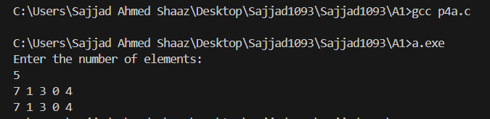Q. Implement a two dimensional array of integers using array of pointers. Accept the value for the elements and print those.

#include <stdio.h>
#include <stdlib.h>

void getDimension(int* r, int* c) {
printf("Enter the number of rows: \n");
scanf("%d", r);
printf("Enter the number of columns: \n");
scanf("%d", c);
}

int* allocateRow(int c) {
return (int *) malloc(c*sizeof(int));
}

void acceptValues(int* arr[], int r, int c) {
for (int i=0; i<r; i++) {
int* row=allocateRow(c);
arr[i]=row;

for (int j=0; j<c; j++) {
scanf("%d", row+j);
}
}
}

void printValues(int* arr[], int r, int c) {
for (int i=0; i<r; i++) {
int* row=arr[i];

for (int j=0; j<c; j++) {
printf("%d ", *(row+j));
}
printf("\n");
}
}

void freeMemory(int* arr[], int r) {
for (int i = 0; i < r; i++) {
free(arr[i]);
}
}

int main () {
int r, c;
printf("Enter number of rows and columns: ");
scanf("%d %d", &r, &c);

// implementation using array of pointers.
int* arr[r];
acceptValues(arr, r, c);
printValues(arr, r, c);
freeMemory(arr, r);
return 0;
}

Output

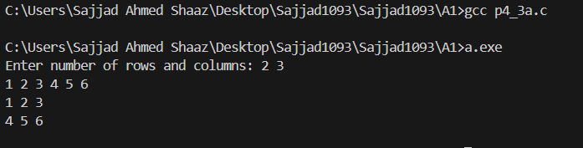

Q. Implement a two dimensional array of integers pointer to pointer (with two malloc statements). Accept the value for the elements and print those.

#include <stdio.h>
#include <stdlib.h>

void getDimension(int *n, int* m) {
printf("Enter the number of rows: \n");
scanf("%d", n);
printf("Enter the number of columns: \n");
scanf("%d", m);
}

int** allocateRows(int r) {
int **arr=(int **)malloc(r*sizeof(int *));
return arr;
}

int* allocateCols(int c) {
int *col=(int *)malloc(c*sizeof(int));
return col;
}

void acceptValues(int** arr, int r, int c) {
for (int i=0; i<r; i++) {
int* row=allocateCols(c);
*(arr+i)=row;

for (int j=0; j<c; j++) {
scanf("%d", row+j);
}
}
}

void printValues(int** arr, int r, int c) {
for (int i=0; i<r; i++) {
int *row =*(arr+i);
for (int j=0; j<c; j++) {
printf("%d ", *(row+j));
}
printf("\n");
}
}

int main () {
int r, c;
getDimension(&r, &c);
int** arr=allocateRows(r);
acceptValues(arr, r, c);
printValues(arr, r, c);
free(arr);
}
Output

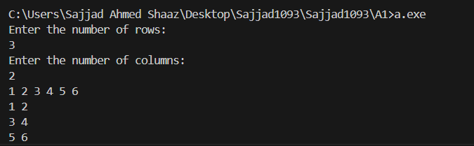

Q. Implement a two dimensional array of integers using pointer to pointer (with one malloc statement). Accept the value for the elements and print those.

#include <stdio.h>
#include <stdlib.h>

void getDimension(int *n, int* m) {
printf("Enter the number of rows: \n");
scanf("%d", n);
printf("Enter the number of columns: \n");
scanf("%d", m);
}
int** allocateMemory(int r, int c) {
int** arr=(int **)malloc(r*sizeof(int *)+r*c*sizeof(int));
return arr;
}
void acceptValues(int** arr, int r, int c) {
for (int i=0; i<r; i++) {
*(arr+i)=(int *)(arr+r+c*i);
int* row=*(arr+i);

for (int j=0; j<c; j++) {
scanf("%d", row+j);
}
}
}
void printValues(int** arr, int r, int c) {
for (int i=0; i<r; i++) {
int *row =*(arr+i);
for (int j=0; j<c; j++) {
printf("%d ", *(row+j));
}
printf("\n");
}
}
int main () {
int r, c;
getDimension(&r, &c);
int** arr=allocateMemory(r, c);
acceptValues(arr, r, c);
printValues(arr, r, c);
free(arr);
}
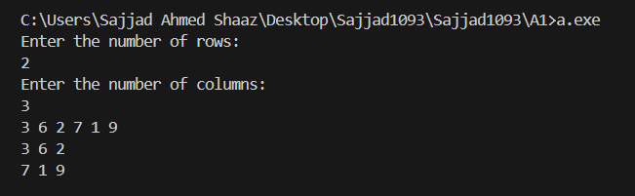
Q. Consider an array that stores roll, name, and score of number of students. Develop a function to sort the array. User of sort() will develop the comparison function for sorting on roll/score and ascending or descending order and reuse the same sort() function.

#include <stdio.h>
#include <stdlib.h>

struct Student {
int roll;
int score;
char* name;
};

void displayData(int n, struct Student** students) {
for (int i=0; i<n; i++) {
printf("%d %s %d \n", students[i]->roll, students[i]->name, students[i]->score);
}
printf("\n\n");
}

void takeUserInput(int n, struct Student** students) {
printf("enter roll name and score: \n");
for (int i=0; i<n; i++) {
struct Student *student=(struct Student *)malloc(sizeof(struct Student));
*(students+i)=student;
student->name=(char *)malloc(sizeof(char)*50);
scanf("%d", &(student->roll));
scanf("%s", student->name);
scanf("%d", &(student->score));
}
printf("\n\n");
}

int ascending(int a, int b) {
return (a>b)?0:1;
}

int descending(int a, int b) {
return (a>b)?1:0;
}

int compareScore(struct Student* student) {
return student->score;
}

int compareRoll(struct Student* student) {
return student->roll;
}

void sort(int n, struct Student** students, int (*compare)(int, int), int (*compareParam)(struct Student*)) {
int min, index=0;

for (int i=0; i<n; i++) {
min=i;
for (int j=i+1; j<n; j++) {
if (compare(compareParam(students[j]), compareParam(students[min]))) {
min=j;
}
}

struct Student* tempStudent=students[i];
students[i]=students[min];
students[min]=tempStudent;
}
}

struct Student** allocateMemory(int n) {
return (struct Student **)malloc(n*sizeof(struct Student *));
}

void freeMemory(int n, struct Student** students) {
for (int i = 0; i < n; i++) {
free(students[i]->name);
free(students[i]);
}
free(students);
}
int main () {
int n;
printf("Enter the number of students:\n");
scanf("%d", &n);
struct Student** students = allocateMemory(n);
takeUserInput(n, students);

int choice;
do {
printf("Menu:\n");
printf("1. Display Students\n");
printf("2. Sort by Roll (Ascending)\n");
printf("3. Sort by Roll (Descending)\n");
printf("4. Sort by Score (Ascending)\n");
printf("5. Sort by Score (Descending)\n");
printf("6. Exit\n");
printf("Enter your choice: ");
scanf("%d", &choice);

switch (choice) {
case 1:
displayData(n, students);
break;
case 2:
sort(n, students, ascending, compareRoll);
printf("Sorted by Roll (Ascending):\n");
displayData(n, students);
break;
case 3:
sort(n, students, descending, compareRoll);
printf("Sorted by Roll (Descending):\n");
displayData(n, students);
break;
case 4:
sort(n, students, ascending, compareScore);
printf("Sorted by Score (Ascending):\n");
displayData(n, students);
break;
case 5:
sort(n, students, descending, compareScore);
printf("Sorted by Score (Descending):\n");
displayData(n, students);
break;
case 6:
printf("Exiting...\n");
break;
default:
printf("Invalid choice! Try again.\n");
}
} while (choice != 6);

freeMemory(n, students);
return 0;

}

Output
