JADAVPUR UNIVERSITY


Programming Fundamentals and Object Oriented Concepts

NAME: SAJJAD AHMED SHAAZ
ROLL: 002410501093

COMPUTER SCIENCE
AND
ENGINEERING
(2024-2028)

ASSIGNMENT – 3

Q. Design the class(es) for the following scenario:

- An item list contains item code, name, rate, and quantity for several items.
- Whenever a new item is added in the list uniqueness of item code is to be checked.
- Time to time rate of the items may change.
- Whenever an item is issued or received existence of the item is checked and quantity is updated.
- In case of issue, availability of quantity is also to be checked.
- User may also like to know price/quantity available for an item.

#include <stdio.h>
#define LIST_SIZE 100

class Item {
private:
int code;
char* name;
int rate;
int quantity;
int issued_quantity;
public:
Item() {
code=0;
name="";
rate=0;
quantity=0;
issued_quantity=0;
}
Item(int code, char* name, int rate, int quantity) {
this->code=code;
this->name=name;
this->rate=rate;
this->quantity=quantity;
issued_quantity=0;
}
void setRate(int rate) {
this->rate=rate;
}
int getCode() {
return code;
}
int getAvailableQty() {
return quantity-issued_quantity;
}
int getRate() {
return rate;
}
void issueItem(int qty) {
issued_quantity+=qty;
}
char* getName() {
return name;
}
};

class ItemList {

private:
Item items[LIST_SIZE];
int count;

int findItem(int code) {
for (int i=0; i<LIST_SIZE; i++) {
if (items[i].getCode()==code)
return i;
}
return -1;
}

public:
ItemList() {
count=0;
}

void addItem(int code, char* name, int rate, int quantity) {
if (findItem(code)==-1) {
Item item(code, name, rate, quantity);
items[count]=item;
count++;
} else {
printf("Item code must be unique!\n");
}
}

void issueItem(int code, int qty) {
int k=findItem(code);
int availableQty=items[k].getAvailableQty();

if (k!=-1) {
if (availableQty>=qty) {
printf("Item issued!");
items[k].issueItem(qty);
} else {
printf("Insufficient quantity!\n");
}
} else {
printf("Unavailable item!\n");
}
}

void displayItemDetail(int code) {
int k=findItem(code);
if (k!=-1) {
printf("Item Code: %d, Item name: %s, available qty: %d, rate: %d\n", code, items[k].getName(), items[k].getAvailableQty(), items[k].getRate());
} else {
printf("Unavailable item!\n");
}
}
};

int main () {
ItemList items;

while (true) {
int option;
printf("\n1. Add Item\t2. Issue Item\t3. Display Item Detail\t4. Exit\n");
scanf("%d", &option);

// use switch case to perform operations based on user input
switch (option) {
case 1: {
int code, rate, quantity;
char name[50];
printf("Enter item code, name, rate and quantity: ");
scanf("%d %s %d %d", &code, name, &rate, &quantity);
items.addItem(code, name, rate, quantity);
break;
}
case 2: {
int code, qty;
printf("Enter item code and quantity to issue: ");
scanf("%d %d", &code, &qty);
items.issueItem(code, qty);
break;
}
case 3: {
int code;
printf("Enter item code to display details: ");
scanf("%d", &code);
items.displayItemDetail(code);
break;
}
case 4:
return 0;
default:
printf("Invalid option! Please try again.\n");
}
}
}

Output

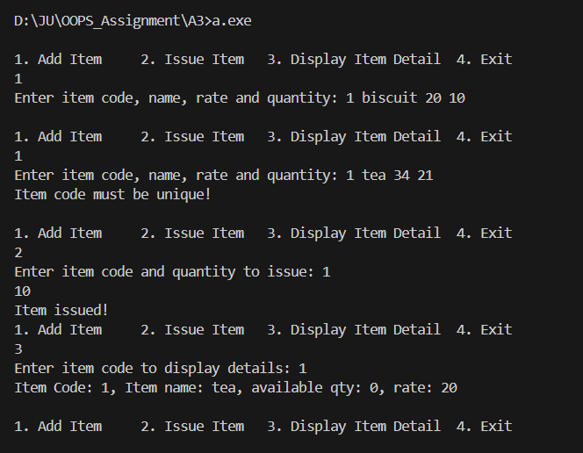

ASSIGNMENT – 4
Q. Design the class(es) for the following. Each account has account number and balance amount. A list of account is to be maintained where one can add and find account, display information of all accounts. While adding, account number must be unique. Withdraw object has account number (must exist) and amount(will not exceed balance amount of corresponding account). Withdraw object will update the balance of corresponding account in the list. User will be able to search and view account, add account and withdraw money from the account. Implement your design. Use friend function wherever required and again, modify your implementation to avoid friend function.

#include <iostream>

using namespace std;
#define MAX_SIZE 100

class Account {
private:
int acc_no;
float balance;
public:
Account() {
acc_no=0;
balance=0.0;
}
Account(int acc_no, float balance) {
this->acc_no=acc_no;
this->balance=balance;
}
int getAccountNumber() {
return acc_no;
}
void deposit(float amount) {
if (amount>0) {
balance+=amount;
cout << "amount depositted successfully.\n";
} else {
cout << "invalid deposit amount.\n";
}
}
void withdraw(float amount) {
if (amount<=0) {
cout << "invalid withdrawl amount.\n";
} else if (amount>balance) {
cout << "insufficient balance.\n";
} else {
balance-=amount;
cout << "amount withdrawn succefully.\n";
}
}
void display() const {
cout << "Account: " << acc_no << " Balance: " << balance << "\n";
}
};

class AccountList {
private:
Account accounts[MAX_SIZE];
int count;
int searchAccount(int acc_no) {
for (int i=0; i<MAX_SIZE; i++) {
if (accounts[i].getAccountNumber()==acc_no) {
return i;
}
}
return -1;
}

public:
AccountList() {
count=0;
}
void addAccount(int acc_number, float balance) {
if (searchAccount(acc_number)==-1) {
Account acc(acc_number, balance);
accounts[count]=acc;
count++;
} else {
cout << "Account already exists\n";
}
}
void getAccountDetail(int acc_no) {
int k=searchAccount(acc_no);

if (k==-1) {
cout << "account not found.\n";
} else {
accounts[k].display();
}
}
void showAllAccounts() {
cout << "All account details";
for (int i=0; i<count; i++) {
accounts[i].display();
}
}
void depositToAccount(int acc_no, float amount) {
int k=searchAccount(acc_no);

if (k==-1) {
cout << "invalid acc no.\n";
} else {
accounts[k].deposit(amount);
}
}
void withdrawFromAccount(int acc_no, float amount) {
int k=searchAccount(acc_no);

if (k==-1) {
cout << "invalid acc no.\n";
} else {
accounts[k].withdraw(amount);
}
}
};

int main () {
AccountList list;

while(1) {

cout << "\n1. Add Account 2. Search Account 3. Withdraw money 4. Deposit Money \n";
int option, acc;
float amt;
cin >> option;

switch (option) {
case 1:
cout << "enter account no: ";
cin >> acc;
list.addAccount(acc, 0);
break;
case 2:
cout << "enter account no: ";
cin >> acc;
list.getAccountDetail(acc);
break;
case 3:
cout << "enter account no: ";
cin >> acc;
cout << "enter amount to withdraw: ";
cin >> amt;
list.withdrawFromAccount(acc, amt);
break;
case 4:
cout << "enter account no: ";
cin >> acc;
cout << "enter amount to deposit: ";
cin >> amt;
list.depositToAccount(acc, amt);
break;
default:
cout << "invalid option\n";
break;
}
}
}

Output

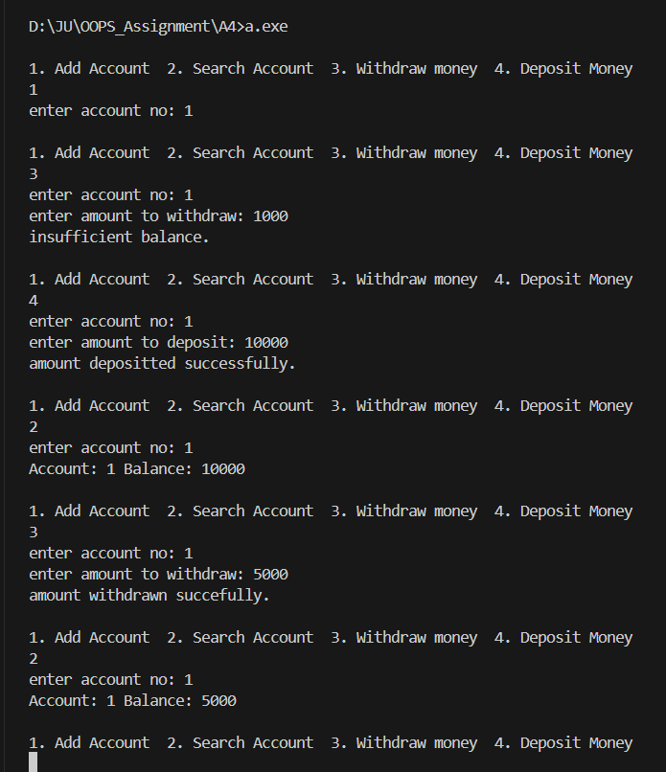

ASSIGNMENT – 5

Q. In a library, for each book book-id, serial number (denotes copy number of a book), title, author, publisher and price are stored. Book-id and serial number together will be unique identifier for a book. Members are either student or faculty. Each member has unique member-id. Name, e-mail, address are also to be stored. For any transaction (book issue or return), members are supposed to place transactions slip. User will submit member id, book-id, and serial number(only for book return). While processing a transaction, check the validity of the member. While issuing, availability of a copy of the book is to be checked. While returning a book, it is to be checked whether this copy was issued to the member or not. A student member can have 2 books issued at a point of time. For faculty members it is 10. Transaction information is to be stored like date of transaction,
member-id, book-id, serial number, returned or not. An entry is made when book is issued and updated when the book is returned. Design the classes and implement. For list consider memory data structure.

Class Design:

//---------------------------------------------
// Class: Book
//---------------------------------------------
class Book {
private:
string bookID;
int serialNumber;
string title;
string author;
string publisher;
double price;
bool isIssued;

public:
// Constructors
Book(string bookID, int serialNumber, string title, string author, string publisher, double price);

// Getters
string getBookID() const;
int getSerialNumber() const;
string getTitle() const;
string getAuthor() const;
string getPublisher() const;
double getPrice() const;
bool getIssuedStatus() const;

// Setters
void setIssuedStatus(bool status);
};

//---------------------------------------------
// Abstract Class: Member
//---------------------------------------------
class Member {
protected:
string memberID;
string name;
string email;
string address;
int issuedCount;

public:
Member(string memberID, string name, string email, string address);

// Virtual Destructor
virtual ~Member() {}

// Getters
string getMemberID() const;
string getName() const;
string getEmail() const;
string getAddress() const;

// Pure virtual function for issue limit
virtual int getIssueLimit() const = 0;

// Manage issued books
void incrementIssuedCount();
void decrementIssuedCount();
int getIssuedCount() const;
};

//---------------------------------------------
// Derived Class: Student
//---------------------------------------------
class Student : public Member {
public:
Student(string memberID, string name, string email, string address);
int getIssueLimit() const;
};

//---------------------------------------------
// Derived Class: Faculty
//---------------------------------------------
class Faculty : public Member {
public:
Faculty(string memberID, string name, string email, string address);
int getIssueLimit() const;
};

//---------------------------------------------
// Class: Transaction
//---------------------------------------------
class Transaction {
private:
string memberID;
string bookID;
int serialNumber;
string dateOfTransaction;
bool returned;

public:
Transaction(string memberID, string bookID, int serialNumber, string dateOfTransaction, bool returned = false);

// Getters
string getMemberID() const;
string getBookID() const;
int getSerialNumber() const;
string getDateOfTransaction() const;
bool isReturned() const;

// Setters
void markReturned();
};

//---------------------------------------------
// Class: Library
//---------------------------------------------
class Library {
private:
vector<Book> books;
vector<Member*> members;
vector<Transaction> transactions;

// Helper functions
Member* findMemberByID(const string& memberID);
Book* findBookByIDAndSerial(const string& bookID, int serialNumber);
bool isBookAvailable(const string& bookID);
bool isBookIssuedToMember(const string& memberID, const string& bookID, int serialNumber);

public:
// Book management
void addBook(const Book& book);
void displayAllBooks() const;

// Member management
void addMember(Member* member);
void displayAllMembers() const;

// Transaction management
void issueBook(const string& memberID, const string& bookID, const string& dateOfTransaction);
void returnBook(const string& memberID, const string& bookID, int serialNumber, const string& dateOfTransaction);
void displayAllTransactions() const;
};

