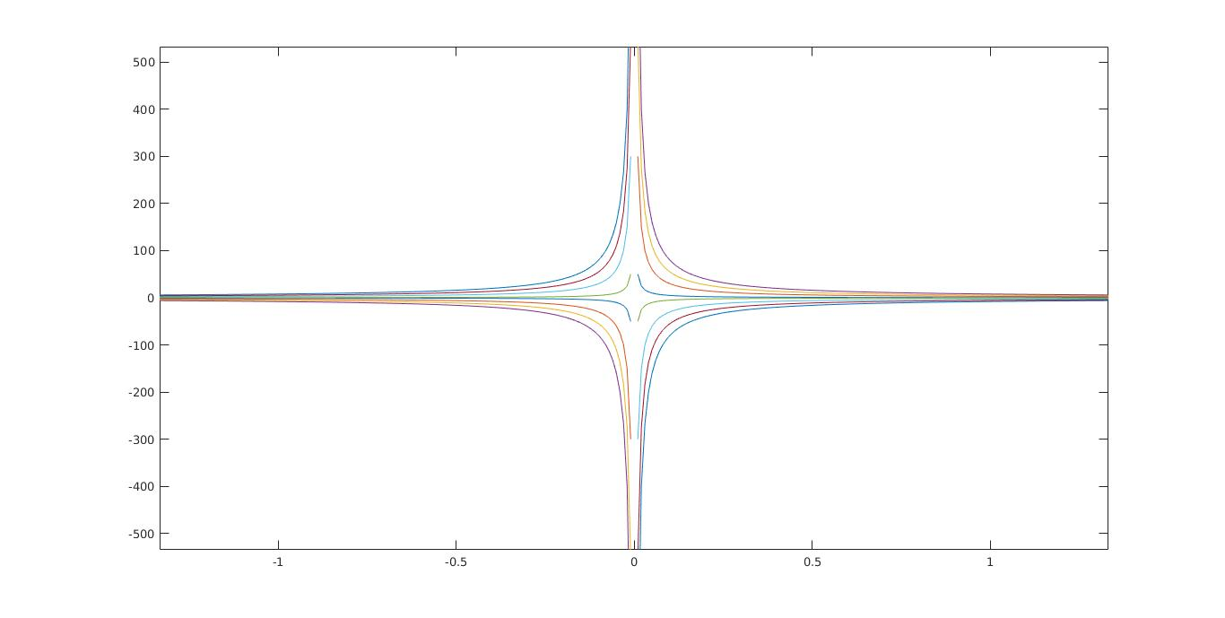
x=-2:0.01:2;
for u=1:5:20
y=u./(2*x);
plot(x,y)
hold on
end
for u=1:5:20
y=(-u)./(2*x);
plot(x,y)
hold on
end

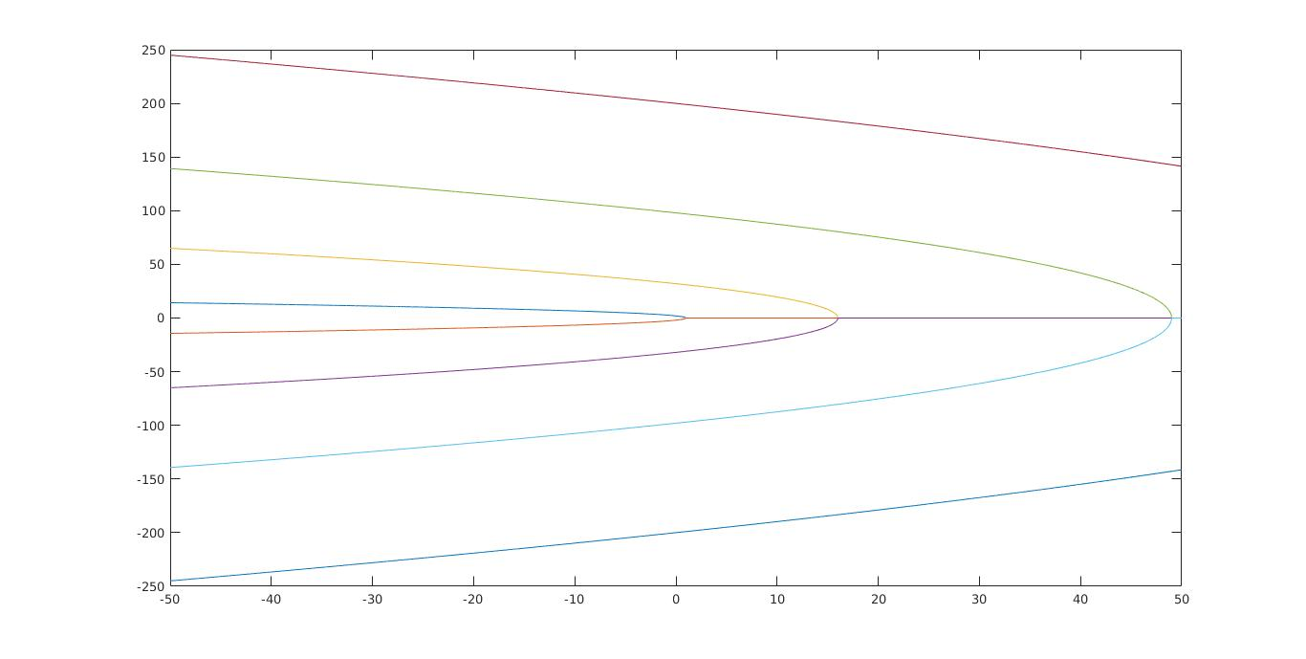
u=-50:0.01:50;
for x=1:3:10
v=sqrt(4*x^2*(x^2-u));
plot(u,v)
hold on
plot(u,-v)
end

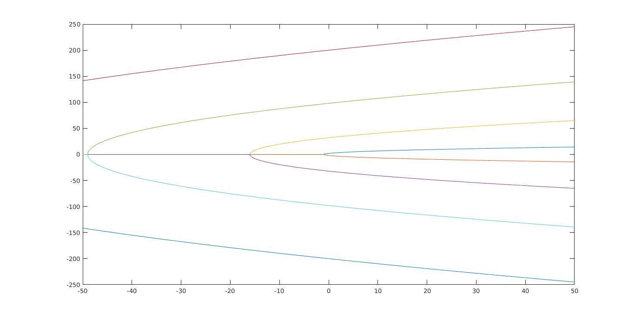
u=-50:0.01:50;
for y=1:3:10
v=sqrt(4*y^2*(y^2+u));
plot(u,v)
hold on
plot(u,-v)
end

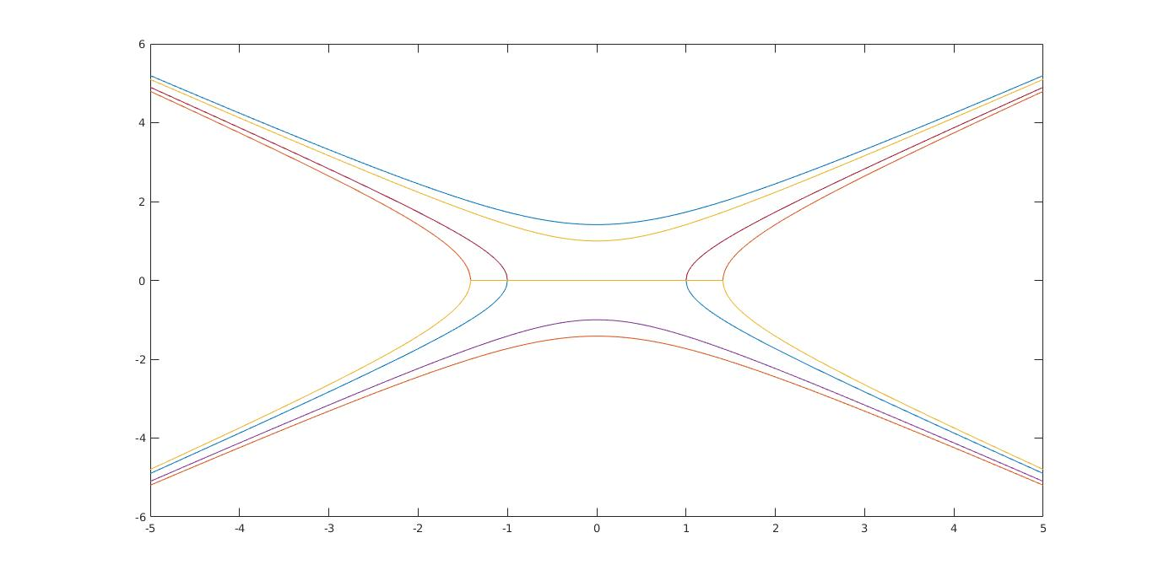
x=-5:0.01:5;
for u=-2:1:2
y=sqrt(u*((x.^2)/u-1));
plot(x,y)
hold on
plot(x,-y)

end

دو کره

