**Name: Hamna Ijaz**

**Date:10-11-2023**

**Step Trainee Assignment**

**How does a browser work?**

A web browser takes you anywhere on the internet. It retrieves information from other parts of the web and displays it on your desktop or mobile device. The information is transferred using the Hypertext Transfer Protocol, which defines how text, images and video are transmitted on the web.

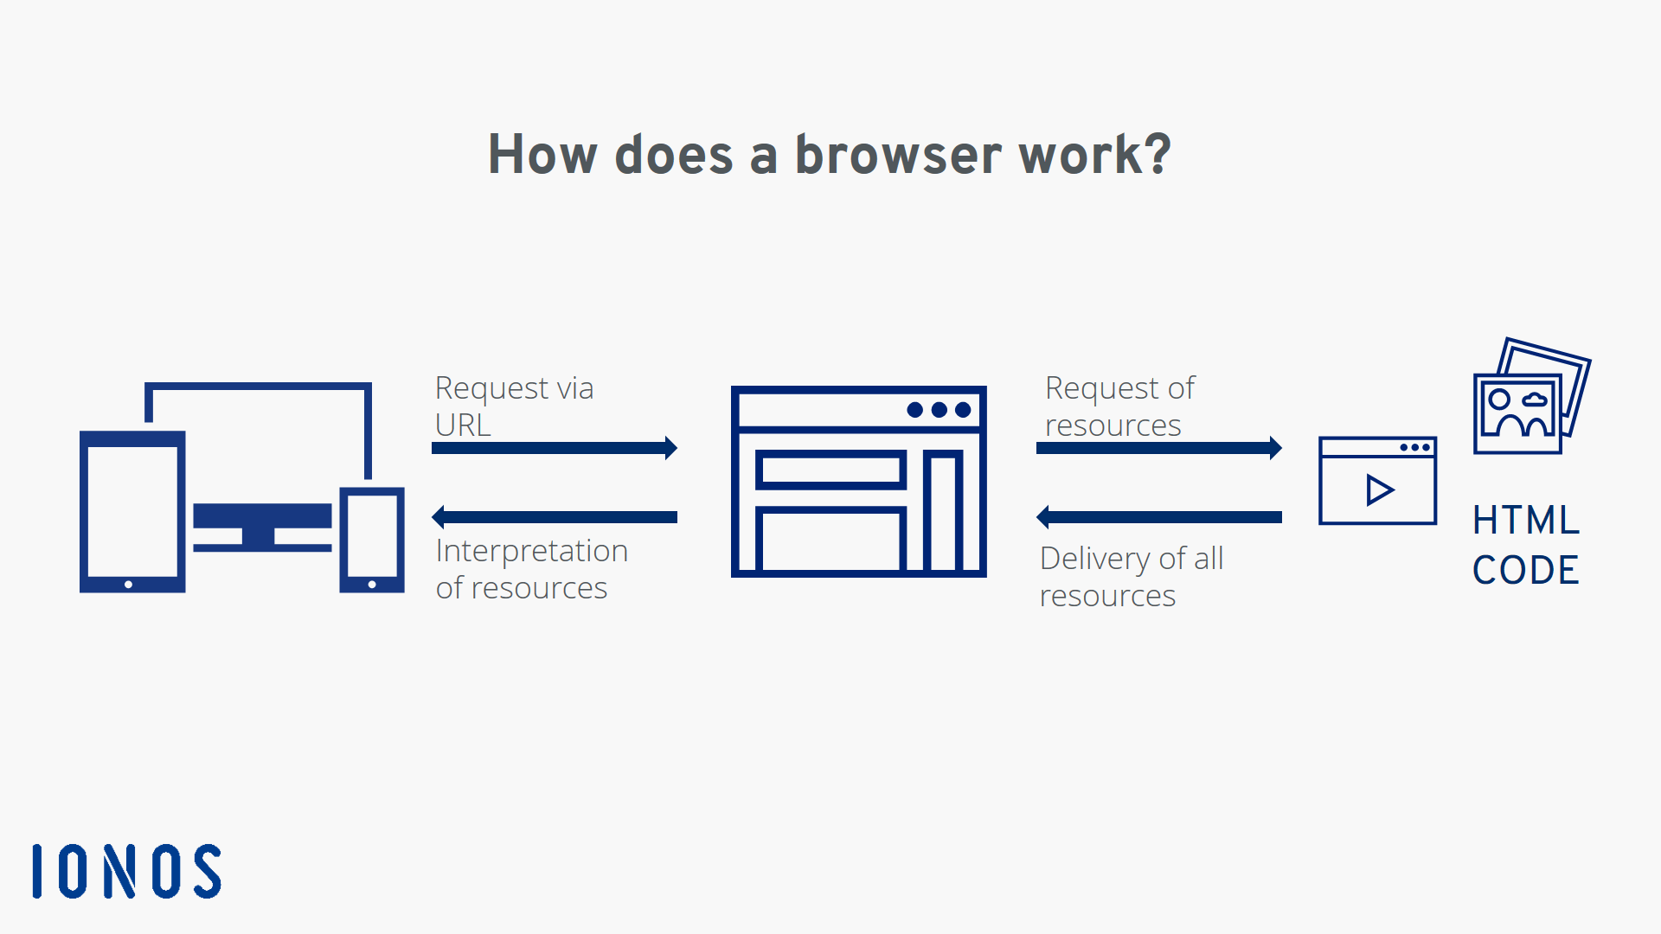

**Git Command:**

* Git init
* Git add
* Git .add
* Git status
* Git commit
* Git config
* Git checkout-b
* Git branch-d
* Git checkout
* Git restore