GitHub link:
Summary Results
1. Final Test Score
The final model was tested one time on the test set:
Test Accuracy: 86.38%
Macro Precision: 86.48%
Macro Recall: 86.51%
Macro F1 Score: 86.23%
This is 14.63 percentage points higher than the Part 2 baseline (71.75%).

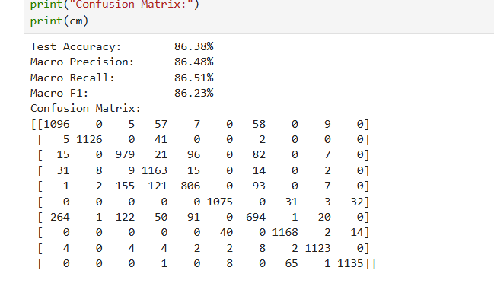
2. Configuration That Produced This Score
The final model used these settings:
Learning rate: 0.0019
Hidden layer width: 256
Dropout rate: 0.487
Batch size: 64
Training data size: 20,000 samples
Optimiser: Adam
This setting was picked using 5-fold cross-validation. It had a high mean accuracy and a low standard deviation across folds.
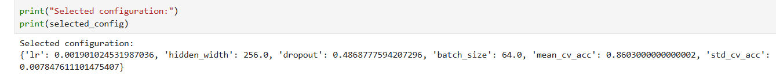

3. The Single Change That Helped Most
The biggest improvement came from using more training data. In Part 6, using 20,000 training samples gave the best result out of all methods tested.
It had the highest validation accuracy (85.12%). It also had the smallest gap between train and validation accuracy (1.35%). This means it helped the model learn well without overfitting.
Other methods, like dropout and weight decay, also helped a little. But more training data gave the biggest and cleanest improvement.
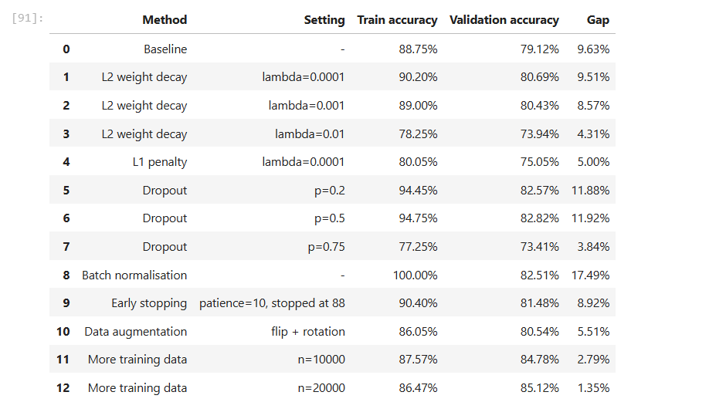

Part 4 table:
