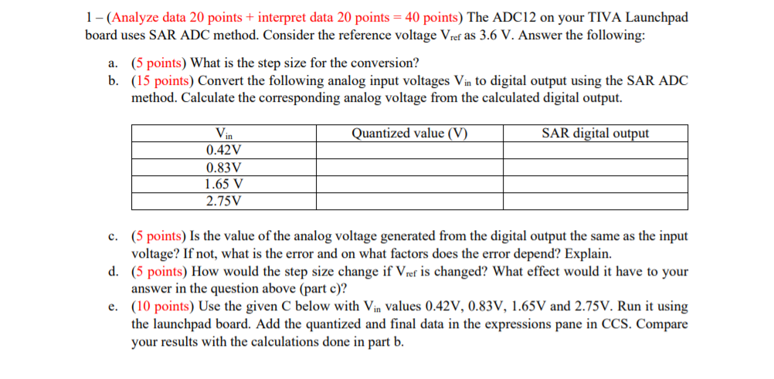

1. The ADC12 on your TIVA Launchpad board uses SAR ADC method. Consider the reference voltage Vref as 3.6 V. Answer the following:
   1. What is the step size for the conversion?
 $step size=\frac{3.6V-0V}{2^{12}}=\frac{3.6V}{4096}=0.879mV$

  2. Convert the following analog input voltages Vin to digital output using the SAR ADC method. Calculate the corresponding analog voltage from the calculated digital output.

|  |  |  |
| --- | --- | --- |
| Vin | Quantized value (V) | SAR digital output |
| 0.42 V | 0.419238269 | 000111011101 |
| 0.83 V | 0.829687476 | 000111011000 |
| 1.65 V | 1.64970696 | 011101010101 |
| 2.75 V | 2.74921846 | 110000111000 |

1. When Vin = 0.42V

Step 1

|  |  |  |  |  |  |  |  |  |  |  |  |
| --- | --- | --- | --- | --- | --- | --- | --- | --- | --- | --- | --- |
| D11 | D10 | D9 | D8 | D7 | D6 | D5 | D4 | D3 | D2 | D1 | D0 |
| 0 | 0 | 0 | 1 | 1 | 1 | 0 | 1 | 1 | 1 | 0 | 1 |

$$Quantized Value=\left(2^{11}×0.879mV\right)=1.8 V>0.42 V hence D11 will be 0$$

$$Quantized Value=\left(2^{10}×0.879mV\right)=0.9 V>0.42 V hence D10 will be 0$$

$$Quantized Value=\left(2^{9}×0.879mV\right)=0.45 V>0.42 V hence D9 will be 0$$

$$Quantized Value=\left(2^{8}×0.879mV\right)=0.225 V<0.42 V hence D8 will be 1$$

$$Quantized Value=\left((2^{8}+2^{7}×0.879mV\right)=0.337536 V<0.42 V hence D7 will be 1$$

$$Quantized Value=\left((2^{8}+2^{7}+2^{6}×0.879mV\right)=0.393792 V<0.42 V hence D6 will be 1$$

$$Quantized Value=\left((2^{8}+2^{7}+2^{6}+2^{5}×0.879mV\right)=0.42192 V>0.42 V hence D5 will be 0$$

$$Quantized Value=\left((2^{8}+2^{7}+2^{6}+2^{4}×0.879mV\right)=0.407856 V<0.42 V hence D4 will be 1$$

$$Quantized Value=\left((2^{8}+2^{7}+2^{6}+2^{4}+2^{3}×0.879mV\right)=0.414888 V<0.42 V hence D3 will be 1$$

$$Quantized Value=\left((2^{8}+2^{7}+2^{6}+2^{4}+2^{3}+2^{2}×0.879mV\right)=0.418404 V<0.42 V hence D2 will be 1$$

$$Quantized Value=\left((2^{8}+2^{7}+2^{6}+2^{4}+2^{3}+2^{2}+2^{1}×0.879mV\right)=0.420162 V>0.42 V hence D1 will be 0$$

$$Quantized Value=\left((2^{8}+2^{7}+2^{6}+2^{4}+2^{3}+2^{2}+2^{0}×0.879mV\right)=0.419283 V<0.42 V hence D0 will be 1$$

1. When Vin = 0.83 V

|  |  |  |  |  |  |  |  |  |  |  |  |
| --- | --- | --- | --- | --- | --- | --- | --- | --- | --- | --- | --- |
| D11 | D10 | D9 | D8 | D7 | D6 | D5 | D4 | D3 | D2 | D1 | D0 |
| 0 | 0 | 1 | 1 | 1 | 0 | 1 | 1 | 0 | 0 | 0 | 0 |

$$Quantized Value=\left(2^{11}×0.879mV\right)=1.8 V>0.83 V hence D11 will be 0$$

$$Quantized Value=\left(2^{10}×0.879mV\right)=0.9 V>0.83 V hence D10 will be 0$$

$$Quantized Value=\left(2^{9}×0.879mV\right)=0.45 V<0.83 V hence D9 will be 1$$

$$Quantized Value=\left(2^{9}+2^{8}×0.879mV\right)=0.675072 V<0.83 V hence D8 will be 1$$

$$Quantized Value=\left((2^{9}+2^{8}+2^{7}×0.879mV\right)=0.787584 V<0.83 V hence D7 will be 1$$

$$Quantized Value=\left((2^{9}+2^{8}+2^{7}+2^{6}×0.879mV\right)=0.84384 V>0.83 V hence D6 will be 0$$

$$Quantized Value=\left((2^{9}+2^{8}+2^{7}+2^{5}×0.879mV\right)=0.815712 V<0.83 V hence D5 will be 1$$

$$Quantized Value=\left((2^{9}+2^{8}+2^{7}+2^{5}+2^{4}×0.879mV\right)=0.829776 V<0.83 V hence D4 will be 1$$

$$Quantized Value=\left((2^{9}+2^{8}+2^{7}+2^{5}+2^{4}+2^{3}×0.879mV\right)=0.836808 V>0.83 V hence D3 will be 0$$

$$Quantized Value=\left((2^{9}+2^{8}+2^{7}+2^{5}+2^{4}+2^{2}×0.879mV\right)=0.833292 V>0.83 V hence D2 will be 0$$

$$Quantized Value=\left((2^{9}+2^{8}+2^{7}+2^{5}+2^{4}+2^{1}×0.879mV\right)=0.831534 V>0.83 V hence D1 will be 0$$

$$Quantized Value=\left((2^{9}+2^{8}+2^{7}+2^{5}+2^{4}+2^{0}×0.879mV\right)=0.830655 V >0.83 V hence D0 will be 0$$

1. When Vin = 1.65 V

|  |  |  |  |  |  |  |  |  |  |  |  |
| --- | --- | --- | --- | --- | --- | --- | --- | --- | --- | --- | --- |
| D11 | D10 | D9 | D8 | D7 | D6 | D5 | D4 | D3 | D2 | D1 | D0 |
| 0 | 1 | 1 | 1 | 0 | 1 | 0 | 1 | 0 | 1 | 0 | 1 |

$$Quantized Value=\left(2^{11}×0.879mV\right)=1.8 V>1.65V hence D11 will be 0$$

$$Quantized Value=\left(2^{10}×0.879mV\right)=0.9 V<1.65 V hence D10 will be 1$$

$$Quantized Value=\left(2^{10}+2^{9}×0.879mV\right)=1.35 V<1.65 V hence D9 will be 1$$

$$Quantized Value=\left(2^{10}+2^{9}+2^{8}×0.879mV\right)=1.575168 V<1.65 V hence D8 will be 1$$

$$Quantized Value=\left((2^{10}+2^{9}+2^{8}+2^{7}×0.879mV\right)=1.68768 V>1.65 V hence D7 will be 0$$

$$Quantized Value=\left((2^{10}+2^{9}+2^{8}+2^{6}×0.879mV\right)=1.631424 V<1.65 V hence D6 will be 1$$

$$Quantized Value=\left((2^{10}+2^{9}+2^{8}+2^{6}+2^{5}×0.879mV\right)=1.659552 V>1.65 V hence D5 will be 0$$

$$Quantized Value=\left((2^{10}+2^{9}+2^{8}+2^{6}+2^{4}×0.879mV\right)=1.645488 V<1.65 V hence D4 will be 1$$

$$Quantized Value=\left((2^{10}+2^{9}+2^{8}+2^{6}+2^{4}+2^{3}×0.879mV\right)=1.65252 V>1.65 V hence D3 will be 0$$

$$Quantized Value=\left((2^{10}+2^{9}+2^{8}+2^{6}+2^{4}+2^{2}×0.879mV\right)=1.649004 V<1.65 V hence D2 will be 1$$

$$Quantized Value=\left((2^{10}+2^{9}+2^{8}+2^{6}+2^{4}+2^{2}+2^{1}×0.879mV\right)=1.650762 V>1.65 V hence D1 will be 0$$

$$Quantized Value=\left((2^{10}+2^{9}+2^{8}+2^{6}+2^{4}+2^{2}+2^{0}×0.879mV\right)=1.649883 V>1.65V hence D0 will be 1$$

1. When Vin = 2.75 V

|  |  |  |  |  |  |  |  |  |  |  |  |
| --- | --- | --- | --- | --- | --- | --- | --- | --- | --- | --- | --- |
| D11 | D10 | D9 | D8 | D7 | D6 | D5 | D4 | D3 | D2 | D1 | D0 |
| 1 | 1 | 0 | 0 | 0 | 0 | 1 | 1 | 1 | 0 | 0 | 0 |

* 1. Is the value of the analog voltage generated from the digital output the same as the input voltage? If not, what is the error and on what factors does the error depend? Explain.
     1. None of the values of the analog voltage generated from the digital output matched the input voltage. This is because the generated voltage can only increase by a specific step size. In our case the step size is 0.879 mV. This means that the analog voltage generated is always going to be a multiple of 0.879 mV. If the input voltage is not a multiple of that value, then it is impossible for the generated voltage will never be equal to the input voltage. The table below shows the error between the Input voltage and the quantized value of the generated voltage:

|  |  |  |
| --- | --- | --- |
| Input Voltage (V) | Quantized Value of Generated Voltage (V) | Error Voltage (V) |
| 0.42 V | 0.419282V | 0.000718 |
| 0.83 V | 0.829776V | 0.000224 |
| 1.65 V | 1.649883V | 0.000117 |
| 2.75 V | 2.749512 V | 0.000488 |

* 1. How would the step size change if Vref is changed? What effect would it have to your answer in the question above?
     1. If Vref is changed, depending on the value it is changed to, if Vref is a multiple of any one of the input voltages, the quantized value of the generated voltage would be the exact same as the input voltage it is a multiple off. This means that the error between the two voltages would be 0.
  2. Using the given C code with Vin values, 0.42V, 0.83V, 1.65V, 2.75V. Run it using the launchpad board. Add the quantized and final data in the expression pan in CCS. Compare your results with the calculations done in part b.
     1. The table below shows the CCS output that calculates the quantized value using a computer system.

|  |  |  |
| --- | --- | --- |
| Vin | Quantized value (V) | SAR digital output |
| 0.42 V | 0.419V | 000111011101 |
| 0.83 V | 0.829V | 000111011000 |
| 1.65 V | 1.649V | 011101010101 |
| 2.75 V | 2.749 V | 110000111000 |