Saj Saha

21201377

Name:

ID:

**BRAC University** Semester: Summer 2023

Course Code: CSE250 Circuits And Electronics Section: 23

Faculty: ABJ, ERD

Assessment: *Simulation Lab test*

Duration: 20 minutes

Date: August 29, 2023

Full Marks: 10

* **Question 1: Insert your circuit screenshot.**

* **Question 2: Insert your simulation result screenshot.**

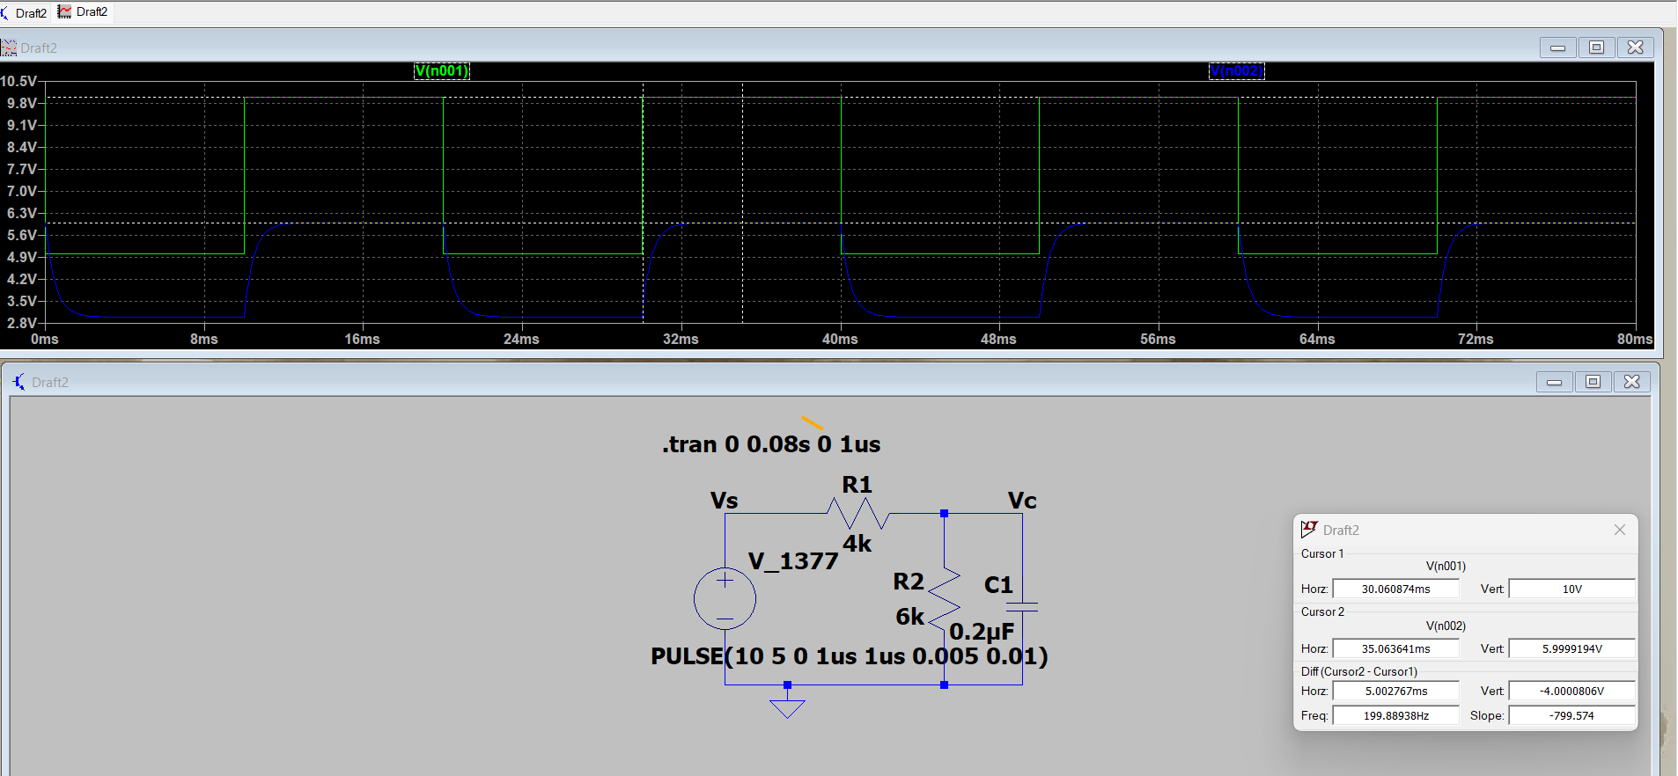

* **Question 3: Answer the questions in your question paper.**

The switch in has been in position a for a long time. At t = 0, it moves to position b. Calculate i(t) for all t > 0.