Tracking loop analysis

Analysis

Abstract: The ECU is overheated due to the non-immediately settling of the tracking loop. Aim of this report is to answer the following questions:
Questions:
- What is the time requirement of the initial phase of the tracking loop?
- In the initial phase the normalized gains and offset can be wrong. What are their effects?

The copyright of this document and all supplements remain to ThyssenKrupp Presta AG. It is strictly prohibited to make copy of it and to inform or make accessible to a third party without a written authorization from ThyssenKrupp Presta AG.

Revision History
Distribution
References
List of symbols and abbreviations

Table of Contents
Table of Contents 3
List of Tables 3
List of Figures 3

List of Tables
Error! No table of figures entries found.

List of Figures
Error! No table of figures entries found.
- Introduction
The ECU is overheated due to the non-immediately settling of the tracking loop. Aim of this report is to answer the following questions:
- What is the time requirement of the initial phase of the tracking loop?
- In the initial phase the normalized gains and offset can be wrong. What are their effects?
- Tracking loop
The tracking loop model can be seen in Fig. 1.
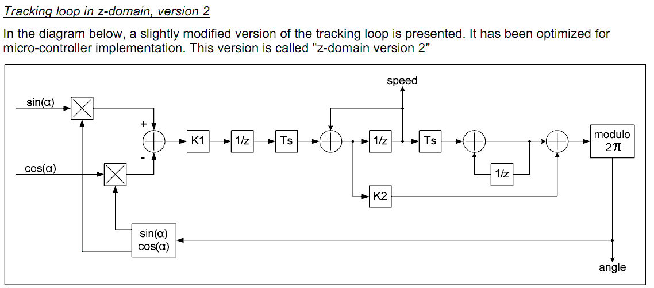
- Model of tracking loop
Its parameters are
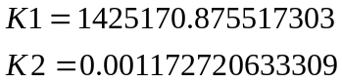
Parameter Ts is the sampling time which is 0.00025 sec
These parameters corresponds to the cutting frequency 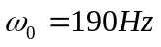and damping 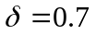.
The model is implemented in MATLAB/Simulink 2009b. Tracking loop is applied to compute motor angle and the motor angle speed from the sinus and cosines of the angle.
- Analysis
  - Settling time
Settling time is determined when the error between the referenced angle and the output angle of the tracking loop is close to zero and it does not leave this environment. The settling time corresponds the delay between the time when each input qualifier and each internal self diagnostic function go to OK and the time when the output qualifier is set.
The settling time can be determined from the Fig 2. One can realize that the settling time is 6 ms (the relative error is less than 2%). Therefore, after the input of the TL is reliable then we have to wait lat least 6 ms to get reliable TL output!
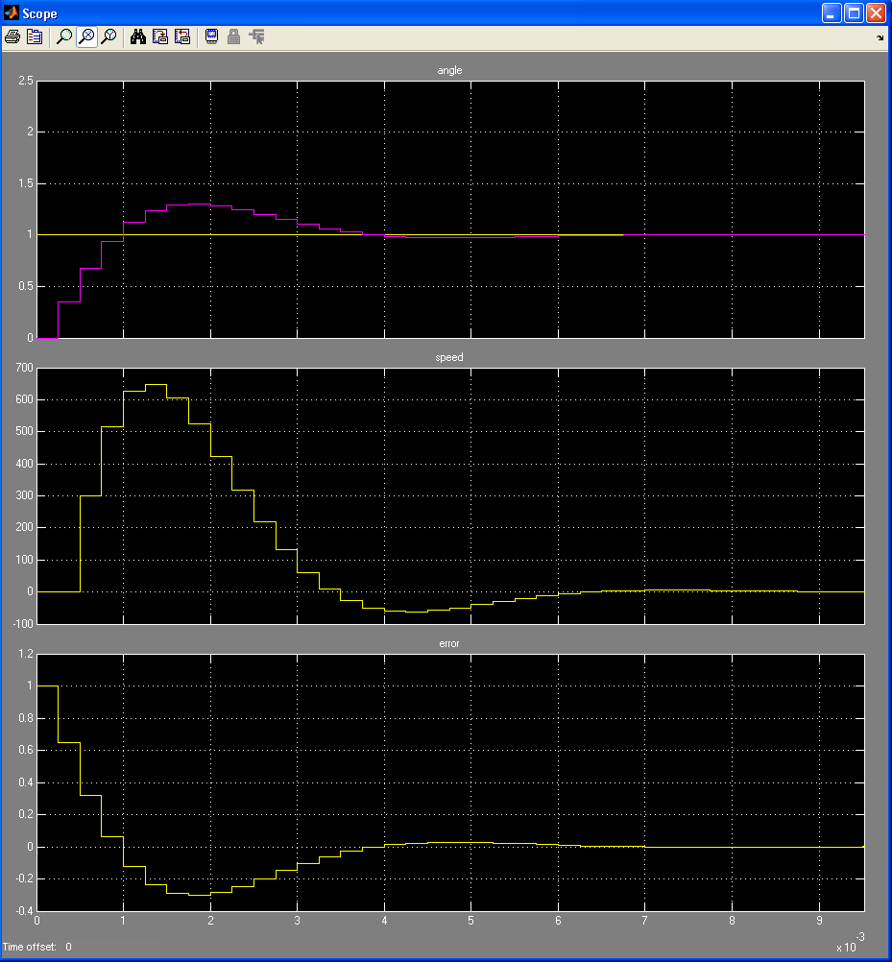
- Upper plot: reference angle (yellow) and the output angle of the TL (red); Middle: output speed of the TL; bottom plot: error between the reference angle and the output angle of the TL. The x-axis is the time in [sec]
  - Wrong gain or offset
If the normalization gains or offset of the input of the TL is wrong, then the tracking loop algorithm remains stable, however it outputs are biased. In Fig 3., the gain of the sinus input of the TL is twice as required. One can see that the settling time is 4 ms, while the estimated angle is 1.25 rad instead of 1 rad. However, one can see that the speed error can be higher in this case!
The same effect can be seen when offset of the normalization is wrong, see Fig 4.
The bias can be very high. Fig 5 shows when the step response when the offsets were wrong. One can see that the bias is almost 40%.
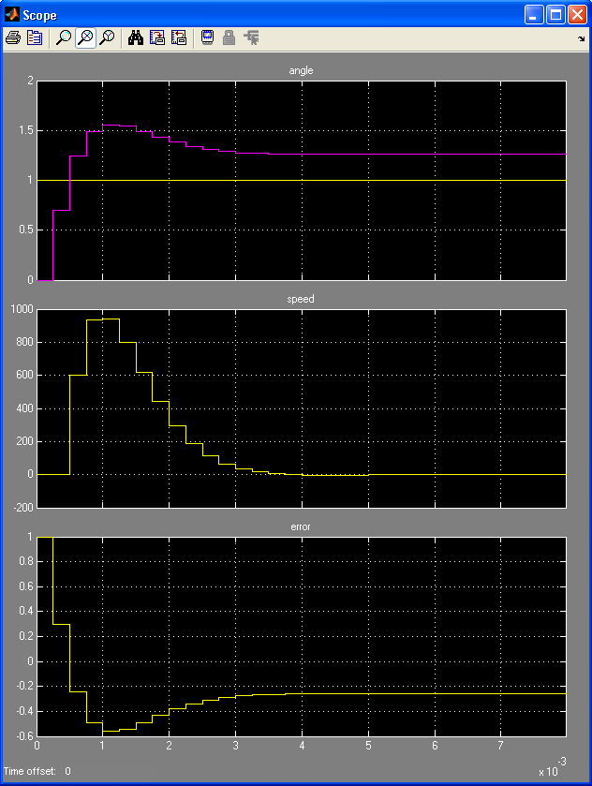
- Gain of sinus input of TL is twice as required
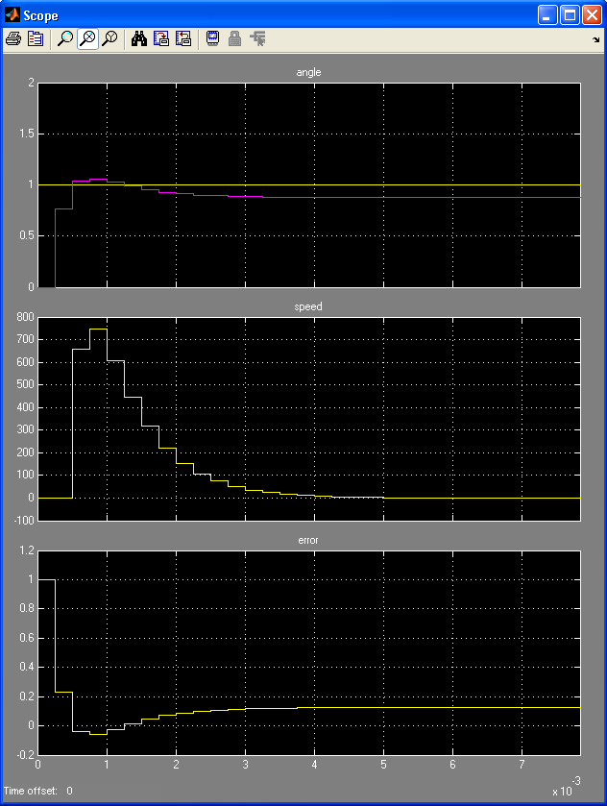
- Offset of the normalization is wrong
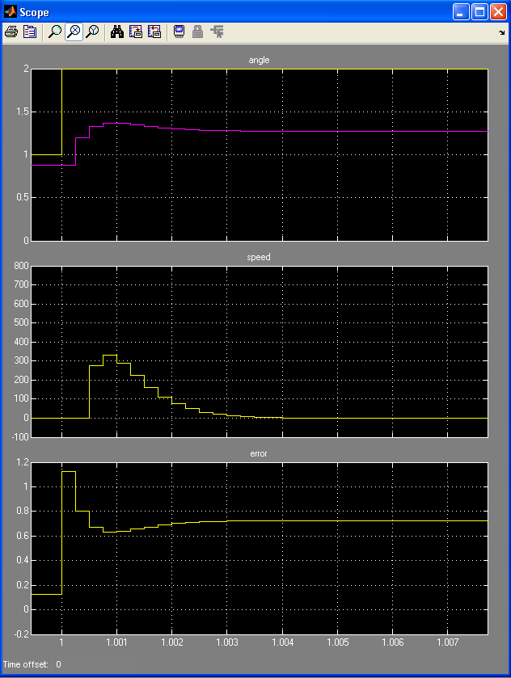
- Bias in the step response
- Conclusion
The answers to the question are the following:
- What is the time requirement of the initial phase of the tracking loop?: The settling time is 6 ms.
- In the initial phase the normalized gains and offset can be wrong. What are their effects? The estimated angle and speed are biased and during the initialization there errors can be higher.
If noise are added to the inputs of the TL, then similar conclusions can be drawn.

