Tracking loop analysis

Analysis

Abstract: One of the RPS sensor diagnostic will be deleted from the software (comparing the speed signals of the two RPS sensor). Therefore, only the angles of the two sensors are compared
Questions: Are there any errors which influence the speed comparison but do not affect the angle comparison? If there is such an error then it will be invisible from the angle comparison check.

The copyright of this document and all supplements remain to ThyssenKrupp Presta AG. It is strictly prohibited to make copy of it and to inform or make accessible to a third party without a written authorization from ThyssenKrupp Presta AG.

Revision History
Distribution
References
List of symbols and abbreviations

Table of Contents
Table of Contents 2
List of Tables 2
List of Figures 2
1. Introduction 3
2. Tracking loop 3
3. Analysis 3

List of Tables
Error! No table of figures entries found.

List of Figures
Figure 1. Model of tracking loop 3
Figure 2. Bode plot from the estimated speed to the estimated angle 4

- Introduction
In the RPS there are two sensors. Both sensors drive the own tracking loops. The tracking loop outputs the estimated angle and the speed signals. Then the two angles signals and the two speed signals are compared, respectively. If there is a significant difference between the two angle signals then the diagnostic D4401 shuts down, while if there is a difference between the two speed signals then the diagnostic D4450 shuts down. These comparisons prove us that the angle and the speed signals are responsible.
However, for hardware consuming reason the speed comparison diagnostic will be deleted. Therefore, a question is arisen: is there any error which cause shut down in speed comparison but does not cause shut down in the angle comparison. If there is such an error, then this error will be invisible.
- Tracking loop
The tracking loop model can be seen in Fig. 1.
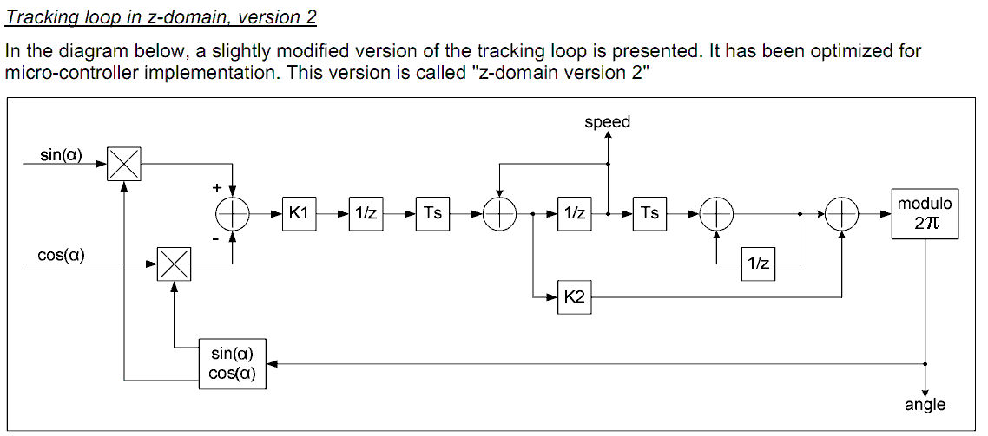
u
ω_{est}
α_{est}
p
q
- Model of tracking loop
Its parameters are
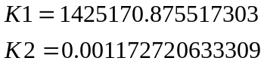
Parameter Ts is the sampling time which is 0.00025 sec
These parameters corresponds to the cutting frequency 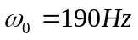and damping 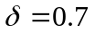.
The model is implemented in MATLAB/Simulink 2009b. Tracking loop is applied to compute motor angle and the motor angle speed from the sinus and cosines of the angle.
- Analysis
The tracking loop is non-linear function (see the sin and cos functions in the feedback). However, if the signal u is given, then the estimated signals 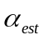 and 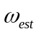 are linear function of the signal u. Therefore, a linear system connects the and the , too.
The z-transformation of the estimated speed can be expressed as
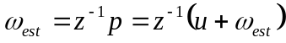
then
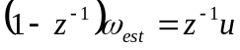
and the transfer function from u to is
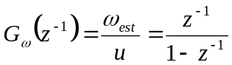
If there is an error which can be seen in the speed comparison but which is invisible in the angle comparison then transfer function from the speed to the angle has to be zero at the frequency spectrum of this error. Therefore, the transfer function from the speed to the angle has to be computed. (The speed comparison and the angle comparison mean a subtraction of two speeds and two angles, respectively. However subtraction is a linear function. Therefore, the transfer function from the speed difference to the angle difference is the same as the transfer function from the speed to the angle).
The z transformation of the estimated angle can be computed as
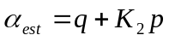
However, from the figure one can conclude that
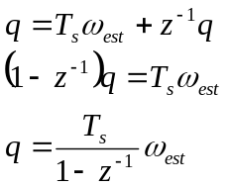
Therefore the estimated angle can be expressed as a function of the estimated speed:
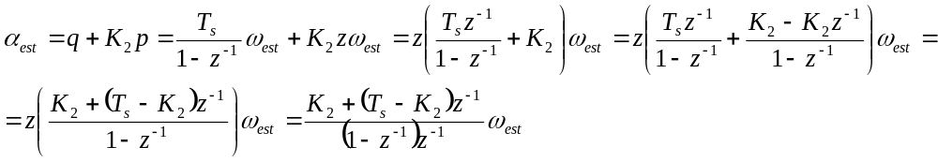
and the transfer function from the estimated speed to the estimated angle is
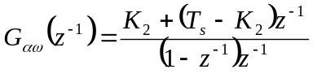
The Bode plot of this transfer function can be seen in Fig 2.
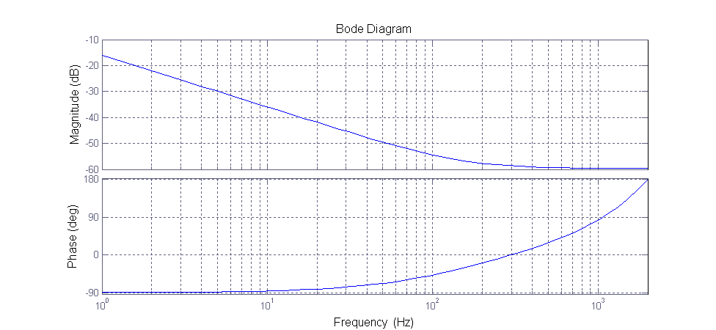
- Bode plot from the estimated speed to the estimated angle
An error is invisible form the angle comparison test point of view if the magnitude of the transfer function is zero at that frequency components of the error signal (since in this case the angle we cannot see anything). One can see in Fig 2 that there is not such frequency interval, therefore every speed comparison error can be seen as an angle comparison error. However, we have to note that the quantity of the angle error depends on the frequency of the error. At low frequency speed error can be cause higher angle error than the high frequency speed error.
This behavior is strength by simulation study also.

