RPS sensor filter analysis

Analysis report

Abstract:

The copyright of this document and all supplements remain to ThyssenKrupp Presta AG. It is strictly prohibited to make copy of it and to inform or make accessible to a third party without a written authorization from ThyssenKrupp Presta AG.

Revision History

Version | Date | Modified by | Description of the modification
1.0 | 14.09.2011 | Csaba Fazekas | Initial revision

Distribution

Company | Names | Date of last distribution
ThyssenKrupp Presta

References

No. | Authors | Title | Published
1 | Gábor Paholics | Sensor Specification | 2011, ThyssenKrupp Presta
2 | Bálint Barki | RPS noise investigation in R6 based ECU | 2011, ThyssenKrupp Presta

List of symbols and abbreviations

Symbol / Abbreviation | Description

Table of Contents

1. Introduction 4
2. Requirements 4
2.1. Motor control 4
2.2. Steering column torque control 4
3. RPC tracking-loop algorithm 4
4. Analysis 5
4.1. B1 ECU 5
4.2. B2 ECU 7

List of Tables

Error! No table of figures entries found.

List of Figures

Figure 1. Block diagram of the tracking loop algorithm 5
Figure 2. Double of the error between the angle filtering using tracking loop (190 Hz and 0.7 damping) when the acceleration is 25000rad/s². 6
Figure 3. Noises on the output of the tracking loop (190 Hz and 0.7 damping) 6
Figure 4. Error during the step response. The settling time is approx. 6 ms. 7
Figure 5. H₂ norm of the tracking loop with cutting frequency 190 Hz. 7
Figure 6. Double of the error between the angle filtering using tracking loop (190 Hz and 0.7 damping) when the acceleration is 25000rad/s² in case of B2 ECU. 8
Figure 7. Noises on the output of the tracking loop (190 Hz and 0.7 damping) 9

- Introduction
The old RPS sensor contained a tracking loop filter to compute the motor angle and the motor speed with less noise. The RPS sensor does not contain that tracking loop filter, however the suitable quality of the motor angle signal is required for the motor control, while the suitable quality of the motor speed signal is required for the steering column torque control.
The aim of this analysis is to develop a suitable RPS tracking loop filter for the new RPS sensor.
- Requirements
  - Motor control
The requirement of the motor angle accuracy (given by MC expert) is the following: at acceleration 25000 rad/s², the angle error has to be lower than 5 deg in electric degree, i.e. it has to be lower than 1 mechanic deg.
Since the motor contains 4 or 5 poles (depending of the type of the motor; Globe, AMK), the phase shift in mechanical degree has to be less than 1 deg. However, the RPS sensor measures the double of the motor angle, i.e. the phase shift of the filter using the raw data of the sensor has to be less than 2 deg in mechanical degree at acceleration 25000rad/s².
Measurement file containing excitation near the 25000rad/s² specification:
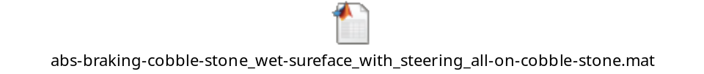
  - Steering column torque control
The variance of the motor angle speed signal should be less than 0.79 [rad²/s²] [1]. It means that the standard deviation of the motor speed signal is approx. 0.3 [rad/s]. (the standard deviation of the noise of the required motor torque should be lower than 0.03 Nm [2]. One of the sources of the required motor torque noise is the noise of the motor angle speed signal. Therefore, if the noise of the motor angle speed is lower than the noise of the required motor torque is also lower.)
The effect of the noise in the input to the noise in the output can be characterized by the H2 norm of the system. The H₂ norm measures the steady-state covariance of the output response to the unit white noise input.
- RPC tracking-loop algorithm
The algorithm of the tracking loop can be seen in Fig 1. The parameters are K1 and K2. They can be computed from the cutting frequency and the damping coefficient:
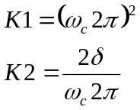
where 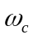 [Hz] is the cutting frequency and [1] is the damping coefficient. The tuned parameters of the tracking loop filter are 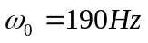and 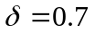, therefore the K1 and K2 parameters are
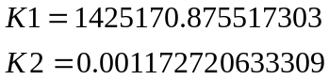
Parameter Ts is the sampling time which is 0.00025 sec.
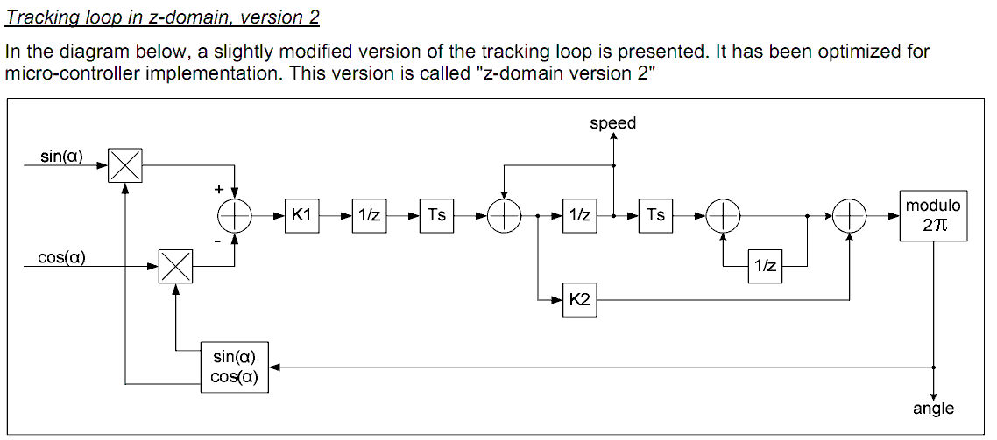
- Block diagram of the tracking loop algorithm
- Analysis
  - B1 ECU
Based on the investigation of Bálint Barki [2], the lowest possible noise on the input sinus and cosines channels of tracking loop is
- Sinus variance: 8.1629e-7
- Cosines variance: 6.1562e-7
The tracking loop filter with parameter and the new MC requirement can be satisfied, as one can see in Fig. 2. (The figure shows the double of the motor angle error in mechanical deg.)
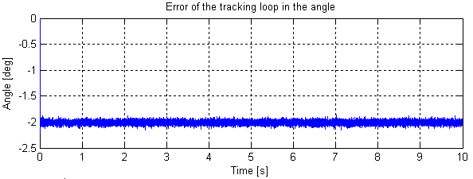
- Double of the error between the angle filtering using tracking loop (190 Hz and 0.7 damping) when the acceleration is 25000rad/s².
Using this new tracking loop and the minimal value of the variance of the sinus and cosines channels the noise in the output of the tracking loop can be seen in Fig 3. The speed variance is 0.3625²=0.1314, which is less than the requirement of the steering column torque controller.
The step response of that filter can be seen in Fig 4. One can conclude that the settling time of the tracking filter is approx. 6 ms.
The H2 norm of that tracking loop can be seen in Fig 5 (tracking loop output is double than the real speed). One can realize that the variance of the speed output is approx 300 higher than the variances of the input channels, i.e. the noise of the speed output channel is sensitive to the input noises.

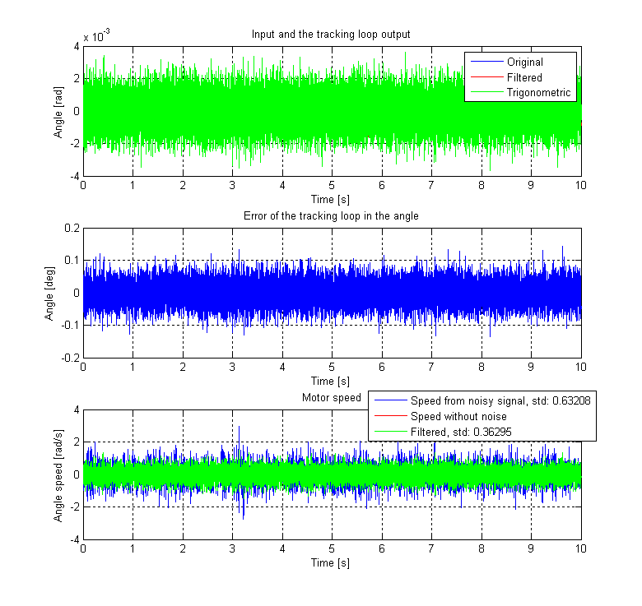
- Noises on the output of the tracking loop (190 Hz and 0.7 damping)
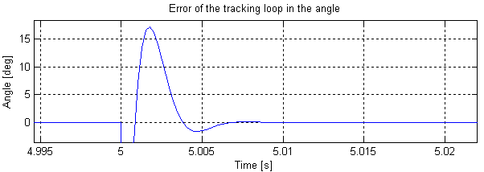
- Error during the step response. The settling time is approx. 6 ms.
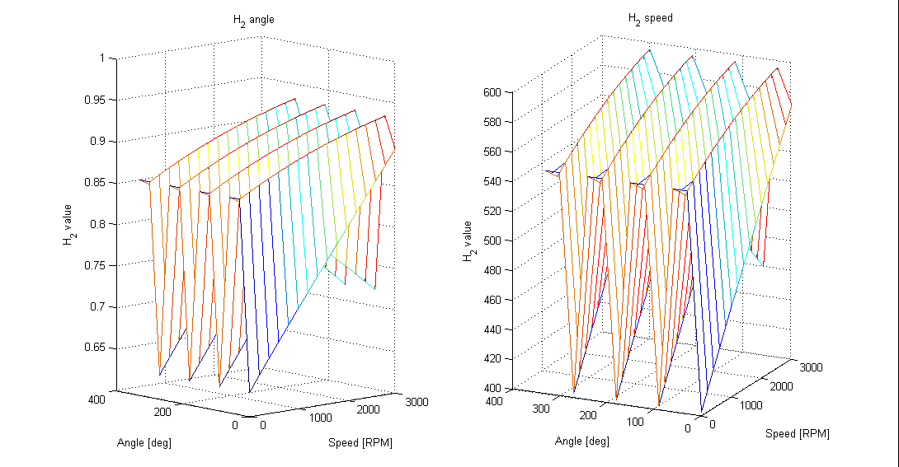
- H₂ norm of the tracking loop with cutting frequency 190 Hz.
  - B2 ECU
The same investigation is performed based on the data of B2 ECU. The MC requirement is the same as before: at acceleration 25000 rad/s², the angle error has to be lower than 5 deg in electric degree, i.e. it has to be lower than 1 mechanic deg.
Based on the investigation of Bálint Barki [2], the lowest possible noise on the input sinus and cosines channels of tracking loop is 17 % of the noise of B1 ECU, i.e.:
- Sinus variance: 8.1629e-7*0.17 = 1.3877e-7
- Cosines variance: 6.1562e-7*0.17 = 1.0466e-7
The tracking loop filter with parameter and the new MC requirement can be satisfied, as one can see in Fig. 6. (The figure shows the double of the motor angle error in mechanical deg.) (It is the same as before.)
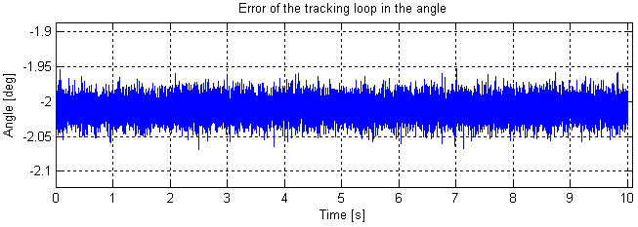
- Double of the error between the angle filtering using tracking loop (190 Hz and 0.7 damping) when the acceleration is 25000rad/s² in case of B2 ECU.
Using the tracking loop and the minimal value of the variance of the sinus and cosines channels the noise in the output of the tracking loop can be seen in Fig 7. The speed variance is 0.15031²=0.026, which is less than the requirement of the steering column torque controller.
The step response of that filter is the same as before, i.e. it is approx. 6 ms.
The H2 norm of that tracking loop it is the same as B1 ECU, because the tracking loop is remain unchanged.
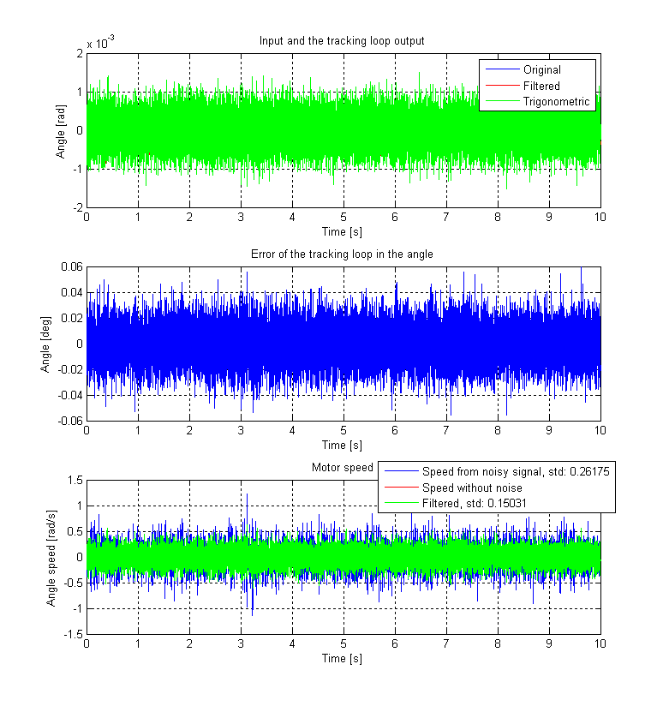
- Noises on the output of the tracking loop (190 Hz and 0.7 damping)

