Starting on April 1, 2024, due to updated authentication methods in the Graph SDK-based PowerShell module, the Microsoft Intune PowerShell (d1ddf0e4-d672-4dae-b554-9d5bdfd93547) is being removed. If you are using the Intune PowerShell application ID (d1ddf0e4-d672-4dae-b554-9d5bdfd93547), you will need to create a new application under App registrations. And then update your scripts with a Microsoft Entra ID registered application ID with the registered application you created to prevent your scripts from breaking.

1.Go to **entra.microsoft.com** > Applications > App registrations and select "New registration".

2.Set the application name, select "Accounts in this organizational directory only (Contoso only - Single tenant)", Redirect URl: urn:ietf:wg:oauth:2.0:oob

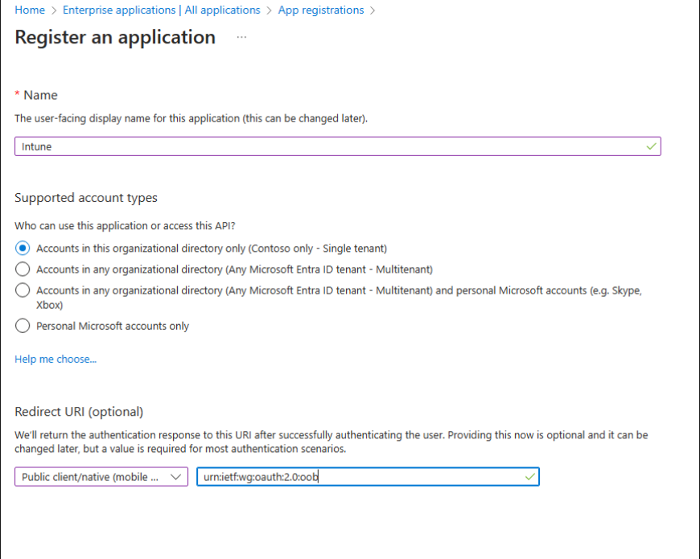

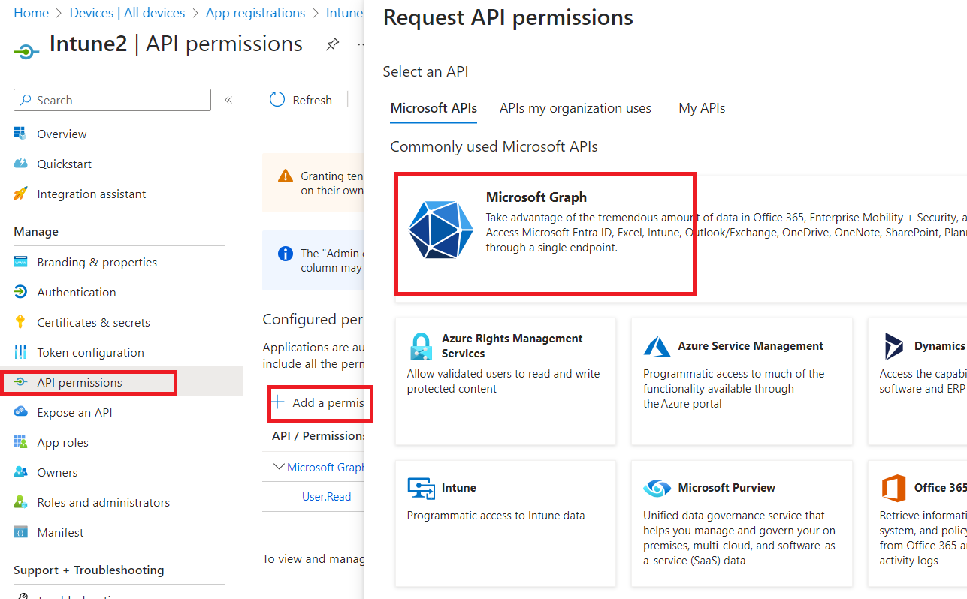

3.Click Register to register the application.

4.Then go to API permissions to add the following permission and "Grant admin consent for Contoso".

DeviceManagementApps.ReadWrite.All

DeviceManagementConfiguration.ReadWrite.All

DeviceManagementManagedDevices.PrivilegedOperations.All

DeviceManagementManagedDevices.ReadWrite.All

DeviceManagementRBAC.ReadWrite.All

DeviceManagementServiceConfig.ReadWrite.All

Directory.Read.All

Group.ReadWrite.All

Openid

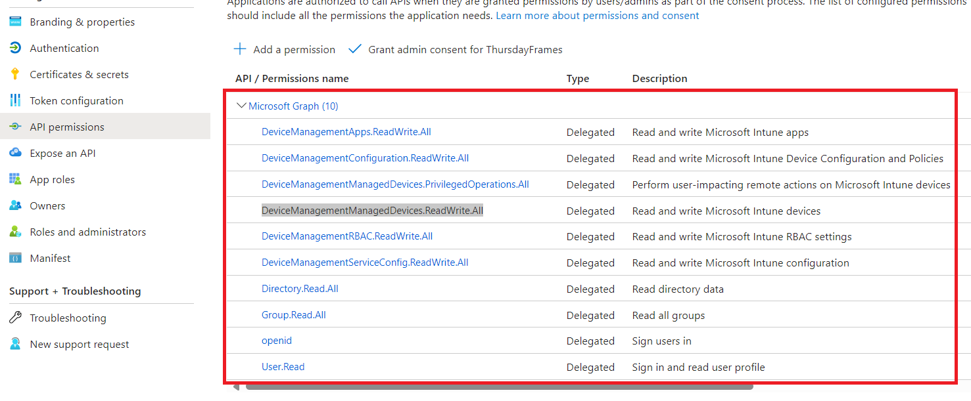

5.After the Application is created, find the application and replace the one in script with this one.

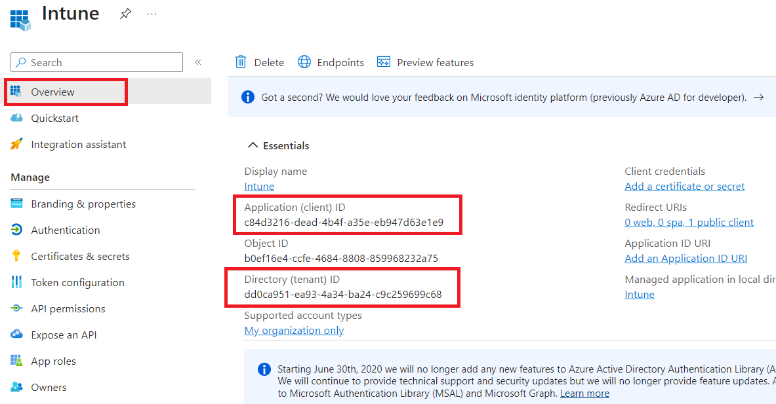

Update-MSGraphEnvironment -AppId <App Client ID of app registration>

Example :

Connect-MgGraph -TenantId **dd0ca951-ea93-4a34-ba24-c9c259699c68**

Update-MSGraphEnvironment -AppId **c84d3216-dead-4b4f-a35e-eb947d63e1e9**