**Northeastern University**

[SPRING 2020]

A

Report On

**“FARMER’S MARKET ACROSS THE U.S”**

Submitted By

Saju Rajagopal

[Section 02]

**INTRODUCTION**

This report gives us an idea of the growth of farmers market across the U.S over the years. The data is taken from the USDA’s National Farmers Market Directory.

**Background:**

Farmers markets allow consumers to have access to locally grown, farm fresh produce, enables farmers the opportunity to develop a personal relationship with their customers, and cultivate consumer loyalty with the farmers who grows the produce. Farmers market forms an important link between farmers and consumers that helps foster farmer consumer relationships. Through its many programs, USDA has helped the growth of farmers markets across the country.

**PRESENCE OF FARMERS MARKET ACROSS THE U.S**

**Insights:**

1. The map shows that California and New York have the greatest number of farmers market in U.S.
2. States such has Nevada, Utah, Wyoming, South Dakota has the least number of farmers market.

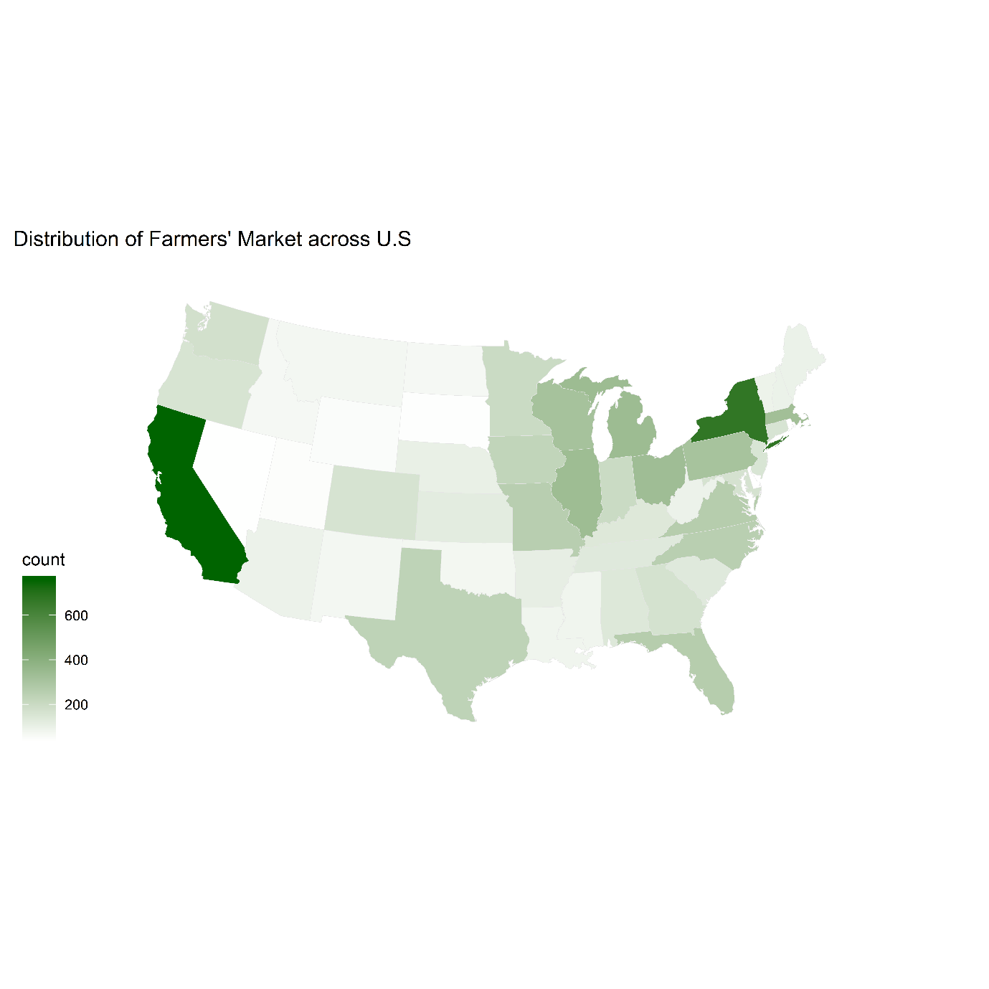

Figure 1

**DISTRIBUTION OF PRODUCT TYPES**

In this part we tried to analyse which products are mostly available in the farmers market and how they are distributed across various states.

**Insights**:

1. Vegetables are the most common product available across the Farmers market.
2. Breakfast items such as Bakedgoods, Honey, Jam and eggs are also the most commonly availble product kept in the market.
3. One of the product that is of interest is Organic food. Interestingly, in only around 2500 farmers market organic products is availble.
4. Seafood are not the most preffered product that are kept in the farmers market. It is avaiable in ery few number of farmers market.



Figure 2

**Insights**:

* It can be seen that vegatbles are the most common product available across all the states.
* Bakedgoods are the second most available product.
* One of the intretsing finding is that herbs are the most available product in Maine



Figure 3

**PAYMENT SYSTEM**

There are various benifts and grants provided for low income and needy families –

* The Seniors Farmers' Market Nutrition Program (SFMNP) – This program is designed to Provide low-income seniors with access to locally grown fruits, vegetables, honey and herbs.
* Supplemental Nutrition Assistance Program(SNAP) - SNAP provides nutrition benefits to supplement the food budget of needy families so they can purchase healthy food and move towards self-sufficiency.
* Special Supplemental Nutrition Program for Women, Infants, and Children (WIC) – This program provides federal grants to states for supplemental foods, health care referrals, and nutrition education for low-income pregnant, breastfeeding, and non-breastfeeding postpartum women, and to infants and children up to age five who are found to be at nutritional risk.

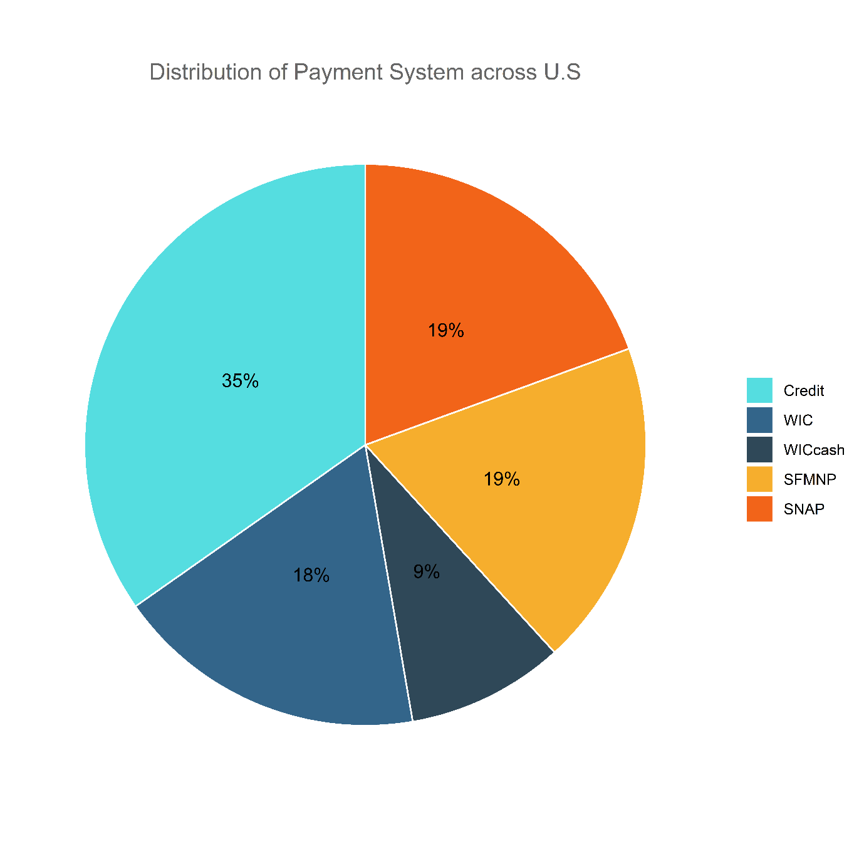

Figure 4

**Highlights**:

1. The above distribution system shows the distribution of various payment system available across the farmer market.
2. 35% of the Farmers market support the Credit for payment.
3. Interestingly, around 38% of the farmers market across the U.S support SNAP and SFMNP program; supporting senior and low-income families.

**PREFFERED OPERATING DAYS**

Not all farmers market operate on all days of the week. This analysis shows the preferred days when the farmers market is open.

**Highlights:**

1. It can be seen that Saturday is the most preffered day when large proportion of farmers market are open. This may be due to the fact that a large population of U.S prefers to shop during weekends so that they are ready for the week ahead.
2. A good number of farmers market are open on Wednesday and Thursday (1013,1102 respectively) as compared to other days. This may be due to the fact that in many households products may run out of stock during mid of the week.
3. Monday has the least open markets.



Figure 5

**DISTRIBUTION OF PRODUCTS ACROSS FARMERS MARKET IN CALIFORNIA**

* As we know from previous insights, California has the highest amount of Farmers Market influence in terms of location and agricultural produce.
* So, to understand the product variety across California State we made use of a tree plot to visualize the different food items available in California State.

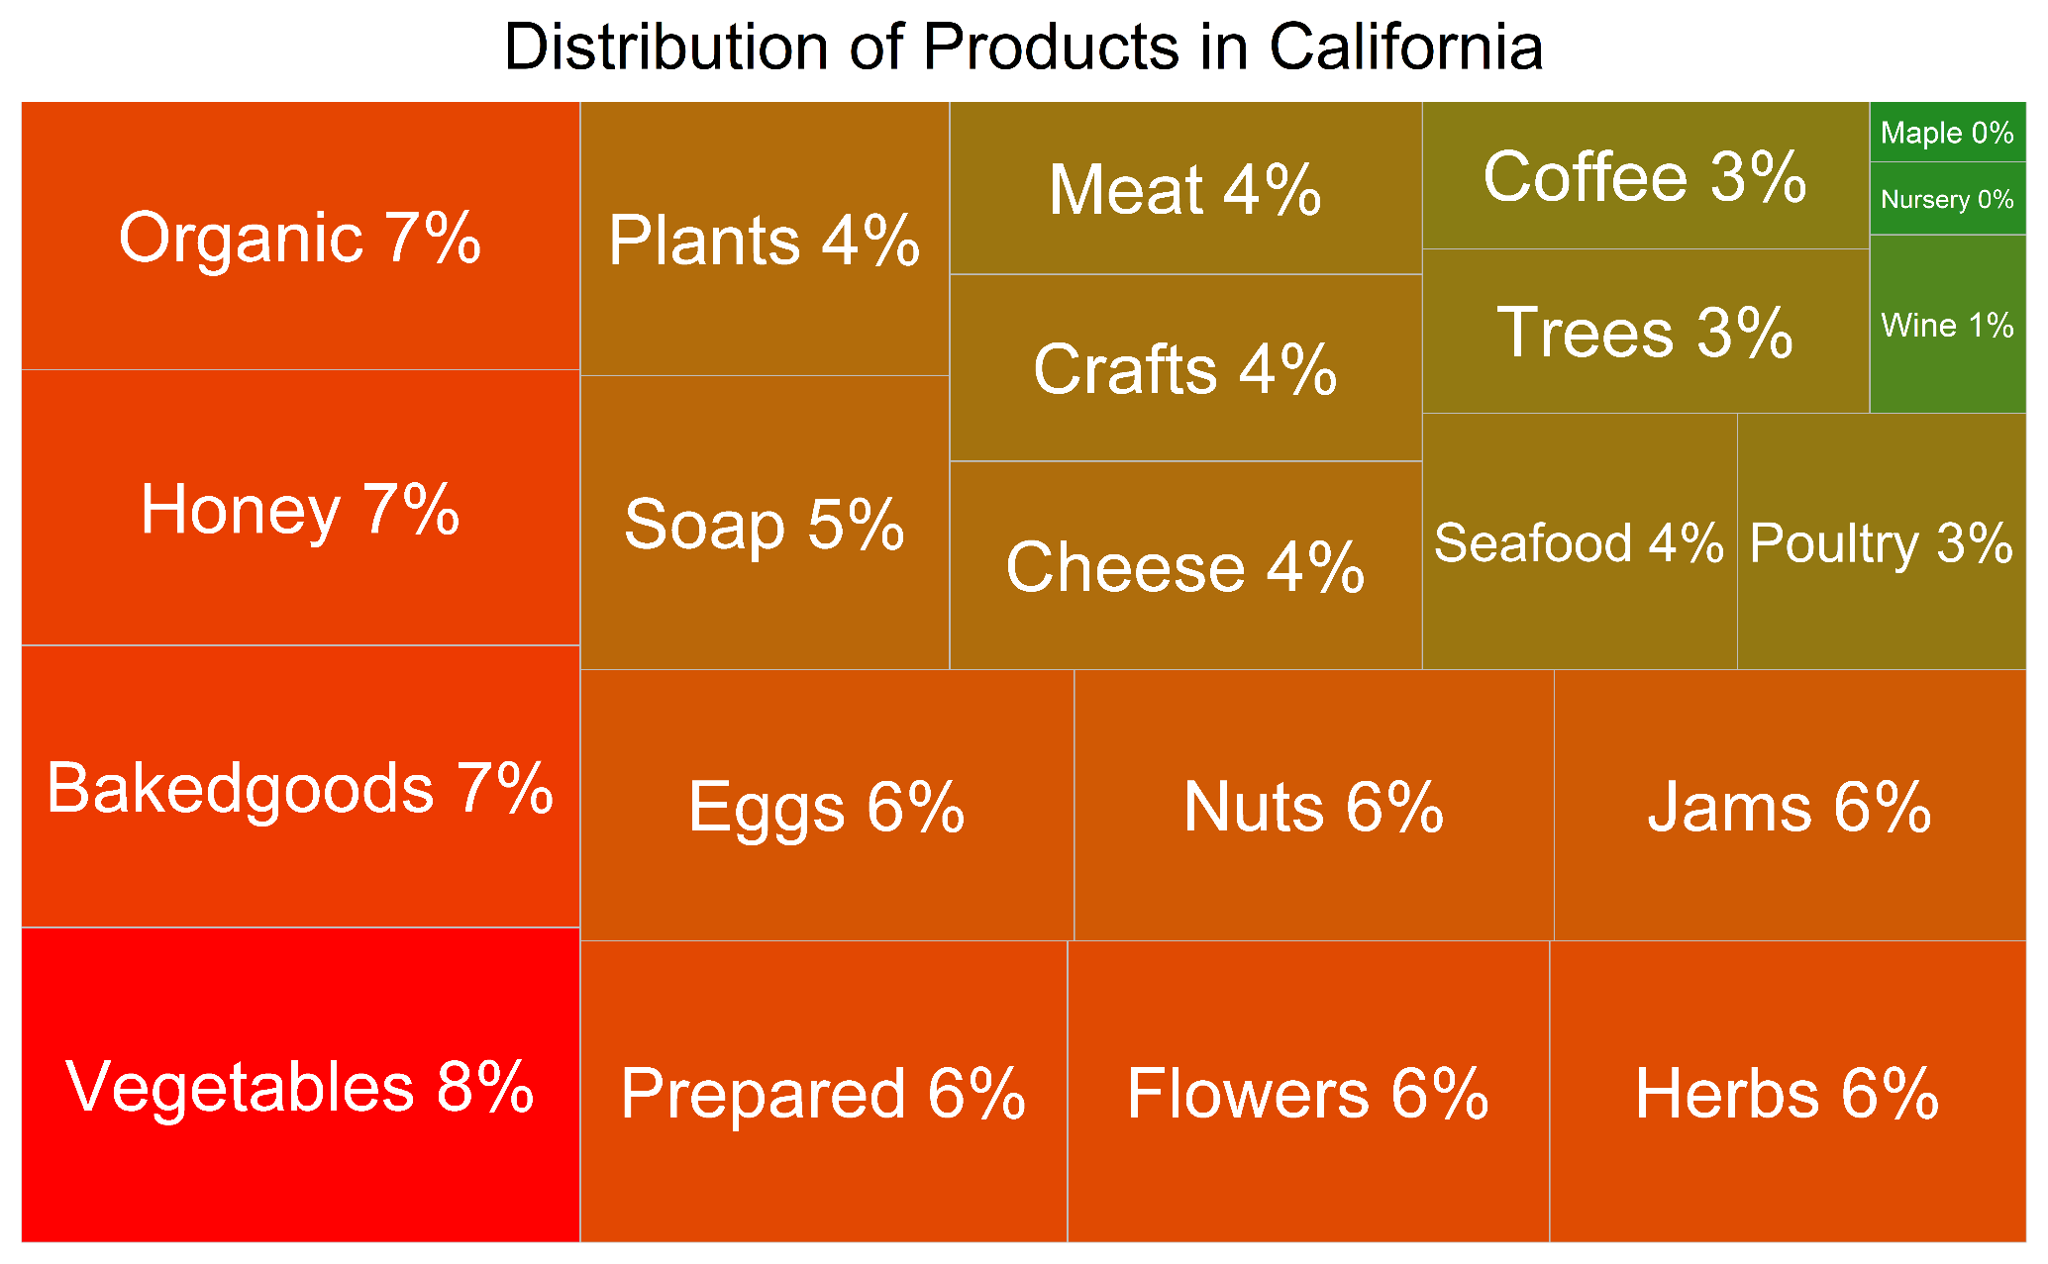

Figure 6

**Insights:**

1. Vegetables and breakfast products make the largest share.
2. Even though organic products are comparatively less available when compared across U.S, it forms a larger share in California’s market.
3. Interestingly, flowers take a 6% share from the total available products.

**FARMERS MARKET PROMOTION PROGRAM(FMPP)**

The Farmers Market Promotion Program (FMPP), awards competitive grants, with the goal of expanding access to locally produced agriculture products and developing new market opportunities for farms and ranches participating in direct farmer-to consumer marketing. Since 2006, FMPP has helped communities establish farmers markets, community supported agriculture (CSA) enterprises, road-side stands, and agritourism in all 50 States and U.S. territories.

FMPP awarded 879 grants for over $58 million since the 2008 Farm Bill. The results of these grant investments include:

* Increases in sales at farmers markets and at other agricultural market outlets
* Increases in new farmers and vendors selling at markets
* Improved infrastructure such as refrigeration or electricity allowing more vendors into markets
* More opportunities for farmers, ranchers, and local food businesses

**Insights**:

* Since 2008, FMPP received over 2,700 applications, requesting over $201 million. Based on available funds, the program funded 879 applications, or 33 percent.
* Most number of applicants belonged from 3 groups, namely, Producer association, Non profit corporations and local governments



Figure 7

Data source: https://www.ams.usda.gov/sites/default/files/media/FMPP2016Report.pdf