VICTORIA UNIVERSITY OF WELLINGTON
Te Whare Wananga o te Upoko o te Ika a Maui



School of Engineering and Computer Science
Te Kura Mātai Pūkaha, Pūrorohiko

PO Box 600  Wellington  New Zealand | Tel: +64 4 463 5341  Fax: +64 4 463 5045  Internet: office@ecs.vuw.ac.nz

Why Do Programmers do What They Do?

Lavanya Sajwan

Supervisor(s): James Noble, Craig Anslow

Submitted in partial fulfilment of the requirements for
Bachelor of Engineering with Honours in Software Engineering

Abstract

Technologies are constantly adapting to match ever-changing trends, and as this occurs new vulnerabilities are exploited by malignant attackers, and can cause significant economic damage to companies. Programmers are therefore constantly having to expand knowledge and skills to protect software. We must understand the thinking behind the decisions and influences of programmers to interpret how they implement and adopt security practices. This proposal will cover an overview of the project ‘Why Do Programmers do What They Do?’, regarding the security choices programmers make, and the output of the project will ultimately present a theory.

Introduction

Tech spaces are now ubiquitous and consequently, software, and the programmers that develop them are now underline most businesses. Absence of security in the software open those businesses to exploitation by external bodies. The lack of attack prevention can cause leakage of sensitive information, danger to users and employees, and massive economic damage.

This project will investigate how software developers may implement and adopt security practices in the work they do, in order to develop an understand on what influences and impact decisions surrounding their technical work. This project will be done by using grounded theory and interviews will to take place to collect the data, to which then analysis will then need to occur.

The Problem

Qualitative research is often neglected and overlooked in favour of more quantitative reasoning and technical traits; the processing speed, the programmers task-completion rate [1]. Programmers provide a human aspect to a technical solution and therefore, there should be a shift to understanding the more background ‘soft’ processes that occur when making decisions; why are the choices made based on past influences, and how they affect the programmers work in the present?

Exploring this topic is essential as it allows for more understanding on how and why programmers think the way they do, and it builds a more robust understanding of the human and social aspects of Software Engineering [2].

Proposed Solution

This project aims to implement a theory as to why programmers implement and adopt security practices in the work they do by interviewing professional developers and using the Grounded Theory Method to analyse the outcomes. The findings of this can be used to identify what security methods developers find as beneficial in their programming. This will allow programmers to complete their work to a high standard, thus overall making their work of a higher value.

The project will be an informative investigation on understanding the decisions programmers make, therefore obtaining data from actual programmers as soon as possible is essential for the smooth running of this project; human ethics approval will be needed quickly.

When it is approved, contact with the sample group will occur by posting on groups and mailing lists with a request for participation [2]. At this point, I can then start interviewing 10-20 interested individuals on their security practices while programming. These people will all be developers in varying stages of their careers and career paths to allow for a wider range of responses.

This project will lead to a deeper and new understanding of the psychology of the decisions made by programmers and the research done by this project could lead to future qualitative research to be done on another under-developed topic on why programmers do what they do. Paired with this research, that future one could help build a profile of a programmer and their thought processes.

Gantt Chart of the proposed timeline:

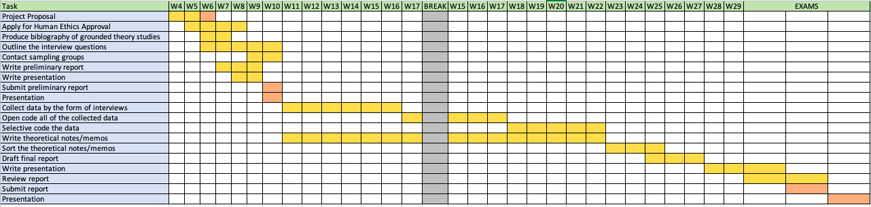

Evaluating your Solution

Pertaining to the final “coded” category from this project as the solution, finding a core group will be essential in the evaluation process. A core category is identified in every grounded theory research, and it holds the most common category and is related to the other main categories. Therefore, without a clear common subject, there is an issue with the outcomes of the research, and I will need to go back to find the categories.

Ethics and Resourcing

Ethics

A human ethics application will need to be approved before any work with participants will occur. This will need to be done as soon as possible to start work as a big portion of this project is dependent on the interviews.

The interviews will be confidential rather than anonymous as they are done in-person and to also allow for follow up questions if necessary. Participants will be welcome to leave at any time during the interview, do not have to answer any questions they do not want to and can choose to leave the study within a week after the interview if they would like.

Safety
Interviews, should be done in safe and private environments, with all participants clear on earthquake and fire evacuation procedures relevant to their location. I will ensure that my own mental and physical wellbeing is taken into account, by mitigating any significant amounts of pressure, Repetitive Strain Injury (RSI) and migraines. Not practicing taking breaks from work will increase eye strain and encourage bad ergonomics which would case RSI and migraine issues.
For both myself, as the surveyor, and for my interviewee’s, I will ensure that interviews will be taken between the times 9 am and 5 pm to support work/life balance. Due to the recent covid-19 outbreak, I will offer zoom interviews for those who are unable or unwilling to meet directly. For in-person interviews, I will provide a box of tissues in the room and a bottle of sanitiser.

Budget

Sanitiser and a box of tissues will be needed to promote healthy hygiene practices during in-person interviews.

All individuals who participated in the interviewees will be given a $15 voucher to a store of their choice, and all will go into the draw to win a $50 voucher of their choice.

Therefore, the estimated budget for this project will be approximately $300-$445, dependent on the number of participants and the inflated cost of sanitiser.

Space and Access

Access to private meeting rooms on campus will be necessary.

Risks and Hazards

Risks | Likelihood | Severity | Mitigation
Participants are ill | Moderate | Moderate | Ask many people to participate, so if someone cannot make it, the saturation of available people will allow the development cycle to continue as planned.
Covid-19 Lockdown | High | High | Have regular video call meetings with supervisor and communicate with participants via video.
Ethics approval takes too long | High | High | Start this as soon as possible to allow for any delays that revisions of the application may cause.
Underestimation of project life cycle | Moderate | High | Need to strictly timebox issues and break down tasks into reasonable blocks.
Failure to obtain relevant data | Low | High | Interview questions need to be planned and revised to ensure that they are relevant to the grounded theory question.

Bibliography

- Michael John, Frank Maurer, and Bjornar Tessem. 2005. Human and social factors of software engineering: workshop summary. SIGSOFT Softw. Eng. Notes 30, 4 (July 2005), 1-6. DOI:https://doi-org.helicon.vuw.ac.nz/10.1145/1082983.1083000
- Hoda, Rashina & Noble, James & Marshall, Stuart. (2011). Grounded Theory for Geeks. ACM International Conference Proceeding Series. 10.1145/2578903.2579162.

