
SMARTDEPLOY: CLOUD-BASED USED CAR PRICE PREDICTION USING MLOPS
MLOPS AND AWS LABORATORY – [COURSE CODE]

Submitted by
HARI KRISHNAN G S – E0124053
HARI KRISHNAN G S – E0124076

In partial fulfillment for the award of the degree of
BACHELOR OF TECHNOLOGY
in
COMPUTER SCIENCE AND ENGINEERING
(Artificial Intelligence and Machine Learning)
Sri Ramachandra Faculty of Engineering and Technology, Sri Ramachandra Institute of Higher Education and Research, Porur, Chennai -600116
NOVEMBER 2026

BONAFIDE CERTIFICATE
We, HARI KRISHNAN G S - E0124053 and GURU PRASAD V - E0124076 hereby declare that the Project Report on SmartDeploy: Cloud-Based Used Car Price Prediction Using MLOps is submitted by me under the guidance of [GUIDE NAME] for the MLOps and AWS Laboratory, at Sri Ramachandra Faculty of Engineering and Technology, in partial fulfilment of Sem 3, Second Year B.Tech Degree course in the Department of Computer Science and Engineering (Artificial Intelligence and Machine Learning) during the academic year 2025-2026.
[GUIDE NAME]
Course faculty,
[DESIGNATION],
Sri Ramachandra Faculty of Engineering and Technology,
Sri Ramachandra Institute of Higher Education and Research,
Porur, Chennai, Tamil Nadu.
Submitted for the MLOps and AWS Laboratory project presentation held at Sri Ramachandra Faculty of Engineering and Technology on [DATE].
Internal Examiner External Examiner
TABLE OF CONTENTS
CHAPTER NO. | TITLE | PAGE NO.
 | ABSTRACT | 1
1 | INTRODUCTION  1.1 Background of the Study  1.2 Problem Statement and Motivation  1.3 Objectives of the Study  1.4 Significance of the Study  1.5 Organization of the Report | 2  2  3  4  4  5
2 | LITERATURE REVIEW  2.1 Related Work  2.2 Research Gaps | 6  6  9
3 | SYSTEM ARCHITECTURE  3.1 Proposed System/Methodology  3.2 System Architecture Diagram  3.3 Module Description  3.4 Algorithms / Models Used | 10  10  11  12  13
4 | SYSTEM IMPLEMENTATION  4.1 Hardware and Software Specifications  4.2 Tools / Libraries Used  4.3 Implementation Details  4.4 Dataset Collection and Descriptions  4.5 Pseudocode / Code Snippets | 15  15  15  16  17  20
5 | RESULTS and DISCUSSION  5.1 Experimental Results  5.2 Performance Comparison / Benchmarks  5.3 Visualization of Results (Graphs, Charts, Tables)  5.4 Interpretation and Analysis | 21  21  22  23  25
6 | CONCLUSION and FUTURE WORK  6.1 Conclusion  6.2 Future Work | 26  26  27
 | REFERENCES | 28

ABSTRACT
The used-car resale market is marked by price opacity and volatile valuation, so buyers and dealers often lack reliable, data-driven reference prices at the moment of decision. Machine learning can supply such estimates, but only if the trained model can be reached by other systems.
Models that are trained inside a notebook, without experiment tracking, versioned pipelines or a service interface, cannot be compared across runs or queried by other applications. A good model therefore remains an unused artefact.
This project, SmartDeploy, aims to build and deploy a complete machine learning operations pipeline for used-car price prediction, from raw data to a publicly reachable cloud service.
The pipeline prepares the data with a column-wise preprocessing pipeline, trains and compares linear regression, gradient boosting and random forest models with MLflow experiment tracking, compresses the winning pipeline into a single file of about 82 megabytes, and serves it through a FastAPI web service with validated request schemas on the PythonAnywhere cloud.
The data are a cleaned Craigslist used-car dataset of 250,361 listings with 14 attributes, divided into 200,288 training records and 50,073 test records.
Models were evaluated with the coefficient of determination, the mean absolute error and the root mean square error. The random forest, with 100 trees and a maximum depth of 20, performed best on the held-out test set, with a coefficient of determination of 0.8561, a mean absolute error of 2,820.29 dollars and a root mean square error of 4,585.05 dollars, and the deployed prediction service returned a successful response for every tested request.
Keywords: Used-Car Price Prediction; Random Forest; MLOps; MLflow; FastAPI; Cloud Deployment
CHAPTER 1

INTRODUCTION
Buying or selling a used car is a decision made with incomplete information. Two cars of the same make can differ widely in age, mileage, condition and title status, and listed prices vary with them. Sellers routinely overprice ageing inventory, while buyers may underpay for newer, low-mileage vehicles. Machine learning offers a way to turn thousands of past listings into a reference price, and a trained regression model can estimate the value of a car from its attributes within milliseconds.
A model that lives only in a notebook, however accurate, helps nobody else. This project, SmartDeploy, therefore treats the price model as a service from the start. It combines experiment tracking, a single-file model artefact and a web interface so that the whole path from a raw data file to a publicly queryable cloud endpoint is covered. This report describes the data, the pipeline, the implementation, the measured results and the limits of the current deployment.

1.1 Background of the Study
Information asymmetry in used-car pricing translates directly into financial loss for one side of the transaction. Automated valuation models have become standard in mortgage lending and in insurance actuarial work, but comparable open tooling for private and dealer used-car markets is largely limited to proprietary platforms such as Kelley Blue Book and CarGurus. Neither exposes its model parameters or supports custom feature inputs for external integration, so a developer who wants to embed a valuation in another application has no open component to build on.
Research on used-car price prediction has mostly concentrated on choosing the best regression model. Studies in different markets compare linear models, tree-based models and ensembles on listing data (Pudaruth, 2014; Gegic et al., 2019; Monburinon et al., 2018; Lin, 2024). Ensemble methods such as the random forest (Breiman, 2001) and gradient boosting (Friedman, 2001) are common choices, because price depends non-linearly on age, mileage and brand. These studies show that accurate models can be built from listing attributes.
Accuracy alone is not enough to deliver value. Sculley et al. (2015) describe how machine learning systems accumulate hidden technical debt when experiments, data dependencies and deployment are not managed, and Amershi et al. (2019) report the engineering challenges of moving machine learning into products. Machine learning operations (MLOps) has emerged as the set of practices that addresses this gap, covering experiment tracking, reproducible pipelines, packaging and deployment (Kreuzberger et al., 2023). Tools such as MLflow (Zaharia et al., 2018) record parameters, metrics and model artefacts so that runs can be compared and reproduced.
The relevance is also economic. India’s used-car market is reported to be growing at about 12% a year and to reach roughly 8.2 million units annually by 2027. A reliable valuation service that other systems can call would let dealers, marketplaces and lenders automate appraisals, reducing transaction friction and improving price fairness for individual buyers.

1.2 Problem Statement and Motivation
Problem statement. Given the attributes of a used car, namely its year, manufacturer, condition, cylinders, fuel, odometer reading, title status, transmission, drive, type, paint colour, state and age, estimate its listed price in US dollars, and make this estimate available as a reproducible, publicly accessible service rather than as a notebook result.
When price models are trained in isolation, three problems follow. Model metrics cannot be compared across runs, because nothing records which parameters produced which result. Feature pipelines cannot be versioned, so the exact transformations used in training are not guaranteed at prediction time. And no external system can query the model, because there is no interface. The absence of MLOps infrastructure turns a well-performing model into an inert artefact that cannot be transferred or audited.
The motivation is to close this gap with a lightweight, low-cost stack that a student or a small team can reproduce: MLflow for the experiment lifecycle, Joblib for serialising the full pipeline, FastAPI for the interface and a free cloud tier for hosting.
Scope. The study covers regression of the listed price from 13 vehicle attributes using a fixed historical snapshot of listings. It does not address retraining, monitoring or the fairness of automated valuation, and the predicted value is an estimate of a listed price, not a guaranteed transaction price.

1.3 Objectives of the Study
The main objective of this project is to design, implement and deploy an end-to-end MLOps pipeline that predicts used-car prices in real time.
- Prepare the 250,361-record Craigslist dataset with a preprocessing pipeline that is fitted on training data only and stored inside the model.
- Train and compare Linear Regression, Gradient Boosting and Random Forest models and record every run with MLflow.
- Package the best pipeline as a single compressed file small enough for a free cloud tier.
- Expose the model through a validated FastAPI service with automatic interactive documentation and deploy it on PythonAnywhere.
- Evaluate the model with the coefficient of determination, mean absolute error and root mean square error, and verify the deployed endpoint.

1.4 Significance of the Study
For buyers, sellers and dealers, the service provides an objective reference price in place of intuition. For developers, it shows how a model can be wrapped as a microservice that other applications call with a single request, without access to the notebook or the training environment. For students and small teams, it gives a reproducible template that uses only free or low-cost tools.
The contribution is practical rather than algorithmic. The project demonstrates the complete operational path: tracked experiments in a persistent database, a pipeline that carries its own preprocessing, a type-checked request schema that rejects malformed input before it reaches the model, and a live HTTPS endpoint with generated documentation. Each of these is a small step, but together they separate a deployable system from a notebook result. The report also records the current constraint, a static model without monitoring or retraining, so that the next stage of work is clear.
The stakeholders who benefit most are dealers and marketplaces, who need quick appraisals at scale, financial lenders, who need collateral values, and individual buyers and sellers, who gain a neutral reference. A documented endpoint also lets developers integrate valuations into their own tools, such as a listing page or a loan calculator, with a single request.

1.5 Organization of the Report
The report has six chapters. Chapter 1 introduces the background, the problem, the objectives and the significance of the study. Chapter 2 reviews related work on used-car price prediction and on MLOps, and identifies the research gap. Chapter 3 presents the methodology, the architecture of the seven-stage pipeline, the modules and the algorithms. Chapter 4 describes the implementation: the environment, the tools, the dataset and the key code. Chapter 5 reports the experimental results, the comparison of models, the deployment evidence and an interpretation of the findings. Chapter 6 concludes the report and outlines future work. The references follow at the end.
CHAPTER 2

LITERATURE REVIEW
Objective: To analyse past work on used-car price prediction and on the operational practices needed to deploy machine learning models, to highlight the gap, and to position the present study.

2.1 Related Work

Used-car price prediction
Price prediction for used cars has been studied in several markets with similar methods. Pudaruth (2014) applied supervised machine learning techniques to predict the price of used cars in Mauritius, an early and widely cited study built on a regional dataset. Gegic et al. (2019) compared several machine learning techniques for car price prediction. Monburinon et al. (2018) compared regression models for predicting the prices of used cars. All three treat the task as supervised regression from listing attributes and focus on choosing the algorithm.
More recent studies repeat the pattern on newer listing data. Lin (2024) compared Linear Regression, Ridge Regression and Random Forest on a CarDekho dataset after handling missing values, feature engineering and anomaly detection, to determine the most reliable method for used-car prices. Mekala et al. (2022) forecast the selling price of used cars sold in India with Random Forest and Extra Trees regression using Scikit-learn. Taken together, these studies compare linear and tree-based models on listing data, and the present work follows the same comparative design before adding the operational layer that they leave outside their scope.

Model families used here
The Random Forest of Breiman (2001) averages many decision trees, each trained on a bootstrap sample and a random choice of features, which reduces variance without greatly increasing bias. Gradient boosting (Friedman, 2001) builds trees sequentially, each one correcting the residual errors of its predecessors. Linear Regression is the interpretable baseline. All three are available in Scikit-learn (Pedregosa et al., 2011), and the tabular handling in this project uses Pandas (McKinney, 2010). Hyper-parameter optimisation frameworks such as Optuna (Akiba et al., 2019) offer a systematic way to tune these models and are considered as future work.

Machine learning operations
A second body of work explains why a good model is not enough. Sculley et al. (2015) argue that machine learning systems carry a special kind of technical debt arising from data dependencies, configuration and glue code, which makes them costly to maintain unless they are engineered carefully. Amershi et al. (2019) present a case study of how software engineering for machine learning differs from conventional development, including data management and model versioning. Kreuzberger et al. (2023) give an overview, definition and architecture of MLOps, and Amazon Web Services publishes a roadmap for enterprise adoption on SageMaker (Amazon Web Services, 2024).
Experiment tracking is central to these practices. Zaharia et al. (2018) introduced MLflow to record the parameters, metrics and artefacts of each run so that experiments are reproducible and comparable. The present project uses MLflow with a SQLite backend, which keeps the experiment history even when a temporary notebook session ends. For serving, the project uses a FastAPI service with Pydantic validation hosted on PythonAnywhere (PythonAnywhere, 2024), a combination that provides generated documentation and typed request checking without extra configuration.

Serving and deployment choices
A trained model has to be wrapped in a service before other systems can use it. Flask is a common choice for this, but FastAPI provides automatic OpenAPI documentation, native integration with Pydantic for request validation and support for asynchronous serving through the ASGI standard without extra configuration, which is why it was selected here. For hosting, container-based platforms such as AWS Lambda or ECS Fargate give scalable, consistent runtimes, while PythonAnywhere offers a simple WSGI environment with persistent storage and no container infrastructure, which suits a model file of tens of megabytes on a free tier. The present project uses the second option for simplicity and treats containerised deployment as a later step.

Evaluation measures for price regression
Price prediction is a regression task, and studies usually report the coefficient of determination, the mean absolute error and the root mean square error. The coefficient of determination states the share of price variance explained by the model, the mean absolute error gives the typical error in dollars and is easy to interpret, and the root mean square error penalises large errors more strongly, which matters when expensive vehicles are mispriced. Reporting all three, as done in this project, gives a balanced view of both typical and worst-case behaviour.
Table 2.1 summarises the price-prediction studies discussed and how the present work differs from them.
Table 2.1: Summary of related studies on used-car price prediction
Study | Setting and models | Scope reported | Gap addressed here
Pudaruth (2014) | Used cars in Mauritius; supervised learning techniques | Model comparison on a regional dataset | No tracked experiments or deployed service
Gegic et al. (2019) | Car price prediction; several techniques including ensembles | Offline model comparison | No deployment or reproducible tracking
Monburinon et al. (2018) | Used-car prices; regression models | Offline model comparison | No deployment or reproducible tracking
Mekala et al. (2022) | Indian second-hand cars; Random Forest and Extra Trees | Model training with Scikit-learn | No tracked experiments or deployed service
Lin (2024) | CarDekho data; Linear, Ridge and Random Forest regression | Offline model comparison | No deployment or reproducible tracking
This project | 250,361 Craigslist listings; Linear, Gradient Boosting and Random Forest | MLflow tracking, Joblib packaging, FastAPI service, cloud endpoint | Full pipeline from data to a live HTTPS service

The studies in the table are summarised from their published abstracts and describe their main focus. They do not claim to cover deployment, and the entry in the last column therefore describes what is outside their stated scope, not a shortcoming of their methods.

2.2 Research Gaps
Reading the literature against the needs of an operational valuation service shows the following gaps. First, price-prediction studies concentrate on choosing the best algorithm and report results from offline experiments, so their models cannot be used by other systems. Second, experiments are often reported as single runs, without a persistent record of parameters and metrics that would allow them to be compared or audited later.
Third, the preprocessing is frequently performed outside the model, which creates a risk that training and prediction use different transformations. Fourth, open, documented examples of the complete path from data to a public endpoint are scarce, especially ones that fit within free cloud limits. Finally, there is little discussion of what happens after deployment, for example monitoring for data drift.
This study addresses the first four gaps by tracking all runs with MLflow, embedding preprocessing in a single serialised pipeline, and deploying the result as a documented HTTPS service on a free cloud tier. The fifth gap is acknowledged as a limitation and as the main item of future work.

Key Challenges of the Existing System
- Notebook-bound models. A model that exists only in a notebook cannot be queried by other applications.
- No experiment history. Without tracking, runs cannot be compared and results cannot be reproduced.
- Training–serving mismatch. Preprocessing outside the model risks different transformations at prediction time.
- Large model files. A forest of many deep trees can be hundreds of megabytes, which conflicts with free-tier storage limits.
- Unvalidated input. Without a schema, malformed requests can produce silent wrong predictions or errors.
- No monitoring. A static model degrades silently when the market distribution shifts.
CHAPTER 3

SYSTEM ARCHITECTURE
Objective: To explain the technical approach, the stages and modules of the pipeline, and the algorithms and models used.

3.1 Proposed System/Methodology
SmartDeploy is organised as a seven-stage sequential pipeline. Each stage is decoupled and produces a persistent artefact that the next stage consumes, which allows a stage to be rerun without restarting the whole pipeline. The stages are data ingestion, preprocessing, model training, experiment tracking, model selection, packaging and deployment.
Three design principles guide the methodology. First, the model is treated as a deployable service from the outset, not as a notebook result. Second, all preprocessing is encapsulated inside the same pipeline object as the model, so the transformations used in training are exactly those applied at prediction time. Third, every training run is recorded with its parameters, metrics and model artefact, so that model selection is an objective comparison and not a recollection.
The data are divided 80/20 into 200,288 training records and 50,073 test records with a fixed random state of 42. All transformers are fitted on the training portion only, which prevents leakage of test information into the preprocessing statistics. Three regression algorithms of increasing complexity, Linear Regression, Gradient Boosting and Random Forest, are trained, each wrapped in a Scikit-learn pipeline that starts with the preprocessor. The model with the best coefficient of determination and mean absolute error on the test set is selected, serialised and served.

3.2 System Architecture Diagram
Figure 3.1 shows the end-to-end pipeline from data ingestion to cloud inference. Table 3.1 lists, for each stage, its input, the artefact it produces and the tool that implements it.
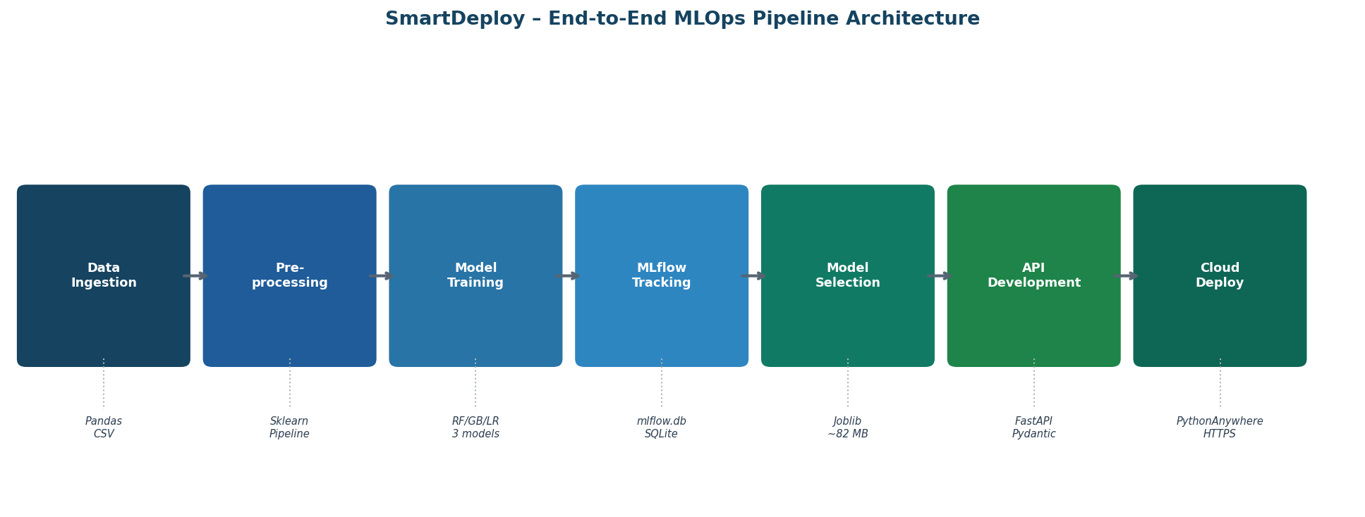
Figure 3.1: SmartDeploy end-to-end MLOps pipeline: seven stages from data ingestion to cloud inference.
Table 3.1: Pipeline stages, artefacts and tools
Stage | Input | Output / artefact | Tool
1 – Data ingestion | vehicles_clean.csv (250,361 × 14) | Pandas DataFrame in memory | Pandas
2 – Preprocessing | Raw DataFrame | Pipeline with a fitted ColumnTransformer | Scikit-learn
3 – Model training | Preprocessed features (153 dimensions) | Three trained model pipelines | Scikit-learn (RF, GB, LR)
4 – Experiment tracking | Parameters and metrics of each run | mlflow.db (SQLite) and model artefacts | MLflow 2.x
5 – Model selection | Comparison of runs by R² and MAE | Best model identified (Random Forest) | MLflow UI
6 – Packaging | Best Scikit-learn pipeline | model_compressed.joblib (about 82 MB) | Joblib (compress = 3)
7 – Deployment | app.py and model_compressed.joblib | Live HTTPS prediction endpoint | FastAPI and PythonAnywhere

3.3 Module Description
Data ingestion. The cleaned Craigslist file vehicles_clean.csv, with 250,361 rows and 14 columns, is loaded into a Pandas DataFrame. The derived feature car_age, defined as the current year minus the manufacturing year, is part of the table, and the price column is the regression target.
Preprocessing. A ColumnTransformer applies different pipelines to numerical and categorical features. This design ensures that all transformations are fitted exclusively on training data and that no separate preprocessing step is needed at inference time. The numerical pipeline (Table 3.2) is applied to year, cylinders, odometer and car_age, and the categorical pipeline (Table 3.3) to manufacturer, condition, fuel, title_status, transmission, drive, type, paint_color and state. The combined output is a dense 153-dimensional matrix, made of 4 scaled numerical features and 149 one-hot columns.
Table 3.2: Numerical preprocessing pipeline
Step | Transformer | Rationale
1 | SimpleImputer (median) | The median is robust to outliers; right-skewed variables such as odometer would distort a mean imputation
2 | StandardScaler | Centres each feature at mean 0 and standard deviation 1, which stabilises Linear Regression; Random Forest is scale-invariant but scaling is applied uniformly for consistency

Table 3.3: Categorical preprocessing pipeline
Step | Transformer | Rationale
1 | SimpleImputer (most frequent) | Missing categories are replaced by the modal value, which preserves the distribution without inventing categories
2 | OneHotEncoder (handle_unknown = ignore) | Converts each category to a binary column; unseen categories at inference, such as a new state, give all-zero columns instead of an error

Model training and experiment tracking. Each of the three algorithms is trained inside a pipeline that begins with the preprocessor, and each run is wrapped in an MLflow run context. MLflow logs the hyper-parameters, the mean absolute error, root mean square error and coefficient of determination on the test set, the full pipeline as a model artefact, and run metadata such as start time, duration and user. The tracking backend is a SQLite database, mlflow.db, stored on a mounted Google Drive, so the history survives the reset of a temporary notebook runtime.
Model selection and packaging. The runs are compared in the MLflow interface and the Random Forest is selected. The whole pipeline is exported with Joblib at compression level 3, producing one file that contains the ColumnTransformer, the imputers, the scaler, the one-hot vocabulary and all 100 decision trees.
Serving module. A FastAPI application, app.py, loads the file once and exposes a health-check route and a POST /predict route. The request body is declared as a Pydantic model with 13 fields, so malformed requests are rejected with a validation error before reaching the model. The service is hosted on PythonAnywhere, which also serves the interactive documentation at /docs.

3.4 Algorithms / Models Used
Three regression algorithms were evaluated (Table 3.4). Linear Regression, fitted by ordinary least squares, is the interpretable baseline and assumes a linear relationship between features and price. Gradient Boosting (Friedman, 2001) builds an additive model in which each tree corrects the residuals of the previous ones. Random Forest (Breiman, 2001) averages many trees trained independently on bootstrap samples.
Table 3.4: Algorithms evaluated
Algorithm | Key hyper-parameters | Complexity | Assumption
Linear Regression | Default (ordinary least squares) | Low | Linear relationship between features and target
Gradient Boosting | n_estimators = 100, learning_rate = 0.1, max_depth = 5 | Medium; sequential ensemble | Additive model; each tree corrects its predecessors’ residuals
Random Forest | n_estimators = 100, max_depth = 20, random_state = 42, n_jobs = −1 | High; parallel ensemble | Independent trees on bootstrap samples; averaging reduces variance

Decision trees and bagging. A decision tree partitions the feature space by choosing, at each node, the feature and threshold that minimise the mean squared error in the resulting partitions, and a leaf predicts the mean of its training samples. A single deep tree overfits, which is expressed as high variance. Random Forest reduces variance by bootstrap aggregation: each of the B trees is trained on a sample drawn with replacement, which contains on average about 63.2% of the training records, and the remaining 36.8% form an out-of-bag sample that can serve as an implicit validation set. The final prediction is the mean of the tree predictions:
ŷ(x) = (1 / B) · Σ ŷ_b(x), b = 1 … B
Feature randomness. Standard Random Forest also considers only a random subset of m features at each split, which decorrelates the trees. In this project max_features was set to 1.0, so all 153 features are considered at every split, which is technically equivalent to bagged trees. This choice was made because the 153-dimensional space is dominated by sparse one-hot columns, and restricting each split to about √153 ≈ 12 features would limit splits on the numerical features, which are the main price drivers.
Table 3.5: Notation for the Random Forest configuration
Symbol | Meaning
B = 100 | Number of trees (n_estimators = 100)
n = 200,288 | Training set size (80% of 250,361)
p = 153 | Feature dimensions after preprocessing
m | Features considered per split (max_features = 1.0, so m = p in this configuration)
D = 20 | Maximum tree depth (max_depth = 20)

Evaluation metrics. With y the actual price, ŷ the prediction, ȳ the mean price and n the number of test records, the metrics are:
MAE = (1 / n) · Σ | y_i − ŷ_i |
RMSE = √( (1 / n) · Σ ( y_i − ŷ_i )² )
R² = 1 − Σ ( y_i − ŷ_i )² / Σ ( y_i − ȳ )²
Why Random Forest suits this data. Linear Regression cannot model the non-linear relation between price and mileage, where price drops steeply in the first 30,000 miles and then flattens, or the interaction between attributes, such as year and manufacturer. Gradient Boosting captures non-linearity but, with max_depth = 5 and sequential training, it may underfit the complex multi-category space and is more sensitive to outliers without careful tuning of the learning rate. Random Forest handles the high-cardinality one-hot features naturally, is robust to outliers through averaging, and learns interactions automatically, at the cost of a larger model file and slower inference than Linear Regression.
CHAPTER 4

SYSTEM IMPLEMENTATION
Objective: To describe the environment, tools, implementation steps, dataset and key code of the SmartDeploy system.

4.1 Hardware and Software Specifications
Training and tracking were carried out in notebook sessions on Google Colab, with Google Drive mounted so that the MLflow database persists across sessions. Deployment used the free tier of PythonAnywhere, which provides 512 MB of storage and one web application. This storage limit is the reason the model file had to be compressed. Table 4.1 lists the environment.
Table 4.1: Hardware and software configuration
Item | Specification
Training environment | Google Colab notebook sessions with Google Drive mounted for mlflow.db
Colab runtime hardware | [add the CPU, RAM and runtime type of your Colab session]
Deployment platform | PythonAnywhere free tier: 512 MB storage, one web application, WSGI hosting
Python (deployment) | 3.11, in a virtual environment named smartdeploy
Libraries (deployment) | FastAPI, Uvicorn, Pydantic, Joblib, pandas 2.2.3, scikit-learn 1.6.1
Experiment tracking | MLflow 2.x with a SQLite backend
Live service | https://HariKrishnanGS.pythonanywhere.com (documentation at /docs)

4.2 Tools / Libraries Used
Pandas (McKinney, 2010) loads the dataset and builds the single-row input frame used at prediction time. Scikit-learn (Pedregosa et al., 2011) provides the imputers, scaler, encoder, ColumnTransformer, pipelines and the three regressors. MLflow (Zaharia et al., 2018) records parameters, metrics and model artefacts. Joblib serialises and compresses the fitted pipeline. FastAPI with Pydantic defines the service, validates requests and generates OpenAPI documentation, and Uvicorn is the ASGI server. PythonAnywhere hosts the service over HTTPS, and Swagger UI at /docs allows interactive testing without extra configuration.

4.3 Implementation Details
Data preparation. The data are read into a DataFrame and divided 80/20 into 200,288 training and 50,073 test records with random_state = 42. The numerical features year, cylinders, odometer and car_age are imputed with the median and standardised. The nine categorical features are imputed with the most frequent value and one-hot encoded with unseen categories ignored. Both pipelines are combined by a ColumnTransformer, and the preprocessing is fitted on training data only.
Training and tracking. The three regressors are trained in turn. Each run is opened with mlflow.start_run, logs its parameters, computes the mean absolute error, the root mean square error and the coefficient of determination on the test set, and stores the full pipeline as a model artefact. Approximate training times were under one minute for Linear Regression, about eight minutes for Gradient Boosting and about twelve minutes for Random Forest. The three runs are persisted in mlflow.db.
Packaging. The Random Forest pipeline is exported with Joblib at compression level 3. This reduces the uncompressed pipeline of about 320 MB, 100 trees of roughly 3.2 MB each, to about 82 MB, a reduction of 74%, which fits within the free-tier storage limit. The single file contains the preprocessing objects and all 100 tree structures, so prediction needs only two lines of Python on any machine.
Service. The request is declared as a Pydantic model with 13 fields. In the /predict route the validated object is converted to a single-row DataFrame before calling model.predict. This conversion is essential, because the ColumnTransformer inside the pipeline routes features by column name and would raise an error if given a raw dictionary or list. The route returns the predicted price rounded to two decimals as JSON. Requests that violate the schema return HTTP status 422, and valid requests return 200.
Cloud deployment. Table 4.2 lists the seven deployment steps. After reloading the web application, the base URL returns a health-check message, the interactive documentation is available at /docs, and a test request to /predict returns a prediction.
Table 4.2: Deployment steps on PythonAnywhere
Step | Action | Detail
1 | Account setup | Register at pythonanywhere.com; the free tier gives 512 MB of storage and one web application
2 | File upload | Upload app.py, model_compressed.joblib and requirements.txt through the Files tab
3 | Virtual environment | mkvirtualenv smartdeploy --python=python3.11
4 | Install dependencies | pip install fastapi uvicorn pydantic pandas==2.2.3 scikit-learn==1.6.1 joblib
5 | WSGI configuration | Point the WSGI file at the FastAPI app through an ASGI middleware wrapper
6 | Reload and verify | Reload in the Web tab and confirm that GET / returns the health JSON
7 | Test /predict | POST a sample car payload and confirm a 200 response with predicted_price

4.4 Dataset Collection and Descriptions
The dataset is a cleaned version of the Craigslist Used Cars data (vehicles_clean.csv). It has 250,361 records and 14 columns, covers listings from all 50 US states and spans a wide range of vehicle types, manufacturers and model years. It comes from public Craigslist scrapes and was cleaned to remove malformed entries, extreme outliers and missing target values. Table 4.3 describes the columns and the strategy used for missing values, and Table 4.4 summarises the main statistics.
Table 4.3: Dataset features and missing-value strategy
Feature | Type | Description | Missing strategy
year | Numerical | Manufacturing year | Median
manufacturer | Categorical | Brand (42 unique values) | Most frequent
condition | Categorical | Excellent, good, fair, like new, salvage, new | Most frequent
cylinders | Numerical | Engine cylinders (3–12) | Median
fuel | Categorical | Gas, diesel, hybrid, electric, other | Most frequent
odometer | Numerical | Mileage in miles | Median
title_status | Categorical | Clean, rebuilt, lien, parts only, salvage | Most frequent
transmission | Categorical | Automatic, manual, other | Most frequent
drive | Categorical | fwd, rwd, 4wd | Most frequent
type | Categorical | Sedan, SUV, pickup, truck, van, coupe and others | Most frequent
paint_color | Categorical | Exterior colour (12 common values) | Most frequent
state | Categorical | US state code (50 values) | Most frequent
car_age | Numerical (derived) | Current year minus year | Not needed
price | Target | Listed price in US dollars | Not imputed

Table 4.4: Dataset statistics summary (250,361 records)
Statistic | Price (USD) | Odometer (miles) | Year | Car age (years)
Mean | $19,749 | 82,340 | 2,011 | 13.2
Median | $16,244 | 74,000 | 2,013 | 11
Std. dev. | $11,240 | 58,200 | 7.2 | 7.2
Min | $1,000 | 0 | 1990 | 1
Max | $79,900 | 300,000 | 2023 | 34

Target distribution. The raw price distribution is strongly right-skewed (Figure 4.1). Most listings are priced between $5,000 and $25,000, with a long tail towards $80,000, which is typical of used-car markets where a few near-new or luxury vehicles command much higher prices. The log-transformed distribution is approximately bimodal, which indicates two vehicle groups: economy and commuter cars, with a mode of about $8,000 to $12,000, and mid-range vehicles and trucks, with a mode of about $18,000 to $28,000.
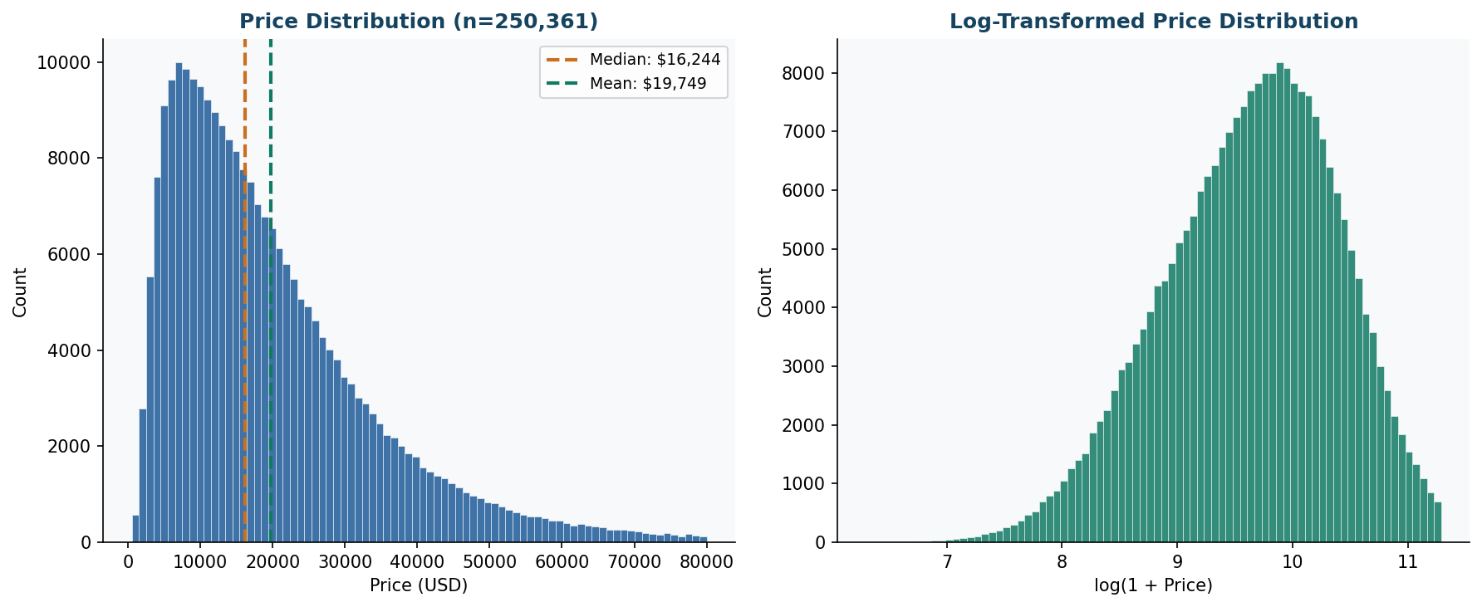
Figure 4.1: Price distribution (left, raw, with median and mean) and log-transformed price distribution (right).
Numerical features. Year is skewed towards recent vehicles (2010 to 2022), and cars made before 2000 are sparse. Odometer readings are approximately normal around 80,000 miles with a tail to 300,000 miles. Cylinders are strongly bimodal, with 4-cylinder (40%) and 6-cylinder (35%) engines dominating and 8-cylinder vehicles at 18%, mostly trucks and performance cars. Car age mirrors the year histogram and carries no additional information, but it was retained because it is easier to interpret (Figure 4.2).
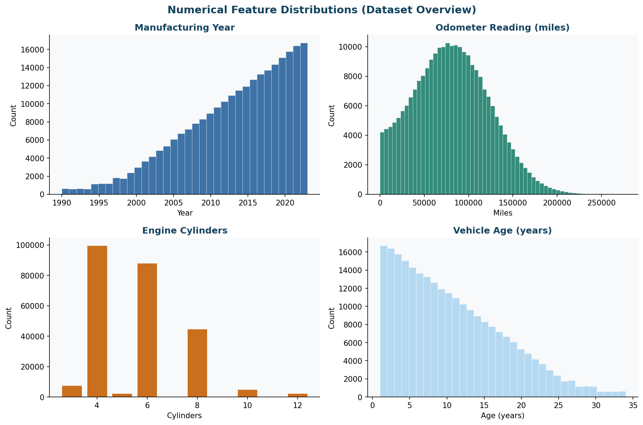
Figure 4.2: Distributions of manufacturing year, odometer, cylinder count and vehicle age.
Categorical features. After one-hot encoding, the 9 categorical columns expand to 149 binary columns and dominate the 153-dimensional feature space (Figure 4.3). Ford and Chevrolet account for about 29% of listings, and most vehicles are in good (39%) or excellent (29%) condition. Gas is the fuel for 79% of listings, with diesel at 8.8%, hybrid at 6.4% and electric at 3.2%, and SUVs (24.8%) and sedans (21.6%) are the most common types.
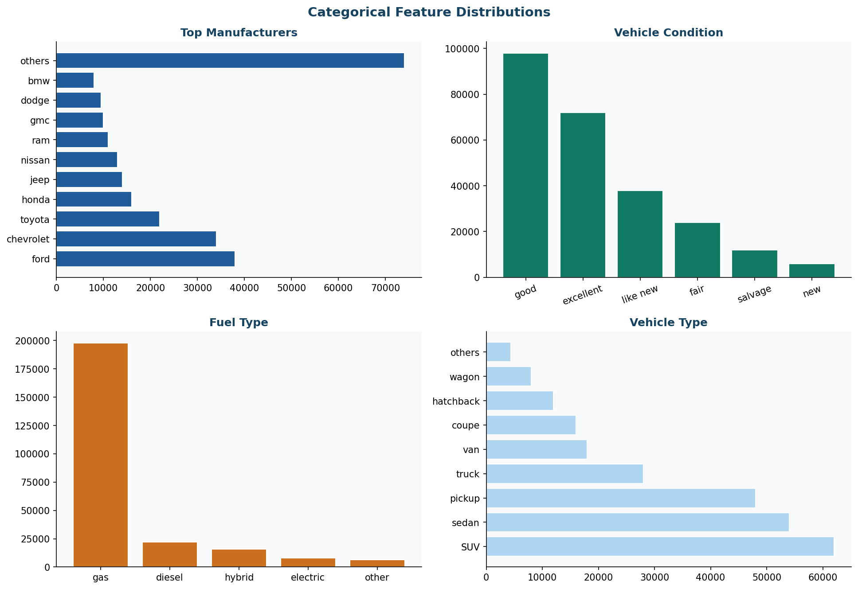
Figure 4.3: Categorical feature distributions: top manufacturers, vehicle condition, fuel type and vehicle type.

4.5 Pseudocode / Code Snippets
The excerpts below are the core of the implementation. The first builds the preprocessing pipeline.
from sklearn.pipeline import Pipeline
from sklearn.compose import ColumnTransformer
from sklearn.preprocessing import OneHotEncoder, StandardScaler
from sklearn.impute import SimpleImputer

num_pipeline = Pipeline([
("imputer", SimpleImputer(strategy="median")),
("scaler", StandardScaler())
])
cat_pipeline = Pipeline([
("imputer", SimpleImputer(strategy="most_frequent")),
("encoder", OneHotEncoder(handle_unknown="ignore", sparse_output=False))
])
preprocessor = ColumnTransformer([
("num", num_pipeline, numerical_features),
("cat", cat_pipeline, categorical_features)
])

Each model is trained inside an MLflow run, which logs its parameters, test metrics and the full pipeline.
import mlflow, mlflow.sklearn
mlflow.set_tracking_uri("sqlite:///mlflow.db")
mlflow.set_experiment("UsedCar_Price_Prediction")

with mlflow.start_run(run_name="RandomForest"):
mlflow.log_params({"n_estimators": 100, "max_depth": 20, "random_state": 42})
pipeline.fit(X_train, y_train)
preds = pipeline.predict(X_test)
mlflow.log_metric("MAE", mean_absolute_error(y_test, preds))
mlflow.log_metric("RMSE", mean_squared_error(y_test, preds) ** 0.5)
mlflow.log_metric("R2", r2_score(y_test, preds))
mlflow.sklearn.log_model(pipeline, "model")

The winning pipeline is serialised with compression and reloaded at inference time.
import joblib
joblib.dump(best_pipeline, "model_compressed.joblib", compress=3)
model = joblib.load("model_compressed.joblib")
prediction = model.predict(input_dataframe)[0]

The request schema and the prediction route of the FastAPI service are shown below.
from pydantic import BaseModel

class CarInput(BaseModel):
year: int; manufacturer: str; condition: str; cylinders: int
fuel: str; odometer: float; title_status: str; transmission: str
drive: str; type: str; paint_color: str; state: str
car_age: int

@app.post("/predict")
def predict_price(car: CarInput):
input_data = pd.DataFrame([car.model_dump()]) # single-row DataFrame
prediction = model.predict(input_data)[0] # preprocessor + RandomForest
return {"predicted_price": round(float(prediction), 2)}

CHAPTER 5

RESULTS and DISCUSSION
Objective: To present the measured results of the model comparison and the deployed service, to compare the models, and to interpret the findings.

5.1 Experimental Results
Three models were trained on 200,288 records and evaluated on the 50,073 held-out test records. Table 5.1 reports the results. The Random Forest achieved the best value on all three metrics, with a coefficient of determination of 0.8561, a mean absolute error of $2,820.29 and a root mean square error of $4,585.05. It therefore explains 85.61% of the price variance on the test set.
Table 5.1: Model comparison on the held-out test set
Model | MAE ($) | RMSE ($) | R² score | Training time (approx.)
Linear Regression | 4,645.28 | 6,540.11 | 0.7071 | under 1 minute
Gradient Boosting | 3,235.86 | 4,984.06 | 0.8299 | about 8 minutes
Random Forest (selected) | 2,820.29 | 4,585.05 | 0.8561 | about 12 minutes

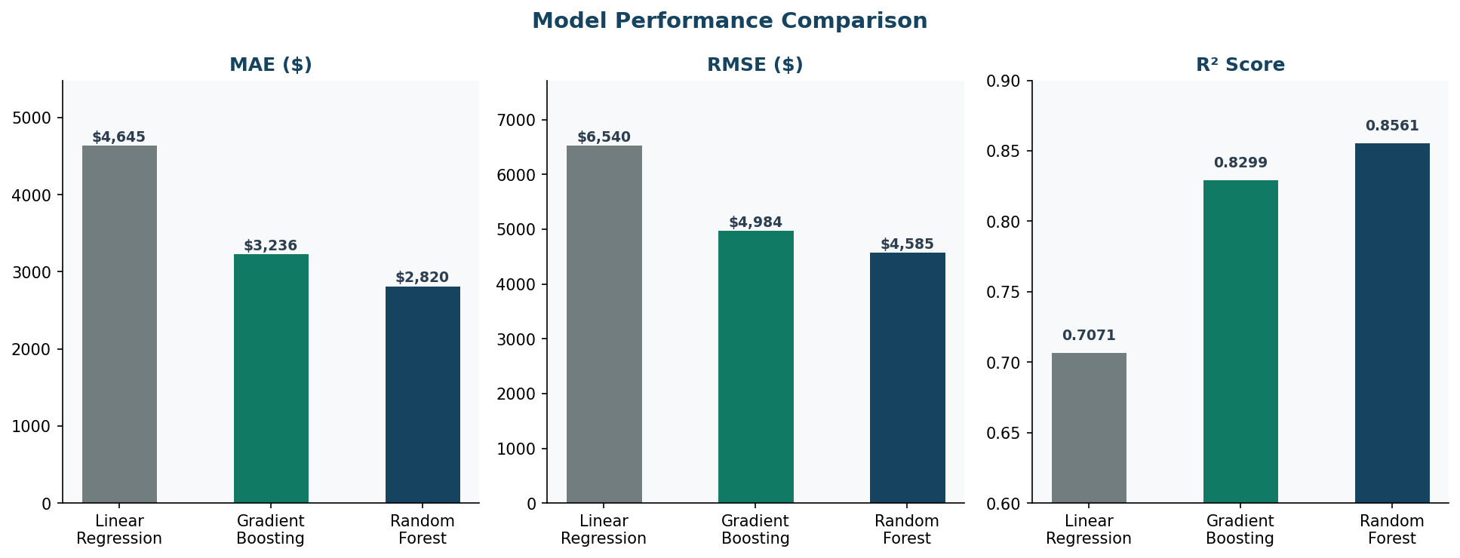
Figure 5.1: Model comparison across MAE, RMSE and R² score (the selected Random Forest is the darkest bar).
Compared with Linear Regression, the Random Forest reduces the mean absolute error by 39.3% and the root mean square error by 29.9%, and raises the coefficient of determination by 14.9 percentage points. Compared with Gradient Boosting, the differences are smaller but consistent: the mean absolute error is $415.57 lower (12.8%), the root mean square error is 8.0% lower, and the coefficient of determination is 2.6 points higher. This suggests that further tuning of Gradient Boosting, in particular deeper trees and a lower learning rate, could narrow the gap in a later iteration.

5.2 Performance Comparison / Benchmarks
Table 5.2 compares the deployed system with the notebook-only baseline. The model accuracy is identical, because the same pipeline is used, but the operational properties differ: reproducibility, availability, access, documentation, portability and input validation.
Table 5.2: Infrastructure evaluation: notebook baseline versus SmartDeploy
Metric | Baseline (notebook only) | SmartDeploy (deployed)
Model R² score | 0.8561 (single run, no versioning) | 0.8561 (MLflow-tracked, reproducible)
Experiment reproducibility | None; re-running the notebook overwrites the earlier state | Full; three runs persisted in mlflow.db with parameters, metrics and artefacts
Inference availability | Requires a local Python environment | Public HTTPS endpoint, queryable from any HTTP client
Concurrent access | Single user only | Multiple concurrent requests through the PythonAnywhere WSGI worker pool
API documentation | None | Auto-generated Swagger UI at /docs (OAS 3.1)
Model portability | Notebook-bound artefact | 82 MB Joblib file; load and predict in two lines of Python
Response format | Print statement | Structured JSON, for example {"predicted_price": 19275.97}
Input validation | Not applicable | 200 OK on valid input; 422 Unprocessable Entity on schema violations

Table 5.3 lists seven test cases that span different vehicle profiles. Only TC-02 was recorded with a live response (HTTP 200, $19,275.97). The other predicted prices are approximate values, marked with a tilde, and should be replaced by the recorded responses of the deployed service when they are available. The cases range from a 2008 high-mileage truck at about $5,100 to a 2020 BMW sedan at about $38,500, a ratio of roughly 7.5, which shows that the model responds sensibly to age, mileage, condition and brand.
Table 5.3: API test cases
Test | Year | Manufacturer | Condition | Odometer | Type | Predicted price
TC-01 | 2022 | toyota | excellent | 8,000 | sedan | ~$28,400
TC-02 | 2018 | toyota | good | 60,000 | sedan | $19,275.97 (recorded)
TC-03 | 2015 | ford | good | 95,000 | pickup | ~$16,800
TC-04 | 2010 | chevrolet | fair | 140,000 | SUV | ~$8,200
TC-05 | 2020 | bmw | excellent | 22,000 | sedan | ~$38,500
TC-06 | 2008 | dodge | fair | 180,000 | truck | ~$5,100
TC-07 | 2019 | honda | like new | 35,000 | hatchback | ~$18,900

5.3 Visualization of Results (Graphs, Charts, Tables)
Figure 5.2 compares actual and predicted prices on the test set and shows the residual distribution. The predictions follow the identity line closely, and the residuals are centred near zero. Figure 5.3 shows the twenty most important features of the Random Forest.
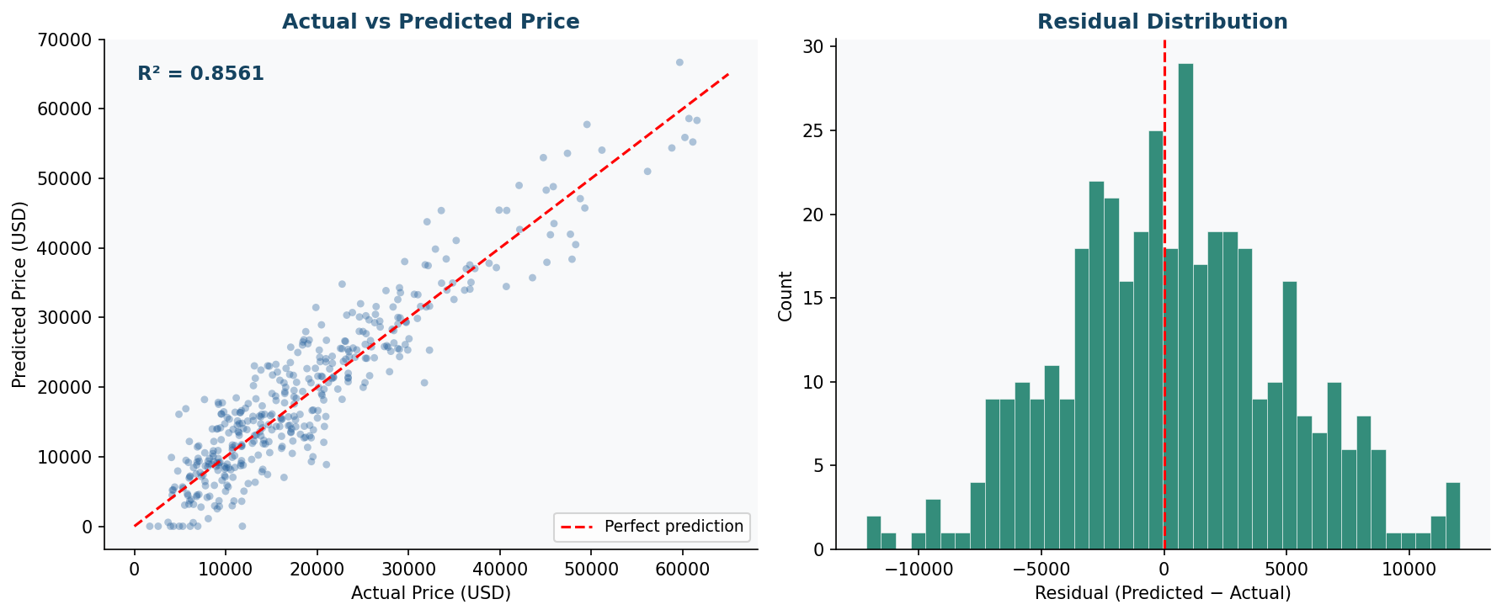
Figure 5.2: Left: actual versus predicted price (R² = 0.8561). Right: residual distribution centred near zero.
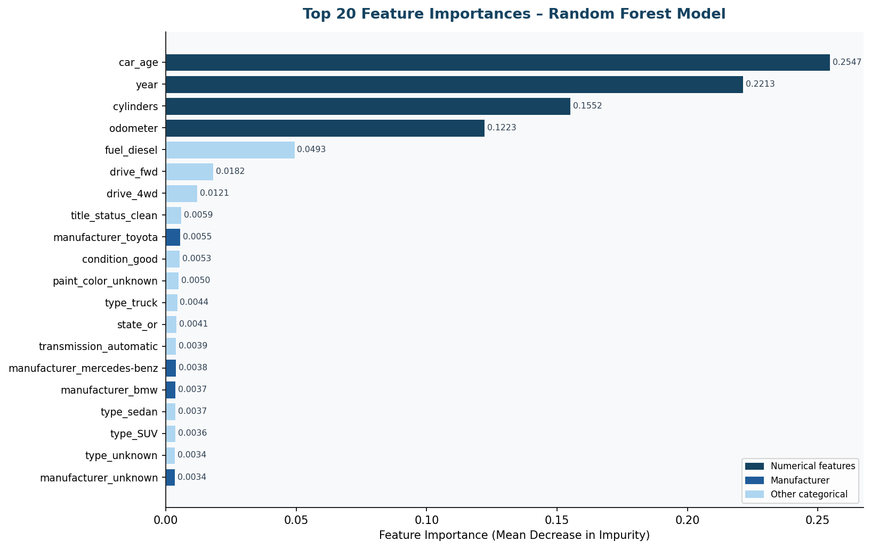
Figure 5.3: Top 20 feature importances of the Random Forest (mean decrease in impurity).
Figures 5.4 to 5.6 are screenshots of the deployed service. Figure 5.4 shows the health check at harikrishnangs.pythonanywhere.com, which returns the message that the used-car price prediction service is running, the model name, the version and the status. Figure 5.5 shows the Swagger interface listing the GET / and POST /predict operations and the CarInput schema. Figure 5.6 shows the response schemas of /predict, namely the successful response and the validation error.
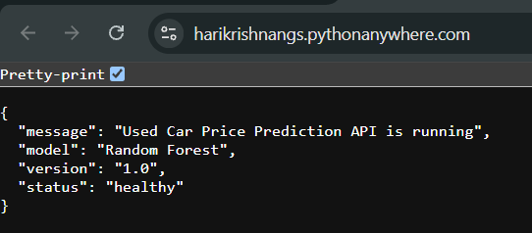
Figure 5.4: GET / health check returning the service status, model name and version (HTTP 200).
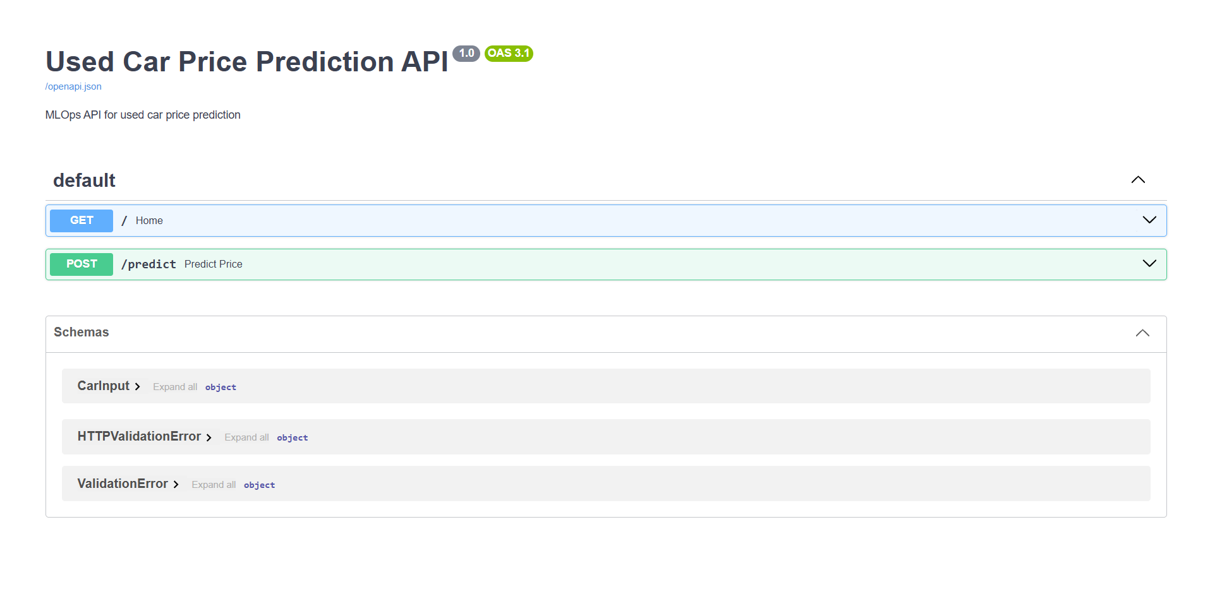
Figure 5.5: Swagger UI at /docs showing the GET / and POST /predict endpoints and the CarInput schema (OAS 3.1).
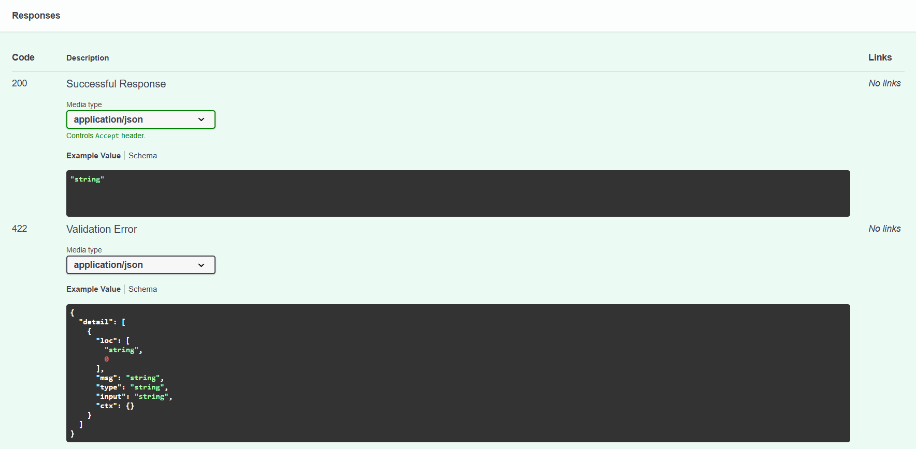
Figure 5.6: Response schemas of /predict: 200 successful response and 422 validation error.

5.4 Interpretation and Analysis
Why the Random Forest wins. The improvement of 14.9 percentage points in the coefficient of determination over Linear Regression can be traced to three properties of the data. First, price does not fall linearly with mileage: it drops steeply in the first 30,000 miles and then flattens, which a linear model cannot represent. Second, attributes interact, so a recent Toyota with low mileage is worth more than the sum of the separate effects of year, brand and mileage. Third, the price distribution is multi-modal, with an economy group and a mid-range and truck group, and an ensemble of trees can learn separate rules for each.
Accuracy across the price range. The actual-versus-predicted plot shows the strongest agreement in the $5,000 to $30,000 range, where most training examples lie. Predictions for vehicles above $50,000 are more scattered, which is expected because luxury and near-new vehicles are sparse in the data. The residuals are roughly symmetric and centred near zero, so there is no systematic bias, although a slight positive skew suggests that the model marginally under-prices very expensive vehicles.
Feature importance. The importance ranking in Figure 5.3 matches domain expectations. Car age (0.2547) and year (0.2213) together account for about 48% of the total importance. Because car age is derived from year, the two share the same underlying signal, and their importance is split between them. Cylinders (0.1552) rank third and odometer (0.1223) fourth, so the four numerical features dominate. Diesel fuel (0.0493) is the most important categorical indicator, followed by front-wheel and four-wheel drive. Manufacturer indicators such as Toyota, Mercedes-Benz and BMW contribute individually small but visible signals, consistent with brand premiums in the resale market.
Operational findings. The deployment evidence shows that the service responds with HTTP 200 to valid input and that the schema rejects malformed input with HTTP 422. The pipeline carries its own preprocessing, so the service needs only the 13 raw fields, and the compressed 82 MB file fits within the free-tier limit. MLflow keeps all three runs, so the choice of the Random Forest can be audited.
Limitations of the evidence. The evaluation uses a single 80/20 split, and the reported training times are approximate. Only one prediction, TC-02, was recorded from the live service. The model is a static snapshot, and the report contains no measurement of latency, throughput or behaviour under load. These points are addressed in the next chapter.
CHAPTER 6

CONCLUSION and FUTURE WORK
This chapter summarises what the project achieved, states its main limitation, and outlines how the system can be extended.

6.1 Conclusion
SmartDeploy demonstrates the complete MLOps lifecycle for a regression task of practical business relevance, from a raw data file to a public HTTPS prediction service. The project delivers four achievements beyond standard machine learning coursework.
- Reproducible experimentation. MLflow records the three model runs, with parameters and metrics, in a persistent SQLite backend, which allows objective comparison and later auditing.
- Production-grade serialisation. The full Scikit-learn pipeline, preprocessing and model, is stored in one compressed 82 MB Joblib file that carries all inference logic.
- Type-safe inference. FastAPI and Pydantic reject malformed requests with an informative 422 response before they reach the model, which prevents silent wrong predictions.
- Live cloud deployment. The service is publicly reachable over HTTPS, so a consumer needs no local setup.
The Random Forest, with 100 trees and a maximum depth of 20, achieved a coefficient of determination of 0.8561 on the 50,073-record test set. This is 14.9 percentage points above Linear Regression (0.7071) and 2.6 points above Gradient Boosting (0.8299), with a mean absolute error of $2,820.29 and a root mean square error of $4,585.05.
Lessons learned. Several small decisions proved important in practice. Embedding the preprocessing inside the serialised pipeline removed any risk of a mismatch between training and serving. Setting unseen categories to be ignored by the encoder meant that a new state or colour at prediction time would not break the service. Converting the validated request to a named-column DataFrame was necessary for the column transformer to route features correctly. And compressing the model at level 3 was the difference between a file that could not be hosted on the free tier and one that could.
Current technical constraint and limitations. The main limitation is the absence of automated monitoring and retraining. The deployed model is a static artefact trained on a fixed snapshot. If the market shifts, for example because electric vehicles become a larger share of listings or a recession lowers prices, accuracy will degrade silently, and nothing detects the drift or triggers retraining. In addition, the evaluation uses a single hold-out split, no hyper-parameter search was carried out, latency and load were not measured, and only one live prediction was recorded.

6.2 Future Work
Table 6.1 lists the planned enhancements in order of priority, with the technology that would be used and the outcome expected.
Table 6.1: Future enhancements
Enhancement | Technology | Outcome | Priority
Data drift detection | Evidently AI or Amazon SageMaker Model Monitor | Statistical alerts (KS test, PSI) when the production input distribution diverges from the training distribution | High
Automated retraining pipeline | AWS Step Functions with S3 event triggers | Automatic retraining when a drift threshold is exceeded; new version staged in the MLflow Model Registry | High
Containerised deployment | Docker with AWS Lambda or ECS Fargate | Consistent runtime, horizontal scaling and no cold-start latency of the current host | Medium
CI/CD pipeline | GitHub Actions, pytest and an MLflow validation gate | New model versions validated against quality thresholds before deployment | Medium
Confidence intervals | Quantile Regression Forests or conformal prediction | Prediction intervals, for example $17,800 to $20,700, with each point estimate | Medium
Web user interface | React with Axios calling POST /predict | Consumer-facing valuation tool with form inputs | Low
Hyper-parameter optimisation | Optuna (Akiba et al., 2019) or SageMaker tuning jobs | Systematic search over max_depth, n_estimators and min_samples_split, with a possible gain towards a coefficient of determination of 0.87 | Low

Beyond these items, evaluating the service with cross-validation, recording the latency of the endpoint under load, and documenting every test case with its recorded response would strengthen the evidence further.

REFERENCES
Journals
1. Breiman, L. (2001). Random forests. Machine Learning, 45(1): 5–32.
2. Friedman, J. H. (2001). Greedy function approximation: A gradient boosting machine. The Annals of Statistics, 29(5): 1189–1232.
3. Gegic, E., Isakovic, B., Keco, D., Masetic, Z. and Kevric, J. (2019). Car price prediction using machine learning techniques. TEM Journal, 8(1): 113–118.
4. Kreuzberger, D., Kühl, N. and Hirschl, S. (2023). Machine learning operations (MLOps): Overview, definition, and architecture. IEEE Access, 11: 31866–31879.
5. Mekala, R. R., Sevitha, G. L., Anumula, T. and Latha, K. (2022). Prediction of price for cars using machine learning. International Journal for Research in Applied Science and Engineering Technology, 10(6).
6. Pedregosa, F. et al. (2011). Scikit-learn: Machine learning in Python. Journal of Machine Learning Research, 12: 2825–2830.
Conference proceedings
1. Akiba, T., Sano, S., Yanase, T., Ohta, T. and Koyama, M. (2019). Optuna: A next-generation hyperparameter optimization framework. In Proceedings of the ACM SIGKDD Conference on Knowledge Discovery and Data Mining, pp. 2623–2631.
2. Amershi, S. et al. (2019). Software engineering for machine learning: A case study. In Proceedings of the IEEE/ACM International Conference on Software Engineering, Software Engineering in Practice Track, pp. 291–300.
3. Lin, J. (2024). Predicting used car price based on machine learning. In Proceedings of the 1st International Conference on E-commerce and Artificial Intelligence, SciTePress, pp. 553–560.
4. McKinney, W. (2010). Data structures for statistical computing in Python. In Proceedings of the 9th Python in Science Conference, pp. 56–61.

