**Sakshi Jadhav**

[sakshijadhav2911@gmail.com](mailto:sakshijadhav2911@gmail.com)

Landmark Analysis In context of Emotion Recognition

Program Feedback

IBM SkillsBuild has been instrumental in broadening my capabilities by offering interactive modules and valuable mentorship that not only strengthened my employability but also encouraged continuous learning and adaptability. This experience has equipped me with diverse skills, practical knowledge, and the confidence to pursue future career opportunities with greater readiness and growth mindset.

Project Short Summary

This project focuses on the generation and analysis of facial landmarks from a given dataset, exploring their effectiveness as input features for neural networks. The primary objective is to observe and evaluate the impact of using landmark-based representations in comparison to raw facial images, highlighting how this approach influences model performance and accuracy in tasks such as recognition and classification.

**DES Pune University**

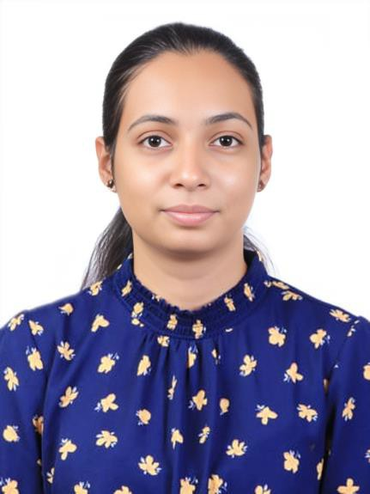

#skillsbuild