**Q1. Which function is used to open a file? What are the different modes of opening a file? Explain each mode of file opening.**

* We use open() function to open a file in python.
  + i.e f = open("file_name.extension", "opening_mode")
* There are about 12 file opening modes in python.
* We generally use 6 out of 12 file opening modes.
  + "r" - Read Only
    - This is the defalt mode for opening a file.
    - It is used for opening a text file with reading purpose.
    - The file pointer is placed at the beginning of the file.
    - It throws an I/O error in case the file doesn't exist.
  + "w" - Write Only
    - It is used for opening a text file with writing purpose.
    - It creates the file if the file doesn't exist.
    - If the file exists, the file content is overwritten with new content passed by the user.
    - The file pointer is placed at the beginning of the file.
  1. "r+" - Read and Write
     + It is used for opening a text file with reading and writing purpose.
     + It throws an I/O error in case the file doesn't exist.
     + The file pointer is placed at the beginning of the file.
  2. "w+" - Write and Read
  + It is used for opening a text file with reading and writing purpose.
  + If the file exists, the file content is overwritten with new content passed by the user.
  + It creates the file if the file doesn't exist.
  + The file pointer is placed at the beginning of the file.

1. "a" - Append Only
   * It is used for opening a text file with writing purpose.
   * It creates the file if the file doesn't exist.
   * If the file exists, the new content is appeneded at the end of the file content.
   * The file pointer is placed at the beginning of the file.
2. "a+" - Append and Read
   * It is used for opening a text file with reading and writing purpose.
   * It creates the file if the file doesn't exist.
   * If the file exists, the new content is appeneded at the end of the file content.
   * The file pointer is placed at the beginning of the file.

* The other 6 operations are same as above with the only difference as they are opened in binary format.

**Q2. Why close() function is used? Why is it important to close a file?**

* close() function is used to close an opened file.
* It is important to close a file to deallocate the file descriptor because there is a limit for file descriptors in python as we have a limited resource on a computer.
* Context Manager is used by using with statement to get rid of closing a file explicitly.

#### Q3. Write a python program to create a text file. Write ‘I want to become a Data Scientist’ in that file. Then close the file. Open this file and read the content of the file.

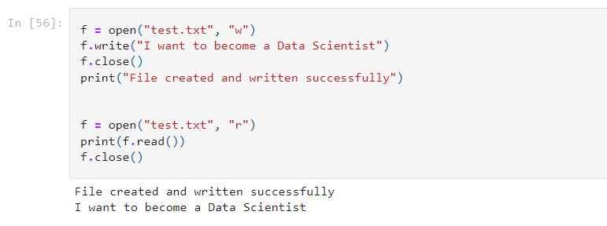

**Q4. Explain the following with python code: read(), readline() and readlines().**

* read()
  + It returns the whole file content line by line.
  + We can also specify number of bytes to return by passing a parameter.
  + Default passed parameter is -1 which means the whole file.
* readline()
  + It iterates one line at a time starting from beginning of the file.
  + We can also specify number of bytes to return by passing a parameter.
  + Default passed parameter is -1 which means the whole file.
* readlines()
  + This method returns a list containing each line in the file as a list item.
  + We can also specify number of bytes to return by passing a parameter.
  + Default passed parameter is -1 which means the whole file.

**Q5. Explain why with statement is used with open(). What is the advantage of using with statement and open() together?**

* The with statement is used with the open() function to open a file.
* With statement is used so that we don't have to close the file descriptor explicitly.
* With statement helps us in a managing resource in an efficient manner.

**Q6. Explain the write() and writelines() functions. Give a suitable example.**

* write()
  + write() function takes a string as an input argument and writes it to file
  + To store data in line by line format, we have to add '\n' character to the end of each string.
  + While writing a numeric value we have to either write it in quotes or typecast it into a string.

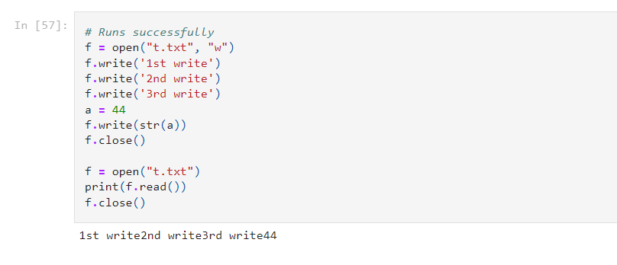

* writelines()
  + writelines() function is used to write iterables (e.g, string, list, tuple) in a file.
  + While writing a numeric value we have to either write it in quotes or typecast it into a string.

