Tut-11 (Conduction Problem)

1. Consider the problem of source free heat conduction in an insulated rod of length 0.5 m, whose ends are maintained at constant temperatures of T_{A}=500°C and T_{B} =100°C respectively.
The 1D problem is governed by
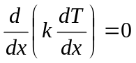, where k=1000W/m/ K, cross sectional area A is 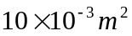

Discretize the equation by FDM for N number of nodes. For interior nodes use 2nd order discretization. Write a computer program to calculate the coefficients for each of the node and solve the matrix aT=b. Submit the plot comparing the exact (analytical) and the numerical solution for the temperature profile that you obtain.

2. The figure below shows a large plate of thickness L = 2 cm with constant thermal conductivity k=0.5W/m/k and a uniform heat generation q=1000KW/m³. The faces are at

T_{A}
T_{B}

L

temperature at T_{A}=200°C and T_{B} =100°C respectively. The other dimensions are so large that the temperature gradient can be considered in x direction only. A is 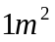 The 1D problem is governed by
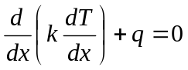.
Divide the domain in N general nodes as before, and discretize just in the first problem. Write a computer program to calculate the coefficients for each of the node and solve the matrix aT=b. Submit the plot comparing the exact (analytical) and the numerical solution for the temperature profile that you obtain.

