# Appendix A

# Deletion of multiple Forums postings.pdf

* When top of the thread is deleted in the Topic View, delete all the children as well (this was discussed via email).
* When a thread is deleted, we agree with the comment in the document: “We recommend that this be changed, so that deleted messages still have author and date created, in addition to indicating who deleted the message and when”
* We recommend against having the checkboxes for the delete feature. We believe that by deleting all the children along with the original thread, much of the issue will be alleviated. Rather than introducing a multiple delete feature, we believe the bigger issue here is that the forums interface conceals the delete button in the interface, making it inconvenient for the forum admins to delete multiple messages. The following changes will help address this:
  + In the “Forums” home view, pull out the “delete” feature from the “Forum Settings” and the “Topic Settings” page to the main screen:

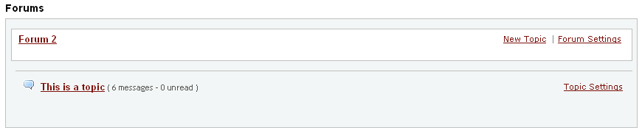

This is the current Topic View – the user has to click and go into the “Settings” page in order to remove the forum or topic. This additional step is unnecessary and unintuitive – most users would expect to see the delete feature on this screen. Below is the suggested Forums view.

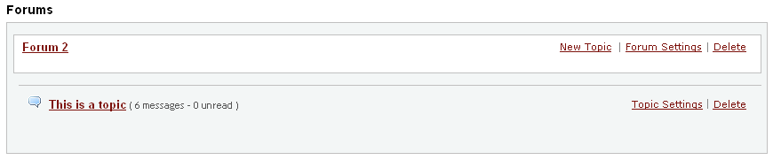

* + In the “Topic” view, include a “delete” link, similar to the suggestions above:

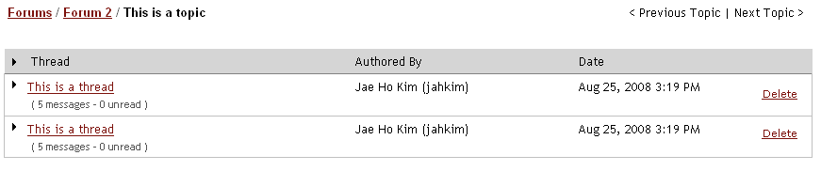

* + In the thread view, always open “Other Actions” so that “Grade” | “Edit” | “Delete” are displayed. This makes it more convenient to delete an offending thread, and simplifies the interface. “Other Actions” is not really necessary when the list of options it hides is only as long as the text “Other Actions”:

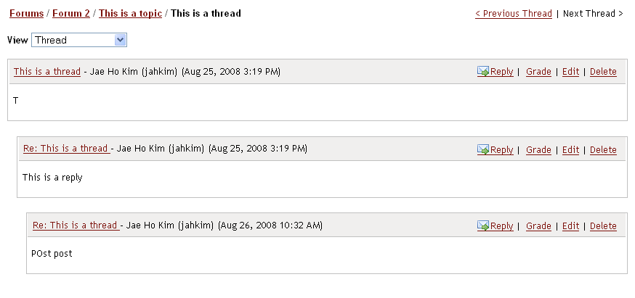

* + For all these action items on the right in the forums section, also consider using the “Actions” drop down as implemented in the “Resources” section.
  + Consider introducing a “move” feature so that messages posted to a wrong thread can easily be moved.
* We like the screen mock “1d” – it is a nicely detailed warning message that is easy to read.