Sakai Properties

Introduction
This document describes configurations that can be made using entries in the sakai.properties file. The organization and use of the sakai.properties file is covered in the document How to Configure Sakai. Properties described are found in the sakai.properties file, or in the components.xml file, or both.

The sakai.properties file is at
/trunk/sakai/kernel/component/src/config/org/sakaiproject/config
in subversion, and should be placed in a folder named ‘Sakai’ in the tomcat root directory (e.g. in /usr/local/tomcat/sakai).

The components.xml file is at
/trunk/sakai/legacy/legacy-components/src/webapp/WEB-INF/components.xml in subversion and is installed in the <tomcat root>/components/sakai-legacy-components/WEB-INF directory.

In the definitions below, the property is listed, followed by the default setting (if there is one), and an explanation of the property. In some cases the comment included with the property in the sakai.properties file says it all. Those comments are included below.

The appendices include a sakai.properties file from Sakai release 2.1, and a copy of the sakai.properties file in use at the University of Michigan.

Sakai OOTB is an alias for the default install of Sakai - Sakai Out Of The Box.

Properties are grouped together below according to their function. The index provides an alphabetized list.

Sakai Properties 1
Introduction 1
Database related configurations 5
hibernate.dialect 5
auto.ddl 5
jdbc.defaultTransactionIsolation 5
Server Information 5
serverId 5
serverUrl 6
serverName 6
gatewaySiteId 6
loggedOutUrl 7
accessPath 7
portalPath 7
helpPath 7
top.login 7
container.login 8
xlogin.enabled 8
xlogin.text 8
xlogin.icon 9
Footer Control 9
bottomnav.count 9
bottomnav.n 9
powered.url 10
powered.img 10
powered.alt 10
bottom.copyrighttext 11
version.service 11
version.sakai 11
OOTB Information Files 12
server.info.url 12
myworkspace.info.url 12
webcontent.instructions.url 13
User Presence List 13
display.users.present 13
Skins 13
skin.default 14
skin.repo 14
iconNames.count 14
iconNames.n 14
iconUrls 15
iconSkins 16
disable.course.site.skin.selection 16
logout.icon 17
Accessibility 18
accessibility.url 18
Resources Storage, Control 18
content.upload.max 18
copyrighttype 19
default.copyright 20
copyrighttype.own 20
copyrighttype.new 21
default.copyright.alert 21
fairuse.url 22
newcopyrightinput 22
resources.show_all_collections.tool 23
resources.show_all_collections.dropbox 23
resources.show_all_collections.helper 24
Worksite Setup 25
activeInactiveUser 25
wsetup.group.support 26
site.setup.import.file 26
titleEditableSiteType 27
courseSiteType 28
roster.available.weeks.before.term.start 28
termterm 29
termyear 30
termlistabbr 31
termiscurrent 31
termstarttime 32
termendtime 32
subjectsize 32
coursesize 32
sectionsize 32
noEmailInIdAccountLabel 33
noEmailInIdAccountName 34
emailInIdAccountName 34
emailInIdAccountLabel 34
emailInIdAccountInstru 35
emailInIdAccount 35
notifyNewUserEmail 36
invalidEmailInIdAccountString 37
Sites tool control 37
sitebrowser.termsearch.type 37
sitebrowser.termsearch.property 38
sitesearch.noshow.sitetype 38
Email 38
support.email 39
mail.support 39
setup.request 39
smtp.dns.1 40
smtp.dns.2 40
smtp.port 40
smtp.enabled 40
ui.institution 40
ui.service 40
force.url.secure 40
News Tool 41
news.title 41
news.feedURL 41
Membership tool 41
disable.membership.unjoin.selection 41
Automatic User Adds – ‘Affiliates’ 42
affiliatesubjects.count 42
affiliatesubjects.n 42
affiliatecampus.count 43
affiliatecampus.n 43
affiliateuniqnames.count 44
affiliateuniqnames.n 44
GradTools 44
withDissertation 44
gradToolsSiteType.count 45
gradToolsSiteType.n 45
No longer used 45
java.beep 45
email-for-user-id 45
login.icon 45
Appendix A 46
Appendix B 52
Index 60

Database related configurations

hibernate.dialect
# set the hibernate dialect (for shared datasource), HSQLDB by default, mySql and Oracle examples

hibernate.dialect=net.sf.hibernate.dialect.HSQLDialect
#hibernate.dialect=net.sf.hibernate.dialect.MySQLDialect
#hibernate.dialect=net.sf.hibernate.dialect.Oracle9Dialect

Sakai 2.1 supports 3 databases. By default, hibernate.dialect is set for HSQLDB. Examples are shown for MySQL and Oracle settings. Uncomment the appropriate setting to correspond with the database used, and remove/comment the others.

auto.ddl
# establish auto.ddl - on by default

auto.ddl=true
#auto.ddl=false

When Sakai starts up, if auto.ddl is set to true, necessary database tables will be created if needed (if the tables do not already exist).

jdbc.defaultTransactionIsolation
# set the default transaction isolation level
# Up to and including 1.7.1, HSQLDB supports only Connection.TRANSACTION_READ_UNCOMMITTED.
# MySQL and Oracle MUST use Connection.TRANSACTION_READ_COMMITTED.

jdbc.defaultTransactionIsolation=
java.sql.Connection.TRANSACTION_READ_UNCOMMITTED
#jdbc.defaultTransactionIsolation=
java.sql.Connection.TRANSACTION_READ_COMMITTED

Server Information

serverId
# identify your application server with a short name, unique among the servers in your cluster.
# choose a server id even if you are running a single app server

serverId=localhost

Used to distinguish servers in a cluster from one another. The serverId value is the server name displayed in the footer and in the Admin Online tool.

For example, if serverId=phantom, the footer displays


serverUrl
# the URL to the server, including transport, DNS name, and port, if any

serverUrl=http://localhost:8080

Should be set to match the ‘port’ defined in the CATALINA_HOME/conf/server.xml file

serverName
# the DNS name of the server

serverName=localhost

gatewaySiteId
# gateway site id

gatewaySiteId=!gateway

The site id of the site which is used for the installation’s gateway (login page). This site will be shown when users go to the URL set in the serverURL property.

With the defaults, going to the URL http://localhost:8080 will take the user to the !gateway site where they find the Login button (and perhaps the user name and password fields depending on the top.login setting) . The !gateway site typically will contain a MOTD (message of the day), and perhaps a web content tool pointing to another document containing installation specific information. The !gateway site may have a left hand menu column of page names. The pages may contain things like ‘Features’, ‘About’, ‘Training’, etc. The Sakai OOTB !gateway site includes a New Account page, which contains the new.account tool. Institutions will want to edit the !gateway site to add/remove pages/tools, or create their own gateway site.

loggedOutUrl
# the URL to send folks to after they logout

loggedOutUrl=/portal

When users click the ‘logout’ button, they are sent to <serverUrl><loggedOutUrl>
With the default settings, this would be http://localhost:8080/portal

accessPath

accessPath=/access

Specifies the URL to the access path. This partial URL is used to construct the full URL for accessing resources. For example, the URL to a resource might be http://localhost:8080/access/content/group/ 1100899697301-3493876 /report.doc where /content/group/ 1100899697301-3493876 /report represents the location of the resource.

portalPath

portalPath=/portal

Specifies the URL to the portal path. This partial URL is used to construct the full URL for accessing Sakai (e.g., http://localhost:8080/portal )

helpPath

helpPath=/help

Specifies the URL to the help path. This partial URL is used to construct the full URL for accessing help content. For example, http://localhost:8082/portal/help/TOCDisplay/content.hlp?docId=aqyk

top.login
# to include the user id and password for login on the gateway site

top.login=true

Controls whether the ‘user id’ and ‘password’ fields are shown in the banner at the top of the Sakai window. If top.login=false, the two fields are not shown.


When an external authorization mechanism is present, installations may want top.login=false to hide the native Sakai login fields.

container.login
# to let the container handle login or not (set to true for single-signon type setups, false for just internal login)

container.login=false

In Sakai OOTB, there is no external login authoricy (e.g., CAS or cosign) setup by default, so container.login=false to let Sakai handle logins. When set to false, Sakai login processing can be bypassed since we trust the container if it says that the user is already logged in.

These two control the extra (x) login button - if it's enabled, what text to show. There should be another for the icon. Then you get two logins - one normal, and one that is "xlogin" that bypasses the container check

xlogin.enabled

xlogin.enabled=

If xlogin.enabled=true, then a 2nd login button will appear (depending on xlogin.text or xlogin.icon). The 2nd ‘xlogin’ button bypasses the container check, and is a way to login to a native Sakai account.

Note that when xlogin.enabled=false, though the 2nd login button doesn’t appear, it is still possible to login via xlogin using the URL such as http://localhost:8080/portal/xlogin.

xlogin.text

xlogin.text=

Specifies the test to show for a 2nd login button in the Sakai header (the xlogin button). For xlogin.text to show, top.login must be false, and xlogin.enabled must be true.

For example, with the settings of

xlogin.text=Mash me
top.login=false
xlogin.enabled=true

The following appears


The xlogin button can be text or an icon but not both. If both xlogin.text and xlogin.icon have a value, the icon ‘wins’.

xlogin.icon

xlogin.icon=

Specifies an icon to use for a 2nd login button in the Sakai header (the xlogin button). For xlogin.icon to show, top.login must be false, and xlogin.enabled must be true.

For example, with the following settings,

xlogin.icon=<path to bullseye icon>
top.login=false
xlogin.enabled=true

The following appears



The xlogin button can be text or an icon but not both. If both xlogin.text and xlogin.icon have a value, the icon ‘wins’.

Footer Control

bottomnav.count

bottomnav.n

bottomnav.count=
bottomnav.1=

Specifies links that can appear at the top of the footer. Links are displayed in an order according to their bottomnav.n association, with the bottomnav.1 item appearing first, bottomnav.2 item second, etc. A vertical bar | separates links. There are bottomnav.count number of links shown. Each link URL is specified by the bottomnav.n value.

Since there are no default bottomnav links specified in Sakai OOTB, the footer area where such links appear is empty.

To add links, create values for the properties. For example, at UM we have

bottomnav.count = 5
bottomnav.1 = <a href="https://ctools.umich.edu/portal/site/!gateway"> CTools Gateway</a>
bottomnav.2 = <a href="mailto:ctools@umich.edu">Contact Us</a>
bottomnav.3 = <a href="http://www.dc.umich.edu/" target="_blank">Duderstadt Center</a>
bottomnav.4 = <a href="http://www.umich.edu/" target="_blank">University of Michigan</a>
bottomnav.5 = <a href="http://sakaiproject.org" target="_blank">The Sakai Project</a>

which produces

(The ‘Powered by Sakai’ icon is controlled by the powered.url and associated properties)

Note: Since Sakai is xhtml, links should be xhtml (e.g.,
<a href="" title="" target="">Anchor</a>
The title should contain a warning if target="_blank".

powered.url

powered.img

powered.alt
# powered by config for the bottom of the portal

powered.url.count=1
powered.url.1=http://sakaiproject.org
powered.img.count=1
powered.img.1=/library/image/sakai_powered.gif
powered.alt.count=1
powered.alt.1=Powered by Sakai

These control the display and hyperlink of the ‘powered by’ icon in the footer. You can add additional logos with their own links and alt text. For example, if you added a gif file named ‘wolverine.gif’ to /library/image directory, and had the following in sakai.properties, the ‘powered by’ section of the footer would look as follows.

powered.url.count=2
powered.url.1=http://sakaiproject.org
powered.url.2=http://www.umich.edu
powered.img.count=2
powered.img.1=/library/image/sakai_powered.gif
powered.img.2=/library/image/wolverine.gif
powered.alt.count=2
powered.alt.1=Powered by Sakai
powered.alt.2=University of Michigan

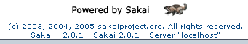

Clicking on the wolverine icon sends the user to the University of Michigan web site.

The ‘powered by’ icons open their links in a new browser window.

bottom.copyrighttext
# strings for the portal pages

bottom.copyrighttext=(c) 2003, 2004, 2005 sakaiproject.org. All rights reserved.

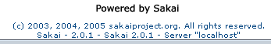

Specifies a line of text just under the ‘powered by’ icon in the footer.

version.service

version.sakai
version.service=2.0.1
version.sakai=2.0.1

Specifies versioning footer text. Installations may want to designate their own versioning scheme.

For example, at UM, we have
version.service= [r2236]
version.sakai= 2.0.0[506121]

which produces the following in the footer:


Also see ui.service (set to ‘CTools’ in the example above), and bottom.copyrighttext (set to ‘Copyright © 2003 – 2005, the Regents of The University of Michigan’ above)

OOTB Information Files
Note regarding content of these files. Since Sakai is xhtml, links in the files should be xhtml (e.g., <a href="" title="" target="">Anchor</a> ). The title should contain a warning if target="_blank".

server.info.url

server.info.url=/library/content/server_info.html

Displayed by the sakai.iframe.service tool, which is typically found on the !gateway site. The server_info.html file has been used to provide information about the institution’s installation.

To be able to change the displayed content without having to re-deploy Sakai, you could change the location to
server.info.url= /content/public/server_info.html.
Then you could upload a file called server_info.html into the Admin’s Resources/public folder, and make edits there anytime as needed without a re-deploy.

myworkspace.info.url

myworkspace.info.url=/library/content/myworkspace_info.html

Displayed by the sakai.iframe.myworkspace tool, which is typically found on the Home page of My Workspaces. The myworkspace_info.html file has been used to provide information to users about the function of their My Workspace.

See the comments for server.info.url for information about why you may want to change the location of the myworkspace_info.html file.

webcontent.instructions.url

webcontent.instructions.url=/library/content/
webcontent_instructions.html

Displayed by the sakai.iframe tool when the URL field for that tool is blank. The webcontent.instructions.html file contains text that explains what to do to point a sakai.iframe tool (Web Content tool) to a particular URL. If the URL field for the Web Content tool contains a URL, then the Web Content tool displays the content at the URL rather then the webcontent.instructions.html text.

See the comments for server.info.url for information about why you may want to change the location of the myworkspace_info.html file

User Presence List

display.users.present
# to enable presence display in the portal

display.users.present=false

Controls whether or not the Users Present list shows in the left hand menu column below page names. When display.users.present=true, the left hand menu column includes the Users Present list in each site. The list shows those who are ‘present’ (looking at) any page of the site. In the example below, 3 users are present in the site. You cannot tell from the list which page in the site users are focused on.
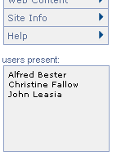
Users Present list is displayed if
display.users.present=true

Skins
See the following documents in the Sakai Development site Resources/Architecture Docs/Sakai 2 folder on http://collab.sakaiproject.org for more detailed information on skinning in Sakai.

Skinning Sakai Portal
http://collab.sakaiproject.org/access/content/group/1097928811887-22636/Architecture%20Docs/Sakai%202/sakai_skin_portal.pdf

Skinning Sakai Tools
http://collab.sakaiproject.org/access/content/group/1097928811887-22636/Architecture%20Docs/Sakai%202/sakai_skin_tool.pdf

And in the Sakaipedia at Confluence –
http://bugs.sakaiproject.org/confluence/display/ENC/Skinning+in+Sakai+2.0

skin.default
# The default skin for sites without a skin setting

skin.default=default

Sites get this skin if no value is selected when creating a course site. All project sites use this skin.

skin.repo
# the path to the skin files

skin.repo=/library/skin

The location of css and image files used in skinning Sakai.

iconNames.count

iconNames.n
# for worksite setup, which offers a list of Appearance (Icon) choices (course sites only)

iconNames.count=3
iconNames.1=humanities
iconNames.2=engineering
iconNames.3=pig

Sets the values that will show up in the ‘Appearance (icon)’ field dropdown.

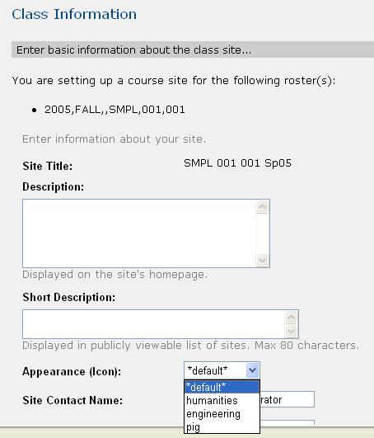
Values that appear in the Appearance (Icon): dropdown are
specified in iconNames.n properties

The names are associated (via the iconUrls property) with gif files. The gif selected via the dropdown shows up at the top of the left hand menu column in the worksite (see the figure in the iconUrls description)

iconUrls

iconUrls.count=3
iconUrls.1=/library/icon/humanities.gif
iconUrls.2=/library/icon/engineering.gif
iconUrls.3=/library/icon/pig.gif

Specifies the location of the ‘worksite icon’ which shows up at the top of the left hand menu column in the worksite. The particular icon is chosen from the ‘Appearance (icon)’field dropdown menu when creating a class worksite.

For example, selecting ‘humanities’ (the iconNames.1 property) from the dropdown when creating a class site puts the humanities icon (the iconUrls.1 icon) in the left hand menu column.

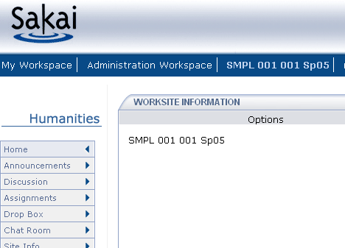
Placement of the iconUrls.n icon

iconSkins

iconSkins.count=3
iconSkins.1=
iconSkins.2=
iconSkins.3=examp-u

Used to provide additional skins which will override the default skin if desired. Normally, the default skin is used in a site, and the iconName.n value selected in the Appearance dropdown when creating a class site just indicates which worksite icon to use. However, if a value is set for an iconSkins.n property, then that value is used as the skin when the corresponding iconName.n value is chosen from the Appearance dropdown.

With the defaults, selecting the ‘pig’ value (the iconNames.3 property) from the Appearance dropdown when creating a class site gives the site the examp-u skin (set by the iconSkins.3 property).

disable.course.site.skin.selection
#show/hide icon/url list with course site edit info

disable.course.site.skin.selection=

When creating a course site, the appearance of the site skin can be customized by adding an icon at the top of the left hand menu column. disable.course.site.skin.selection controls the ability to edit that skin once the site has been created. If set to true, the Appearance Icon dropdown does not appear when editing the site with Worksite Setup or Site Info’s Edit Site Information function.

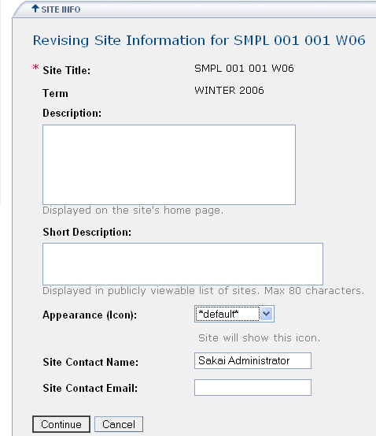
By default, the Appearance Icon dropdown appears when editing a site.
If disable.course.site.skin.selection=true, the field will not
appear when editing a site.

logout.icon

logout.icon=

If set, causes the image specified by the URL value to appear in the upper right corner of the Sakai page after login.

For example, if logout.icon=<url to a closing door icon>, the icon will replace the Logout button.



Accessibility

accessibility.url
#the location (url) of the accessibility info
#accessibility.url=http://www.umich.edu/~umctdocs/
Accessibility.html

If there is a value (URL), it renders an invisible link in the portal to the URL given by the value. This is so that screen reader users can go to a summary page of how to navigate Sakai with a screen reader.

Sakai OOTB does not have a value set for accessibility.url.

Resources Storage, Control

content.upload.max
# upload limit per request, in megs

content.upload.max=20

When uploading files into Resources, there can be a limit set to control the size of files uploaded. Some institutions may want to control how large files in Resources are to minimize problems site participants may have downloading large files over dial-up lines.

This limit is not enforced when uploading files via WebDav.

The limit applies to all files in an upload action. If 3 files are uploaded, the combined size of all 3 files cannot exceed the content.upload.max setting.

MySQL note: The MySQL database has its own file size limit, stored in a variable called max_allowed_packet, which is 1Mb by default. Visit this page for instructions on changing it: http://dev.mysql.com/doc/mysql/en/program-variables.html

This limit should not be confused with the max space setting that can be set per site, which puts a limit on the total size of all resources in a site. The max size per site limit is set in the components.xml file. The siteQuota property in the
org.sakaiproject.service.legacy.content.ContentHostingService bean sets the limit to a default of 1Gb.
<bean id=”org.sakaiproject.service.legacy.content.ContentHostingService”
...snip...
<property name=”siteQuota”><value>1048576</value></property>
</bean>

This can be overridden in sakai.properties. For example,
siteQuota@.sakaiproject.service.legacy.content.
ContentHostingService = 2000000

The max size limit of a site’s Resources can be set on a site by site basis, to override the installation default set by siteQuota. Visit the site as admin, click on the Edit Properties link for the top level folder. An editable field on the properties page can be used to override the siteQuota value for the site.

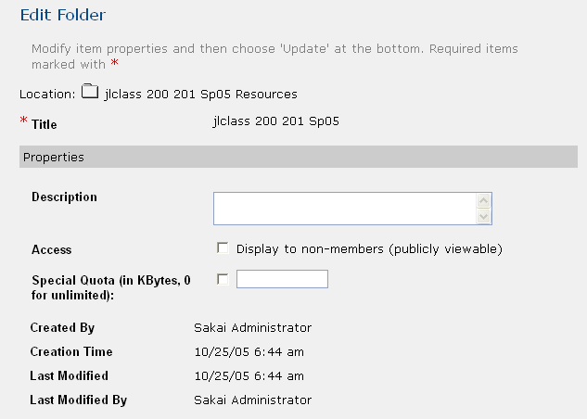
The Edit Properties page – editing the top level Folder in a site’s Resources to
Override the siteQuota limt

copyrighttype
# the copyright options for the resources tool

copyrighttype.count=6
copyrighttype.1=Material is in public domain.
Copyrighttype.2=I hold copyright.
Copyrighttype.3=Material is subject to fair use exception.
Copyrighttype.4=I have obtained permission to use this material.
Copyrighttype.5=Copyright status is not yet determined.
Copyrighttype.6=Use copyright below.

Configures copyright options that appear when adding/creating a file in Resources.

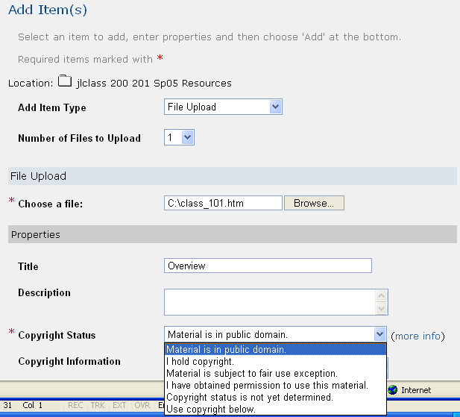
Copyright options when adding/creating a file in Resources

default.copyright
default.copyright=I hold copyright.

Specifies which copyrighttype option is the default selection in the Copyright Status dropdown appears.

copyrighttype.own

copyrighttype.own=I hold copyright.

The copyright for an item in Resources can be automatically constructed to include the user’s name. copyrighttype.own specifies which item in the Copyright Status list (which copyrighttype.n value) when chosen causes the Copyright Information field to be seeded with a default copyright notice that includes the user’s name.

With the defaults, if the user selects ‘I hold copyright.’ From the Copyright Status list, the Copyright Information field is seeded with the text “copyright © <year>, <username>. All rights reserved” where <year> is the current year, and <username> is replaced by the users First Last name.

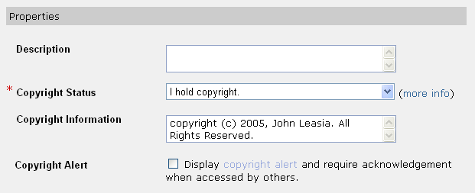
If ‘I hold copyright’ is selected, text in the Copyright Information field
is automatically constructed and includes the user’s name

copyrighttype.new

copyrighttype.new=Use copyright below.

Specifies which item in the Copyright Status list (which copyrighttype.n value) when chosen causes the user entered text in the Copyright Information field to be used for the file’s copyright.

With the defaults, if the user selects ‘Use copyright below’ From the Copyright Status list, then text they enter in the Copyright Information field will be used for the Copyright.

default.copyright.alert

default.copyright.alert=true

Specifies whether the Copyright Alert checkbox on the Add Item page in Resources should be checked on (true) or off (false) by default.

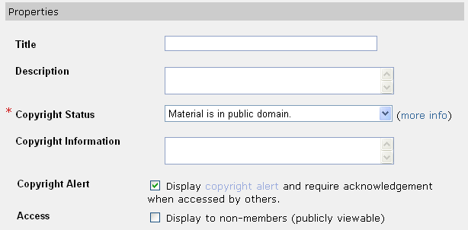
Default setting of the ‘Copyright Alert’ checkbox controlled by default.copyright.alert

fairuse.url

fairuse.url=http://fairuse.stanford.edu

On the Add Item page of Resources, there is a ‘more info’ link next to the ‘Copyright Status’ field that can be used to provide information about copyright issues. The default points to a page served by Stanford about Fair Use.

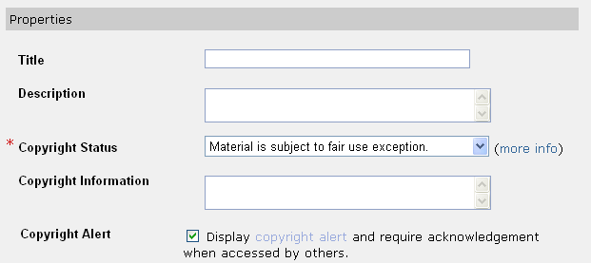
The fairuse.url property specifies what URL to use for the ‘more info’ link

newcopyrightinput

newcopyrightinput=true

Controls the appearance of the ‘Copyright Information’ field on the Add Item page of Resources. If newcopyrightinput=false, the Copyright Information field is not shown.

newcopyrightinput must be set to true for
the Copyright Information field to appear

resources.show_all_collections.tool
# indicates whether users should see "Show Other Sites" twiggle in list mode of resources tool

resources.show_all_collections.tool=true

The Resources list changed with 2.1 to include the ability to show resources from other sites in which the user is a participant. When resources.show_all_collections.tool=true, the list includes a twiggle control that is used to toggle open the list of Resource folders from other sites. If resources.show_all_collections.tool=false, the twiggle control does not appear and users see only resources for the site in a site.
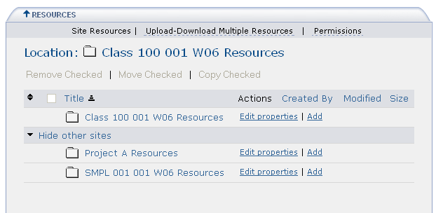
Resources from other sites are shown when
resources.show_all_collections.tool=true, and can be
shown or hidden with the
‘hide other sites|show other sites’ toggle

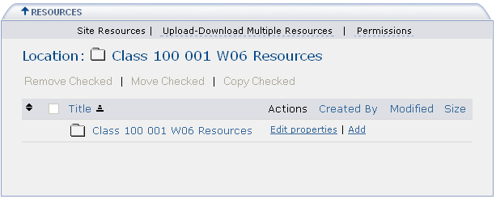
Only resources from the site are shown in the
Resources tool when resources.show_all_collections.tool=false

resources.show_all_collections.dropbox
# indicates whether users should see "Show Other Sites" twiggle in list mode of dropbox tool

resources.show_all_collections.dropbox=false

The DropBox list changed with 2.1 to include the ability to optionally show resources from other sites in which the user is a participant.
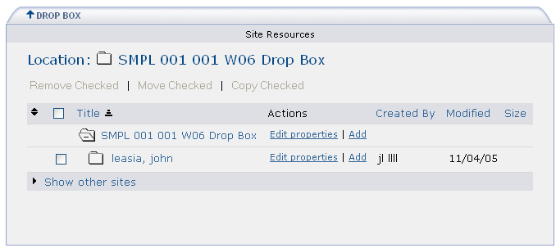
If resources.show_all_collections.dropbox=true,
then the ‘show other sites | hide other sites’ toggle is present.

As is the case with dropbox, maintain/instructor type roles see all dropboxes. Resources from other sites they participate in will show if Show other sites is toggled open. Users with a role that permits them to see only their own dropbox will similarly have the toggle to open resources from sites they participate in.

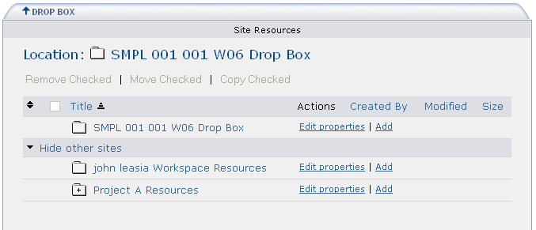
A student type role view of dropbox when resources.show_all_collections.dropbox=true

resources.show_all_collections.helper
# indicates whether users should see "Show Other Sites" twiggle in list mode of file picker

resources.show_all_collections.helper=true

The Attachment widget (file picker) changed with 2.1 to include the ability to optionally show resources from other sites in which the user is a participant when browsing for a file to attach.

For example, when resources.show_all_collections.helper=true, creating an attachment to an Announcement includes resources from other sites in the Select a resource section of the attachment page.

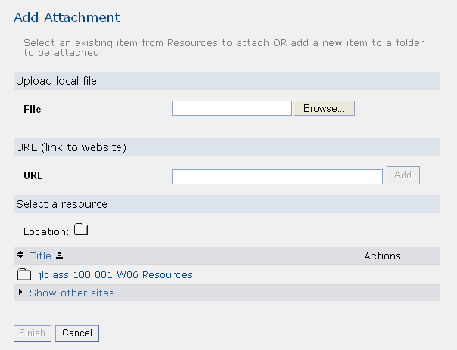
The ‘Show other sites | hide other sites’ toggle
Appears in the file picker when making attachments if
resources.show_all_collections.helper=true

Worksite Setup

activeInactiveUser
# worksite setup - enable the ability to control a participant's activation in a site

activeInactiveUser=true

Used to control whether the ‘Active/Inactive’ control is available, in the list of users that is shown when revising a site via Worksite Setup or in Site Info.

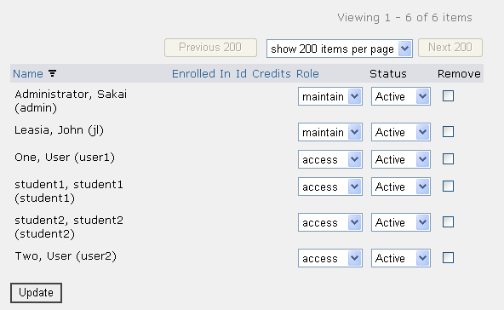
If activeInactiveUser=false this column does not appear

Some institutions may not want to give site owners the ability to inactivate users (such as registered students) due to local policy. See also disable.membership.unjoin.selection for a related feature.

wsetup.group.support
# whether to suppport group in Worksite Setup tool. Default to be true

wsetup.group.support=true

Use to hide or show the group support feature in Worksite Setup/Site Info tools.
If wsetup.group.support=true (or not set), Worksite Setup and Site Info will show the ‘Manage Groups’ action in the toolbar. The Manage Groups action will not be shown in Worksite Setup and Site Info if wsetup.group.support=false.
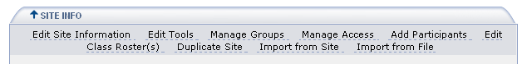
The Manage Groups action is shown in Worksite Setup and Site Info tool
if wsetup.group.support=true

site.setup.import.file
# disable from worksite setup the "import file" option

site.setup.import.file = false

The toolbar of the Site Info tool can optionally contain an item ‘Import from File’.

This feature allows one to import site materials from a zip file that includes information formatted in a way that Sakai can understand. It's basically the Site Archive tool, but in zip format so that someone can bring material in from outside of the system.

Installations will want to hide the Import from File action from the toolbar unless they have files available for import (e.g., from their legacy system).

An example of its use: Indiana has built an export zip file from their legacy system that contains content zipped into one file. Their users can then use the Import from File action to import the zip file content.

See the Worksite Archiving.pdf document in the Sakai Development Resources/Configuration docs folder on http://collab.sakaiproject.org for more information on archiving in Sakai. http://collab.sakaiproject.org/access/content/group/1097928811887-22636/Configuration%20docs/Worksite%20Archiving.pdf

titleEditableSiteType
# for worksite setup

titleEditableSiteType.count=1
titleEditableSiteType.1=project

Controls end user editing of site titles. Titles of sites with types specified by the titleEditableSiteType.n property can be changed by roles with site.upd permission. If a site type is not specified by a titleEditableSiteType.n property, the title field on the Edit Site Information page is a display only field

For example, with the default settings shown above, where jlproj777 is a project site, and jl20 20 20 is a class site, the following are images are from Site Info > Edit Site Information for the two sites.

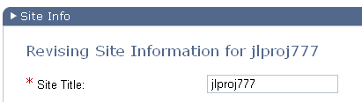

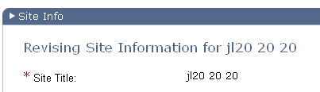

To allow site title editing for both course and project sites, the following settings could be used:
titleEditableSiteType.count=2
titleEditableSiteType.1=project
titleEditableSiteType.2=course

courseSiteType
courseSiteType=course

Specifies the type of site that is treated as a ‘course’ site. For the course site type, the term field can be edited with the Admin Sites tool. The term field does not show up for other types of sites (e.g., project).

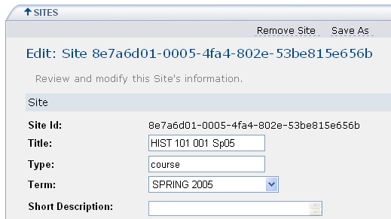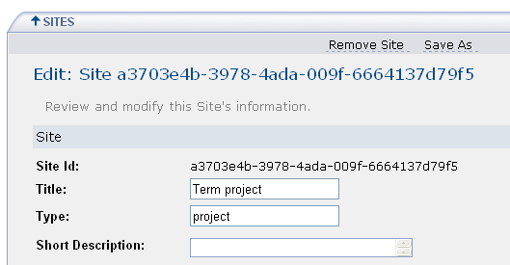
Course site Project site

roster.available.weeks.before.term.start

roster.available.weeks.before.term.start=4

Controls the flow through Worksite Setup when creating a new course site. The value is the number of weeks before start of next term when class lists will be presented to instructors for section selection when creating class sites. If an instructor creates a class site for the next term before roster.available.weeks.before.term.start weeks from start of next term, they will not see a list of their assigned classes when creating the site. Instead, the flow through Worksite Setup has them enter the class information manually.

This is to prevent the confusion that can arise when instructors create class sites too early, when information about teaching assignments is still in flux.

At UM, roster.available.weeks.before.term.start=8
If an instructor creates a class site 8 weeks before term starts, they must enter the class information manually as seen in the following

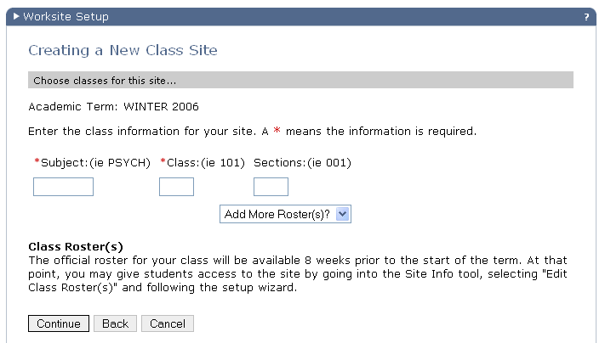

If the instructor creates a class site 7 weeks before term starts, they will see this page instead, which includes a listing of the classes they will be teaching for the term.
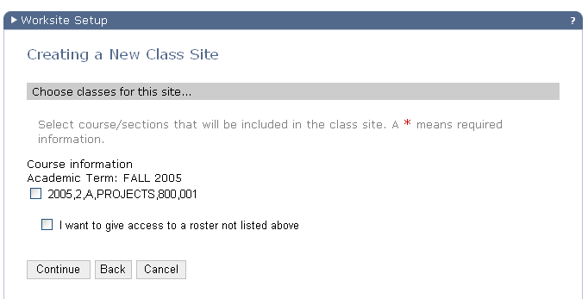

termterm
# course management information

termterm.count=11
termterm.1=FALL
termterm.2=WINTER
termterm.3=SPRING
termterm.4=SPRING_SUMMER
termterm.5=SUMMER
termterm.6=FALL
termterm.7=WINTER
termterm.8=SPRING
termterm.9=SPRING_SUMMER
termterm.10=SUMMER
termterm.11=FALL

Terms (semesters) are known by different names at different institutions. This list is where the particular terminology used for terms/semesters is specified. The termterm.count value should match the number of terms specified by termterm.n entries.

These values, combined with the tearmyear.n values, are those presented in the Term dropdown when creating a class worksite. Values before the current term (based on termendtime) are not shown in the list.
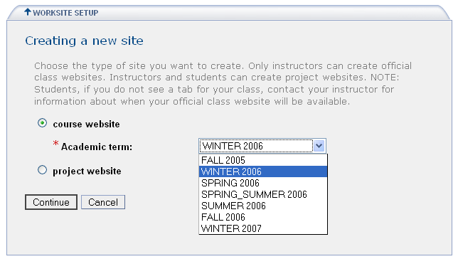

Note: Term values for past terms should remain in the various termyear.n, termterm.n, termlistabbr.n, etc. lists. Though they may not appear in the Term dropdown for selection, they are still needed for those class sites that may have been created during the past term.

termyear

termyear.count=11
termyear.1=2003
termyear.2=2004
termyear.3=2004
termyear.4=2004
termyear.5=2004
termyear.6=2004
termyear.7=2005
termyear.8=2005
termyear.9=2005
termyear.10=2005
termyear.11=2005

termyear specifies the term year for the associated termterm value. The termyear.count value should match the number of years specified by termyear.n entries.

termlistabbr

termlistabbr.count=11
termlistabbr.1=F03
termlistabbr.2=W04
termlistabbr.3=Sp04
termlistabbr.4=SpSu04
termlistabbr.5=Su04
termlistabbr.6=F04
termlistabbr.7=W05
termlistabbr.8=Sp05
termlistabbr.9=SpSu05
termlistabbr.10=Su05
termlistabbr.11=F05

An abbreviation for the term/semester label specified in the associated termterm.n property. The abbreviation is used rather than the full term name when real estate is at a premium (e.g., in a class site title, where ‘W05’ is used rather than ‘Winter 2005’). The termlistabbr.count value should match the number of years specified by termlistabbr.n entries.

termiscurrent

termiscurrent.count=11
termiscurrent.1=false
termiscurrent.2=false
termiscurrent.3=false
termiscurrent.4=false
termiscurrent.5=false
termiscurrent.6=false
termiscurrent.7=false
termiscurrent.8=true
termiscurrent.9=false
termiscurrent.10=false
termiscurrent.11=false

termiscurrent specifies which term value shows up as the default in the dropdown term list presented when creating a new course worksite.

At institutions where instructors create their own course sites (as opposed to the institution bulk creating a site for every course), the course site creation for the next term usually starts sometime before the current term ends. Along about the middle of the current term, when current term course site creation falls off, it is useful to change the default that appears for the term choice in the Term dropdown menu to the next term. The termiscurrent.count value should match the number of years specified by termiscurrent.n entries.

See also roster.available.weeks.before.term.start

termstarttime

termstarttime.count=11
termstarttime.1=20030901000000000
termstarttime.2=20040101000000000
termstarttime.3=20040501000000000
termstarttime.4=20040515000000000
termstarttime.5=20040801000000000
termstarttime.6=20040901000000000
termstarttime.7=20050101000000000
termstarttime.8=20050501000000000
termstarttime.9=20050515000000000
termstarttime.10=20050801000000000
termstarttime.11=20050901000000000

Specifies the start date of the associated termterm.n. Format is yyyyMMddHHmmssSSS. The termstarttime.count value should match the number of years specified by termstarttime.n entries.

termendtime

termendtime.count=11
termendtime.1=20031201000000000
termendtime.2=20040501000000000
termendtime.3=20040801000000000
termendtime.4=20040801000000000
termendtime.5=20040801000000000
termendtime.6=20041201000000000
termendtime.7=20050501000000000
termendtime.8=20050801000000000
termendtime.9=20050801000000000
termendtime.10=20050801000000000
termendtime.11=20051201000000000

Specifies the end date of the associated termterm.n. Format is yyyyMMddHHmmssSSS. The termendtime.count value should match the number of years specified by termendtime.n entries.

subjectsize

coursesize

sectionsize

subjectsize=8
coursesize=3
sectionsize=3

Used to control how many characters are allowed in the Subject, Class, Section fields when the user manually enters that data during a course site setup.
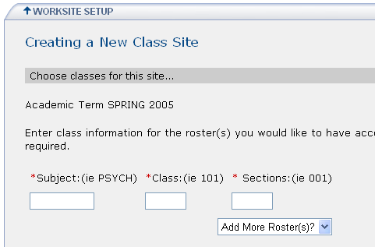
The max number of characters allowed in the Subject, Class,
Sections fields can be controlled by properties

noEmailInIdAccountLabel

noEmailInIdAccountLabel=Username(s)

Specifies the label of the first entry field on the Add Participants page in Worksite Setup and Site Info tools. The first entry field is where provided user account names are entered.
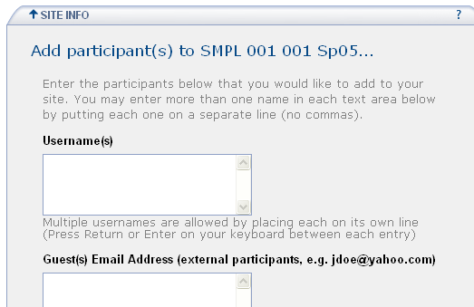

noEmailInIdAccountName

emailInIdAccountName

noEmailInIdAccountName=username
emailInIdAccountName=guest

The text to use when referring to the institution affiliated account and guest account in alert messages and new account notification emails.

When adding a user with the Add Participants page of Site Info, there is a field for two types of user accounts; the institution’s affiliated account (username), and the institution’s guest type account (guest). The names of these types of accounts can be set using noEmailInIdAccountName and emailInIdAccountName. These names are then used in alerts and in the email notification that can optionally be sent to new users when they are added to a site.

For example, the Alert given when Continue is clicked and the entry fields are blank on the Add Participants page mentions username and guest with the default settings of noEmailInIdAccountName and emailInIdAccountName.

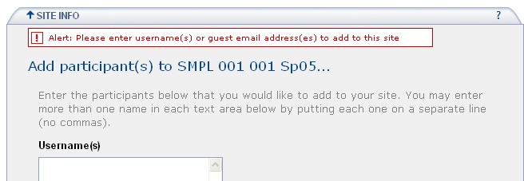
The alert text is contsturcted using noEmailInIdAccountName and
emailInIdAccountName property settings

emailInIdAccountLabel

emailInIdAccountLabel=Guest(s) Email Address (external participants, e.g. jdoe@yahoo.com)

Specifies the label of the second entry field on the Add Participants page in Worksite Setup and Site Info tools. The second entry field is where non-provided user account names are entered.

emailInIdAccountInstru

emailInIdAccountInstru=To log in, you must first get a guest account. A guest account is a special kind of account that is used to give non-Sakai University members access to the general Sakai University web environment. The Sakai University web environment includes many tools and services, one of which is Sakai

When a new guest account is added via the 2nd entry box on the Add Participants page, an email can be sent to the new user notifying them that they have been authorized to login to Sakai (see notifyNewUserEmail). At institutions where there is an external login authority, this message can be used to inform the user that there may be some other account creation needed.

emailInIdAccount

emailInIdAccount.url

The URL where guests go to get an institution’s guest account. The value of this property is used in the email message sent to new users whose account has been created by entering their email address in the 2nd entry box on the Add Participants page. See emailInIdAccount. See also notifyNewUserEmail which controls whether new users get an email when their account has been created via the Add Participant page.

notifyNewUserEmail

notifyNewUserEmail=true

In Sakai, when an external authority is used to grant access, there may be two types of users attempting to gain access. Institutional users are assumed to have authority to enter Sakai and are let in. Guest users, though they may be able to login to the institution’s system, are not automatically assumed to have authority to enter Sakai. A guest account must be authorized to use Sakai.

When Sakai is handed a user who has a valid institutional guest account and has logged in successfully, Sakai has to know whether to let the user in – whether the guest user is authorized to use Sakai.

The authorization is accomplished using a local account in Sakai that corresponds to the institutional account. If a local account exists in Sakai for a guest user, then that guest user gets all the way in and is placed at their My Workspace.

The Sakai account can be created by support using the Admin User tool. But since that takes a support intervention, it’s also possible for site maintainers to authorize guest accounts to use Sakai. This happens automatically when a guest account is entered into the 2nd field on the Add Participants page. If the guest account entered there doesn’t already exist in Sakai, a new user account is created. The Sakai account then exists which matches the institution guest account, and when the user logs into Sakai via the institution’s login mechanism, they get all the way into Sakai.

When an account is created in Sakai, the account has a password. In the scenario above, the Sakai account password isn’t used – it is the guest account/pwd setup with the institution that the guest user signs on with. It is just the account name in Sakai that is used to authorize the guest user. So in that case, the Sakai password is not used, and the user doesn’t need to know it. The notifyNewUserEmail property should be set to false in that case, so the user doesn’t get an email with the (not used) Sakai password in it.

When would you set notifyNewUserEmail=true? For installations where there is no external authorization mechanism (e.g., http://collab.sakaiproject.org), the local Sakai account password is used. The Sakai account/pwd is the only means used to log in to Sakai. If a user is added to a site and doesn’t already have a Sakai account, a new account is created. Setting notifyNewUserEmail=true causes an email to be sent to the new user informing them of their password. Otherwise, they would have a new account and no one would know the password. They couldn’t login without support getting involved and changing their password to some known value, emailing them, etc.

invalidEmailInIdAccountString

invalidEmailInIdAccountString=nowhere.org

Though the guest account must be an email address, it must not contain this string.

For example, at UM, guest accounts must be email addresses, and cannot contain umich.edu (since if they have a umich.edu email address, they must have a UM uniqname and therefore a regular UM account). This is a way of preventing mistakes – site maintainers cannot add a guest account which contains umich.edu because we have invalidEmailInIdAccountString=umich.edu

Sites tool control

sitebrowser.termsearch.type

sitebrowser.termsearch.type=course

In the Sites tool commonly placed on the Gateway site (site.browser), searches for sites can be constrained by a particular semester/term. This property specifies which type of site can be constrained by term when searching.

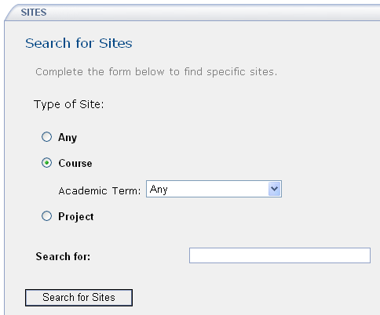
The term constraint shows up for course site types in the
Sites tool when sitebrowser.termsearch.type=course

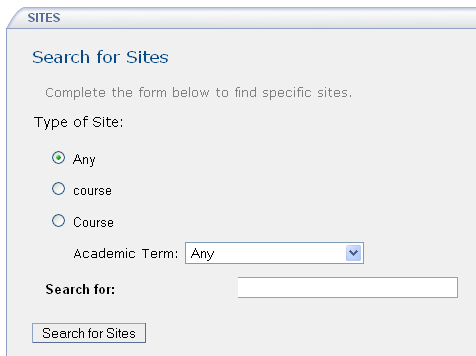

sitebrowser.termsearch.property

sitebrowser.termsearch.property=term

Defines the name of the property that is used to constrain searches on sites of type sitebrowser.termsearch.type when searching using the Sites tool.

sitesearch.noshow.sitetype

sitesearch.noshow.sitetype=

Used to specify the types of sites which shouldn’t be shown as a search option in the Site Browser tool. The default is to not prevent any type from being shown (all types are shown).

At UM, the setting is sitesearch.noshow.sitetype=GradTools as we don’t allow users to search through GradTools sites. If you wanted to keep project sites from showing up as a search option in the Site Browser tool, you could set sitesearch.noshow.sitetype=project. The value matches a site type that exists in your installation.

Email
For details on configuring James see documentation in Confluence in the Sakaipedia. See the Administrator Information section and in particular the postings on Configuring Mail
http://bugs.sakaiproject.org/confluence/display/ENC/Configuring+Mail
and the Sendmail Integration document under Integrating Sakai
http://bugs.sakaiproject.org/confluence/display/ENC/Sendmail+integration

support.email
# contact support email address (contact support tool)

support.email=

If you send email to a site and there is a problem and the email gets bounced, this is the email referenced inside the bounce email reply that gives the user somewhere to email for further help.

For example, at UM the setting is
support.email=ctools-support@request.umich.edu
which results in the following bounce reply email when sending to a non-existent site at UM’s Sakai installation.

The attached message was not delivered.

Error message below:
Your message cannot be delivered because the address is unknown.

If you have further questions about this feature, please email ctools-support@request.umich.edu

Message details:
Subject: testing
Sent date: Wed Nov 02 09:28:37 EST 2005
To: nonexistantsite@ctools.umich.edu
Size (in bytes): 4

mail.support
# email for support (contact support tool only)

#mail.support=

An early version of the Help tool (sakai.contactSupport) included a ‘contact support’ form that emailed the content of the form to the email address set by the mail.support property.

This is not used in the newer Help system.

setup.request
# email address which is used in notification emails for requested site.

setup.request=

When a class site is created, email can be sent to the support organization notifying them of the site creation. When a class site is created by manually entering course information rather than by selecting a class from the list of classes presented to the user, support may need to manually add the provider id. Setting setup.request to the support email address gives support notice that such a site has been created and that there may need to be some manual processing to link the roster to the class site.

smtp.dns.1

smtp.dns.2
# dns addresses used by James for incoming email

smtp.dns.1=
smtp.dns.2=

smtp.port
# SMTP port on which James runs. Default is 25. Recommend running on 8025, and using a standard mailer on 25 to forward mail to Sakai.

smtp.port=

smtp.enabled
# flag to enable or disable James for incoming email (true | false)

smtp.enabled=false

ui.institution

ui.service
# some fill-ins for the css/vm ui (Worksite Setup, Digest Service, Email notification, Worksite Setup, Contact Support, Portal)

ui.institution=Sakai Using Institution
ui.service=Sakai Based Service

The institution name and Sakai installation name (e.g. for UM, CTools). These values are used in various places in the UI and in messages sent from Sakai.

force.url.secure
# force all URLs out of Sakai back to Sakai to be secure, i.e. to use https, on this port. Leave out to respond with the same transport as the request.
# Otherwise, the URLs will reflect the attributes of the request URL. (443 | 8443 | or any other port) [defaults to missing]

#force.url.secure=443

News Tool

news.title

news.feedURL
# default title and feed URL for the news tool

news.title = Sakai News
news.feedURL =http://www.sakaiproject.org/cms/index2.php?option=
com_rss&amp;feed=RSS2.0&amp;no_html=1

When the News tool is added to a site, it is added with a default News feed URL.

Membership tool

disable.membership.unjoin.selection
#Disable the unjoin link in membership tool

disable.membership.unjoin.selection=

Before 2.1, a site that is not joinable could be unjoined with the Membership tool. The availability of unjoin for such sites caused problems to users who unjoined by mistake as they couldn’t rejoin.

However, there is also the desire to allow someone to unjoin a project site they might have been added to which they don’t want to belong.

The disable.membership.unjoin.selection= property allows institutions to set their own policy. If set to true, then users cannot unjoin sites (the unjoin action is not shown in the Membership tool). If set to false, users can unjoin sites.

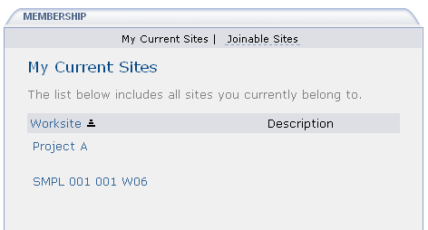
disable.membership.unjoin.selection=true
The ‘unjoin’ action is not shown under site names

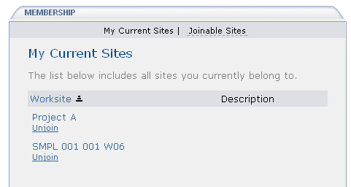
disable.membership.unjoin.selection=false
The ‘unjoin’ action is shown under site names

Automatic User Adds – ‘Affiliates’

affiliatesubjects.count

affiliatesubjects.n
# course affiliates

affiliatesubjects.count=
affiliatesubjects.1=

Until hierarchy comes to Sakai, using the affiliatesubjects.count and related properties is a way to automatically add certain users to sites with certain subject codes. This is useful if you have support personnel in the field at the unit level. All subject codes for that unit can be specified along with the user accounts that should be added to the site whenever a class site is created that contains one of the subject codes.

For example, if the College of Pharmacy has the subject codes of INTERHUM, INTERNS, and INTERSS, the following would define the subject codes which, if present in a provider id for a class site, would cause associated user accounts to be added to the site.

# course affiliates
affiliatesubjects.count=1
affiliatesubjects.1=INTERHUM,INTERNS,INTERSS

Which accounts get added are specified with the affiliateuniqnames properties.

Affiliates are added during the class site creation process if the site is created ‘automatically’. When a class site is created, if the creator is the instructor of record, they can pick the class from a list of their classes presented. In that case, since the list comes from the Registrar, they are known to be authorized to see the roster, and the provider id can be automatically attached to the site. At that point, affiliates are added as participants, with the Affiliate role.

If the class site creator isn’t the instructor of record, the class does not show up in their class list, and they must enter the class info manually. Support will vet the request, and if valid (creator has the right to create the class site and see the roster), support will add the provider id (using the Admin Realm tool). At that point, when the provider id is added manually, support must add affiliates manually to the site as participants with the Affiliate role.

Note: Another mechanism is being tested at UM in CTools, whereby affiliates are added via the provider id watcher. The watcher notices whenever a provider id changes (either via Worksite Setup or the Admin Realm tool). This insures Affiliates are added when support personnel add the provider id for a manually created class site. Check the CTools branch if you are interested in this code.

Institutions using the affiliate add mechanisms should also insure that the Affiliate role exists in the !site.template and/or !site.template.course realms.

The affiliatesubjects.count value should match the number of years specified by affiliatesubjects.n entries.

See appendix B for examples when there are more than one affiliatesubjects.n property.

affiliatecampus.count

affiliatecampus.n

affiliatecampus.count=
affiliatecampus.1=

Used to specify a particular campus for an affiliate. The affiliatecampus.count property specifies the number of affiliatecampus values.

For example, at UM, the College of Pharmacy is on the Ann Arbor campus (designated as ‘A’), and we would use the following to go along with the affiliatesubject property example used above.

affiliatecampus.count=1
affiliatecampus.1=A

The affiliatecampus.count value should match the number of years specified by affiliatecampus.n entries.

See appendix B for examples when there are more than one affiliatecampus.n property.

affiliateuniqnames.count

affiliateuniqnames.n

affiliateuniqnames.count=
affiliateuniqnames.1=

affiliateuniqnames.n specifies the user account names that will be added when class sites with the subject codes specified in affiliatesubjects.n on the campus affiliatecampus.n are created.

For example, the settings below insure the accounts peterwolf and abester are added to class sites created on the Ann Arbor campus with subject codes of INTERHUM, INTERNS, or INTERSS given the property settings shown in the examples for affiliateuniqnames and affiliatesubjects.

affiliateuniqnames.count=1
affiliateuniqnames.1=petewolf, abester

The affiliateuniqnames.count value should match the number of years specified by affiliateuniqnames.n entries.

See appendix B for examples when there are more than one affiliateuniqnames.n property.

GradTools
The GradTool is not currently used at many institutions other than UM. Values are included for completeness.

withDissertation

withDissertation=

Specifies whether GradTools shows up as a site type option when creating sites in Worksite Setup. When set to true, a user creating a site will see class, project, and dissertation as options when creating a site. However, they well only see dissertation as an option if they are in the PhD program at the institution, and have not yet created their GradTools site.

gradToolsSiteType.count

gradToolsSiteType.n
# gradtools site types

gradToolsSiteType.count=
gradToolsSiteType.1=

Specifies the types of sites used by GradTools. For example, at UM, we have

gradToolsSiteType.count=3
gradToolsSiteType.1=GradToolsStudent
gradToolsSiteType.2=GradToolsRackham
gradToolsSiteType.3=GradToolsDepartment

The gradToolsSiteType.count value should match the number of years specified by gradToolsSiteType.n entries.

No longer used

java.beep

email-for-user-id

login.icon

Appendix A
Sakai 2.1 sakai.properties listing

# sakai.properties - the default edition
# This file is the default for providing all configuration and placeholder values for Sakai.
# All other sakai.properties files override these settings

# set the hibernate dialect (for shared datasource), HSQLDB by default, mySql and Oracle examples
hibernate.dialect=net.sf.hibernate.dialect.HSQLDialect
#hibernate.dialect=net.sf.hibernate.dialect.MySQLDialect
#hibernate.dialect=net.sf.hibernate.dialect.Oracle9Dialect

# establish auto.ddl - on by default
auto.ddl=true
#auto.ddl=false

# set the default transaction isolation level
# Up to and including 1.7.1, HSQLDB supports only Connection.TRANSACTION_READ_UNCOMMITTED.
# MySQL and Oracle MUST use Connection.TRANSACTION_READ_COMMITTED.
jdbc.defaultTransactionIsolation=java.sql.Connection.TRANSACTION_READ_UNCOMMITTED
#jdbc.defaultTransactionIsolation=java.sql.Connection.TRANSACTION_READ_COMMITTED

# Note: the folowing used to be in the legacy-components components.xml file, but are now here, and can be used as placeholders if desired

# identify your application server with a short name, unique among the servers in your cluster.
# choose a server id even if you are running a single app server
#serverId=localhost

# the URL to the server, including transport, DNS name, and port, if any
serverUrl=http://localhost:8080

# the DNS name of the server
serverName=localhost

# gateway site id
gatewaySiteId=!gateway

# the URL to send folks to after they logout
loggedOutUrl=/portal

accessPath=/access
portalPath=/portal
helpPath=/help

# to include the user id and password for login on the gateway site
top.login=true

# to let the container handle login or not (set to true for single-signon type setups, false for just internal login)
container.login=false

# to enable some beeping in the user interfaces
java.beep=false

# strings for the portal pages
bottom.copyrighttext=(c) 2003, 2004, 2005 sakaiproject.org. All rights reserved.

version.service=TRUNK
version.sakai=TRUNK

# locations of resources to display for server, myworkspace, and unconfigured web content
server.info.url=/library/content/server_info.html
myworkspace.info.url=/library/content/myworkspace_info.html
webcontent.instructions.url=/library/content/webcontent_instructions.html
webdav.instructions.url=/library/content/webdav_instructions.html

# to enable presence display in the portal
display.users.present=true

# The default skin for sites without a skin setting
skin.default=default

# the path to the skin files
skin.repo=/library/skin

# upload limit per request, in megs
content.upload.max=20

# the copyright options for the resources tool
copyrighttype.count=6
copyrighttype.1=Material is in public domain.
copyrighttype.2=I hold copyright.
copyrighttype.3=Material is subject to fair use exception.
copyrighttype.4=I have obtained permission to use this material.
copyrighttype.5=Copyright status is not yet determined.
copyrighttype.6=Use copyright below.
copyrighttype.own=I hold copyright.
copyrighttype.new=Use copyright below.
default.copyright=I hold copyright.
default.copyright.alert=true
fairuse.url=http://fairuse.stanford.edu
newcopyrightinput=true

# worksite setup - enable the ability to control a participant's activation in a site
activeInactiveUser=true

# course management information
termterm.count=17
termterm.1=FALL
termterm.2=WINTER
termterm.3=SPRING
termterm.4=SPRING_SUMMER
termterm.5=SUMMER
termterm.6=FALL
termterm.7=WINTER
termterm.8=SPRING
termterm.9=SPRING_SUMMER
termterm.10=SUMMER
termterm.11=FALL
termterm.12=WINTER
termterm.13=SPRING
termterm.14=SPRING_SUMMER
termterm.15=SUMMER
termterm.16=FALL
termterm.17=WINTER

termyear.count=17
termyear.1=2003
termyear.2=2004
termyear.3=2004
termyear.4=2004
termyear.5=2004
termyear.6=2004
termyear.7=2005
termyear.8=2005
termyear.9=2005
termyear.10=2005
termyear.11=2005
termyear.12=2006
termyear.13=2006
termyear.14=2006
termyear.15=2006
termyear.16=2006
termyear.17=2007

termlistabbr.count=17
termlistabbr.1=F03
termlistabbr.2=W04
termlistabbr.3=Sp04
termlistabbr.4=SpSu04
termlistabbr.5=Su04
termlistabbr.6=F04
termlistabbr.7=W05
termlistabbr.8=Sp05
termlistabbr.9=SpSu05
termlistabbr.10=Su05
termlistabbr.11=F05
termlistabbr.12=W06
termlistabbr.13=Sp06
termlistabbr.14=SpSu06
termlistabbr.15=Su06
termlistabbr.16=F06
termlistabbr.17=W07

termiscurrent.count=17
termiscurrent.1=false
termiscurrent.2=false
termiscurrent.3=false
termiscurrent.4=false
termiscurrent.5=false
termiscurrent.6=false
termiscurrent.7=false
termiscurrent.8=false
termiscurrent.9=false
termiscurrent.10=false
termiscurrent.11=false
termiscurrent.12=true
termiscurrent.13=false
termiscurrent.14=false
termiscurrent.15=false
termiscurrent.16=false
termiscurrent.17=false

termstarttime.count=17
termstarttime.1=20030901000000000
termstarttime.2=20040101000000000
termstarttime.3=20040501000000000
termstarttime.4=20040515000000000
termstarttime.5=20040801000000000
termstarttime.6=20040901000000000
termstarttime.7=20050101000000000
termstarttime.8=20050501000000000
termstarttime.9=20050515000000000
termstarttime.10=20050801000000000
termstarttime.11=20050901000000000
termstarttime.12=20060101000000000
termstarttime.13=20060501000000000
termstarttime.14=20060515000000000
termstarttime.15=20060801000000000
termstarttime.16=20060901000000000
termstarttime.17=20070101000000000

termendtime.count=17
termendtime.1=20031201000000000
termendtime.2=20040501000000000
termendtime.3=20040801000000000
termendtime.4=20040801000000000
termendtime.5=20040901000000000
termendtime.6=20041201000000000
termendtime.7=20050501000000000
termendtime.8=20050801000000000
termendtime.9=20050801000000000
termendtime.10=20050901000000000
termendtime.11=20051201000000000
termendtime.12=20060501000000000
termendtime.13=20060801000000000
termendtime.14=20060801000000000
termendtime.15=20060901000000000
termendtime.16=20061201000000000
termendtime.17=20070501000000000

subjectsize=8
coursesize=3
sectionsize=3

# for worksite setup, which offers a list of Appearance (Icon) choices (course sites only)
iconNames.count=3
iconNames.1=humanities
iconNames.2=engineering
iconNames.3=pig

iconUrls.count=3
iconUrls.1=/library/icon/humanities.gif
iconUrls.2=/library/icon/engineering.gif
iconUrls.3=/library/icon/pig.gif

iconSkins.count=3
iconSkins.1=
iconSkins.2=
iconSkins.3=examp-u

# ???
noEmailInIdAccountName=username
noEmailInIdAccountLabel=Username(s)

emailInIdAccountName=guest
emailInIdAccountLabel=Guest(s) Email Address (external participants, e.g. jdoe@yahoo.com)
emailInIdAccountInstru=To log in, you must first get a guest account. A guest account is a special kind of account that is used to give non-Sakai University members access to the general Sakai University web environment. The Sakai University web environment includes many tools and services, one of which is Sakai.

# for worksite setup... ???
titleEditableSiteType.count=1
titleEditableSiteType.1=project

roster.available.weeks.before.term.start=4

courseSiteType=course

editViewRosterSiteType.count=1
editViewRosterSiteType.1=project

sitebrowser.termsearch.type=course
sitebrowser.termsearch.property=term
sitesearch.noshow.sitetype=

# email support address used in incoming email rejection messages
#mail.support=

# dns addresses used by James for incoming email
#smtp.dns.1=
#smtp.dns.2=

# SMTP port on which James runs. Default is 25. Recommend running on 8025, and using a standard mailer on 25 to forward mail to Sakai.
#smtp.port=

# flag to enable or disable James for incoming email (true | false)
smtp.enabled=false

# powered by config for the bottom of the portal
powered.url.count=1
powered.url.1=http://sakaiproject.org
powered.img.count=1
powered.img.1=/library/image/sakai_powered.gif
powered.alt.count=1
powered.alt.1=Powered by Sakai

# send an email to the user when the user is added
notifyNewUserEmail=true

# some fill-ins for the css/vm ui (Worksite Setup, Digest Service, Email notification, Worksite Setup, Contact Support, Portal)
ui.institution=Sakai Using Institution
ui.service=Sakai Based Service

# force all URLs out of Sakai back to Sakai to be secure, i.e. to use https, on this port. Leave out to respond with the same transport as the request.
# Otherwise, the URLs will reflect the attributes of the request URL. (443 | 8443 | or any other port) [defaults to missing]
#force.url.secure=443

# default title and feed URL for the news tool
news.title = Sakai News
news.feedURL = http://www.sakaiproject.org/cms/index2.php?option=com_rss&amp;feed=RSS2.0&amp;no_html=1

# indicates whether users should see "Show Other Sites" twiggle in list mode of resources tool
resources.show_all_collections.tool=true
# indicates whether users should see "Show Other Sites" twiggle in list mode of dropbox tool
resources.show_all_collections.dropbox=false
# indicates whether users should see "Show Other Sites" twiggle in list mode of file picker
resources.show_all_collections.helper=true

# Indicates whether or not we allow web-service logins
webservices.allowlogin=true

# Indicates the shared secret between the Sakai JSR-168 Portlet and this instance of Sakai
webservice.portalsecret=plugh-xyzzy

# whether to suppport group in Worksite Setup tool. Default to be true
wsetup.group.support=true

Appendix B
University of Michigan CTools sakai.properties listing

# sakai.properties - the CTools edition

# the URL to the server, including transport, DNS name, and port, if any
serverUrl=https://ctools.umich.edu

# the DNS name of the server
serverName=ctools.umich.edu

loggedOutUrl=https://weblogin.umich.edu/cgi-bin/logout?https://ctools.umich.edu/portal

# default to the ctools skin in our lib
skin.default=ctools
skin.repo=/ctlib/skin

# use oracle
vendor@org.sakaiproject.service.framework.sql.SqlService=oracle
driverClassName@javax.sql.BaseDataSource=oracle.jdbc.driver.OracleDriver
url@javax.sql.BaseDataSource=${ctools.oracle.driver}
username@javax.sql.BaseDataSource=${ctools.oracle.user}
password@javax.sql.BaseDataSource=${ctools.oracle.password}
validationQuery@javax.sql.BaseDataSource=select 1 from DUAL

# we like presence
display.users.present=true

# umiac info
umiac.address = localhost
umiac.port = 8888

# smtp server for outgoing emails - overrides that configured in the email service
smtp@org.sakaiproject.service.framework.email.EmailService=mail-relay.itd.umich.edu

# email for support (contact support tool only) - used in rejected incoming email messages
mail.support = ctools-support@request.umich.edu

# dns addresses used by James for incoming email
smtp.dns.1 = 141.211.203.32
smtp.dns.2 = 141.211.144.17

# SMTP port on which James runs
smtp.port = 8025

# flag to enable or disable James for incoming email (true | false)
smtp.enabled = true

# worksite setup requests email from address
setup.request = ctools@umich.edu

# contact support email address (contact support tool)
support.email=ctools-support@request.umich.edu

# upload limit per request, in megs
content.upload.max=20

# links placed on the bottom nav - .count of them
bottomnav.count = 5
bottomnav.1 = <a href="https://ctools.umich.edu/portal/site/!gateway">CTools Gateway</a>
bottomnav.2 = <a href="mailto:ctools@umich.edu">Contact Us</a>
bottomnav.3 = <a href="http://www.dc.umich.edu/" target="_blank">Duderstadt Center</a>
bottomnav.4 = <a href="http://www.umich.edu/" target="_blank">University of Michigan</a>
bottomnav.5 = <a href="http://sakaiproject.org" target="_blank">The Sakai Project</a>

# some fill-ins for the css/vm ui (Worksite Setup, Digest Service, Email notification, Worksite Setup, Contact Support, Portal)
ui.institution = University of Michigan
#ui.institution.url = http://www.umich.edu/
ui.service = CTools

# versions displayed on the portal footer
version.service = [r??]

# # minutes to cache each security question in the SecurityService - set to 0 to disable caching.
cacheMinutes@org.sakaiproject.service.legacy.security.SecurityService = 3

# sessions expire if nothing happens in this many seconds (1 hour)
inactiveInterval@org.sakaiproject.api.kernel.session.SessionManager=3600

# presence expires if not refreshed in this many seconds
timeoutSeconds@org.sakaiproject.service.legacy.presence.PresenceService=60

# root of archive file system area
storagePath@org.sakaiproject.service.legacy.archive.ArchiveService = /afs/umich.edu/group/ct/ctxml/

# the file system root for content hosting's external stored files (default is null, i.e. store them in the db)
bodyPath@org.sakaiproject.service.legacy.content.ContentHostingService = /afs/umich.edu/group/ctfs

# when storing content hosting's body bits in files, an optional set of folders just within the content.filesystem.root
# to act as volumes to distribute the files among - a comma separate list of folders. If left out, no volumes will be used.
bodyVolumes@org.sakaiproject.service.legacy.content.ContentHostingService = fs1,fs2,fs3,fs4,fs5,fs6,fs7,fs8,fs9,fs10,fs11,fs12,fs13,fs14,fs15,fs16,fs17,fs18,fs19,fs20,fs21,fs22,fs23,fs24,fs25,fs26,fs27,fs28,fs29,fs30,fs31,fs32,fs33,fs34,fs35,fs36,fs37,fs38,fs39,fs40,fs41,fs42,fs43,fs44,fs45,fs46,fs47,fs48,fs49,fs50,fs51,fs52,fs53,fs54,fs55,fs56,fs57,fs58,fs59,fs60,fs61,fs62,fs63,fs64,fs65,fs66,fs67,fs68,fs69,fs70,fs71,fs72,fs73,fs74,fs75,fs76,fs77,fs78,fs79,fs80,fs81,fs82,fs83,fs84,fs85,fs86,fs87,fs88,fs89,fs90,fs91,fs92,fs93,fs94,fs95,fs96,fs97,fs98,fs99

# course affiliates (Worksite Setup)
affiliatesubjects.count=22
affiliatesubjects.1=HISTART
affiliatesubjects.2=ACC,BA,BE,BIT,CSIB,ES,EMBA,FIN,LHC,MKT,OMS,OM,OB,PC,RE,SMS,MO
affiliatesubjects.3=AEROSP,AMCULT,ARTDES,AOSS,AUTO,BIOMEDE,CHE,CEE,EECS,ENGR,ENSCEN,MFG,MATSCIE,MATH,MECHENG,MUSICOL,NRE,NAVARCH,NERS,PHRMACOL,STATS,TCHNCLCM,THEORY,VOICELIT
affiliatesubjects.4=ARCH,UD,UP
affiliatesubjects.5=BIOSTAT,EHS,EPID,HBEHED,HMP
affiliatesubjects.6=AG,CHLDY,CSS,COMORG,DOC,EVAL,HLTH,HB,INTP,MHS,MHLTH,P&E,RES,SWPS,SOCWK,SPEC,UNDG
affiliatesubjects.7=MEDCHEM,PHARMACY,PHARMCHM,PHARMCOG,PHARMSCI,SOCADMIN
affiliatesubjects.8=LAW
affiliatesubjects.9=NURS
affiliatesubjects.10=PHYSICS
affiliatesubjects.11=FILMVID
affiliatesubjects.12=MEDADM
affiliatesubjects.13=PUBPOL
affiliatesubjects.14=IOE
affiliatesubjects.15=MOVESCI
affiliatesubjects.16=AT,PHYSED,SPTMGMTC,KINESLGY
affiliatesubjects.17=INTERHUM,INTERNS,INTERSS
affiliatesubjects.18=ELI
affiliatesubjects.19=JUDIAC
affiliatesubjects.20=BIOLOGY,EEB
affiliatesubjects.21=CLARCH,CLCIV,CLLING,GREEK,GTBOOKS,LATIN,MODGREEK
affiliatesubjects.22=AAAS,AAST,ACC,AENG,AMST,ANTH,ARBC,ART,ARTH,BA,BCHM,BE,BI,BIOL,BPS,CCM,CHEM,CIS,COML,COMM,COMP,CRJ,DS,ECE,ECON,EDA,EDB,EDC,EDD,EDF,EDK,EDMA,EDN,EDT,EMGT,ENGL,ENGR,ENST,ENT,ESCI,EXPS,FILM,FIN,FREN,GEOG,GEOL,GER,HIST,HPS,HRM,HUM,IMSE,LAT,LE,LIBR,LIBS,LING,MAPP,MATH,MCL,ME,MHIS,MICR,MILS,MIS,MKT,NSCI,OB,OM,PADM,PHIL,PHYS,POL,PPOL,PSYC,RELS,SOC,SPAN,SPEE,STAT,STS,WST

affiliatecampus.count=22
affiliatecampus.1=A
affiliatecampus.2=A
affiliatecampus.3=A
affiliatecampus.4=A
affiliatecampus.5=A
affiliatecampus.6=A
affiliatecampus.7=A
affiliatecampus.8=A
affiliatecampus.9=A
affiliatecampus.10=A
affiliatecampus.11=A
affiliatecampus.12=A
affiliatecampus.13=A
affiliatecampus.14=A
affiliatecampus.15=A
affiliatecampus.16=A
affiliatecampus.17=A
affiliatecampus.18=A
affiliatecampus.19=A
affiliatecampus.20=A
affiliatecampus.21=A
affiliatecampus.22=D

affiliateuniqnames.count=22
affiliateuniqnames.1=hamedia_UM@hotmail.com
affiliateuniqnames.2=debiec,jcaracc,tle,jamm
affiliateuniqnames.3=aaelreserves@hotmail.com
affiliateuniqnames.4=karbogas,aaelreserves@hotmail.com
affiliateuniqnames.5=dhunsche,pattyb
affiliateuniqnames.6=cherdt
affiliateuniqnames.7=tjasin,dcamper,chatlang,johnpj,lphaneuf
affiliateuniqnames.8=shawndel,bgenoa
affiliateuniqnames.9=cjtaylor,gmoney,antoniom,jimcb,craftd,degroote,espring
affiliateuniqnames.10=dxp
affiliateuniqnames.11=ejarque
affiliateuniqnames.12=sjweir
affiliateuniqnames.13=nbrack
affiliateuniqnames.14=frtlss,aaelreserves@hotmail.com
affiliateuniqnames.15=bralph,jeanhunt,aaelreserves@hotmail.com
affiliateuniqnames.16=bralph,jeanhunt
affiliateuniqnames.17=karbogas
affiliateuniqnames.18=derdody
affiliateuniqnames.19=mmahler,cheript
affiliateuniqnames.20=cpsujek
affiliateuniqnames.21=jawllms
affiliateuniqnames.22=clandrum

# icons for units
iconNames.count=22
iconNames.1=CTools default
iconNames.2=College of Architecture and Urban Planning
iconNames.3=School of Art and Design
iconNames.4=Business School
iconNames.5=School of Dentistry
iconNames.6=School of Education
iconNames.7=College of Engineering
iconNames.8=School of Information
iconNames.9=Division of Kinesiology
iconNames.10=Law School
iconNames.11=LS&A
iconNames.12=Medical School
iconNames.13=School of Music
iconNames.14=School of Natural Resources and Environment
iconNames.15=School of Nursing
iconNames.16=Officer Education Programs
iconNames.17=College of Pharmacy
iconNames.18=School of Public Health
iconNames.19=School of Public Policy
iconNames.20=Rackham School of Graduate Studies
iconNames.21=School of Social Work
iconNames.22=UM Dearborn

iconUrls.count=22
iconUrls.1=/ctlib/icon/ctng.gif
iconUrls.2=/ctlib/icon/arc.gif
iconUrls.3=/ctlib/icon/art.gif
iconUrls.4=/ctlib/icon/bus.gif
iconUrls.5=/ctlib/icon/den.gif
iconUrls.6=/ctlib/icon/edu.gif
iconUrls.7=/ctlib/icon/eng.gif
iconUrls.8=/ctlib/icon/inf.gif
iconUrls.9=/ctlib/icon/kin.gif
iconUrls.10=/ctlib/icon/law.gif
iconUrls.11=/ctlib/icon/lsa.gif
iconUrls.12=/ctlib/icon/med.jpg
iconUrls.13=/ctlib/icon/mus.gif
iconUrls.14=/ctlib/icon/nre.gif
iconUrls.15=/ctlib/icon/nur.gif
iconUrls.16=/ctlib/icon/off.gif
iconUrls.17=/ctlib/icon/pha.gif
iconUrls.18=/ctlib/icon/sph.gif
iconUrls.19=/ctlib/icon/spp.gif
iconUrls.20=/ctlib/icon/rac.gif
iconUrls.21=/ctlib/icon/ssw.gif
iconUrls.22=/ctlib/icon/umd.gif

iconSkins.count=22
iconSkins.1=
iconSkins.2=
iconSkins.3=
iconSkins.4=
iconSkins.5=
iconSkins.6=
iconSkins.7=
iconSkins.8=
iconSkins.9=
iconSkins.10=
iconSkins.11=
iconSkins.12=med
iconSkins.13=
iconSkins.14=
iconSkins.15=
iconSkins.16=
iconSkins.17=
iconSkins.18=
iconSkins.19=
iconSkins.20=
iconSkins.21=
iconSkins.22=

#copyright text to appear in the bottom area of each web page.
bottom.copyrighttext=Copyright &copy; 2003 - 2005, the Regents of The University of Michigan

#SiteSearch no-show site types in siteBrowser and SiteManage tools
sitesearch.noshow.sitetype=GradTools

#check for friend account
noEmailInIdAccountName=uniqname
noEmailInIdAccountLabel=Uniqname(s)
emailInIdAccountName=friend
emailInIdAccountLabel=Friend(s) Email Address (external participants, e.g. jdoe@yahoo.com)
invalidEmailInIdAccountString=umich.edu
emailInIdAccount.url=https://weblogin.umich.edu/friend/

# no login up top
top.login=false

# do let the container handle login
container.login = true

# enble GradTools integration in worksite setup
withDissertation = true

# we want custom content for help
help.location = http://www.umich.edu/~umctdocs/

activeInactiveUser = false

# disable from worksite setup the "import file" option
site.setup.import.file = false

# gradtools site types
gradToolsSiteType.count=3
gradToolsSiteType.1=GradToolsStudent
gradToolsSiteType.2=GradToolsRackham
gradToolsSiteType.3=GradToolsDepartment

# don't send an password notification email to the friend user when the user is added
notifyNewUserEmail=false

# course management information
termterm.count=12
termterm.1=FALL
termterm.2=WINTER
termterm.3=SPRING
termterm.4=SPRING_SUMMER
termterm.5=SUMMER
termterm.6=FALL
termterm.7=WINTER
termterm.8=SPRING
termterm.9=SPRING_SUMMER
termterm.10=SUMMER
termterm.11=FALL
termterm.12=WINTER

termyear.count=12
termyear.1=2003
termyear.2=2004
termyear.3=2004
termyear.4=2004
termyear.5=2004
termyear.6=2004
termyear.7=2005
termyear.8=2005
termyear.9=2005
termyear.10=2005
termyear.11=2005
termyear.12=2006

termlistabbr.count=12
termlistabbr.1=F03
termlistabbr.2=W04
termlistabbr.3=Sp04
termlistabbr.4=SpSu04
termlistabbr.5=Su04
termlistabbr.6=F04
termlistabbr.7=W05
termlistabbr.8=Sp05
termlistabbr.9=SpSu05
termlistabbr.10=Su05
termlistabbr.11=F05
termlistabbr.12=W06

termiscurrent.count=12
termiscurrent.1=false
termiscurrent.2=false
termiscurrent.3=false
termiscurrent.4=false
termiscurrent.5=false
termiscurrent.6=false
termiscurrent.7=false
termiscurrent.8=false
termiscurrent.9=false
termiscurrent.10=false
termiscurrent.11=true
termiscurrent.12=false

termstarttime.count=12
termstarttime.1=20030901000000000
termstarttime.2=20040101000000000
termstarttime.3=20040501000000000
termstarttime.4=20040515000000000
termstarttime.5=20040801000000000
termstarttime.6=20040901000000000
termstarttime.7=20050101000000000
termstarttime.8=20050501000000000
termstarttime.9=20050515000000000
termstarttime.10=20050801000000000
termstarttime.11=20050901000000000
termstarttime.12=20060101000000000

termendtime.count=12
termendtime.1=20031201000000000
termendtime.2=20040501000000000
termendtime.3=20040801000000000
termendtime.4=20040801000000000
termendtime.5=20040801000000000
termendtime.6=20041201000000000
termendtime.7=20050501000000000
termendtime.8=20050801000000000
termendtime.9=20050801000000000
termendtime.10=20050801000000000
termendtime.11=20051201000000000
termendtime.12=20060501000000000

roster.available.weeks.before.term.start=8

#Title and feed URL for news tool
news.title = UM News
news.feedURL = http://www.umich.edu/news/news.xml

# run the cluster service's maintenance "ghost busting" and cleanup only 10% of each pass (from each app server in the cluster)
ghostingPercent@org.sakaiproject.service.framework.cluster.ClusterService=10

# run the cluster service's app server checkin (to show it's still alive) at once every 10 minutes (default is 1 minute)
refresh@org.sakaiproject.service.framework.cluster.ClusterService=600

# and give us 30 minutes to consider it lost
expired@org.sakaiproject.service.framework.cluster.ClusterService=1800

# wait 5 seconds (not the default 2) for checks to the db for new events from elsewhere in the cluster
period@org.sakaiproject.service.legacy.event.EventTrackingService=5

# minutes to cache each user access in the UserDirectoryService - set to 0 to disable caching.
cacheMinutes@org.sakaiproject.service.legacy.user.UserDirectoryService = 5
cacheCleanerMinutes@org.sakaiproject.service.legacy.user.UserDirectoryService = 5

# minutes to cache each site (site, page, tool) access in the SiteService - set to 0 to disable caching.
cacheMinutes@org.sakaiproject.service.legacy.site.SiteService = 5
cacheCleanerMinutes@org.sakaiproject.service.legacy.site.SiteService = 5

# the copyright options for the resources tool
copyrighttype.count=6
copyrighttype.1=Material is in public domain.
copyrighttype.2=I hold copyright.
copyrighttype.3=Material is subject to fair use exception.
copyrighttype.4=I have obtained permission to use this material.
copyrighttype.5=Copyright status is not yet determined.
copyrighttype.6=Use copyright below.
copyrighttype.own=I hold copyright.
copyrighttype.new=Use copyright below.
default.copyright=I hold copyright.
default.copyright.alert=false
fairuse.url=http://fairuse.stanford.edu
newcopyrightinput=true

Index

accessibility.url, 18
accessPath, 7
activeInactiveUser, 25
affiliatecampus.count, 43
affiliatecampus.n, 43
affiliatesubjects.count, 42
affiliatesubjects.n, 42
affiliateuniqnames, 44
affiliateuniqnames.count, 44
auto.ddl, 5
bottom.copyrighttext, 11
bottomnav.count, 9
bottomnav.n, 9
container.login, 8
content.upload.max, 18
copyrighttype, 19
copyrighttype.new, 21
copyrighttype.own, 20
courseSiteType, 28
coursesize, 32
default.copyright, 20
default.copyright.alert, 21
disable.course.site.skin.selection, 16
disable.membership.unjoin.selection, 41
display.users.present, 13
email-for-user-id, 45
emailInIdAccount, 35
emailInIdAccountInstru, 35
emailInIdAccountLabel, 34
emailInIdAccountName, 34
fairuse.url, 22
force.url.secure, 40
gatewaySiteId, 6
gradToolsSiteType.count, 45
gradToolsSiteType.n, 45
helpPath, 7
hibernate.dialect, 5
iconNames.count, 14
iconNames.n, 14
iconSkins, 16
iconUrls, 15
invalidEmailInIdAccountString, 37
java.beep, 45
jdbc.defaultTransactionIsolation, 5
loggedOutUrl, 7
login.icon, 45
logout.icon, 17
mail.support, 39
myworkspace.info.url, 12
newcopyrightinput, 22
news.feedURL, 41
news.title, 41
noEmailInIdAccountLabel, 33
noEmailInIdAccountName, 34
notifyNewUserEmail, 36
portalPath, 7
powered.alt, 10
powered.img, 10
powered.url, 10
resources.show_all_collections.dropbox, 23
resources.show_all_collections.helper, 24
resources.show_all_collections.tool, 23
roster.available.weeks.before.term.start, 28
sectionsize, 32
server.info.url, 12
serverId, 5
serverName, 6
serverUrl, 6
setup.request, 39
site.setup.import.file, 26
sitebrowser.termsearch.property, 38
sitebrowser.termsearch.type, 37
sitesearch.noshow.sitetype, 38
skin.default, 14
skin.repo, 14
smtp.dns.1, 40
smtp.dns.2, 40
smtp.enabled, 40
smtp.port, 40
subjectsize, 32
support.email, 39
termendtime, 32
termiscurrent, 31
termlistabbr, 31
termstarttime, 32
termterm, 29
termyear, 30
titleEditableSiteType, 27
top.login, 7
ui.institution, 40
ui.service, 40
version.sakai, 11
version.service, 11
webcontent.instructions.url, 13
withDissertation, 44
wsetup.group.support, 26
xlogin.enabled, 8
xlogin.icon, 9
xlogin.text, 8

How to Configure Sakai is in the Sakai Development worksite Resources on http://collab.sakaiproject.org at http://collab.sakaiproject.org/access/content/group/1097928811887-22636/Architecture%20Docs/Sakai%202/sakai_config.pdf Also see Sakai 2.0 Configuration information http://bugs.sakaiproject.org/confluence/display/ENC/Sakai+2.0+Configuration in the Confluence Sakaipedia at http://bugs.sakaiproject.org/confluence

