 | Changing the Appearance of the Sakai 2.1 Tools

Background 2
How it works 2
Getting started 2
The Tool 3
The Elements 3
List Elements 4
Item Elements 5
Form Elements 6
Assorted Elements 7
Standard elements 7
Fieldset, legend 7
Textarea 7
Input 7
A, a pseudo classes 7
Named elements:layout 7
div.leftNav (left Navigator) 7
p.breadCrumb 7
.abc 7
Named elements:messages 7
p.step 7
p.validation 7
p.success 7
p.information 7
p.alert 7
span.inlineAlert 7
Assorted elements 7
p.discTria 7
.skip 7
table.calendar 8
Appendix A– Helpful Links 8
Appendix B – Index 8
Appendix C – Post 2.0 changes 8
2.0.1 9
Appendix D –2.1 changes 9
Renaming and consolidating selectors 9
Rationalizing calendar 9
New classes for complex tables 10
Accessibility enhancements 10
Links 11
Tool sizing 11
Resources 12
New widgets 12

Background

A tool will be produced via many different mechanisms. The actual markup in the response will conform with the Sakai Style Guide, and the most important components of the UI that are of interest in a skinning situation are addressable via the CSS.

For skinning framework outline, and suggestions on how to work to customize skins in general, please see the Skinning the Sakai 2.1 Portal document.

Note 2.00 > 2.01: If you have a tool skin based on 2.0 changes will be indicated in the text below, as well as addressed generally in Appendix C

Note 2.01 > 2. 1: If you have a tool skin based on 2.0 or 2.01 changes will be indicated in the text below, as well as addressed generally in Appendix D

How it works

The tool links to two css files:

<link href="/library/skin/tool_base.css" type="text/css" rel="stylesheet" media="all" />
<link href="/library/skin/default/tool.css" type="text/css" rel="stylesheet" media="all" />

The first is a repository of all the rules that are meant to apply to all the tools, and it is devoid of any skinning or branding.

The second one holds the definitions of interest in a skinning/branding situation.

Getting started

Copy the /library/skin/default directory and rename as below. Reminder: we are working on a deployed version, not the source

Note – If you have started the customizing process with the portal, your new_skin directory should be all set – if not take a look at the Skinning the Sakai 2.0 Portal document.

Before | After
library/skin  tool_base.css |  library/skin  tool_base.css
default | default
tool.css | tool.css
portal.css | portal.css
images | images
 | new_skin
 | tool.css
 | portal.css
 | images

If you are running your own version locally – you can modify the server configuration service’s bean registration in \components\sakai2-legacy-components\WEB-INF\components.xml (path is in deployed version of tomcat root) to point to new_skin as the default skin, so:

<!-- this is the default skin -->
<prop key="skin.default">new_skin</prop>
<!-- this is the path to the skin repository -->
<prop key="skin.repo">/library/skin</prop>

You will need to restart tomcat for this to have an effect.

Again – if you see gaps in the “addressability” issue, and I will assume you will, or if you have any suggestions for improvements (I assume you will too!) – do contact <gsilver-at-umich.edu >.

Note – if your local Sakai instance is compiled from source, work in the deployed version, not in the source. If you work in the source and compile and deploy after every small change to see how things look you will go melancholy mad. Just make sure that you save your changes elsewhere so if you do run maven to recompile and redeploy you do not loose your work.

The Tool
The tool framework consists of a box classed as .portletBody - it is the child of the <body> node. Not much to say here except if you change the padding of this selector you will need to change the negative margins of elements that were designed to be flush with it (at the top, sides, bottom). An example below

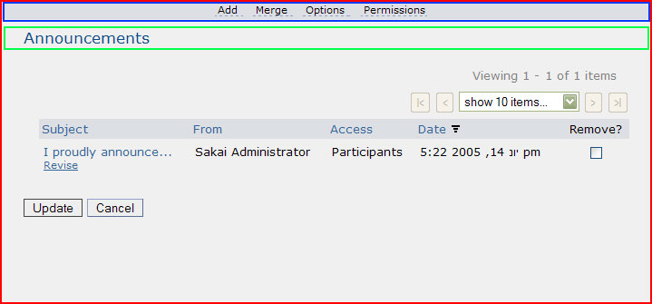
div.portletBody
(p/div).navIntraTool

The Elements
Since the different elements that are addressable are not present at once in the same tool the rest of this guide will consist of various screenshots of different screen “genres”, highlighting the addressable element. See the index at end for a listing of each element – referencing a page number.

Notes:

- highlighted elements will have an orange outline
- the callout references the selector name – providing as much contextual information as may be needed
- the common name of the element is in the list below each screenshot – paired with the selector name – it is the common name that will be listed in the index
- the common name is also based on what the element is called in the Style Guide.
- The selector may be found in tool_base.css, tool.css or in both. You are encouraged to change only tool.css
- Some selectors in the css are paired up – same definitions, different names- this is to help transition the different tools to the same css, don’t let this throw you.

List Elements

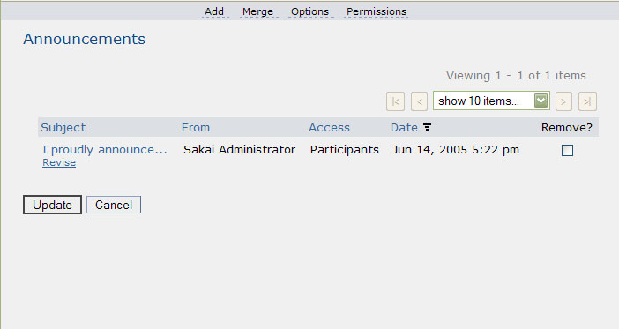
div.navIntraTool
div.navIntraTool a
table.listHier
table.listHier th
table.listHier th a
p.act
div.itemAction
p.act input
p.act input.active
h3
div.rightNav
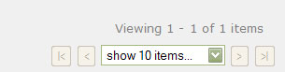
span.instruction

Common name | Selector
Toolbar | div.navIntraTool
Tool header | h3
List | table.listHier
List/page navigator | div.rightNav
List actionable items | div.itemAction
Action inputs (buttons) | p.act
Default action button | p.act input.active

Item Elements
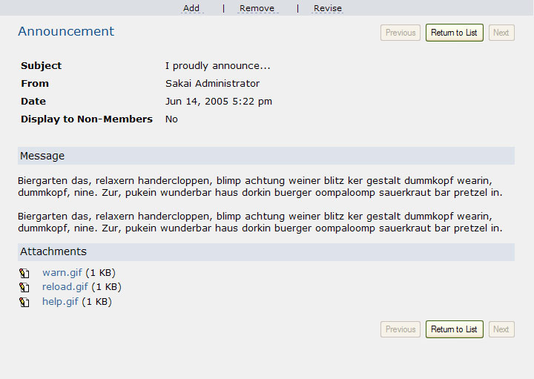
p.rightNav
div.navIntraTool
div.navIntraTool a
table.itemSummary
table.itemSummary th
h3
H4
ul.attachList

Common name | Selector
Toolbar | div.navIntraTool
Tool header | h3
Item Summary | table.itemSummary
Item navigator | p.rightNav
Sub header | h4
Attachment list | ul.attachList

Form Elements
p.instruction
h3
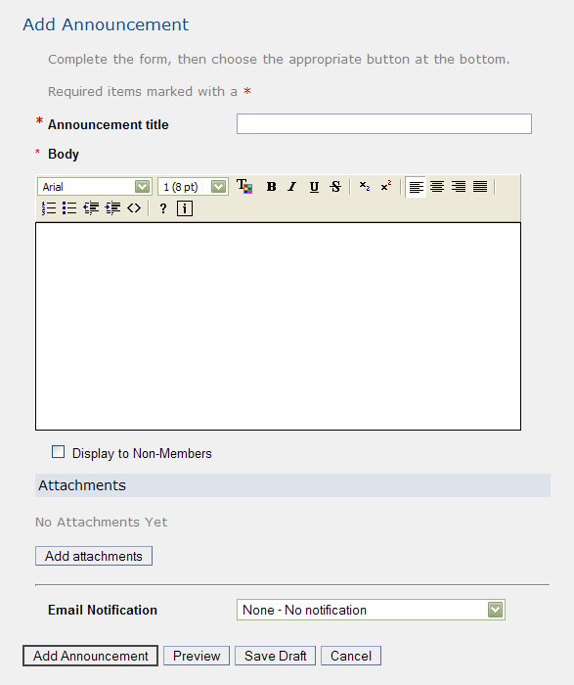
span.reqStarInline
p.shorttext label
p.shorttext
p.shorttext label
span.reqStar label
p.longtext
p.longtext label.block
p.checkbox
p.checkbox label
p.act
p.shorttext
p.act input.active
p.act

Common name | Selector
Tool header | h3
Instruction | p.instruction
Required (in instruction) | span.reqStarInline
Short text block | p.shorttext
Required (in form) | span.reqStar
Long text block | p.longttext

Notes:

- inputs are contextually defined (as children of the shorttext, longtext and checkbox selectors) – you can change their appearance there or globally. In the later case keep in mind that to Internet Explorer 6 and below an input is an input, as attribute selectors will not work with it.
- longtext can have 2 types of layout –the “block” class on the label above forces a top-bottom display. Minus that, it will be side by side.

Assorted Elements

Standard elements

Fieldset, legend
Used in tools to group logical inputs together – devoid of decoration

Textarea

Input

A, a pseudo classes
<a> is defined contextually in many places – table headers, toolbars, etc – this is the generic one

Named elements:layout

div.leftNav (left Navigator)
Block floated left – used when the same horizontal space is shared by two UI groups (right hand is occupied by rightNav block), children are accessible via inheritance.

p.breadCrumb
Displays breadcrumbs in hierarchical situations
> used in Resources, other places

.abc
Block used to display links (abc or 123) to different sections of a long/complex list – display of links are contextually defined

Named elements:messages

p.step
used in wizards to display status – where user is in the process
> create a site to see

p.validation
used in forms to let user know that something is missing
> fill out form missing a required item

p.success
used in complex actions to let user know that things turned out as expected
> create a new grade entry in gradebook

p.information
used to let used know change of status in something
> join a site

p.alert
general all purpose display of system alerts

span.inlineAlert
when a message of importance needs to be embedded inside a block level element
> copy a resource in Resources to see

Assorted elements

p.discTria
Used to display an action that will toggle the visibility of an associated area
> see Samigo, or create and view an Assignment

.skip
Used to render an element that will be picked up by a screen reader but will remain invisible to a sighted user

table.calendar
Used only in one tool the legacy Schedule – massive number of children…

Appendix A– Helpful Links
See the appendix in the Changing the Appearance of the Sakai 2.0 Portal document.

Appendix B – Index

.abc 7
.skip 8
A, a pseudo classes 7
Action inputs (buttons) 4
Attachment list 5
Default action button 4
Div.itemaction 4
Div.leftnav 7
Div.navintratool 4, 5
Div.rightnav 4
Fieldset 7
H3 4, 5, 6
H4 5
Input 7
Instruction 6
Item navigator 5
Item Summary 5
Legend 7
List 4
List actionable items 4
List/page navigator 4
Long text block 6
P.act 4
P.act input.active 4
P.alert 7
P.breadcrumb 7
P.disctria 7
P.information 7
P.inlinealert 7
P.instruction 6
P.longttext 6
P.rightnav 5
P.shorttext 6
P.step 7
P.success 7
P.validation 7
Required (in form) 6
Required (in instruction) 6
Short text block 6
Span.reqstar 6
Span.reqstarinline 6
Sub header 5
Table.calendar 8
Table.itemsummary 5
Table.listhier 4
Textarea 7
Tool header 4, 5, 6
Toolbar 4, 5
Ul.attachlist 5

Appendix C – Post 2.0 changes

2.0.1

The major changes for this version where a number of improvements for accessibility. This affected mostly the portal – but since a number of elements that “look” like they are in the portal are actually tools the tool.css was also affected. The issue in that case was that the tool title (inside of the tool title iframe) became an <h2> - this needs to be treated in the tool css by overriding the default rendering of <h2> - in the case of Euphoria University:

.toolTitle td.title h2{

margin:0;

padding:0;

display:inline;

}

You may want to adjust the font-size, font-weight, color, etc. The important part is to make <h2> behave like a bit of inline text instead as a block.

Appendix D –2.1 changes

Quite a few changes to the markup and the css for 2.1. These are organized below into categories to make it easier to update a skin. Please use the default tool.css as a guide as where these things take place in the file is of some importance.

Renaming and consolidating selectors

All you will need to do is change these in the tool.css.

chefPortletToolbarWrap > navIntraTool
chefPortletToolbarWrapForm > navIntraTool
chefPortletToolbarMessage > h3
chefButtonRow > act
chefSectionMessage > instruction
chefAlertBox > alertMessage
alert > reqStar
chefAlert > highlight
toolbarForm > inlineForm
syllabusTable > listHier

Removed the following from both template files and css

.gbContent

Rationalizing calendar

The calendar is just one tool, but accounted for 20% or the css lines in tool.css – it also had some hardwired styles that were removed – so we simplified it radically and removed the inline style and addressed this in the tool.css

Not sure what the best way to update would be. Maybe the best thing would be to take a screenshot of your current calendar to preserve the palette, then copy over to your tool.css the calendar stuff from the default tool.css for 2.1, then modify the colors.

New classes for complex tables

Some tables needed some horizontal visual organizing – this was done by adding the “lines” class to these tables in the templates, then specifying the rendering in tool.css

For example

<table class=”listHier lines”>

And in the css (as an example)

table.lines{
border-collapse:collapse
}
table.lines tr:hover{
background-color:#ffc
}
table.lines td{
border-bottom:1px solid #bbb;
border-top:1px solid #eee
}

The default tool.css underlines each row and provides a hover color for CSS1 compliant browsers. But you can style this as you see best. The tables affected are the one in resources, and the one in permissions (as well as others in the Admin area that the public never sees).

Some tables needed to highlight rows so a class was added

tr.highLightRow{
background:#ddd
}

Accessibility enhancements

Screen readers will use <h1>, etc. As a navigational aid for users. Users can see the hierarchy and use the headers as links to navigate to specific parts of the content.

So the legacy tools have quite a few extra headers now in the tabular data tables– but did not want these displayed as such. So the following was added:

.listHier th h3,.listHier th h4,.listHier th h5,.listHier th h6,.listHier td h3,.listHier td h4,.listHier td h5,.listHier td h6
{
margin:0;
padding:0;
font-size:1em;
background:none;
font-weight:normal;
font-family:your_font_family_here !important
}

Also – make sure that you have a .skip class in your tool.css (see default) – as this is used extensively to present information to screen-readers but make the same information invisible for other users.

Links

In 2.0 we could not give a skin the a:visited functionality because certain links are all the same (have “#” as the href attribute value) – which meant that visit one, all will be rendered as visited.

For 2.1 we have isolated where these “ahistorical” links happen in the legacy tools, so that you can provide a “visited” look in the remainder.

So – after you have defined the generic “a:visited” address the exceptions, for example:

.specialLink a:link,.specialLink a:visited{
color:#35b;
text-decoration:none
}

The “specialLink” is the parent of all ahistorical links in the markup, so setting the a:visited to be the same as the a:link will avoid the problem. You may want to mave a:visited and a:link the same for links inside of .navIntraTool, itemAction and .listHier th as well – as they are also “#”)

Here is a list of link areas:

.navIntraTool (toolbar)
.listHier th (sortable headers in tables)
.itemAction (links that perform an action on items)
.specialLink (ahistorical links that happen anywhere)

So you can define each type of link differently. The rest are normal links.

Tool sizing

The tool iframes are resized via javascript to be as large as the document they contain. For 2.1 the javascript has been modified – removing some of the padding, and the padding added to the bottom of the .portletBody class. Experiment with this till the scrollbars disappear.

Resources

This legacy tool was extensively redone for 2.1 – new rendering definitions were needed.

The interface now allows for selecting, then choosing copy or move. Then the list refreshes – with new links (Paste copied/moved items here)

After something has been selected and copied the item row can be highlighted. See .selectedMove and .selectedCopy (and all it contextually defined children) in the default as a model. If you are looking for these classes in the default – they appear in several places

The control that a user clicks to copy or move an item is an <input type=”button” />

Some users wanted to style these to make them look like a link. This is provided via the wrapper for these inputs. Since the inputs are disabled till the user picked an item, that also needed to be addressed (for example):

.navIntraToolLink input{
padding:0;
border:none;
background:transparent
}
.navIntraToolLink input.disabled{
padding-bottom:1px;
border-bottom:none;
background:transparent
}
.navIntraToolLink input.enabled{
color:#35b;
border-bottom:1px solid #35b;
background:transparent
}

New widgets

A new widget added (used in Preferences and in the Group creation process) was the side by side select, by which users can be moved from one list to the other.

This is done in a table, classed .sidebyside – the main thing was giving the <select /> a default width (regardless of the content):

.sidebyside{}
.sidebyside th{padding:.3em;text-align:left;font-weight:normal}
.sidebyside td{padding:.3em}
.sidebyside select{width:18em}

