

MULTIMEDIA COMPUTING

STEGANOGRAPHY
(Image & Text)

Altamash Sameer (01FB16ECS051)
Kumar Satyam (01FB16ECS171)
Rahul Sharma (01FB16ECS290)
Shadan Alam Kaifee (01FB16ECS346)

OUTLINE

Introduction
Problem Statement
Literature Survey
Proposed Methodology
Implementation
Results & Conclusion
References

INTRODUCTION

Steganography is the practice of concealing a file, message, image, or video within another file, message, image, or video. The word steganography combines the Greek words steganos - meaning "covered, concealed, or protected", and graphein meaning "writing" .
The advantage of steganography over cryptography alone is that the intended secret message does not attract attention to itself as an object of scrutiny. Whereas cryptography is the practice of protecting the contents of a message alone, steganography is concerned with concealing the fact that a secret message is being sent as well as concealing the contents of the message.

Steganography includes the concealment of information within computer files. In digital steganography, electronic communications may include steganographic coding inside of a transport layer, such as a document file, image file, program or protocol.

Media files are ideal for steganographic transmission because of their large size. For example, a sender might start with an innocuous image file and adjust the color of every hundredth pixel to correspond to a letter in the alphabet. The change is so subtle that someone who is not specifically looking for it is unlikely to notice the change.

History

The first recorded uses of steganography can be traced back to 440 BC when Herodotus mentions two examples in his Histories . Histiaeus sent a message to his vassal, Aristagoras by shaving the head of his most trusted servant, "marking" the message onto his scalp, then sending him on his way once his hair had regrown, with the instruction, "When thou art come to Miletus, bid Aristagoras shave thy head, and look thereon." Additionally, Demaratus sent a warning about a forthcoming attack to Greece by writing it directly on the wooden backing of a wax tablet before applying its beeswax surface. Wax tablets were in common use then as reusable writing surfaces, sometimes used for shorthand.

Techniques

- Hidden messages distributed, according to a certain rule or key, as smaller parts (e.g. words or letters) among other words of a less suspicious covertext. This particular form of steganography is called a null cipher
- Messages written in Morse code on yarn and then knitted into a piece of clothing worn by a courier.
- Messages written on envelopes in the area covered by postage stamps.
- In the early days of the printing press, it was common to mix different typefaces on a printed page because the printer did not have enough copies of some letters in one typeface. Thus, a message could be hidden by using two or more different typefaces, such as normal or italic.
- Concealing messages within the lowest bits of noisy images or sound files. A survey and evaluation of relevant literature/techniques on the topic of digital image steganography can be found here.
- Concealing data within encrypted data or within random data. The message to conceal is encrypted, then used to overwrite part of a much larger block of encrypted data or a block of random data

Applications

Some modern computer printers use steganography, including Hewlett- Packard and Xerox brand color laser printers. The printers add tiny yellow dots to each page. The barely-visible dots contain encoded printer serial numbers and date and time stamps.
The larger the cover message (in binary data, the number of bits) relative to the hidden message, the easier it is to hide the hidden message so digital pictures, which contain much data, are used to hide messages on the Internet and on other communication media. It is not clear how common this practice actually is.
For example, a 24-bit bitmap uses 8 bits to represent each of the three color values (red, green, and blue) of each pixel The blue alone has 28 different levels of blue intensity. The difference between 11111111 and 11111110 in the value for blue intensity is likely to be undetectable by the human eye.

Therefore, the least significant bit can be used more or less undetectably for something else other than color information. If that is repeated for the green and the red elements of each pixel as well, it is possible to encode one letter of ASCII text for every three pixels

In 2010, the Federal Bureau of Investigation alleged that the Russian foreign intelligence service uses customized steganography software for embedding encrypted text messages inside image files for certain communications with "illegal agents" (agents without diplomatic cover) stationed abroad

PROBLEM STATEMENT

It is proposed a new framework of an image Steganography system to hide a digital text and images of a secret message.

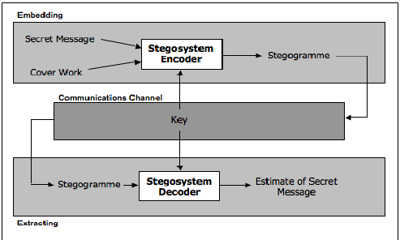
LITERATURE SURVEY

Sumit Kumar Moudgil Et al[2], focussed on the strength Steganography methods to enhance the security of communication over an open channel by means of embedding the message bits in the deeper layer of samples and alter other bits to decrease the error.

Acqueela G Palathingal Et al[3], had made the data security using combined encryption by means of cloud data security which ensures multilevel security mechanism of data. We integrate RSA Algorithm with other algorithm to provide more security of data by analysing the image binary code to find out the differences.

Dr.Amit Kumar Goel Et al[1], had proposed to resolve two problems of substitution technique of audio steganography, having low robustness against attacks which try to reveal the hidden message and second one is having low robustness against distortions with high average power.

R.Rejani Et al[2], focussed on digital data protection by means of authentication algorithm and protection algorithm, it uses triple protection that is hardware properties, strong encryption and custom steganography through which protection will be difficult to hack or break.

Amirthanjan Et al[2], focussed on digital communication by means of LSB Steganography, Information hiding , Inverted pattern approach and pixel value differencing , writing messages in such a way such that no one apart from the sender and the intended receiver suspect the existence of messages.

Chen, Wen-Jan Et al[1], focussed on employing the LSB substitution technique as a fundamental stage, we take advantage of edge detection technique. The experimental results show that the proposed scheme not only achieves high embedding capacity but also enhances the quality of the stego image from the HVS by an edge detection technique.

Nameer N. EL-Emam Et al[1], had Constructed and implemented new algorithm based on hiding a large amount of data (image, audio, text) file into color BMP image and adaptive image filtering and adaptive image segmentation with bits replacement on the appropriate pixels. This Algorithm can embed efficiently a largeamount of data that has been reached to 75% of the image size with high quality of the output.

Sharmishta Desai Et al[2], have used double layer Data Privacy, one being the Steganographic Algorithm and other being password enabled Encoding and Decoding for implementation of LSB Algorithm.

Mohammed Tanvir Parvez Et al[1], had made stored variable number of bits in each channel (R,G,B) of pixel based on actual color values of that pixel (lower color component stores higher number of bits) which provides high capacity for cover media compared to other existing algorithm.

S.Phad Vitthal Et al[2], have focussed on novel security by means of two major branches of Data Security that is Cryptography and Steganography. Both the method are combined to give two tier security to secret data, Advanced Encryption standard is used to encrypt secret message and PVD and K bit LSB substitution method to hide encrypted secret message into cover image.

PROPOSED METHODOLOGY

Requirement of this steganography system is that the hider message carried by stego-media should not be sensible to human beings.
The other goal of steganography is to avoid drawing suspicion to the existence of a hidden message.

METHODOLOGY
IMPLEMENTATION

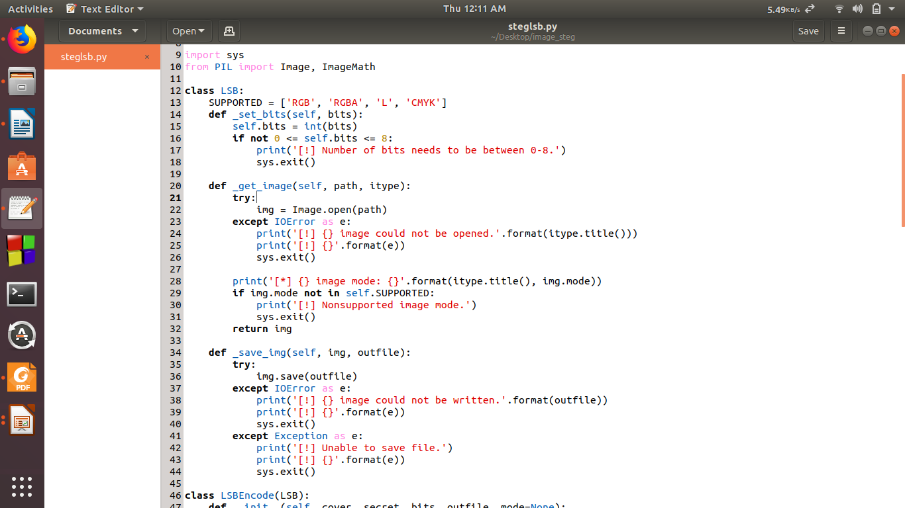

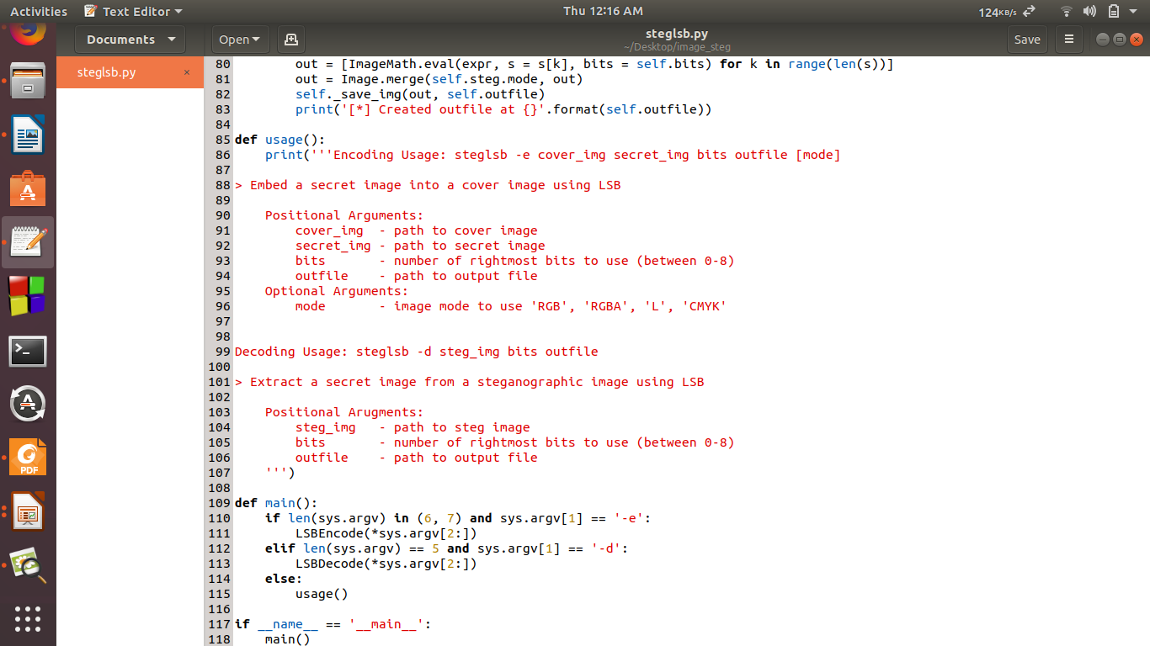
METHODOLOGY

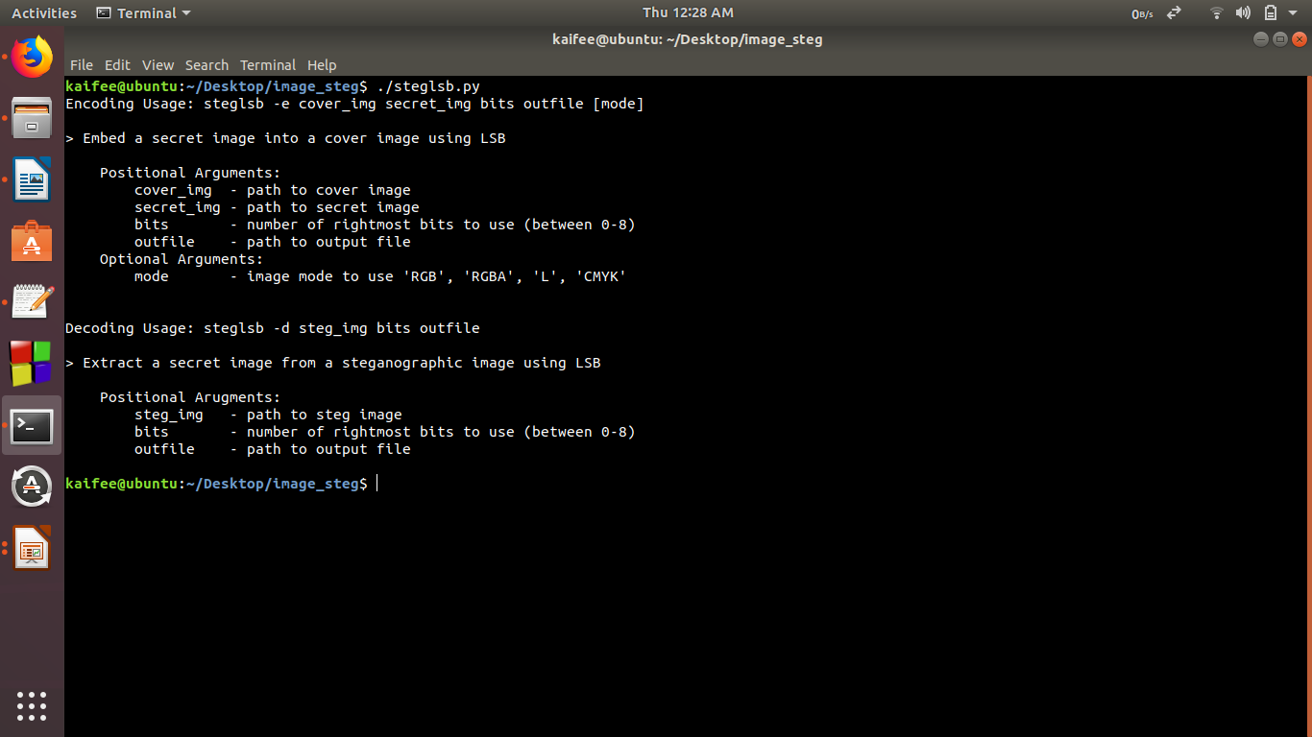

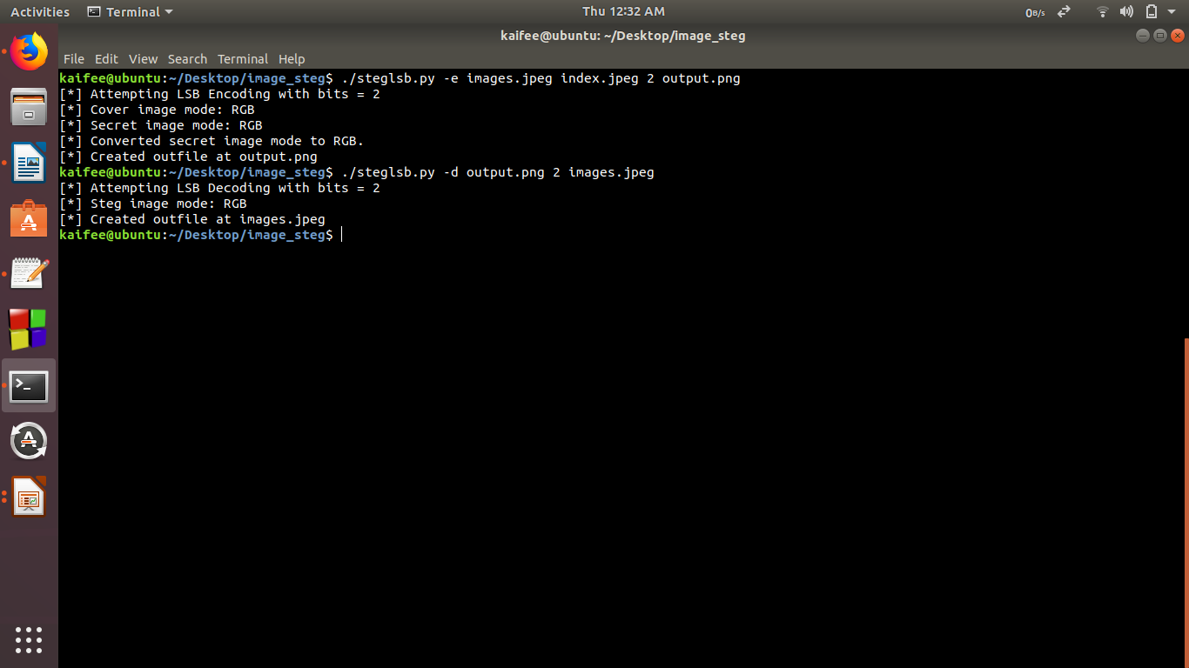

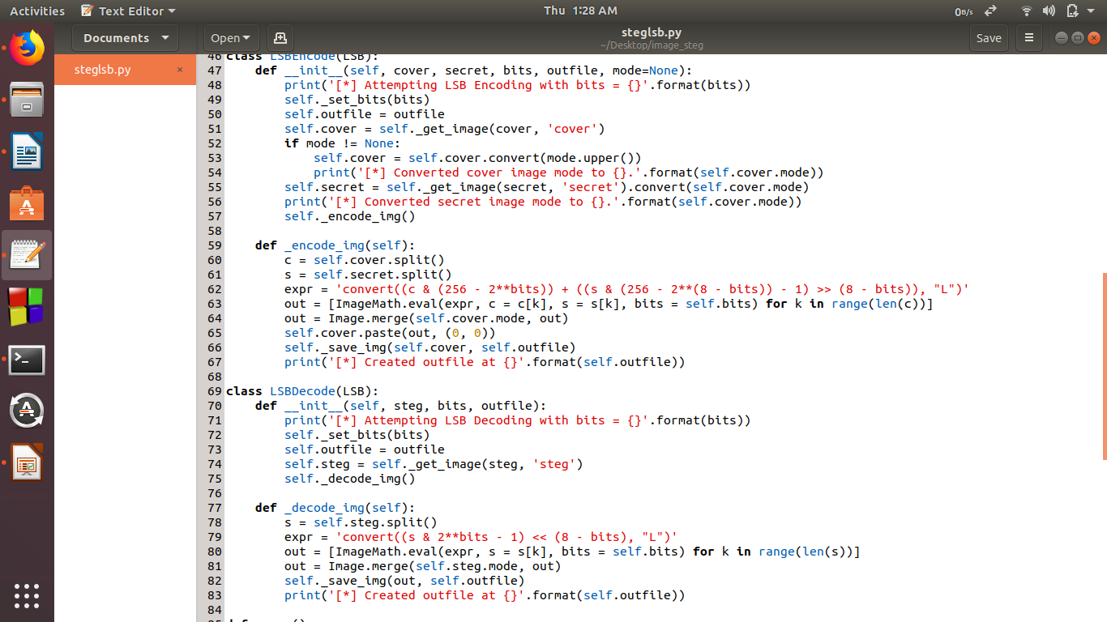
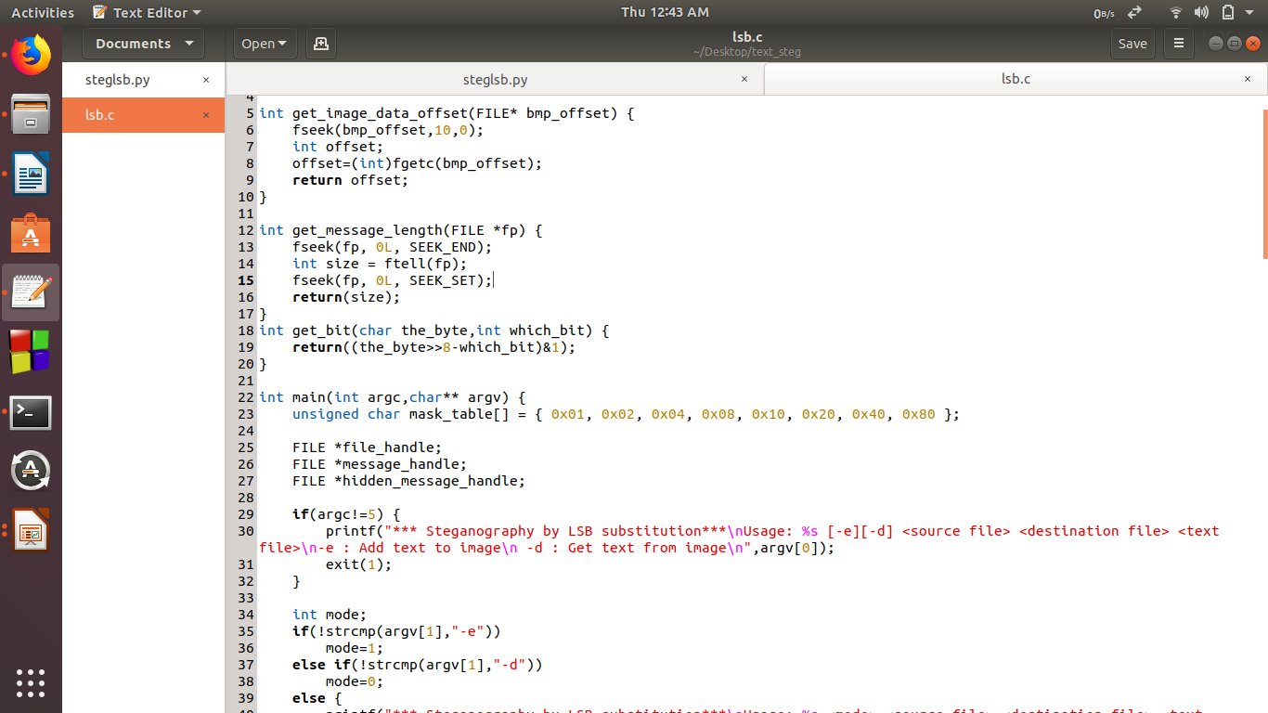
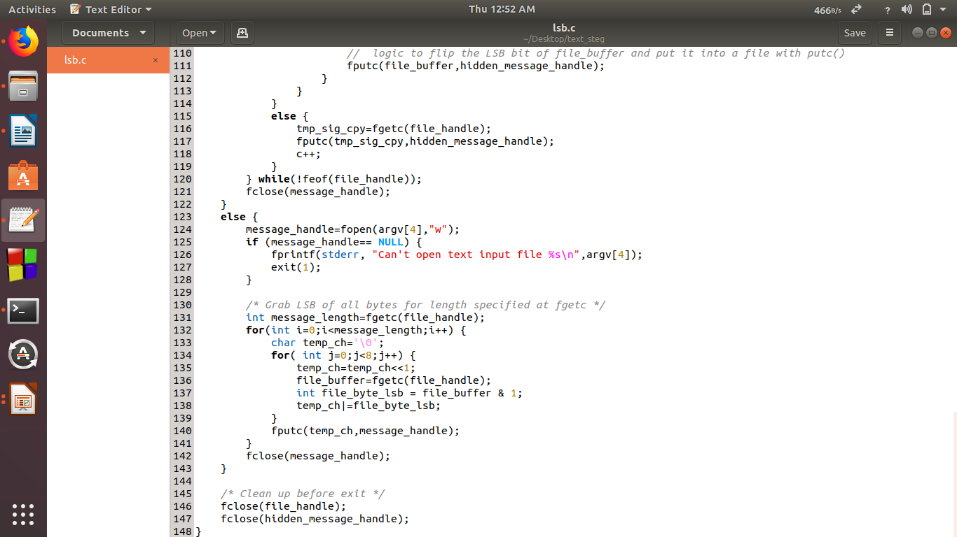

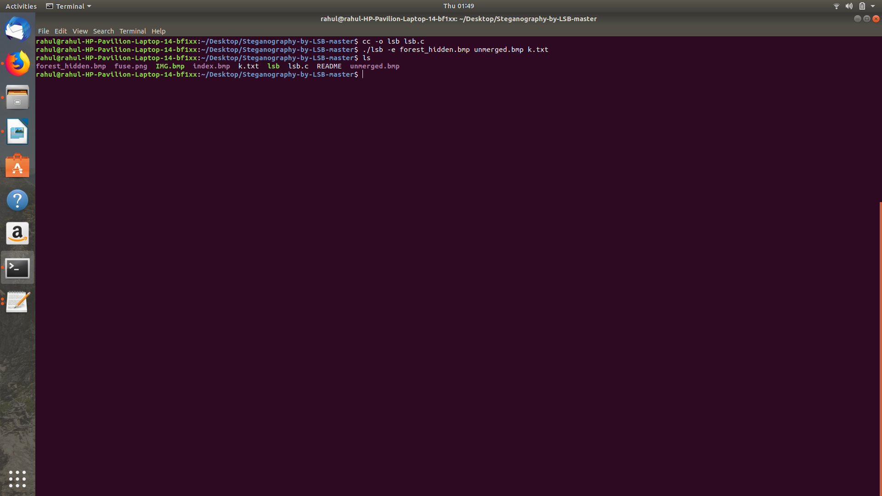

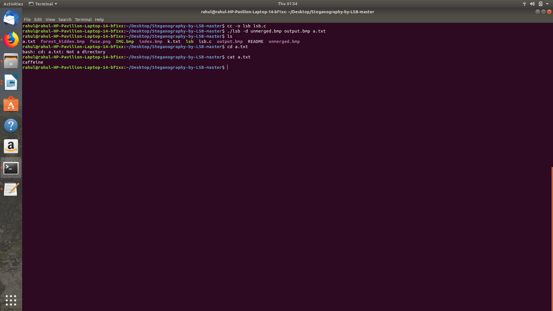

RESULT & CONCLUSION

It is mainly concentrated on embedding the data into an image and have designed the steganographic application which embedded the data into the image.
Normally, after embedding the data into the image, the image may lose its resolution. In the proposed approach, the image remains unchanged in its resolution as well in size.
It is mainly the Least Significant Bit algorithm in designing the steganographic application because LSB algorithm works efficiently when we consider bit map images. The speed of embedding is also high when using LSB compared to the JSteg algorithm.

REFERENCES

[1] Sumit Kumar MoudgiL, Dr.Amit Kumar Goel and Dr.Manish Sharma, “Steganography on Audio Wave Tenth Layer by Using Signal to Noise Ratio Test and Spectrogram Analysis”, International Journal of Applied Engineering Research, Volume 13,Issue: May 2018.

[2] Acqueela G Palathingal, Anny George, Blessy Ann Thomas and Ann Rija Paul, “Enhanced Cloud Data Security using Combined Encryption and Steganography”, International Research Journal of Engineering and Technology (IRJET), Volume 05, Issue: 03, March 2018.

[3] Dr.Amit Kumar Goel, Sumit Kumar Moudgil, “Optimization of Steganography on Audio Wave by embedding the minimum and maximum message layers and Spy Analysis”, AKGEC International Journal of Technology, volume 8,Issue: Jan-Feb 2017

[4] R.Rejani, D.Murugan and Deepu V.Krishnan, “Digital Data Protection Using Steganography”, ICTACT Journal on Communication Technology, Volume 07,Issue: March 2016.

[5] Amirthanjan, R.Akila and Deepika Chowdavarapu, “A Comparative Analysis of Image Steganography:A Computational Intelligence Approach”, International Journal of Computer Applications, Volume 2, Issue: 3, May 2010.

[6] Chen, Wen-Jan, Chang, Chin-Chen and Hoang Ngan Le, “High Payload Steganography Mechanism using Hybrid Edge Detector”, Expert System with Applications, volume 37, Issue: 4, April 2010.

[7] Nameer N. EL-Emam, “Hiding a Large Amount of Data with high security using Steganography Algorithm”, Journal of Computer Science, Volume 3,Issue: 4, Nov 2007.

[8] Sharmishta Desai, Sanaa Amreliwala and Vineet Kumar, “Enhancing Security in Mobile Communication using a unique Approach in Steganography”, International Journal of Computer Science and Mobile Computing,Volume 03, Issue: 2014.

[9] Mohammed Tanvir Parvez and Adnan Abdul Aziz Gutub, “RGB Intensity Based Variable-Bits Image Steganography”, Proceedings of IEEE Asia- Pacific Services Computing Conference,Volume 07, Issue: 2008.

[10] S.Phad Vitthal, S.Bhosale Rajkumar and R.Panhalkar Archana, “A Novel Security Scheme For Secret Data using Cryptography and Steganography” International Journal Computer Network and Information Security, Volume 04, Issue:2012

Thanks !

