

PRINCIPLES OF PROGRAMMING LANGUAGES

TIC-TAC-TOE
(Language used - ADA)

Shadan Alam Kaifee (01FB16ECS346)
Sharmishta Singh (01FB16ECS354)
Shashwat Mishra (01FB16ECS361)

OUTLINE

Introduction
Subprograme Types
Overview
Implementation
Output
Results & Conclusion

INTRODUCTION

Ada was originally targeted at embedded and real-time systems. The Ada 95 revision, designed by S. Tucker Taft of Intermetrics between 1992 and 1995, improved support for systems, numerical, financial, and object-oriented programming (OOP).

Features of Ada include: strong typing, modularity mechanisms (packages), run-time checking , parallel processing (tasks, synchronous message passing, protected objects, and nondeterministic select statements), exception handling, and generics. Ada 95 added support for object-oriented programming, including dynamic dispatch.

The syntax of Ada minimizes choices of ways to perform basic operations, and prefers English keywords (such as "or else" and "and then") to symbols (such as "||" and "&&"). Ada uses the basic arithmetical operators "+", "-", "*", and "/", but avoids using other symbols. Code blocks are delimited by words such as "declare", "begin", and "end", where the "end" (in most cases) is followed by the identifier of the block it closes (e.g., if … end if, loop … end loop). In the case of conditional blocks this avoids a dangling else that could pair with the wrong nested if-expression in other languages like C or Java.
Ada is designed for development of very large software systems. Ada packages can be compiled separately. Ada package specifications (the package interface) can also be compiled separately without the implementation to check for consistency. This makes it possible to detect problems early during the design phase, before implementation starts. A large number of compile-time checks are supported to help avoid bugs that would not be detectable until run-time in some other languages or would require explicit checks to be added to the source code.

History

In the 1970s, the US Department of Defense (DoD) was concerned by the number of different programming languages being used for its embedded computer system projects, many of which were obsolete or hardware-dependent, and none of which supported safe modular programming. In 1975, a working group, the High Order Language Working Group (HOLWG), was formed with the intent to reduce this number by finding or creating a programming language generally suitable for the department's and the UK Ministry of Defence requirements. After many iterations beginning with an original Straw man proposal the eventual programming language was named Ada. The total number of high-level programming languages in use for such projects fell from over 450 in 1983 to 37 by 1996.
The HOLWG working group crafted the Steelman language requirements, a series of documents stating the requirements they felt a programming language should satisfy. Many existing languages were formally reviewed, but the team concluded in 1977 that no existing language met the specifications.
In April 1978, after public scrutiny, the Red and Green proposals passed to the next phase. In May 1979, the Green proposal, designed by Jean Ichbiah at CII Honeywell Bull, was chosen and given the name Ada—after Augusta Ada , Countess of Lovelace. This proposal was influenced by the programming language LIS that Ichbiah and his group had developed in the 1970s. The preliminary Ada reference manual was published in ACM SIGPLAN Notices in June 1979.

Ada attracted much attention from the programming community as a whole during its early days. Its backers and others predicted that it might become a dominant language for general purpose programming and not just defense-related work. Ichbiah publicly stated that within ten years, only two programming languages would remain, Ada and Lisp

Language constructs

Ada is an ALGOL-like programming language featuring control structures with reserved words such as if, then, else, while, for, and so on. However, Ada also has many data structuring facilities and other abstractions which were not included in the original ALGOL 60, such as type definitions, records , pointers , enumerations. Such constructs were in part inherited from or inspired by Pascal.

"Hello, world!" in Ada
A common example of a language's syntax is the Hello world program: (hello.adb)

with Ada.Text_IO; use Ada.Text_IO;
procedure Hello is
begin
Put_Line ("Hello, world!");
end Hello;

This program can be compiled by using the freely available open source compiler GNAT, by executing
gnatmake hello.adb

Data Types

Ada's type system is not based on a set of predefined primitive types but allows users to declare their own types. This declaration in turn is not based on the internal representation of the type but on describing the goal which should be achieved. This allows the compiler to determine a suitable memory size for the type, and to check for violations of the type definition at compile time and run time (i.e., range violations, buffer overruns, type consistency, etc.). Ada supports numerical types defined by a range, modulo types, aggregate types (records and arrays), and enumeration types. Access types define a reference to an instance of a specified type; untyped pointers are not permitted. Special types provided by the language are task types and protected types.

type Day_type is range 1 .. 31;
type Month_type is range 1 .. 12;
type Year_type is range 1800 .. 2100;
type Hours is mod 24;
type Weekday is (Monday, Tuesday, Wednesday, Thursday, Friday, Saturday, Sunday);

type Date is
record
Day : Day_type;
Month : Month_type;
Year : Year_type;
end record;

SUBPROGRAM TYPES

PROCEDURE
procedure H(arguments) is
declarations
begin
statement
end H;
Typical use is procedure Main is...
Which defines the main program

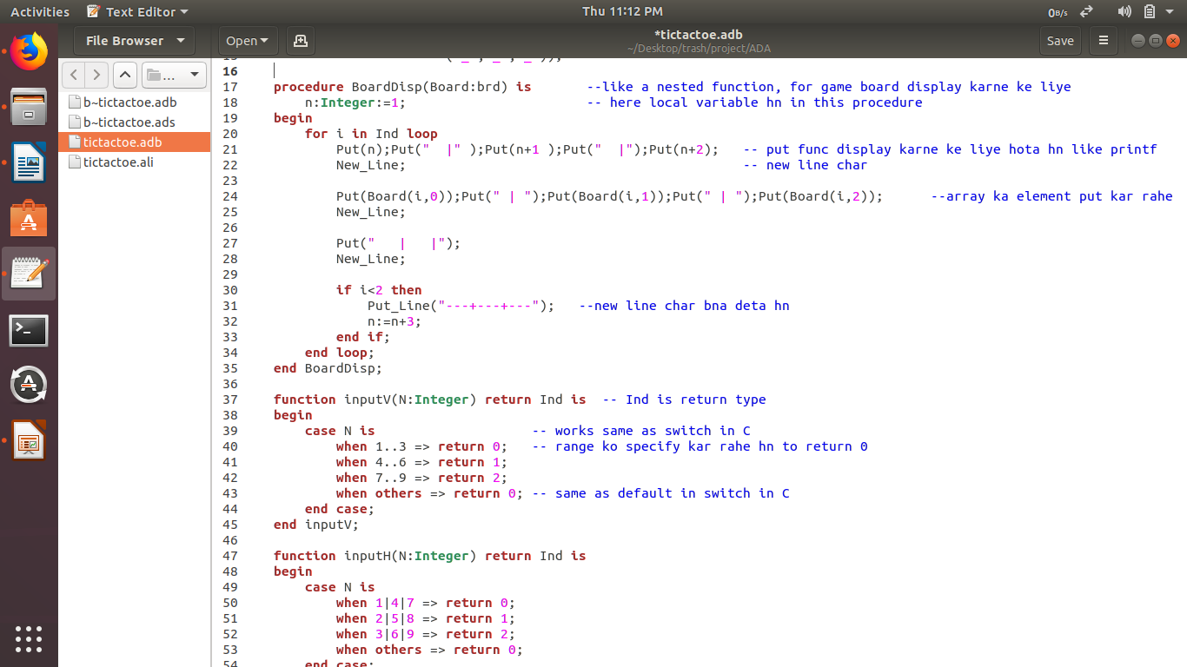
FUNCTIONS
function F(arguments) return type is
declarations
begin
statements
return :
end F;

Type -> return type all the functions
Function must have atleast one return statement
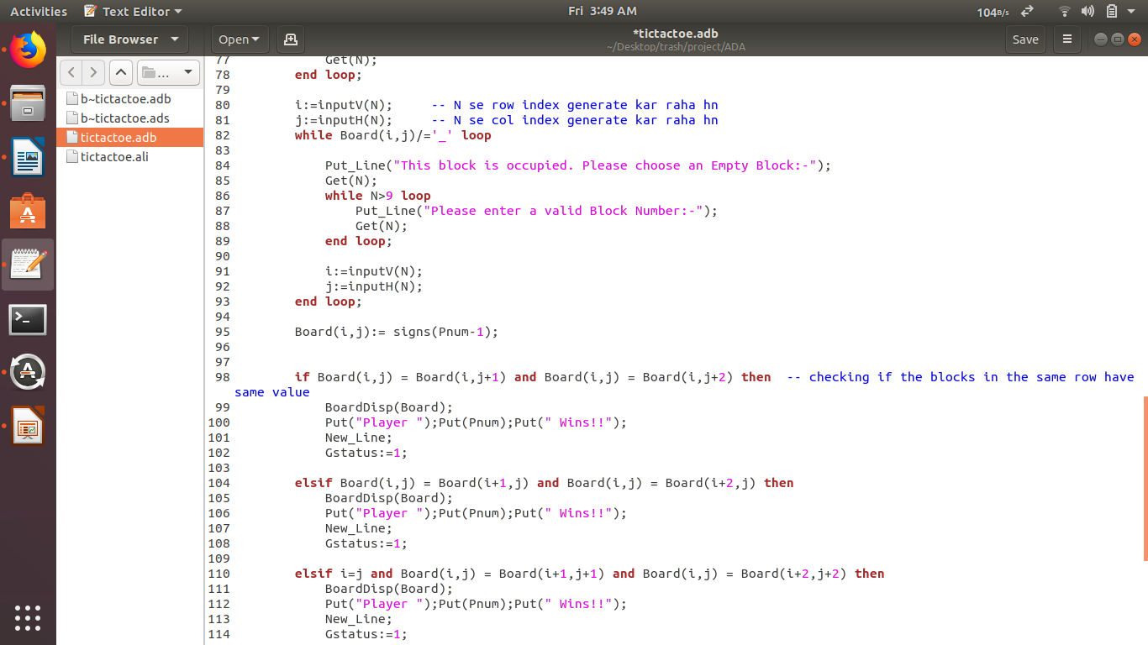

OVERVIEW

Tic-tac-toe (also known as noughts and crosses or Xs and Os) is a paper-and-pencil game for two players, X and O, who take turns marking the spaces in a 3×3 grid. The player who succeeds in placing three of their marks in a horizontal, vertical, or diagonal row wins the game.
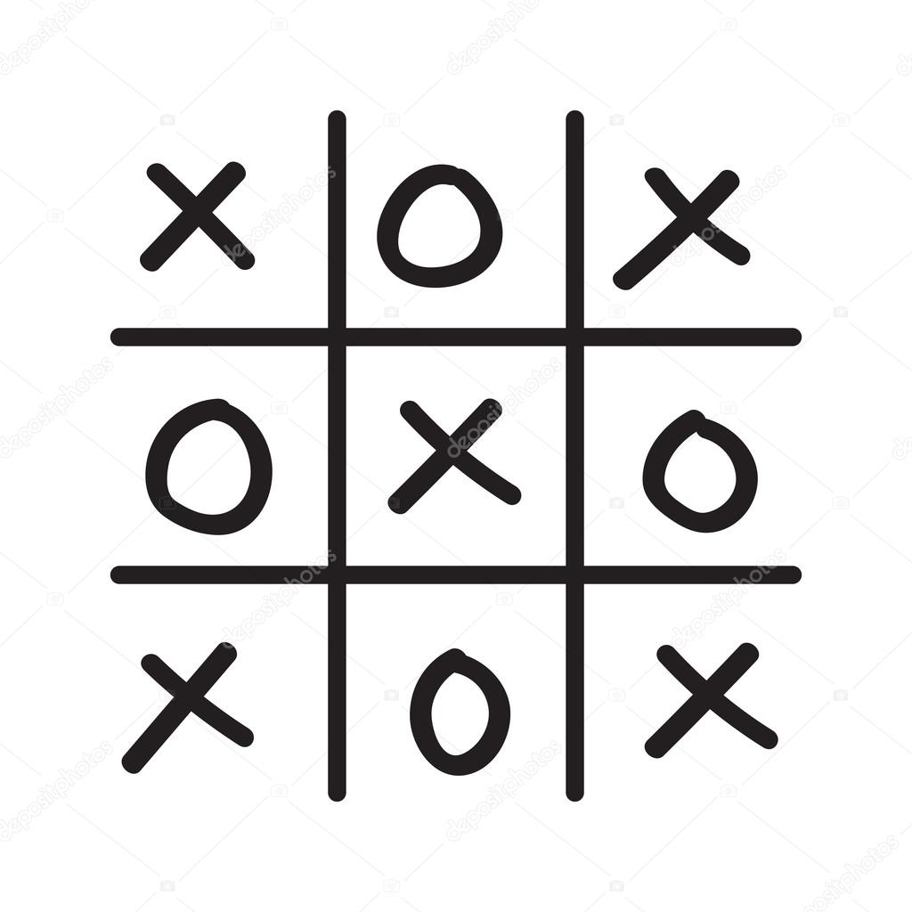
Players soon discover that the best play from both parties leads to a draw .The game can be generalized to an m,n,k-game in which two players alternate placing stones of their own color on an m×n board.

IMPLEMENTATION

2 -D Array
Modular Types
Loops
-- > For Loop
-- > While Loop
-- > Loop Block

Selection Statement
-- > If – Else Block
-- > Case Block

2 -D Array

A: array (R,C) of Types

A -> Variable name
R -> Range of row indices
C -> Range of Column indices

Types -> Types of values to be stored
Use -> For making 3 x 3 grid for the game

Modular Types

Modular Types have wrap around:

Type M is mod N; -- Values are 0,1,2,3,4,5,6
q : m := 6; -- initialization
q : q + 2; -- results is 1

Used for indexing the 3 x 3 grid in the game

Loops

For Loop

For J in Range Loop
Statements
end loops;

Range --> range of values for J
Use --> for display the game board

While Loop

while condition loop
Statements
end loop;
Condition --> a condition statement ,result must be boolean
Use --> for ensuring the validity of input
Loop Block

loop
statements
end loop;

terminated only with exit statement:
exit when condition;
Can use labels;
label : loop
statements
end loop labels;

Selection Statement

IF -ELSE Block

if condition then
statements
elsif condition then
statements
else
statements
end if ;

Condition Statements must have a boolean results

Case Block

Works same as switch block in C

Case expression is
When 0 => statements
When 1..10 => statements
When others => statements
end case;

Use --> to generate indices for game board from user input

OUTPUT
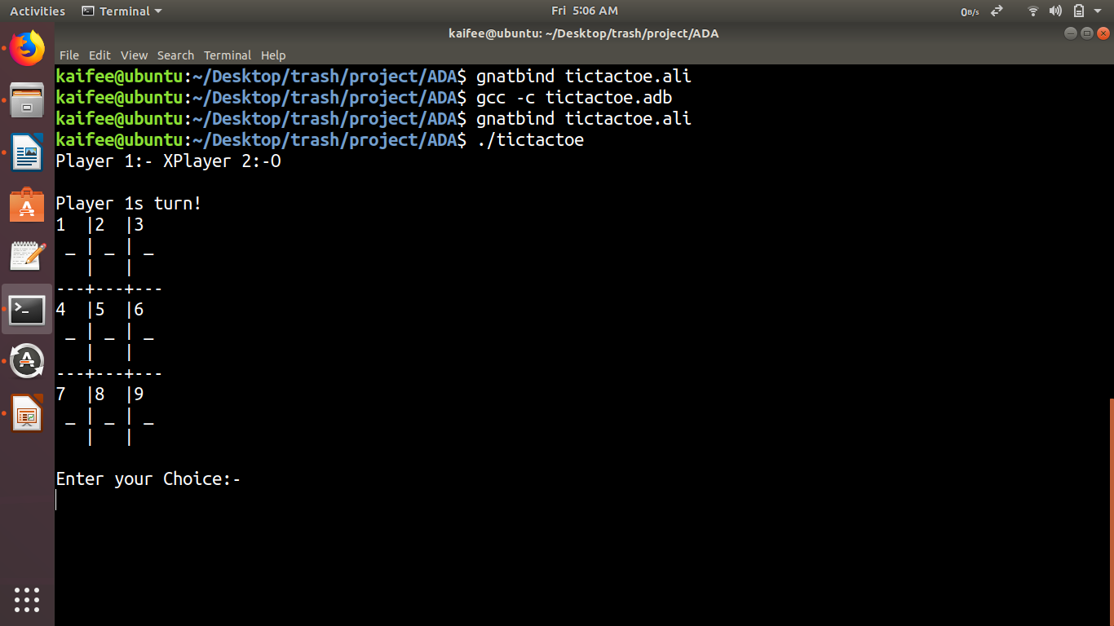
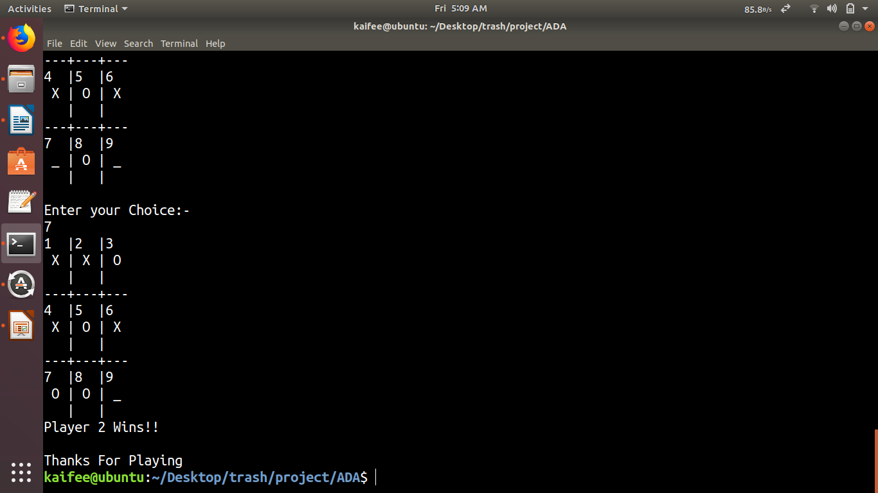

RESULTS & CONCLUSION

The tictac-toe game is run in Ubuntu Terminal with two players. Fig(above) shows the screen shorts of game at various stages presenting player 1 choosing symbol, player 2 choosing symbol. In this system, we create a 3 x 3 tic-tac-toe game in terminal view.
The system is designed so that two players can play a game of tic-tac-toe using keyboard . The program will contain a display function and a select function to place the symbol as well as toggle between the symbols allowing each player a turn to play the game.
The program will update after each player makes their move and will check for the conditions of the game as it goes on. Overall the system works without any bugs and is able to use.

Thank you!

