Using the Sakai Basic LTI Portlet
Charles Severance
October 13, 2009

Introduction
The Sakai Basic LTI portlet implements the IMS Basic Learning Tools Interoperability standard. BasicLTI allows the launching and sharing of information with an externally hosted tool using standard protocols, signed securely using the OAuth (www.oauth.net) security mechanism.

The Sakai BasicLTI portlet supports three basic use cases:

- An instructor can crate a tool placement which points to an external tool and put in a URL, secret, and password to "mash-up" functionality from various sources into their course.

- The system administrator can create virtual tool pointing to an externally hosted tool and place the tool into Site Setup. Instructors can add the tool to their site without even knowing that the tool is hosted externally and it will be launched using Basic LTI.

- The system administrator makes a site-licensing arrangement with an external provide of software as a service (such as Icodeon) or protected content from a publisher (such as Pearson or McGraw-Hill) and allow instructors to point to the resources without needing a password.

The basic idea is that the Basic LTI portlet provides an endpoint for an externally hosted tool or content and makes it appear if the externally hosted tool is running within Sakai. In a sense this is kind of like a smart “iFrame” tool that can host lots of different content.

The Basic LTI portlet provides the externally hosted tool/content with information about the individual, course, tool placement, and role within the course and allows a “federated single-sign-on” using in-browser REST-style launching and allows an externally hosted tool to support many different LMS’s from multiple vendors with a single instance of the external tool or resource.

Basic Mash-Up
Once the Basic LTI Portlet is added to your Sakai instance, it can either be made available directly to instructors or stealthed so only technical support can add it to courses. Since the LTI portlet (like LinkTool) shares information with external servers, keeping it stealthed is a good first approach until experience is gained with the tool. When the tool is available to instructors, it simply shows up as an available tool in Site Setup.

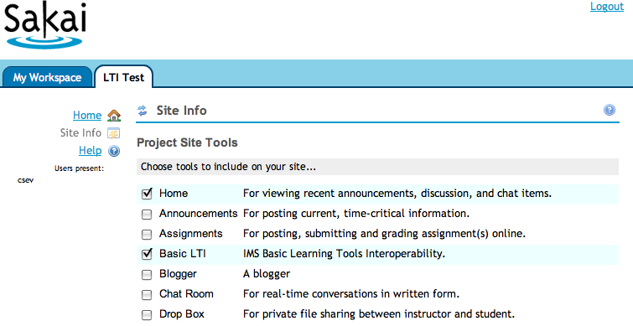

Once the tool is placed in the site, it must be configured. Pressing the "pencil" icon in the title bar configures JSR-168 portlets. The configuration screen of the Basic LTI tool is as follows:

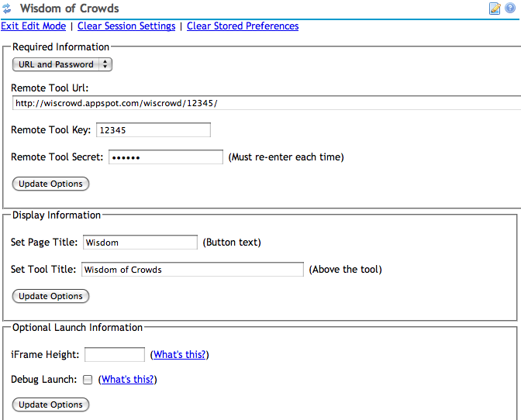

The external tool provider will give the instructor a launch url, key and secret. In addition to providing these fields, the instructor can set the button text, title text, and iframe height to control how the tool is displayed in Sakai.

The "debug launch" feature causes Sakai to pause before submitting the single sign on data to the external tool. In a debug launch the user is presented a button to submit the launch data to the external tool. He debug launch is described in more detail below.

The next set of configuration fields deal with the release of student names and E-Mail addresses and allows the instructor to set any needed custom parameters.

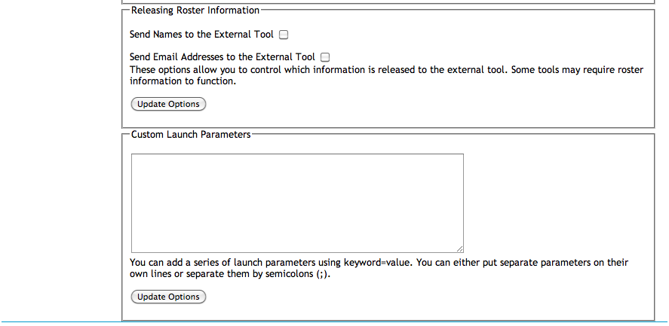

The custom parameters are fields are defined by the tool and may be required by the external tool.

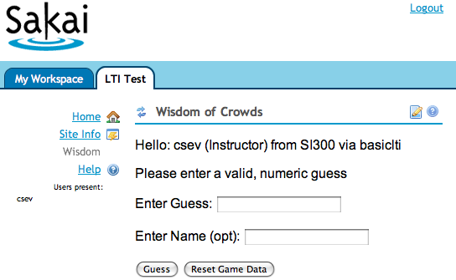

Once the tool configuration is completed, the tool is immediately launched.

Site-Wide Passwords / Site-Licensed Content
Sometimes a vendor will want to give a site-wide license to some content to an LMS. The vendor will want to give a single secret and password that is to be used to sign all of the requests coming from that LMS system.

Having a site-wide secret/password gives a lot of benefit to the external tool/content providers:

- It eliminates managing lots of passwords and talking to lots of instructors and resetting lots of lost passwords..

- It allows the external tool to assume that launches with the same user_id from course to course represents the same user and that when the tool sees the same course_id across multiple launches, it is truly the same course, regardless of the password/secret in the possession of the instructor. This allows the external tool to look at its data for a user across courses within an institution.

- It allows them to distribute "generic" urls that do not encode a "course id" in the URL such as http://katana.mhhe.com/psycology/chapter04/ where the URL indicates a resource – but does not include "context" the user is coming from.

These site-wide passwords are set based on a site-wide identifier chosen by the LMS admin and used across tool vendors. This is set in sakai.properties as follows:

basiclti.consumer_instance_guid=ctools.umich.edu
basiclti.consumer_instance_name=CTools At University of Michigan
basiclti.consumer_instance_url=http://ctools.umich.edu

You can set LMS_wide key/password combinations using the following properties. The LMS-wide properties use the hostname in the launch URL to look up the key and secret. The LMS-wide key and secret take precedence over the resource-level key and secret. If the consumer_instance_guid is specified, it is the default for a launch domain if the key is not specified.

basiclti.consumer_instance_secret=mostly-useless

basiclti.consumer_instance_secret.mhhe.com=98765

basiclti.consumer_instance_key.math.pearson.com=uimch.edu
basiclti.consumer_instance_secret.math.pearson.com=d1c2e3

basiclti.consumer_instance_key.imsglobal.org=lmsng.school.edu
basiclti.consumer_instance_secret.imsglobal.org=secret

Where math.pearson.com, mhhe.edu, and physics.umich.edu are pulled from the hostname in the launch url to select the correct secret for the particular launch. In this example katana.mhhe.com in a launch url would match mhhe.com.

When a site wide key/password combination exists for a launch, it is always used (i.e. any instructor-entered key/secret information is ignored). This also means that tools can be placed with no key/secret information at all. It also means that any authoring UI needs to have the key and secret be optional.

These secrets should be protected (like database connection passwords) so care should be taken when storing this information in source control or passing files around. Also the secrets should be long and random and changed from time to time.

The OAuth security mechanism is vulnerable to robot-guessing of the password. So having long passwords and varying the length and content makes robot guessing far less tractable.

Test Sites
I have several test sites that you can use that I will try to keep up as much as possible:
http://www.imsglobal.org/developers/BLTI/tool.php
This site accepts a site-level secret of lmsng.edu / secret. This site also includes a test LMS so you can test your own external tools with a known LMS implementation.
The php-simple code is also available for your use at:
http://code.google.com/p/ims-dev/
You can run a local copy on your workstation or your own server. This also includes sample code for Java and PHP which shows how to construct and receive valid launches using the OAuth security libraries. The Sakai Basic LTI tool uses the Java sample code provided by IMS.

Launching with Debug Mode
If you select Debug Mode the tool launch is paused "half-way-through" and the user is presented a button to continue. This is most useful to debug problems with an external tool. You can view the source of the iframe or simply look at the parameters on the screen.

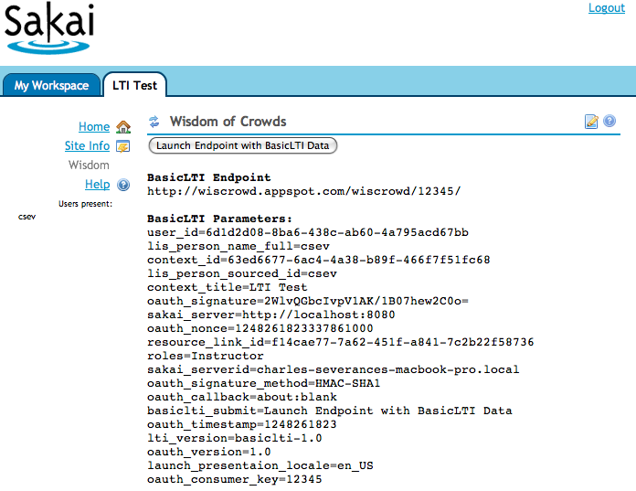

When you press the button, the launch continues to the external tool. While it might seem strange to see the launch data, the OAuth approach (www.oauth.net) to security is designed assuming that the launch data may be viewed as it passes through the browser in a form post.

LMS Feature - Virtual Tool
In this scenario, the Sakai administrator is going to create a virtual tool and set some or all of the parameters for the tool. The Instructor will see the virtual tool as any other tool in Site Setup and the students will see and use the tool like any other tool with no indicator that the tool is running outside Sakai.

We create a virtual tool by editing the tool registration file - IMSBLTIPortlet.xml – this file contains the registration for the Basic LTI Tool as follows:
<?xml version="1.0"?>
<registration>
<tool
id="sakai.basiclti"
title="Basic LTI"
description="IMS Basic Learning Tools Interoperability.">

<configuration name="sakai:portlet-pre-render" value="true" />

<category name="course" />
<category name="project" />
<category name="portfolio" />

<configuration name="functions.require" />
<configuration name="imsti.launch" />
<configuration name="imsti.xml" />
<configuration name="imsti.secret" />
<configuration name="imsti.key" />
<configuration name="imsti.pagetitle" />
<configuration name="imsti.tooltitle" />
<configuration name="imsti.newwindow" />
<configuration name="imsti.frameheight" />
<configuration name="imsti.debug" />

<configuration name="final.launch" value="false"/>
<configuration name="final.xml" value="false"/>
<configuration name="final.secret" value="false"/>
<configuration name="final.key" value="false"/>
<configuration name="final.pagetitle" value="false"/>
<configuration name="final.tooltitle" value="false"/>
<configuration name="final.newwindow" value="false"/>
<configuration name="final.frameheight" value="false"/>
<configuration name="final.debug" value="false"/>
</tool>
</registration>

The administrator can add multiple tool registrations to this file by adding multiple <tool> sections. The Basic LTI portlet has several capabilities controlled by properties. The basic idea is that you can set a property that is equivalent to setting the property in the configuration screen of the tool. And if you also set the corresponding "final" property to "true" – then the instructor will neither see, nor be able to change that property. So the administrator can set and completely lock down the properties – or lock-down most of the properties.
The configuration screen only displays the "non-final" properties. Here is a simple example additional registration:
<tool
id="sakai.testlti"
title="Testing BLTI"
description="Testing Basic LTI.">

<configuration name="sakai:portlet-pre-render" value="true" />

<category name="course" />
<category name="project" />
<category name="portfolio" />

<configuration name="functions.require" />

<configuration name="imsti.launch"
value="http://www.imsglobal.org/developers/BLTI/tool.php" />
<configuration name="imsti.xml" />
<configuration name="imsti.secret" value="secret" />
<configuration name="imsti.key" value="lmsng.school.edu" />
<configuration name="imsti.pagetitle" />
<configuration name="imsti.tooltitle" />
<configuration name="imsti.frameheight" />
<configuration name="imsti.debug" />

<configuration name="final.launch" value="true"/>
<configuration name="final.xml" value="true"/>
<configuration name="final.secret" value="true"/>
<configuration name="final.key" value="true"/>
<configuration name="final.pagetitle" value="false"/>
<configuration name="final.tooltitle" value="false"/>
<configuration name="final.newwindow" value="false"/>
<configuration name="final.frameheight" value="false"/>
<configuration name="final.debug" value="false"/>

</tool>

Note that it is important to give the new tool registration a new tool identifier (i.e. sakai.testlti).
Also note that the xml and launch parameters are related when it comes to making them final. If xml, secret, and key are final, then launch will not be editable in the portlet and similarly if launch, secret, and key are final, then xml will not be editable in the portlet.
Also note that launch has precedence over xml. If both are specified - launch will be used.
Another way to set properties for a portlet is to use the sakai.properties file. When you set a property in this way it acts as final and overrides values in the tool registration, above and suppresses the ability to edit the field in the Portlet.
sakai.testlti.launch=http://www.imsglobal.org/developers/BLTI/tool.php
sakai.testlti.key=lmsng.edu
sakai.testlti.secret=secret

It is a good idea when using this feature to set all of the configuration in the tool registration XML including which fields are final, except perhaps the launch, key and secret and then specify launch, key and secret in the sakai.properties file. This allows you to change a key and secret without touching the XML registration file.
When this tool registration is added, it appears in the tool list as any other tool:
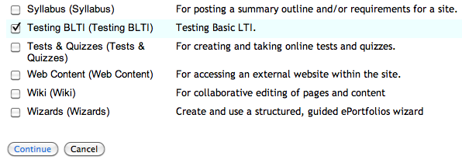
Once the tool is selected, since the launch is pre-configured – the user (Instructor or student) simply sees the tool output:

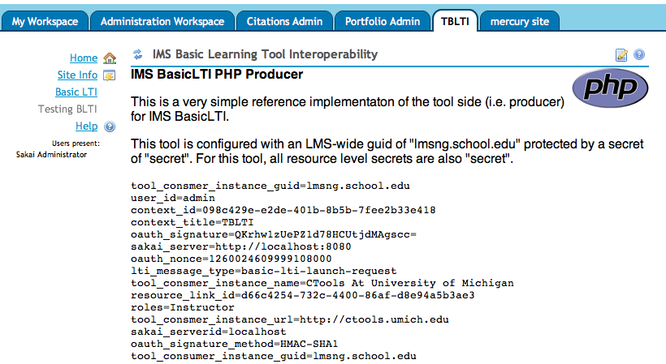

If the instructor goes into the configuration screen, those properties marked "final" are not shown and cannot be edited.

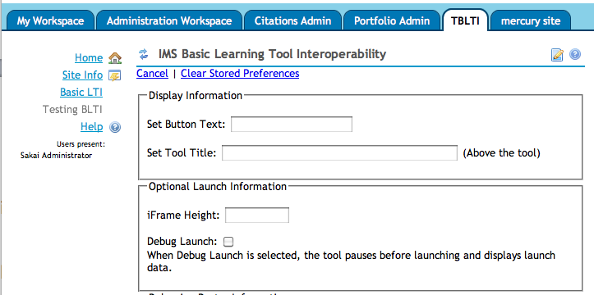

This provides a lot of flexibility in allowing the instructor to set some of the fields as determined by the LMS administrator.

The additional tool registrations can be placed in the IMSBLTIPortlet.xml file in the basiclti source tree or they can be placed in the sakai.home directory within your tomcat as follows:

${sakai.home}/portlets/imsblti/IMSBLTIPortlet.xml
${sakai.home}/portlets/IMSBLTIPortlet.xml

The path that includes the servlet name (imsblti) is the preferred location for the files. The name of the XML file must match the portlet's name as defined in the portlet.xml file. When either of these files is present, the IMSBLTIPortlet.xml file from the war is ignored.

Important Note: When you create either of these files in sakai.home, Sakai's portlet tool registration will ignore the tool registration of sakai.basiclti from within the war file. So you must include the registration of sakai.basiclti in the file that you store in sakai.home. This does give you the option of choosing to not registe the "generic tool" and only registering the virtual tools that you choose. It also allows you to change the defaults of the generic sakai.basiclti tool as well based perhaps on your site's policies by creating this file in sakai.home.

This allows administrators to deploy new tools and change configuration options without making a patch or recompiling Sakai.

Administrators can also create "one-off" custom tools for a site by placing the generic Basic LTI tool into a site and going into the administrator screen and altering the properties for the tool placement. The admin can set all properties and mark them as final as needed. This can be used to whip up a "virtual tool" without restarting Sakai or to test tool settings before making a new permanent tool registration.

Architecture and Hacking
The Basic LTI approach is quite simple – to launch the tool, the LMS creates a form with the LMS data, uses OAuth to sign the form data and posting URL, and the OAuth parameters are added to the form. The form is then sent to the browser and looks as follows:
<div id="ltiLaunchFormSubmitArea">
<form action="http://wiscrowd.appspot.com/wiscrowd/12345/" name="ltiLaunchForm" id="ltiLaunchForm" method="post">
<input type="hidden" size="40" name="user_id" alue="6d1d2d08-8ba6-438c-ab60-4a795acd67bb"/>
<input type="hidden" size="40" name="lis_person_name_full" value="csev"/>
<input type="hidden" size="40" name="context_id" value="63ed6677-6ac4-4a38-b89f-466f7f51fc68"/>
<input type="hidden" size="40" name="lis_person_sourced_id" value="csev"/>
<input type="hidden" size="40" name="context_title" value="LTI Test"/>
<input type="hidden" size="40" name="oauth_signature" value="ORm1rXpJUOQj8nl1Haqzxg9Y138&#61;"/>
<input type="hidden" size="40" name="ext_sakai_server" value="http://localhost:8080"/>
<input type="hidden" size="40" name="oauth_nonce" value="1248267304363525000"/>
<input type="hidden" size="40" name="resource_link_id" value="1df05052-51e6-4d52-a118-997f62229000"/>
<input type="hidden" size="40" name="roles" value="Instructor"/>
<input type="hidden" size="40" name="ext_sakai_serverid" value="charles-severances-macbook.local"/>
<input type="hidden" size="40" name="oauth_signature_method" value="HMAC-SHA1"/>
<input type="hidden" size="40" name="oauth_callback" value="about:blank"/>
<input type="submit" size="40" name="basiclti_submit" value="Launch Endpoint with BasicLTI Data"/>
<input type="hidden" size="40" name="oauth_timestamp" value="1248267304"/>
<input type="hidden" size="40" name="lti_version" value="basiclti-1.0"/>
<input type="hidden" size="40" name="oauth_version" value="1.0"/>
<input type="hidden" size="40" name="launch_presentaion_locale" value="en_US"/>
<input type="hidden" size="40" name="oauth_consumer_key" value="12345"/>
</form>
</div> <script language="javascript">
document.getElementById("ltiLaunchFormSubmitArea").style.display = "none";
nei = document.createElement('input');
nei.setAttribute('type', 'hidden');
nei.setAttribute('name', 'basiclti_submit');
nei.setAttribute('value', 'Launch Endpoint with BasicLTI Data');
document.getElementById("ltiLaunchForm").appendChild(nei);
document.ltiLaunchForm.submit();
</script>

The form contains both the LMS data and the OAuth security material including the oauth_signature. The portlet also includes Javascript to hide the form, and then automatically submit the form. If Javascript is turned off, the form submit button remains visible and the user must press the button to proceed to the external tool.
Since Basic LTI is a portlet, we do not have the "frame-within-frame" problem that Linktool would have since LinkTool is a traditional Sakai tool. But since Basic LTI demands an iframe for an external tool the Basic LTI portlet generates an iframe for the external tool content and places the following URL into the iframe:
/access/basiclti/site/63ed6677-6ac4-4-466f7f51fc68/dcb61c3e-508-3238ecd330cc
The URL is served through /access and a basiclti Entity Producer. This means that the URL can effectively be used anywhere. It needs to be in its own window or in an iFrame because it will generate and auto-submit the form data as shown above – but this allows clever reuse of these placement urls.
An instructor could author some placements – then hide the buttons using Page Order tool and then simply use these URLs wherever appropriate. Of course users must belong to the site and be logged in for the external resource to launch.
In fact, if there was interest, we could write web services or a Site Info extension to make placements independent of the tool and then simply launch to the proper URL. Another possible feature would be to add a checkbox to "hide the tool from students" and show the instructor the access URL as part of the configuration dialog.

Comparing Basic LTI With Sakai LinkTool
Within the Sakai community, one of my goals is to convince developers to stop using the LinkTool since the LinkTool only works with Sakai. Developers who have built external tools that support the LinkTool protocol should be able to add Basic Tool Interoperability.

Since Basic LTI uses OAuth, it does not require any web-services call-back to Sakai for key validation (i.e. you do not need to call SakaiSigning.jws). This allows as Sakai site to use Basic LTI with web-services turned off and also improves reliability in situations where campus proxy servers are in operation which may block some of these web service calls. Also it discourages the writing of tools that "trust" the linktool call parameters without calling Sakaisigning.jws.

The ultimate advantage of using Basic LTI over LinkTool is primarily the fact that as more consumer/proxy tools are written in different environments such as SharePoint, Blackboard, WebCT, Moodle, Kewl3, etc – that these tools can work in those environments as well as Sakai.

Basic LTI does put a small additional burden on external tool developers, as they need to support the OAuth approach and Basic LTI sign-on (see sample code from IMS).
It is possible for an external tool that uses Basic LTI for launch, provisioning, and trust to use the run-time web services developed for use with LinkTool tools. The Sakai BasicLTI tool includes a signed session key and server information in the ext_sakai_session and ext_sakai_server variables. These values are created in the exact same manner as the LinkTool so they can be used with these web services.

Conclusion
By getting started and using Basic LTI to integrate external tools into a number of Learning Management Systems, we can make real progress in important functionality mash up use cases. This work will inform the IMS LTI effort and help accelerate the time when we have a common standard for functionality mash up for extremely rich learning tools.

If you would like to learn more about the IMS Basic LTI work, you can visit:

http://www.imsglobal.org/

or join the Free IMS Community Developer's forum at:

http://www.imsglobal.org/community/forum/index.cfm?forumid=11

The longest-term goal is to create a market for external tools and content that can easily be plugged into any LMS system including some we have not even yet imagined.

Going Forward With Basic LTI

The logical next steps beyond this work are to (1) upgrade Simple LTI support in Melete to include Basic LTI, and (2) build support for importing IMS Common Cartridges with embedded BasicLTI links into Sakai and Melete.

Another possibility is to add the ability to author a Basic LTI placement in the Resources tool. Since so much of Basic LTI is based on provided library code and we already have an EntityProducer in hand – the additional work may not be so great – but first we need some motivating use cases for such a feature.

