Using Basic LTI Simple Outcomes
Charles Severance
August 4, 2010

Introduction
This document describes some very initial support in Sakai for receiving grades from an external tool and routing those grades to the Sakai grade book that was launched via IMS Basic LTI.

Configuration
In order to enable the Basic LTI Tool Provider, you must add the following values to the sakai.properties for your server:
basiclti.outcomes.enabled=true
webservices.allow=.+

The first item enables the provider and the second item sets the values for the IP address and/or domain addresses from which requests will be accepted. The Basic LTI Tool Provider uses the same request filter to block incoming requests as Sakai web services. For details on IP address filtering, see org.sakaiproject.util.RemoteHostFilter.
Also, the Gradebook demands to know an account that is setting each grade. Since these grades are being set via web services, we can define that account that is to be treated as the "grade setting" account using the following properties:
basiclti.outcomes.userid=basiclti
basiclti.outcomes.usereid=basiclti

You must create the User in the administrator interface before accepting web service requests to set outcomes. If this points to a non-existent account, any attempt to set a grade will fail with a Null Pointer Exception.

Testing Outcomes
You can point a Basic LTI Tool at the following URL
http://developers.imsglobal.org/BLTI/tool.php
key: lmsng.school.edu
secret: secret

Since the Outcome service is server to server call, the IMS server will not be able to call back to your Outcome service if it is running on localhost (i.e. without a real IP address). The solution is to do your testing on a real server or to check out a copy of the testing harness from:
http://code.google.com/p/ims-dev/

If you run this PHP code on your local host, then it will be able to make the callbacks to your Sakai server also running on your localhost. The screen to exercise the outcomes service looks as follows
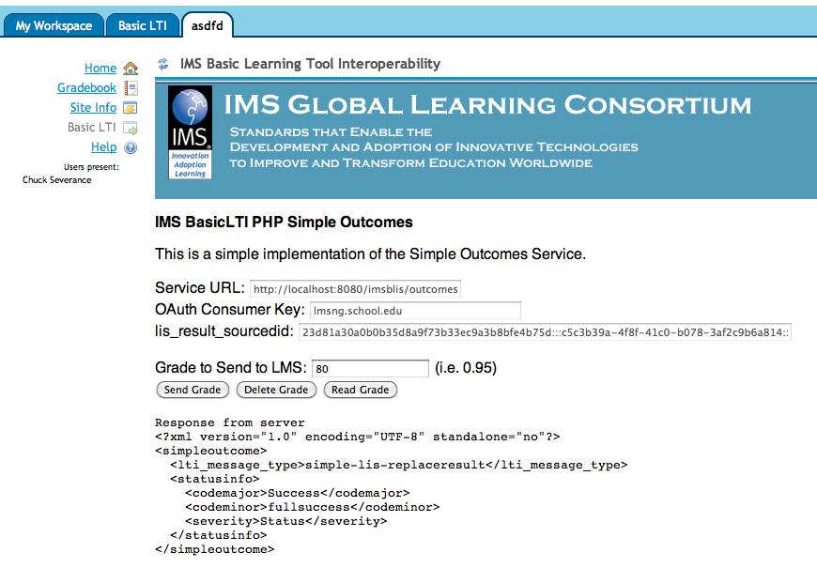
The source code for making the outcome callbacks is in the setoutcome.php code in the ims-dev code above.

Security Checks for Release
Since it is so important to protect the URL for the outcomes, please make the following test of every released version of Sakai.
Once your Sakai has started up, navigate to the following URL:
http://localhost:8080/imsblis/outcomes

The out-of-the-box distribution should not include properties to enable outcomes so unless you have added the properties, you should see a 403 (Forbidden) message as shown below:

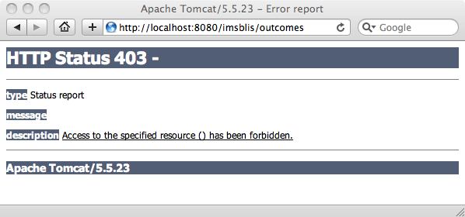

You should also see a warning message in the catalina.out file:
2010-08-04 13:12:41,656 WARN http-8080-Processor21 org.sakaiproject.blti.SimpleOutcomesServlet - Basic LTI Outcomes are Disabled IP=0:0:0:0:0:0:0:1%0

These two indicate that the Basic LTI Outcomes is properly disabled in the out of the box configuration. Out of the box, there are two ways that the servlet is protected and two properties that need to be changed. First, the RemoteHostFilter is configured to only accept "local" IP addresses. Second, to get past the 403 response, the outcomes servlet must be enabled in sakai.properties as shown above.

Conclusion
This feature makes it possible to have external tools set grades in Sakai using web services.

If you would like to learn more about the IMS Basic LTI work, you can visit:

http://www.imsglobal.org/developers/BLTI

or join the Free IMS Community Developer's forum at:

http://www.imsglobal.org/community/forum/index.cfm?forumid=11

