Sakai External Tool API
Charles Severance
February 8, 2014

Introduction
This document describes APIs available to an External Tool when launched from Sakai using IMS LTI. Sakai provides APIs for the following capabilities:
- Retrieving a roster including the ability to set al the grades for all of the people in the roster
- Setting a grade in the grade book (outcome) – this is deprecated and included for backwards compatibility since LTI 1.1 now supports outcomes in a standard cross-LMS manner.
- Store a 4K settings string in Sakai that is placed on each launch request. This allows zero-footprint External Tools to be built if all the tool data can be reduced to a single 4K string.
Several of these extensions APIs are implemented in the same fashion in the BasicLTI4Moodle, ATutor 2.0.2, and the Building Block and PowerLink from SPV Software

Testing/Sample Code
Can check out testing/sample code from the following location:
https://source.sakaiproject.org/svn/basiclti/trunk/
basiclti-docs/resources/docs/sakai-api-test

Since these APIs are server to server calls, the simplest approach is to check out a copy of the code onto your development environment running PHP. Once you have checked out the code you can access the extensions tool using a URL like:
http://localhost/~csev/sakai-api-test/tool.php
key: lmsng.school.edu
secret: secret

The test code is quite simple and all of the code is in a few files and so you can use this as sample code if your application is written in PHP.

Configuration
In order to enable the Basic LTI Tool Provider, you must add the following values to the sakai.properties for your server:
basiclti.outcomes.enabled=true
basiclti.roster.enabled=true
basiclti.settings.enabled=true
basiclti.lori.enabled=true

Note: After the LTI 2.1.1 / Sakai 2.9.3 release these four parameters default to "true". See https://jira.sakaiproject.org/browse/BLTI-263 for details.
If you are using the LORI API, you should also probably enable debug logging for the API and leave it on during initial testing and even during light production usage as follows:
log.config.count=2
log.config.1 = DEBUG.org.sakaiproject.blti.ServiceServlet
log.config.2 = DEBUG.org.sakaiproject.blti.LessonsFacade

It is helpful to be able to debug any problems even after the fact. Once things are running smoothly.
Also, the Gradebook demands to know an account that is setting each grade. Since these grades are being set via web services, we can define that account that is to be treated as the "grade setting" account using the following properties:
basiclti.outcomes.userid=basiclti
basiclti.outcomes.usereid=basiclti

You must create the User in the administrator interface before accepting web service requests to set outcomes. If this points to a non-existent account, any attempt to set a grade will fail with a Null Pointer Exception.

Security Checks for Release
Since it is so important to protect the URL for the outcomes, please make the following test of every released version of Sakai.
Once your Sakai has started up, navigate to the following URL:
http://localhost:8080/imsblis/outcomes

The out-of-the-box distribution should not include properties to enable outcomes so unless you have added the properties, you should see a 403 (Forbidden) message as shown below:

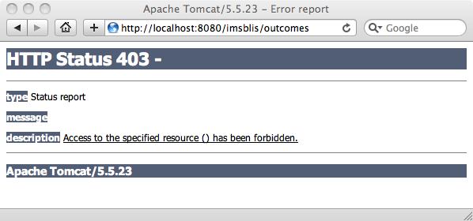

You should also see a warning message in the catalina.out file:
2010-08-04 13:12:41,656 WARN http-8080-Processor21 org.sakaiproject.blti.SimpleOutcomesServlet - Basic LTI Outcomes are Disabled IP=0:0:0:0:0:0:0:1%0

These two indicate that the Basic LTI Outcomes is properly disabled in the out of the box configuration. Out of the box, there are two ways that the servlet is protected and two properties that need to be changed. First, the RemoteHostFilter is configured to only accept "local" IP addresses. Second, to get past the 403 response, the outcomes servlet must be enabled in sakai.properties as shown above.

Configuration Within Sakai
Once you have enabled the extensions in sakai.properties, you must enable them in the tool placement configuration as well:

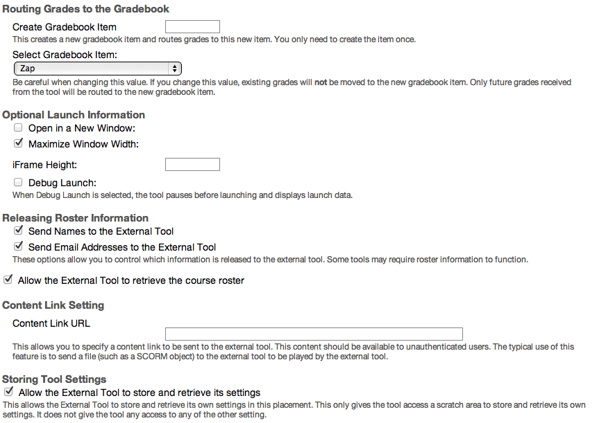

Once you have the settings enabled, the tool.php code will detect the additional launch parameters and allow you to exercise the APIs:

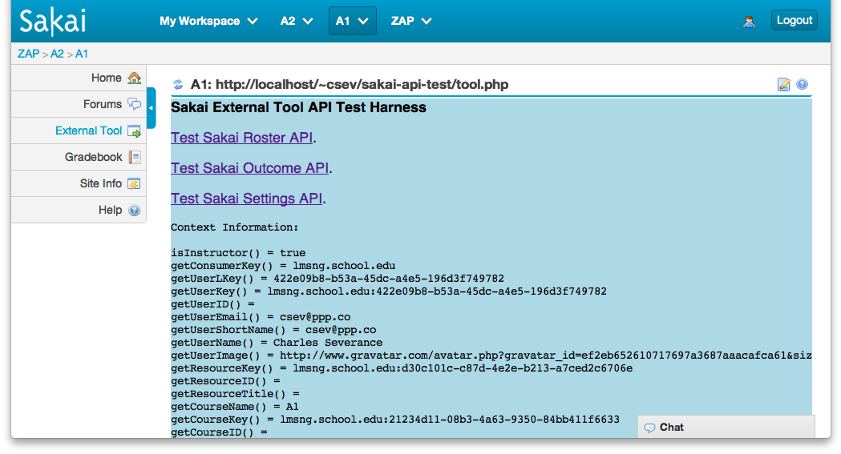
There is a test harness for each API that allows you to exercise the API. Each screen has a form to specify parameters, makes the calls and dumps out request and response data to help you debug your tools and implementations.

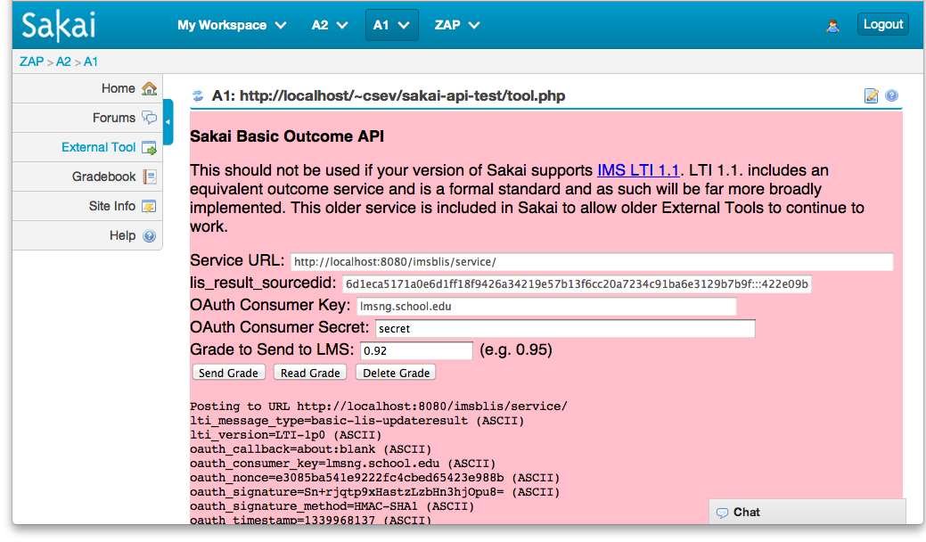
You can also look at the source code of the test harness to help develop your own External Tools to call this API.

Roster API
This is the most useful of the extensions - it allows the External Tool to retrieve the entire roster of the context_id (i.e. course). If Sakai is willing to provide the roster it adds the following values to the launch:

ext_ims_lis_memberships_url=http://localhost:8080/imsblis/service/ ext_ims_lis_memberships_id=7d65a1b397c0d4b1e86b6
To retrieve the roster, the Tool Provider sends the following POST data (form encoded) and signed using OAuth to the ext_ims_lis_memberships_url.

POST http://localhost:8080/imsblis/service/
id=7d65a1b397c0d4b1e86b6
lti_message_type=basic-lis-readmembershipsforcontext
lti_version=LTI-1p0
oauth_callback=about:blank
oauth_consumer_key=12345
oauth_nonce=0c9a78b4fef3a8c06852af669b682ac4 oauth_signature=lyd/UAIyf/82kyw/bljrxILcGhM=
oauth_signature_method=HMAC-SHA1
oauth_timestamp=1338867958
oauth_version=1.0

id
The id is the one provided on the launch as ext_ims_lis_memberships_id. This value is opaque and signed by Sakai to insure that it is not modified by the External Tool.
Returned Data
<?xml version="1.0" encoding="UTF-8" standalone="no"?>
<message_response>
<lti_message_type>basic-lis-readmembershipsforcontext</lti_message_type>
<members>
<member>
<lis_result_sourcedid>7d69999997</lis_result_sourcedid>
<person_contact_email_primary>hir@ppp.com</person_contact_email_primary>
<person_name_family>Sakai</person_name_family>
<person_name_full>Hirouki Sakai</person_name_full>
<person_name_given>Hirouki</person_name_given>
<person_sourcedid>hirouki</person_sourcedid>
<role>Instructor</role>
<user_id>422e099999-45dc-a4e5-196d3f749782</user_id>
</member>
<member>
<lis_result_sourcedid>7d65a1b397</lis_result_sourcedid>
<person_contact_email_primary>csev@ppp.co</person_contact_email_primary>
<person_name_family>Severance</person_name_family>
<person_name_full>Charles Severance</person_name_full>
<person_name_given>Charles</person_name_given>
<person_sourcedid>csev</person_sourcedid>
<role>Learner</role>
<user_id>422e09b8-b53a-45dc-a4e5-196d3f749782</user_id>
</member>
</members>
<statusinfo>
<codemajor>Success</codemajor>
<codeminor>fullsuccess</codeminor>
<severity>Status</severity>
</statusinfo>
</message_response>

Basic Outcomes API (Deprecated after LTI 1.1)
If Sakai is willing to allow the external tool to set an outcome for a particular user/resource/context combination, it adds the following values to the launch:
ext_ims_lis_basic_outcome_url=http://localhost:8080/imsblis/service/
lis_result_sourcedid=7d65a1b397

The lis_result_sourcedid is not prefixed with "ext_" because it is a valid launch parameter in LTI 1.0 and 1.1.
To set the outcome, the Tool Provider sends the following POST data (form encoded) and signed using OAuth to the ext_ims_lis_basic_outcome_url.
POST http://localhost:8080/imsblis/service/

lti_message_type=basic-lis-updateresult
result_resultscore_textstring=0.10
result_resultdata_text=Nice work!
sourcedid=7d65a1b397
lti_version=LTI-1p0
oauth_callback=about:blank
oauth_consumer_key=12345
oauth_nonce=bdcb2d645ba41255f0bce60bb31e3ace
oauth_signature=0G0SXTS1eLMh4FCZ9q4JYlLjSyE=
oauth_signature_method=HMAC-SHA1
oauth_timestamp=1338868573
oauth_version=1.0

sourcedid
This is the value from the launch lis_result_sourcedid for the user/resource/context combination. This value is opaque and is internally signed by the Sakai to insure that it is not modified by the External Tool.
result_resultscore_textstring
A floating point number between 0.0 and 1.0.
Returned Data
<?xml version="1.0" encoding="UTF-8" standalone="no"?>
<message_response>
<lti_message_type>basic-lis-updateresult</lti_message_type>
<statusinfo>
<codemajor>Success</codemajor>
<codeminor>fullsuccess</codeminor>
<severity>Status</severity>
</statusinfo>
</message_response>

Launch Setting Service
This setting extension is not widely used. It allows an External Tool to store up to 4K of data within the Sakai tool placement to be included on every launch. There is one setting per resource_link_id across all values for user_id. The idea was to allow a service to be built that required no storage on a per resource_link_id basis. If the Sakai is willing to store launch data, it adds the following values to the launch:

ext_ims_lti_tool_setting_id=832823923899238 ext_ims_lti_tool_setting_url=http://localhost:8080/imsblis/service/

If there is a setting associate with the launch, the TC adds this parameter to every launch from the resource_link_id:
ext_ims_lti_tool_setting=previous launch data
This data will be the same for all values of the user_id parameter form a particular resource_link_id. This is a per-resource store. Not per-user store.
To set the launch data, the does the following:
POST http://localhost:8080/imsblis/service/
id=832823923899238
lti_message_type=basic-lti-savesetting
lti_version=LTI-1p0
setting=Some Setting Data
oauth_callback=about:blank
oauth_consumer_key=12345
oauth_nonce=14c6211cc66d9525304f085551d50b1d
oauth_signature=IGy7KlO9DZ1qfShYBYE+BhCfuec=
oauth_signature_method=HMAC-SHA1
oauth_timestamp=1338872426
oauth_version=1.0

The id value is the value from ext_ims_lti_tool_setting_id on the launch. The setting is the data to be included in the setting. It is a maximum of 4K.
Returned Data
<?xml version="1.0" encoding="UTF-8" standalone="no"?>
<message_response>
<lti_message_type>basic-lti-savesetting</lti_message_type>
<statusinfo>
<codemajor>Success</codemajor>
<codeminor>fullsuccess</codeminor>
<severity>Status</severity>
</statusinfo>
</message_response>

Learning Object Repository Integration (LORI) XML API
This LORI API allows an External Tool to call back into Sakai and install LTI links in the Lessons tool. The External tool can retrieve the current Lessons structure and install a single link or hierarchical list of links into Lessons. The ability to install links is under the control of the Admin or Instructor on a site-by-site basis. There is both an XML (LTI 1.1 style) and JSON (LTI 2.0 style) version of this API.
External tools that only need to work with Sakai can use either API. You can check with other LMS systems to see if they have equivalent APIs. Neither of the two variants of this API are an IMS standard – they are only Sakai-specific extension.
If Sakai is willing to allow the external tool to install tools into Lessons for this site, it adds the following values to the launch:
ext_lori_api_url_xml=http://localhost:8080/imsblis/service
lis_result_sourcedid=7d65a1b397

The lis_result_sourcedid is not prefixed with "ext_" because it is a valid launch parameter in LTI 1.0 and 1.1. The lis_result_sourcedid is an opaque token that is signed by Sakai and connects to the permission to insert items into Lessons stored in the LT launch structure within Sakai.
If you are using the External Tool Portlet in Sakai, the following checkbox is available if you are running the proper version of LTI in your Sakai and have enabled the LORI API in your sakai.properties as described above.

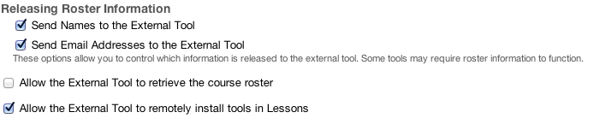
This permission can be revoked even after the External Tool has received the lis_result_sourcedid because the setting is checked in the placement after the lis_result_sourcedid has been verified as valid in a web service request.
If the sakai-api-test/tool.php code detects that these parameters are present, it offers to run test code to exercise the APIs. This code also serves as a sample as to how to call these APIs from PHP.
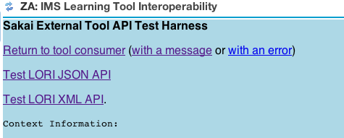
There are two capabilities available via the API. You can retrieve the hierarchical list of folders in Lessons and you can add one or more LTI links to Lessons.
To retrieve the list of existing folders in Lessons, send the following XML to the ext_lori_api_url_xml signed using OAuth body hashing using the same technique as IMS LTI 1.1.
<?xml version="1.0" encoding="UTF-8" standalone="no"?>
<imsx_POXEnvelopeRequest>
<imsx_POXHeader>
<imsx_POXRequestHeaderInfo>
<imsx_version>V1.0</imsx_version>
<imsx_messageIdentifier>50ca1693</imsx_messageIdentifier>
</imsx_POXRequestHeaderInfo>
</imsx_POXHeader>
<imsx_POXBody>
<getCourseStructureRequest>
<params>
<courseId>f3fbe9113e</courseId>
<userId>6eb4fba7</userId>
<sourcedGUID>
<sourcedId>91fa5d81e961bd506074b1c2d29</sourcedId>
</sourcedGUID>
</params>
</getCourseStructureRequest>
</imsx_POXBody>
</imsx_POXEnvelopeRequest>

Returned Data
<?xml version="1.0" encoding="UTF-8"?>
<imsx_POXEnvelopeResponse>
<imsx_POXHeader>
<imsx_POXResponseHeaderInfo>
<imsx_version>V1.0</imsx_version>
<imsx_messageIdentifier>135517</imsx_messageIdentifier>
<imsx_statusInfo>
<imsx_codeMajor>success</imsx_codeMajor>
<imsx_severity>status</imsx_severity>
<imsx_description>Cool</imsx_description>
<imsx_messageRefIdentifier>50ca1693</imsx_messageRefIdentifier>
<imsx_operationRefIdentifier>
getCourseStructureRequest
</imsx_operationRefIdentifier>
</imsx_statusInfo>
</imsx_POXResponseHeaderInfo>
</imsx_POXHeader>
<imsx_POXBody>
<getCourseStructureResponse>
<resources>
<resource>
<description>Lessons</description>
<folderId>1</folderId>
<resources>
<resource>
<description>Pre-Work</description>
<folderId>3</folderId>
<title>Pre-Work</title>
<type>folder</type>
</resource>
</resources>
<title>Lessons</title>
<type>folder</type>
</resource>
</resources>
</getCourseStructureResponse>
</imsx_POXBody>
</imsx_POXEnvelopeResponse>

The following is the send and received data when you want to add one or more items into the Lessons structure:
<?xml version="1.0" encoding="UTF-8" standalone="no"?>
<imsx_POXEnvelopeRequest>
<imsx_POXHeader>
<imsx_POXRequestHeaderInfo>
<imsx_version>V1.0</imsx_version>
<imsx_messageIdentifier>50ca1693</imsx_messageIdentifier>
</imsx_POXRequestHeaderInfo>
</imsx_POXHeader>
<imsx_POXBody>
<addCourseResourcesRequest>
<params>
<folderId>3</folderId>
<courseId>f3fbe9113e</courseId>
<userId>6eb4fba7</userId>
<sourcedGUID>
<sourcedId>91fa5d81e961bd506074b1c2d29</sourcedId>
</sourcedGUID>
<resources>
<resource>
<launchUrl>http://localhost/~csev/sakai-api-test/ext/lori_xml.php</launchUrl>
<tempId>4fe4d1794b65eb4b43000001</tempId>
<title>Color Test</title>
<type>lti</type>
</resource>
</resources>
</params>
</addCourseResourcesRequest>
</imsx_POXBody>
</imsx_POXEnvelopeRequest>

Returned Data
<?xml version="1.0" encoding="UTF-8"?>
<imsx_POXEnvelopeResponse>
<imsx_POXHeader>
<imsx_POXResponseHeaderInfo>
<imsx_version>V1.0</imsx_version>
<imsx_messageIdentifier>135517</imsx_messageIdentifier>
<imsx_statusInfo>
<imsx_codeMajor>success</imsx_codeMajor>
<imsx_severity>status</imsx_severity>
<imsx_description>Cool</imsx_description>
<imsx_messageRefIdentifier>50ca1693</imsx_messageRefIdentifier>
<imsx_operationRefIdentifier>
getCourseStructureRequest
</imsx_operationRefIdentifier>
</imsx_statusInfo>
</imsx_POXResponseHeaderInfo>
</imsx_POXHeader>
<imsx_POXBody>
<addCourseResourcesResponse>
<resources>
<resource>
<id>/blti/35</id>
<tempId>4fe4d1794b65eb4b43000001</tempId>
</resource>
</resources>
</addCourseResourcesResponse>
</imsx_POXBody>
</imsx_POXEnvelopeResponse>

There is a tempId / id pair for each link that was inserted successfully.

Conclusion
These services allow external tools to have a more rich interaction with Sakai.

