Using the Sakai Basic LTI Portlet
Charles Severance
October 13, 2009

Introduction
The Sakai Basic LTI portlet implements the IMS Basic Learning Tools Interoperability standard. BasicLTI allows the launching and sharing of information with an externally hosted tool using standard protocols, signed securely using the OAuth (www.oauth.net) security mechanism.

The Sakai BasicLTI portlet supports three basic use cases:

- An instructor can crate a tool placement which points to an external tool and put in a URL, secret, and password to "mash-up" functionality from various sources into their course.

- The system administrator can create virtual tool pointing to an externally hosted tool and place the tool into Site Setup. Instructors can add the tool to their site without even knowing that the tool is hosted externally and it will be launched using Basic LTI.

- The system administrator makes a site-licensing arrangement with an external provide of software as a service (such as Icodeon) or protected content from a publisher (such as Pearson or McGraw-Hill) and allow instructors to point to the resources without needing a password.

The basic idea is that the Basic LTI portlet provides an endpoint for an externally hosted tool or content and makes it appear if the externally hosted tool is running within Sakai. In a sense this is kind of like a smart “iFrame” tool that can host lots of different content.

The Basic LTI portlet provides the externally hosted tool/content with information about the individual, course, tool placement, and role within the course and allows a “federated single-sign-on” using in-browser REST-style launching and allows an externally hosted tool to support many different LMS’s from multiple vendors with a single instance of the external tool or resource.

Basic Mash-Up
Once the Basic LTI Portlet is added to your Sakai instance, it can either be made available directly to instructors or stealthed so only technical support can add it to courses. Since the LTI portlet (like LinkTool) shares information with external servers, keeping it stealthed is a good first approach until experience is gained with the tool. When the tool is available to instructors, it simply shows up as an available tool in Site Setup.

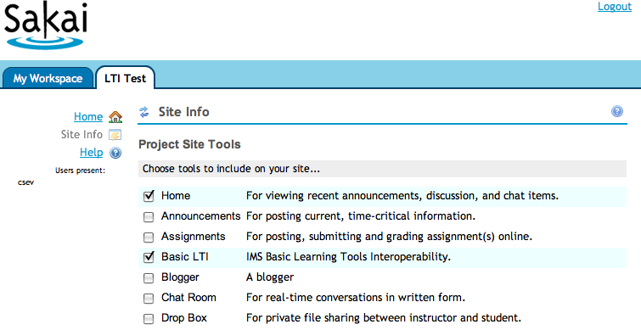

Once the tool is placed in the site, it must be configured. Pressing the "pencil" icon in the title bar configures JSR-168 portlets. The configuration screen of the Basic LTI tool is as follows:

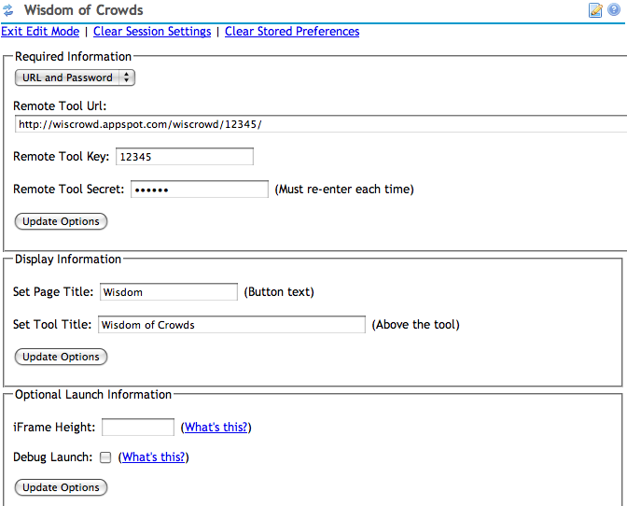

The external tool provider will give the instructor a launch url, key and secret. In addition to providing these fields, the instructor can set the button text, title text, and iframe height to control how the tool is displayed in Sakai.

The "debug launch" feature causes Sakai to pause before submitting the single sign on data to the external tool. In a debug launch the user is presented a button to submit the launch data to the external tool. He debug launch is described in more detail below.

The next set of configuration fields deal with the release of student names and E-Mail addresses and allows the instructor to set any needed custom parameters.

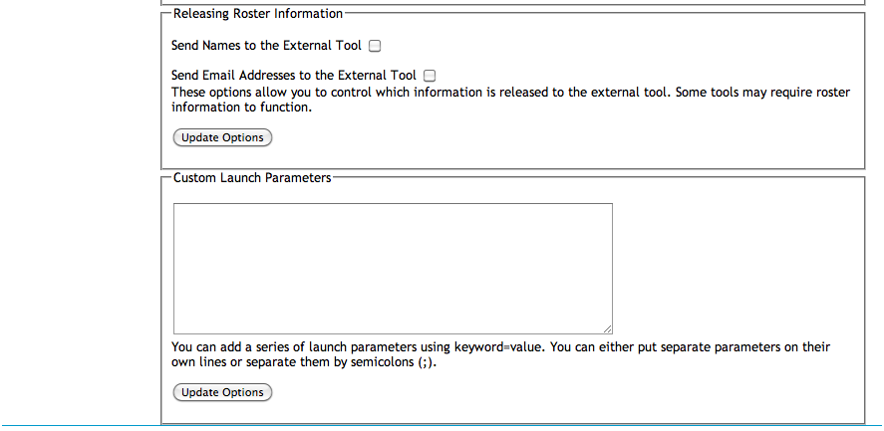

The custom parameters are fields are defined by the tool and may be required by the external tool.

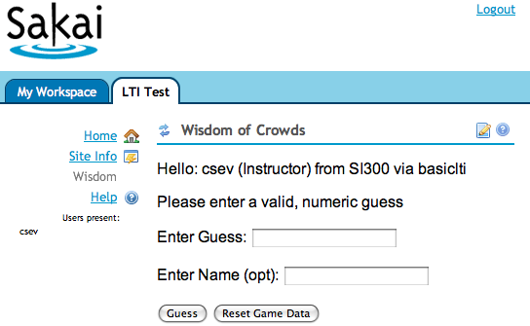

Once the tool configuration is completed, the tool is immediately launched.

LMS Feature - Virtual Tool
In this scenario, the Sakai administrator is going to create a virtual tool and set some or all of the parameters for the tool. The Instructor will see the virtual tool as any other tool in Site Setup and the students will see and use the tool like any other tool with no indicator that the tool is running outside Sakai.

We create a virtual tool by editing the tool registration file - IMSBLTIPortlet.xml – this file contains the registration for the Basic LTI Tool as follows:
<?xml version="1.0"?>
<registration>
<tool
id="sakai.basiclti"
title="Basic LTI"
description="IMS Basic Learning Tools Interoperability.">

<configuration name="sakai:portlet-pre-render" value="true" />

<category name="course" />
<category name="project" />
<category name="portfolio" />

<configuration name="functions.require" />
<configuration name="imsti.launch" />
<configuration name="imsti.xml" />
<configuration name="imsti.secret" />
<configuration name="imsti.key" />
<configuration name="imsti.pagetitle" />
<configuration name="imsti.tooltitle" />
<configuration name="imsti.newwindow" />
<configuration name="imsti.frameheight" />
<configuration name="imsti.debug" />

<configuration name="final.launch" value="false"/>
<configuration name="final.xml" value="false"/>
<configuration name="final.secret" value="false"/>
<configuration name="final.key" value="false"/>
<configuration name="final.pagetitle" value="false"/>
<configuration name="final.tooltitle" value="false"/>
<configuration name="final.newwindow" value="false"/>
<configuration name="final.frameheight" value="false"/>
<configuration name="final.debug" value="false"/>
</tool>
</registration>

The administrator can add multiple tool registrations to this file by adding multiple <tool> sections. The Basic LTI portlet has several capabilities controlled by properties. The basic idea is that you can set a property that is equivalent to setting the property in the configuration screen of the tool. And if you also set the corresponding "final" property to "true" – then the instructor will neither see, nor be able to change that property. So the administrator can set and completely lock down the properties – or lock-down most of the properties.
The configuration screen only displays the "non-final" properties. Here is a simple example additional registration:
<tool
id="sakai.wisdom"
title="Crowds"
description="Wisdom of Crowds - James Surowecki.">

<configuration name="sakai:portlet-pre-render" value="true" />

<category name="course" />
<category name="project" />
<category name="portfolio" />

<configuration name="functions.require" />

<configuration name="imsti.launch"
value="http://wiscrowd.appspot.com/wiscrowd/12345/" />
<configuration name="imsti.xml" />
<configuration name="imsti.secret" value="secret" />
<configuration name="imsti.key" value="12345" />
<configuration name="imsti.pagetitle" />
<configuration name="imsti.tooltitle" />
<configuration name="imsti.frameheight" />
<configuration name="imsti.debug" />

<configuration name="final.launch" value="true"/>
<configuration name="final.xml" value="true"/>
<configuration name="final.secret" value="true"/>
<configuration name="final.key" value="true"/>
<configuration name="final.pagetitle" value="false"/>
<configuration name="final.tooltitle" value="false"/>
<configuration name="final.newwindow" value="false"/>
<configuration name="final.frameheight" value="false"/>
<configuration name="final.debug" value="false"/>

</tool>

Note that it is important to give the new tool registration a new tool identifier (i.e. sakai.wisdom).
When this tool registration is added, it appears in the tool list as any other tool:
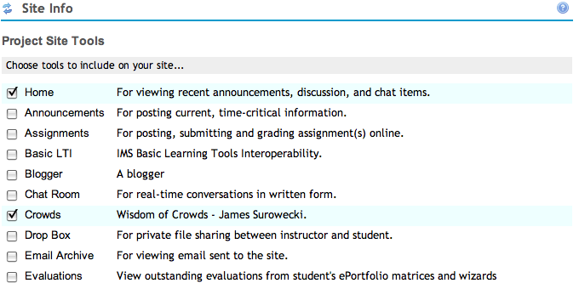

Once the tool is selected, since the launch is pre-configured – the user (Instructor or student) simply sees the tool output:

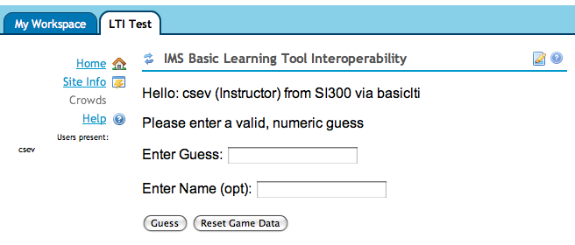

If the instructor goes into the configuration screen, those properties marked "final" are not shown and cannot be edited.

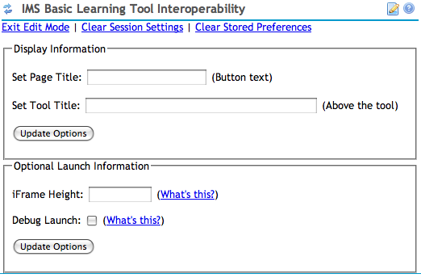

This provides a lot of flexibility in allowing the instructor to set some of the fields as determined by the LMS administrator.

The additional tool registrations can be placed in the IMSBLTIPortlet.xml file in the basiclti source tree or they can be placed in the sakai.home directory within your tomcat as follows:

${sakai.home}/portlets/sakai-blti-portlet/IMSBLTIPortlet.xml
${sakai.home}/portlets/IMSBLTIPortlet.xml

The form which includes the servlet path (sakai-blti-portlet) is the preferred location for the files. The name of the XML file must match the portlet's name as defined in the portlet.xml file. When either of these files is present, the IMSBLTIPortlet.xml file from the war is ignored.

This allows administrators to deploy new tools and change configuration options without making a patch or recompiling Sakai.

Administrators can also create "one-off" custom tools for a site by placing the generic Basic LTI tool into a site and going into the administrator screen and altering the properties for the tool placement. The admin can set all properties and mark them as final as needed. This can be used to whip up a "virtual tool" without restarting Sakai or to test tool settings before making a new permanent tool registration.

Site-Wide Passwords / Site-Licensed Content
Sometimes a vendor will want to give a site-wide license to some content to an LMS. The vendor will want to give a single secret and password that is to be used to sign all of the requests coming from that LMS system.

Having a site-wide secret/password gives a lot of benefit to the external tool/content providers:

- It eliminates managing lots of passwords and talking to lots of instructors and resetting lots of lost passwords..

- It allows the external tool to assume that launches with the same user_id from course to course represents the same user and that when the tool sees the same course_id across multiple launches, it is truly the same course, regardless of the password/secret in the possession of the instructor. This allows the external tool to look at its data for a user across courses within an institution.

- It allows them to distribute "generic" urls that do not encode a "course id" in the URL such as http://katana.mhhe.com/psycology/chapter04/ where the URL indicates a resource – but does not include"context" the user is coming from.

These site-wide passwords are set based on a site-wide identifier chosen by the LMS admin and used across tool vendors. This is set in sakai.properties as follows:

basiclti.consumer_instance_guid=ctools.umich.edu
basiclti.consumer_instance_name=CTools At University of Michigan
basiclti.consumer_instance_url=http://ctools.umich.edu

The GUID is the key for site-wide launches. When making the arrangements for the site-license, the admin communicates their GUID to the external tool/content vendor and the vendor gives them back a secret to be configured into the LMS.

The secret is placed in sakai.properties as follows:

basiclti.consumer_instance_secret=mostly-useless
basiclti.consumer_instance_secret.mhhe.com=98765
basiclti.consumer_instance_secret.math.pearson.com=d1c2e3
basiclti.consumer_instance_secret.physics.umich.edu=karaoke

Where math.pearson.com, mhhe.edu, and physics.umich.edu are pulled from the hostname in the launch url to select the correct secret for the particular launch. In this example katana.mhhe.com in a launch url would match mhhe.com.

When a site wide password exists for a launch, it is always used (i.e. any instructor-entered key/secret information is ignored). This also means that tools can be placed with no key/secret information at all.

These secrets should be protected (like database connection passwords) so care should be taken when storing this information in source control or passing files around. Also the secrets should be long and random and changed from time to time.

The OAuth security mechanism is vulnerable to robot-guessing of the password. So having long passwords and varying the length and content makes robot guessing far less tractable.

Test Sites
I have several test sites that you can use that I will try to keep up as much as possible:
http://www.dr-chuck.com/ims/php-simple/
http://www.dr-chuck.com/ims/php-simple/tool.php
This site accepts a site-level secret of lmsng.edu / 12345. This site also includes a test LMS so you can test your own external tools with a known LMS implementation.
The php-simple code is also available for your use at:
http://code.google.com/p/ims-dev/
You can run a local copy on your workstation or your own server. This also includes sample code for Java and PHP which shows how to construct and receive valid launches using the OAuth security libraries. The Sakai Basic LTI tool uses the Java sample code provided by IMS.
I also have another test site that is a little more fun used in the examples above:
http://wiscrowd.appspot.com/wiscrowd/12345/
This accepts tool level secrets (key=12345, secret=secret) . The fun thing about this test harness is that the "12345" in the URL is the context id – and so no matter which course or LMS you launch Basic LTI from, you are playing the same game instance.
The game lets crowd guess averages. Students don't see the running average; instructors can see the running average by pressing "Guess" over and over. Instructors can reset the game by pressing "Reset". You can learn more about crowd and their wisdom at:
http://en.wikipedia.org/wiki/The_Wisdom_of_Crowds
I will keep the wisdom-of-crowds up and running as a nice test site unless somehow I need to make it real and in production.

You can also get make your own instance of the Wisdom of Crowds application hosted on Google's App Engine by going to:
http://www.tsugiproject.org/

Launching with Debug Mode
If you select Debug Mode the tool launch is paused "half-way-through" and the user is presented a button to continue. This is most useful to debug problems with an external tool. You can view the source of the iframe or simply look at the parameters on the screen.

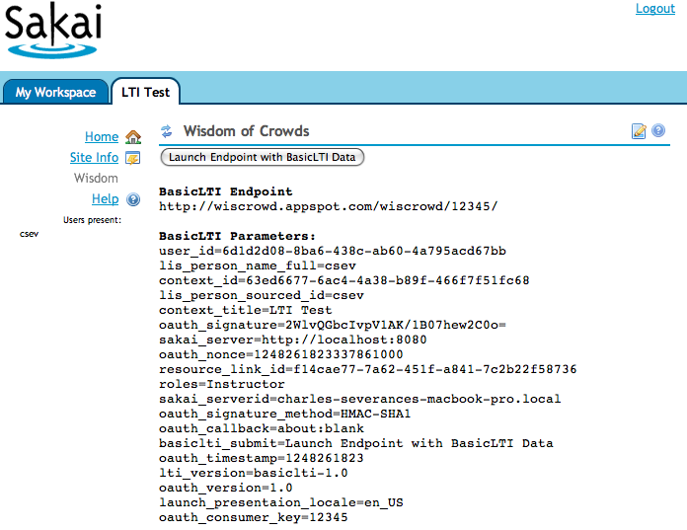

When you press the button, the launch continues to the external tool. While it might seem strange to see the launch data, the OAuth approach (www.oauth.net) to security is designed assuming that the launch data may be viewed as it passes through the browser in a form post.

Architecture and Hacking
The Basic LTI approach is quite simple – to launch the tool, the LMS creates a form with the LMS data, uses OAuth to sign the form data and posting URL, and the OAuth parameters are added to the form. The form is then sent to the browser and looks as follows:
<div id="ltiLaunchFormSubmitArea">
<form action="http://wiscrowd.appspot.com/wiscrowd/12345/" name="ltiLaunchForm" id="ltiLaunchForm" method="post">
<input type="hidden" size="40" name="user_id" alue="6d1d2d08-8ba6-438c-ab60-4a795acd67bb"/>
<input type="hidden" size="40" name="lis_person_name_full" value="csev"/>
<input type="hidden" size="40" name="context_id" value="63ed6677-6ac4-4a38-b89f-466f7f51fc68"/>
<input type="hidden" size="40" name="lis_person_sourced_id" value="csev"/>
<input type="hidden" size="40" name="context_title" value="LTI Test"/>
<input type="hidden" size="40" name="oauth_signature" value="ORm1rXpJUOQj8nl1Haqzxg9Y138&#61;"/>
<input type="hidden" size="40" name="sakai_server" value="http://localhost:8080"/>
<input type="hidden" size="40" name="oauth_nonce" value="1248267304363525000"/>
<input type="hidden" size="40" name="resource_link_id" value="1df05052-51e6-4d52-a118-997f62229000"/>
<input type="hidden" size="40" name="roles" value="Instructor"/>
<input type="hidden" size="40" name="sakai_serverid" value="charles-severances-macbook-pro.local"/>
<input type="hidden" size="40" name="oauth_signature_method" value="HMAC-SHA1"/>
<input type="hidden" size="40" name="oauth_callback" value="about:blank"/>
<input type="submit" size="40" name="basiclti_submit" value="Launch Endpoint with BasicLTI Data"/>
<input type="hidden" size="40" name="oauth_timestamp" value="1248267304"/>
<input type="hidden" size="40" name="lti_version" value="basiclti-1.0"/>
<input type="hidden" size="40" name="oauth_version" value="1.0"/>
<input type="hidden" size="40" name="launch_presentaion_locale" value="en_US"/>
<input type="hidden" size="40" name="oauth_consumer_key" value="12345"/>
</form>
</div> <script language="javascript">
document.getElementById("ltiLaunchFormSubmitArea").style.display = "none";
nei = document.createElement('input');
nei.setAttribute('type', 'hidden');
nei.setAttribute('name', 'basiclti_submit');
nei.setAttribute('value', 'Launch Endpoint with BasicLTI Data');
document.getElementById("ltiLaunchForm").appendChild(nei);
document.ltiLaunchForm.submit();
</script>

The form contains both the LMS data and the OAuth security material including the oauth_signature. The portlet also includes Javascript to hide the form, and then automatically submit the form. If Javascript is turned off, the form submit button remains visible and the user must press the button to proceed to the external tool.
Since Basic LTI is a portlet, we do not have the "frame-within-frame" problem that Linktool would have since LinkTool is a traditional Sakai tool. But since Basic LTI demands an iframe for an external tool the Basic LTI portlet generates an iframe for the external tool content and places the following URL into the iframe:
/access/basiclti/site/63ed6677-6ac4-4-466f7f51fc68/dcb61c3e-508-3238ecd330cc
The URL is served through /access and a basiclti Entity Producer. This means that the URL can effectively be used anywhere. It needs to be in its own window or in an iFrame because it will generate and auto-submit the form data as shown above – but this allows clever reuse of these placements.
An instructor could author some placements – then hide the buttons using Page Order tool and then simply use these URLs wherever appropriate. Of course users must belong to the site and be logged in for the external resource to launch.
In fact, if there was interest, we could write web services to make placements independent of the tool and then simply launch to the proper URL.

Comparing Basic LTI With Sakai LinkTool
Within the Sakai community, one of my goals is to convince developers to stop using the LinkTool since the LinkTool only works with Sakai. Developers who have built external tools that support the LinkTool protocol should be able to add Basic Tool Interoperability.

Since Basic LTI uses OAuth, it does not require any web-services call-back to Sakai for key validation (i.e. you do not need to call SakaiSigning.jws). This allows as Sakai site to use Basic LTI with web-services turned off and also improves reliability in situations where campus proxy servers are in operation which may block some of these web service calls. Also it discourages the writing of tools that "trust" the linktool call parameters without calling Sakaisigning.jws.

The ultimate advantage of using Basic LTI over LinkTool is primarily the fact that as more consumer/proxy tools are written in different environments such as SharePoint, Blackboard, WebCT, Moodle, Kewl3, etc – that these tools can work in those environments as well as Sakai.

Basic LTI does put a small additional burden on external tool developers, as they need to support the OAuth approach and Basic LTI sign-on (see sample code from IMS).
It is possible for an external tool that uses Basic LTI for launch, provisioning, and trust to use the run-time web services developed for use with LinkTool tools. The Sakai BasicLTI tool includes a signed session key and server information in the sakai_session and sakai_server variables. These values are created in the exact same manner as the LinkTool so they can be used with these web services.

Conclusion
By getting started and using Basic LTI to integrate external tools into a number of Learning Management Systems, we can make real progress in important functionality mash up use cases. This work will inform the IMS LTI effort and help accelerate the time when we have a common standard for functionality mash up for extremely rich learning tools.

If you would like to learn more about the IMS Basic LTI work, you can visit:

http://www.imsglobal.org/

or join the Free IMS Community Developer's forum at:

http://www.imsglobal.org/community/forum/index.cfm?forumid=11

The longest-term goal is to create a market for external tools and content that can easily be plugged into any LMS system including some we have not even yet imagined.

Going Forward With Basic LTI

The logical next steps beyond this work are to (1) upgrade Simple LTI support in Melete to include Basic LTI, and (2) build support for importing IMS Common Cartridges with embedded BasicLTI links into Sakai and Melete.

Another possibility is to add the ability to author a Basic LTI placement in the Resources tool. Since so much of Basic LTI is based on provided library code and we already have an EntityProducer in hand – the additional work may not be so great – but first we need some motivating use cases for such a feature.

