Pre-Installing the IMS BasicLTI Test Tool in Sakai
May 26, 2011

Note:
This document is a skeleton intended to serve as a base document for vendors who want to write documentation as to how to pre-install their tool in a Sakai installation.

This document is Copyright 2011, Charles Severance - Creative Commons CC0

CC0 is effectively a 'Public Domain' - You are granted permission to use this document in any way you see fit, including removing the above copyright and making the resulting document have your own copyright and then republishing your new document. You can even include and/or adapt portions of this document in your own documentation without any attribution.

The intent of this liberal copyright is this to become part of the vendor documentation in whatever form is most appropriate for the vendor.

If you want more detail, you can see the file:

basiclti/basiclti-docs/resources/docs/sakai_basiclti_portlet.doc

Which give you a more in-depth description of the options available when pre-configuring Basic LTI tools in Sakai.

Introduction
Thank you for your interest in the IMS Basic LTI test tool. This document will describe how to install the IMS Basic LTI test tool in your Sakai instance.
At this point you should have been provided a URL, key, and secret for the IMS Basic LTI Test Tool.
URL: https://www.tsugi.org/lti-test/tool.php
Key: 12345 (or anything else actually)
Secret: secret
Make sure to write these values down in a safe place.

Making Your Own Copy of the Tool Registration File
The Sakai tool registration process reads an XML document to create as many pre-configured Basic LTI tools as you like. The default BasicLTI tool registration is in the source tree at the following location:

basiclti/basiclti-portlet/src/webapp/WEB-INF/sakai/IMSBLTIPortlet.xml

The exact same file is also in your deployed Apache Tomcat at

webapps/imsblti/WEB-INF/sakai/IMSBLTIPortlet.xml

The first step is to make a copy of this file into your sakai.home folder. Normally this folder is in your deployed Tomcat in the directory sakai. The sakai.home folder is where your sakai.properties file is stored.

You need to make a copy of this file in your sakai.home folder under the following path

$TOMCAT_HOME/sakai/portlets/imsblti/IMSBLTIPortlet.xml

The portlets folder should be in the same directory as your sakai.properties file resides.

Note: You only have to copy this file into sakai.home once regardless of the number of pre-configured Basic LTI tools that you want to install. If you look in sakai.home and find this file is already there, all that is necessary is to add a new tool registration XML to the existing file.

Once the copy of the IMSBLTIPortlet.xml file is properly placed in the sakai.home folder, it overrides the copy in the imsblti webapp. So you need to maintain the existing sakai.basiclti tool registration in the new copy of the file unless you explicitly intend to not provide a generic Basic LTI tool for your users.

The Tool Registration File

The default IMSBLTIPortlet.xml file contains the registration for the Basic LTI Tool and looks as follows.
<?xml version="1.0"?>
<registration>
<tool
id="sakai.basiclti"
title="Basic LTI"
description="IMS Basic Learning Tools Interoperability.">

<configuration name="sakai:portlet-pre-render" value="true" />

<category name="course" />
<category name="project" />
<category name="portfolio" />

<!-- Allow this to be set -->
<configuration name="functions.require" />

<!-- The default / pre-configured settings for this
placement. If you set a value here and don't make
it final below - it is just the default and the
Instructor can edit it. If you make it final
the Instructor won't even see the value.

If you make everything final, then the Instructor's
tool configuration screen will be empty.

Adminitrators can set any of these Parameters in the
Sites tool and set the finalness of the parameters
as well. -->
<configuration name="imsti.launch" />
<configuration name="imsti.xml" />
<configuration name="imsti.secret" />
<configuration name="imsti.key" />
<configuration name="imsti.pagetitle" />
<configuration name="imsti.tooltitle" />
<configuration name="imsti.newpage" /> <!-- on/off -->
<configuration name="imsti.maximize" /> <!-- on/off -->
<configuration name="imsti.frameheight" />
<configuration name="imsti.debug" /> <!-- true/false -->
<configuration name="imsti.releasename" /> <!-- on/off -->
<configuration name="imsti.releaseemail" /> <!-- on/off -->
<configuration name="imsti.custom" />
<configuration name="imsti.allowsettings" /> <!-- on/off -->
<configuration name="imsti.allowroster" /> <!-- on/off -->
<configuration name="imsti.allowoutcomes" /> <!-- on/off -->
<configuration name="imsti.contentlink" />

<!-- Setting these to true means the corresponding above values
cannot be altered by the instructor. -->
<configuration name="final.launch" value="false"/>
<!-- We default xml to final to suppress it in the display -->
<configuration name="final.xml" value="true"/>
<configuration name="final.secret" value="false"/>
<configuration name="final.key" value="false"/>
<configuration name="final.pagetitle" value="false"/>
<configuration name="final.tooltitle" value="false"/>
<configuration name="final.newpage" value="false"/>
<configuration name="final.maximize" value="false"/>
<configuration name="final.frameheight" value="false"/>
<configuration name="final.debug" value="false"/>
<configuration name="final.releasename" value="false"/>
<configuration name="final.releaseemail" value="false"/>
<configuration name="final.custom" value="false"/>
<configuration name="final.allowsettings" value="false"/>
<configuration name="final.allowroster" value="false"/>
<configuration name="final.allowoutcomes" value="false"/>
<configuration name="final.contentlink" value="false"/>

<!-- Allow multiple instances of this tool within one site -->
<configuration name="allowMultipleInstances" value="true" />

</tool>
<!-- Add New Tools Here -->
</registration>

We add multiple tool registrations to this file by adding multiple <tool> sections. The Basic LTI tool capabilities are controlled by properties. The basic idea is that you can set a property that is equivalent to setting the property in the configuration screen of the tool. And if you also set the corresponding "final" property to "true" – then the instructor will neither see, nor be able to change that property. So the administrator can set and completely lock down the properties – or lock-down most of the properties.

Adding the IMS Basic LTI Test Tool to your System
Once you have made a copy of the IMSBLTIPortlet.xml file, we simply need to add the new tool registration for the IMS Basic LTI Test Tool. The following is an example of the additional tool registration to be inserted as indicated above.
<tool
id="sakai.imstestlti"
title="Awesomeness"
description="IMS Basic LTI Test.">

<configuration name="sakai:portlet-pre-render" value="true" />

<category name="course" />
<category name="project" />
<category name="portfolio" />

<configuration name="functions.require" />

<configuration name="imsti.launch"
value="http://www.imsglobal.org/developers/BLTI/tool.php" />
<configuration name="imsti.xml" />
<configuration name="imsti.secret" value="secret" />
<configuration name="imsti.key" value="lmsng.school.edu" />

<configuration name="imsti.pagetitle" />
<configuration name="imsti.tooltitle" />
<configuration name="imsti.newpage" value="off" />
<configuration name="imsti.maximize" value="on" />
<configuration name="imsti.frameheight" value="1024" />
<configuration name="imsti.debug" />
<configuration name="imsti.releasename" value="off"/>
<configuration name="imsti.releaseemail" value="on"/>
<configuration name="imsti.custom" />
<configuration name="imsti.allowsettings" value="on"/>
<configuration name="imsti.allowroster" value="on"/>
<configuration name="imsti.allowoutcomes" value="on"/>
<configuration name="imsti.contentlink" />

<configuration name="final.launch" value="true"/>
<configuration name="final.xml" value="true"/>
<configuration name="final.secret" value="true"/>
<configuration name="final.key" value="true"/>

<configuration name="final.pagetitle" value="false"/>
<configuration name="final.tooltitle" value="false"/>
<configuration name="final.newpage" value="true"/>
<configuration name="final.maximize" value="true"/>
<configuration name="final.frameheight" value="true"/>
<configuration name="final.debug" value="false"/>
<configuration name="final.releasename" value="true"/>
<configuration name="final.releaseemail" value="true"/>
<configuration name="final.custom" value="true"/>
<configuration name="final.allowsettings" value="true"/>
<configuration name="final.allowroster" value="true"/>
<configuration name="final.allowoutcomes" value="true"/>
<configuration name="final.contentlink" value="true"/>
</tool>

It is important to give the new tool registration a new unique tool identifier (i.e. sakai.imstestlti). These identifiers are long-term logical keys that Sakai uses to find the tool associated with a particular tool placement. So the identifier should have a vendor string in it to keep them unique. A good example might be 'sakai.khanacademy' if this was a registration for www.khanacademy.org.
In our example we have placed the URL, Key, and Secret in as parameters and marked them as final.
We have marked every single settable parameter except for debug, pagetitle and tooltitle as final. So the instructor will only be allowed to set these values in the configuration screen.
We set the values for custom and contentlink to be nothing and then marked them as final. These will have no value and the instructor will not be allowed to give them a value in their configuration screen.

Testing Your New Tool
Once you have made a copy of the IMSBLTIPortlet.xml file into the appropriate location in the sakai.home folder (if necessary) and added the new tool registration XML to the file, you can restart your Sakai and test the new tool.
You can watch the Tomcat log as Sakai starts and look for the tool identifier (i.e. sakai.imstestlti) as Sakai detects and registers the new tool. You might find a problem in the log if there is a mistake in the XML that makes it impossible to register the tool.
A successful tool registration looks as follows:
2011-05-26 22:14:22,246 INFO main org.sakaiproject.portal.service.PortletTool - Portlet registered from tool registration with Sakai toolId=sakai.imstestlti
If your Sakai restarts and you do not see the tool in Site Info, you should check the Tomcat log for errors. Search for the string 'imsblti' in the logs as that is the name of the servlet that contains the Basic LTI tool.
If the installation was successful, you should see the new tool as available for use in the Site Info tool as shown below:
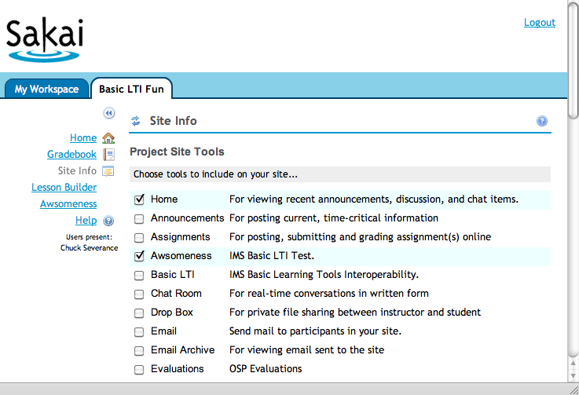
You can see that the new 'Awesomeness' tool appears and can be selected as if it is any other tool.
Since we left a few parameters as not final, the instructor can go into the configuration screen and change the parameters we decided to allow them to change but none of the other parameters appear:
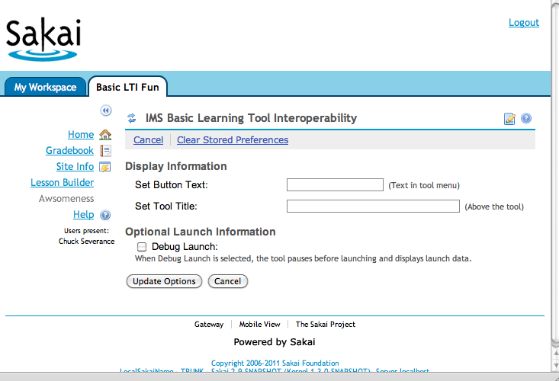
If we adjust the tool registration above, setting all of the parameters to be final, the instructor will not be able to change any configuration options at all.

