Using the Sakai Basic LTI Tool Provider
Charles Severance
May 27, 2010

Introduction
This document describes Sakai's support for IMS Basic LTI Tool Provider. Using this feature, Sakai can provision and export users, sites, and tools so that those tools can be used in any portal or learning management system that supports the IMS Basic LTI Consumer.
Tool Provider support in Sakai is intended to allow Sakai to act as a multi-tenancy capable "tool appliance" providing tools to any system which presents the proper credentials. While you can use the Sakai instance configured to provide these tools in the normal way, the default behaviour of the Basic LTI Provider is to keep sites and users separate from the sites and users created in the normal fashion using the Sakai user interface. The sites and users which are provisioned via Basic LTI Provider are name-spaced using the oauth_consumer_key which is shared between the tool provider and tool consumer. It is also possible to bypass this name-spacing and allow the clean passthrough of site and user credentials, which is useful for integrating other systems with Sakai, where you want to share user accounts and existing sites - see the configuration section regarding 'highly trusted consumers'.
Since the Basic LTI Tool Provider is very powerful, it is configured off by default. It is very important to the security of Sakai releases that this feature is never defaulted to be on and certainly there should not be any default provider passwords configured out of the box. In order to allow testing, a special sakai.properties has been placed on the nightly server.

Configuration
In order to enable the Basic LTI Tool Provider, you must add the following values to the sakai.properties for your server:
basiclti.provider.enabled=true
webservices.allow=.+

The first item enables the provider and the second item sets the values for the IP address and/or domain addresses from which requests will be accepted. The Basic LTI Tool Provider uses the same request filter to block incoming requests as Sakai web services. For details on IP address filtering, see org.sakaiproject.util.RemoteHostFilter.
You also need to list the Sakai tool ids that you will allow to be served out as IMS Provided tools using the following property:
basiclti.provider.allowedtools=sakai.announcements:sakai.singleuser:sakai.assignment.grades:blogger:sakai.dropbox:sakai.mailbox:sakai.forums:sakai.gradebook.tool:sakai.podcasts:sakai.poll:sakai.resources:sakai.schedule:sakai.samigo:sakai.rwiki

The Tool Provider will refuse to provide any tool that is not on this list. If this item is not included, no tools will be provided.
Once you have enabled the provider and listed the allowed tools, you need to set a key and secret for the requesting Tool Consumer. This value should be protected as carefully as your database connection password as knowing this secret allows an external system to create sites and users and assume user identities if it knows this secret.
The following line adds a secret of "secret" for a key of "lmsng.school.edu". You can have as many secrets as you like using this pattern.
basiclti.provider.lmsng.school.edu.secret=secret

Please do not use such a simple secret – a good secret should be at least as long and random as a typical GUID.
In order to allow clean passthrough of site and user credentials, add the key to the list of trusted consumers using the following property:
basiclti.provider.highly.trusted.consumers=lmsng.school.edu:another.school.edu

If a request comes through from a consumer on this list, then the user and site credentials will be used as-is, ie they will not be namespaced. The provider will then check the user has access to the site and tool, and redirect as before. The role attribute in the request is ignored - the role the user has in the site is used instead.

Using the Basic LTI Tool Provider
Once the tool provider is enabled, the web services filter is set, and you have specified a key and secret in the properties, you can access the tools for testing using an IMS Basic LTI Consumer. In this section we will use a PHP consumer at the following address:
http://developers.imsglobal.org/BLTI/lms.php

If you don't want to share your secret with Dr. Chuck, you can grab your own copy of the PHP based Basic LTI code at
http://code.google.com/p/ims-dev/

Once you have the test LMS up, enter the URL of your Sakai instance as follows:
URL: http://localhost:8080/imsblti/provider/sakai.rwiki
Key: lmsng.school.edu
Password: secret

Note that the default key is "12345" – not lmsng.school.edu – so make sure to change it and press "Submit" to you don't get "Invalid OAuth Consumer" from the Sakai Provider when you launch.
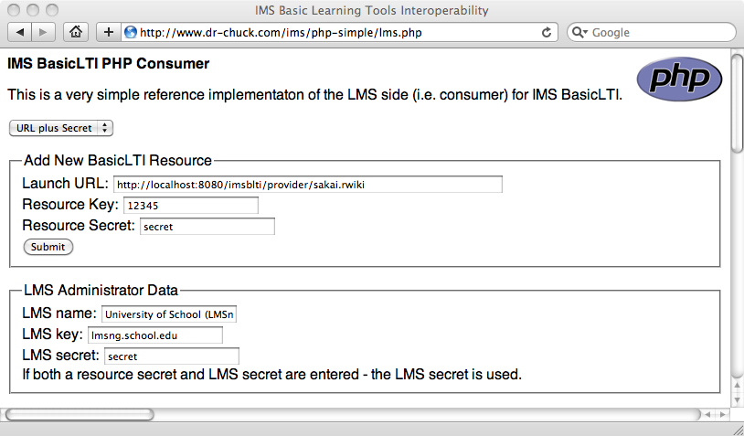
Then press "Submit" and then scroll down and press "Launch Endpoint with Basic LTI Data".
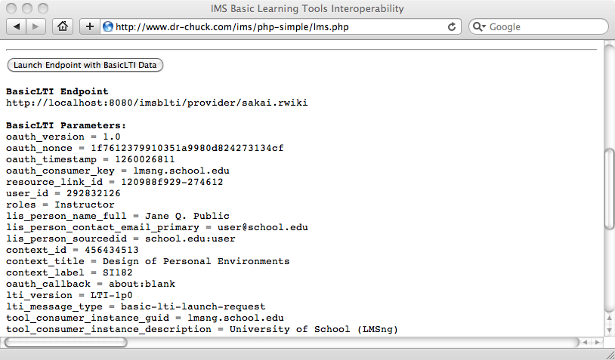
You should see the Sakai Wiki tool. Notice the name "Jane Q. Public" which was provisioned from the Basic LTI PHP Tool Consumer.
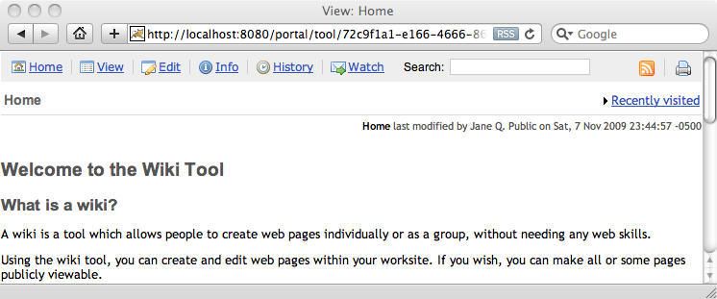
You should also see log messages indicating the creation of the user, site, and tool as follows:
INFO http-8080-Processor25 org.sakaiproject.blti.ProviderServlet - Created user=lmsng.school.edu:292832126
INFO http-8080-Processor25 org.sakaiproject.blti.ProviderServlet - Created site=lmsng.school.edu:456434513 label=SI182 type=project title=Design of Personal Environments
INFO http-8080-Processor25 org.sakaiproject.blti.ProviderServlet - Tool added site=lmsng.school.edu:456434513 tool_id=sakai.rwiki

Using this approach you can plug Sakai tools into any LMS, portal or software that supports the IMS Basic LTI Consumer.

Security Checks for Release
Since it is so important to protect this URL, please make the following test of every released version of Sakai.
Once your Sakai has started up, navigate to the following URL:
http://localhost:8080/imsblti/provider/sakai.singleuser

You should see a 403 (Forbidden) message as shown below:
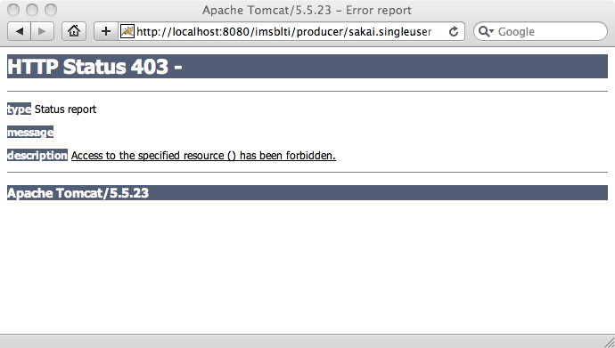
You should also see a warning message in the catalina.out file:
WARN http-8080-Processor25 org.sakaiproject.blti.ProviderServlet - Basic LTI Provider is Disabled IP=0:0:0:0:0:0:0:1%0

These two indicate that the Basic LTI Tool Provider is properly disabled in the out of the box configuration. Out of the box, there are two ways that the servlet is protected and two properties that need to be changed. First, the RemoteHostFilter is configured to only accept "local" IP addresses. Second, to get past the 403 response, the servlet must be enabled in sakai.properties as shown above.

Implementation Detail
You can log into your Sakai and see how the Sakai Basic LTI Provider implements multi-tenancy and keeps the incoming Basic LTI users and sites from "mixing" with the normal Sakai users and sites.
In order to limit collisions, the Basic LTI Provider prepends the oauth_consumer_key to the Basic LTI user_id value to produce the Sakai Enterprise ID (i.e. EID). Similarly, the Provider prepends the oauth_consumer_key to the Basic LTI context_id value to produce the site's id as shown below in the Administrator Sites tool.
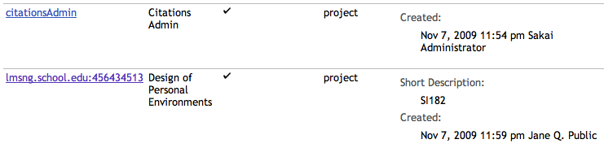

Similarly, if you look in the Sakai Administrator's Users tool, you can see the name-spaced user accounts:
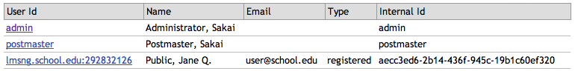
And if you look in the Realms tool, you can see that the name-spaced user account has been properly joined to the name spaced site with the correct role as requested by the IMS Basic LTI Consumer.
Note that if you are integrating with the Provider and are a 'highly trusted consumer', no namespacing will occur; the user and site credentials will be used as-is.
Regarding the siteId – unless the consumer is highly trusted, the siteId will become a SHA-1 hash of the oauthConsumerKey and ltiContextId (i.e. siteId = ShaUtil.sha1Hash(oauth_consumer_key + ":" + context_id)). The original LTI contextId passed by the consumer will be stored in a site property called “lti_context_id” for future reference and/or matching.

Conclusion
This feature makes it possible to export Sakai tools to other Learning Management Systems using the IMS Basic LTI standard.

The code for the Basic LTI Tool Provider for Sakai is relatively straightforward and is completely contained in:

basiclti-portlet/src/java/org/sakaiproject/blti/ProviderServlet.java

The code supports the "Sakai Tool Appliance" use case out of the box. However if organizations want to add or change business rules based on local needs, the code is relatively straightforward and easy to modify. Of course if you choose to modify be very mindful of security implications as you go through the code.

If you would like to learn more about the IMS Basic LTI work, you can visit:

http://www.imsglobal.org/

or join the Free IMS Community Developer's forum at:

http://www.imsglobal.org/community/forum/index.cfm?forumid=11

The longest-term goal is to create a market for external tools and content that can easily be plugged into any LMS system including some we have not even yet imagined.

Acknowledgements
Many people contributed to the creation of the IMS Basic LTI specification, including Lance Newmann of Blackboard, Greg McFall of Pearson Education, Bruno Van Haetsdaele and Mark Ritter of Wimba, Anthony Whyte of Sakai Foundation, and Noah Botimer and Matt Jones of the University of Michigan, and many others.
The code for the IMS Basic LTI Provider is based on some earlier work by Katie Edwards who was supported by Google to work on Sakai during the 2008 Google Summer of Code.

