Minimized Navigation in Sakai's Portal
Charles Severance
csev@umich.edu

December 31, 2007

Introduction

Note: This feature is currently in trunk beyond r4091 - it was completed too late be included in Sakai 2.5 - if there is community interest, back-ports to previous versions of Sakai can be done.

Sakai's portal now supports a maximized view for an application. This maximized view can be controlled on a request-by-request basis in a JSR-168 portlet and can be requested for a Sakai tool in its tool registration or properties.

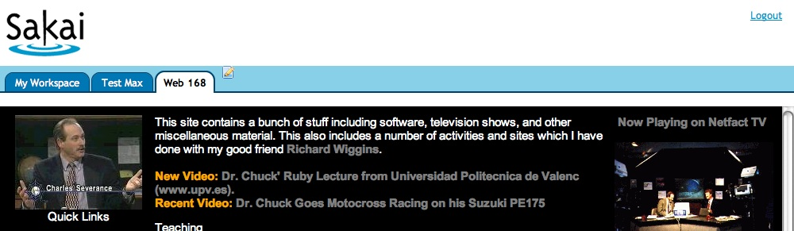

Effectively when maximized mode is requested, the portal is directed to reduce navigation to be as small as possible and give as much of the screen real estate to the tool - in particular the Sakai left navigation is eliminated when the tool is in maximized mode.

Use Cases

While this feature can be turned on for all tools - the primary expectation is to use this for tools that are designed to use the full page. One general use case is when content is coming from elsewhere and is designed to be full screen. The iFrame tool, IMS Tools Interoperability, and other shims to external tools fall into this category. Another use case would be a for a Sakai SCORM player - most SCORM content is designed to have a left navigation bar in the content - this feature allows a SCORM player to work *within* Sakai without causing two left navigation bars - which is very unusable.

Minimized Navigation

When the portal goes into Minimized Navigation mode, it generates a top-level document with two frames. The top frame is the login/logout, logo and site tab area.

The tool or requested Url is in the lower frame. When there is more than one page the screen looks as follows when we are in the "Test Max" site running the "Web 168" tool.

My Workspace is always shown. The current site is also always shown. In the minimal navigation view, if the tool/portlet supports reset, clicking on "Web 168" tab acts as a "reset" of the tool. If the tool is a JSR_168 portlet and the user has permission to edit the portlet - the portlet--edit icon is shown to switch the portlet into Edit mode.

Clicking on "My Workspace" or the current site tab ("Text Max") navigates to a normal (non-frameset) view of the sites with normal page tabs as shown below. This allows users to get back to a normal navigation view so they can switch tools even when some or all of the tools are requesting minimal navigation. For example, if the user clicked on "Test Max" above the next screen would look as follows:

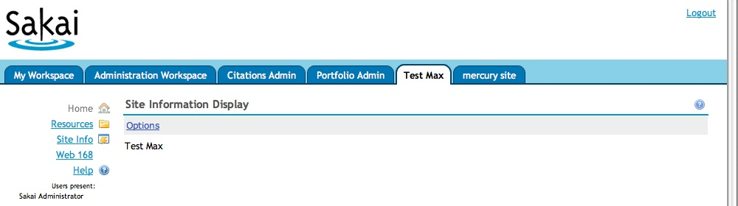

If there is only one page in a site, that page has a single tool, and that tool requests minimized navigation the screen looks as follows:

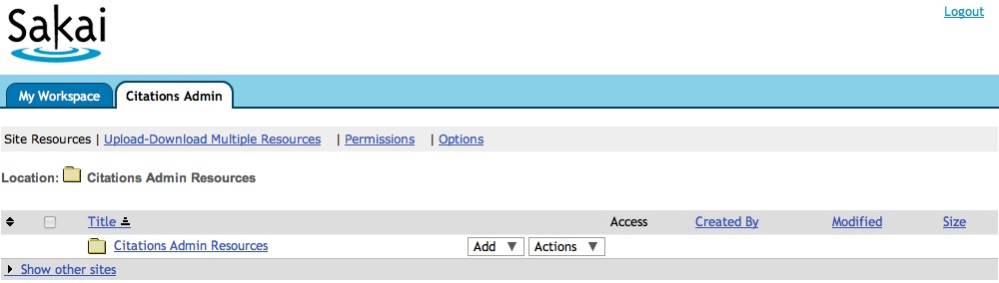

Even though in this example, the tool is the Resources tool, in the top bar, all we see is the "Citations Admin" site tab and it is selected. Clicking on "Citations Admin" acts as a reset of the Resources tool. It is as if you navigated away from the site and then back - since there is only one tool and it requests maximized view - it is what we see when we navigate to the site. Since there is only one tool - inter-tool navigation is not needed.

If a tool in My Workspace requests maximized view, the top tabs show "My Workspace" and the tool title. Clicking on My Workspace shows all the tools and clicking on the tool title acts as a reset of the tool.

Triggering Reduced Navigation in a JSR-168 Portlet

JSR-168 portlets do not operate in an iFrame for normal operation. Not eeding an iFrame is a god thing should not be changed in general.

However if a JSR-168 portlet would generate an iFrame tag as part of its output, it can give the URL to the portal instead and have the portal display the URL in reduced navigation mode. The following code is done as follows:

import org.sakaiproject.tool.api.Session;
import org.sakaiproject.tool.cover.SessionManager;

public void doView( …
…
Session session = SessionManager.getCurrentSession();
session.setAttribute("sakai:maximized-url","http://www.cnn.com/");
}

In addition, you must tell the portal to pre-read the portlet content so the portal can look for the url in the session after the content is created. This is done in the tool registration file by adding a sakai:portlet-pre-render property and setting its value to true.

<registration>
<tool
id="sakai.iframe.168"
title="Web 168">

<configuration name="source" value="" />
<configuration name="height" value="600px" />

<configuration name="sakai:portlet-pre-render" value="true" />

This could be set in the tool registration or set by the tool at run-time. If this is being set at run-time, it must be set on the tool placement at least one request *before* the maximized-url request is made. The best approach is to simply make this part of the tool registration.

Triggering Reduced Navigation in a Sakai Tool

Since Sakai tools currently operate in an iFrame - the portal is only involved in setting up the iFrame for the tool to operate in.

So if a regular Sakai tool wants to operate in maximized mode - it must indicate this in its tool registration by setting the sakai:prefer-maximize property to "true" as follows:

<registration>
<tool
id="sakai.mailbox"
title="Email Archive">

<configuration name="channel" value="" />

<configuration name="sakai:prefer-maximize" value="true" />

With this set, the tool will always be presented in reduced navigation mode.

Tool Designer - Note

It is important for tool designers to realize that whether or not the portal actually does the maximization is up to the portal. For example - if the tool is placed with more than one tool on a page - maximization will not happen.

So in cases where the tool is requesting maximized display - the tool should still generate the proper output in case maximized display does not happen for one reason or another.

This is particularly important for JSR-168 tools - when the Tool gives the portal a URL to display - it should still generate output with an iFrame tag.

Developers should test their tools with portal.frameset=never to make sure their tools work properly in the case that the portal refuses to go into maximized mode.

For Sakai tools this is less of an issue because the tool is operating in a frame either way. Sakai tool should still be tested with the never setting to make sure that the tool properly handles any frame resizing activity that is needed. When the tool is shown in minimized navigation there is no need to resize the frame because the tool is automatically given the *rest* of the screen.

Advantages

The approach uses framesets not iFrames. The navigation is in a small (140 pixel tall) frame and the content is in a frame that takes up the "rest of the browser". This means that it is not necessary to resize the lower frame. It automatically takes the rest of the browser's vertical space.

While Sakai tools have mechanisms to resize their enclosing iframe - this is not possible for externally hosted content because cross-site JavaScript is prohibited. And it is not likely that externally hosted content would be changed to support Sakai's iFrame resizing protocol.

Using framesets eliminates any need for resize protocol and insures that there will only be one scrollbar on the screen at any one time.

Frames Are Bad - Why use Frames?

The trend in Sakai for Sakai tools to eliminate the use of frames. Currently all Sakai tools except for JSR-168 tools display in an iFrame which limits usability and impairs accessibility.

Eliminating these iFrames is a long-term goal of Sakai - either by converting tools to use JSR-168 or to build framework shims to inline existing tools into the background document.

However - some applications such as the web content tool and IMS Tool Interoperability require the use of frames as part of their design. When frames are required, frame sets are better than iFrames because of enhanced usability and no need to resize frames dynamically.

So while this work does not reduce the use of frames in Sakai, it does allow externally hosted content to be presented in a more usable manner than in an iFrame with left navigation and reduces the use of iFrames.

Conclusion

This feature makes it possible to display more complex content in Sakai - particularly content hosted outside of Sakai.

With IMS Tool Interoperability, the Web Content tool, and the Link Tool - increasingly we will have nifty content hosted outside of Sakai.

Also this will make it quite nice to integrate publisher hosted content into Sakai when the publisher content it itself a content management system with left side or top navigation.

TODO List

Back-port the trunk portal to 2.5, 2.4, and 2.3 along with many other current portal features. An initial back-port to 2.4 was done in a few hours. The key is that when someone uses the back-port - they gain the new features of the current portal - but they have to update their skins to the latest approach.

It occurs to me that we should sometimes maybe to a popup confirmation before we do a reset. But this should be a separate feature that is properly discussed.

We could discuss if we want a "maximize button" that the user can click on. That also should be a new feature that is discussed separately.

