Sakai Properties

Introduction
This document describes configurations that can be made using entries in the sakai.properties file. The organization and use of the sakai.properties file is covered in the document How to Configure Sakai. Properties described are found in the sakai.properties file, or in the components.xml file, or both.

The sakai.properties ‘kernal’ file as delivered with default settings is at
https://source.sakaiproject.org/svn/component/trunk/component-api/component/src/config/org/sakaiproject/config/sakai.properties

in subversion. To override default settings, a file called sakai.properties containing the override values should be placed in a folder named ‘sakai’ in the tomcat root directory (e.g. in /usr/local/tomcat/sakai). You can either create the override sakai.properties file from scratch or copy in a known working copy and then edit to fit your environment.

A sample sakai.properties file which self-documents many of the standard properties in comments can be found in subversion at
https://source.sakaiproject.org/svn/reference/trunk/docs/sakai.properties

The sakai.properties file that is used for the ‘demo’ version of Sakai, and which builds on/overrides properties set in the ‘kernal’ version is at

https://source.sakaiproject.org/svn/reference/trunk/demo/sakai.properties

Another version of sakai.properties that is used on QA servers is at

https://source.sakaiproject.org/contrib/qa/trunk/sakai.properties

Like the ‘demo’ version, this file builds on the "kernel" sakai.properties file. However, it usually includes settings specific to the QA/release cycle that are needed to test new
tools and functionality.

sakai.properties can define two different types of settings. The first type sets those values that are made available to the running code from the Sakai configuration service. A line of sakai.properties sets this sort of value if it has the form:

name=value

The second type of sakai.properties setting overrides the configuration defaults of individual Sakai components. These defaults are set in
/trunk/sakai/legacy/legacy-components/src/webapp/WEB-INF/components.xml
and in the components.xml file of any particular component, so this configuration can in principle be achieved by also editing a large number of components.xml files (one for each component). It’s a best practice to keep all configuration changes in sakai.properties.

Override settings have the form:

name@component-name=value

New value settings can be freely added to the sakai.properties file, since any component property can in principle be overridden here, and so any sample sakai.properties will show only a small fraction of all the possible settings.

In the definitions below, the property is listed, followed by the default setting (if there is one), and an explanation of the property. In some cases the comment included with the property in the sakai.properties file says it all. Those comments are included below.

Properties are grouped together below according to their function. The index provides an alphabetized list.

Sakai OOTB is an alias for the default install of Sakai - Sakai Out Of The Box.

Sakai Properties 1
Introduction 1
Database related configurations 9
driverClassName 9
url 9
defaultTransactionIsolationString 9
vendor 10
hibernate.dialect 10
hibernate.show_sql 10
showSql@org.sakaiproject.db.api.SqlService 10
username@javax.sql.BaseDataSource 11
password@javax.sql.BaseDataSource 11
validationQuery 11
auto.ddl 11
DbFlatPropertiesCache 11
Server related settings 12
serverId 12
serverUrl 12
serverName 12
gatewaySiteId 12
gatewaySiteList 13
loggedOutUrl 13
accessPath 14
portalPath 14
top.login 14
container.login 14
xlogin.enabled 15
xlogin.text 15
xlogin.icon 16
login.use.xlogin.to.relogin 16
Logging 16
enabled 16
log.config.count 17
log.config.count.n 17
Footer Control 18
bottomnav.count 18
bottomnav.n 18
powered.url 19
powered.img 19
powered.alt 19
bottom.copyrighttext 20
version.service 20
version.sakai 20
OOTB Information Files 20
server.info.url 21
myworkspace.info.url 21
webcontent.instructions.url 21
User Presence List 22
display.users.present 22
presence.inchat.icon 22
Skins 22
wysiwyg.editor 23
skin.default 23
skin.repo 23
iconNames.count 24
iconNames.n 24
iconUrls.count 25
iconUrls.n 25
iconSkins.count 25
iconSkins.n 25
disable.course.site.skin.selection 26
logout.icon 26
java.beep 27
Accessibility 27
accessibility.url 27
Announcement Tool control 27
announcement.merge.display 27
Assignment Tool control 28
allowGroupAssignments 28
allowGroupAssignmentsInGradebook 28
assignment.useContentReview 28
assignment.instructor.notifications 29
assignment.instructor.notifications.default 29
assignment.submission.confirmation.email 29
Calendar Summary Tool 30
calendarSummary.viewMode 30
calendarSummary.[high | medium | low]PriorityColor 30
calendarSummary.highPriorityEvents.count 30
calendarSummary.highPriorityEvents.n 30
calendarSummary.mediumPriorityEvents.count 31
calendarSummary.mediumPriorityEvents.n 31
Fourms Tool control 31
mc.showForumLinksInNav 31
mc.disableLongDesc 31
Help Tool control 32
helpPath 32
display.help.menu 32
display.help.icon 32
help.location 32
help.welcomepage 33
help.redirect.external.webapp 33
help.collections 33
help.hide 33
Message Center 34
mc.threadedview 34
OSP 34
sakai.reports.useWarehouse 34
osp.upgrade25 34
displayToolCategories 34
Preferences 35
preference.pages 35
prefs.research.collab 35
Resources 36
content.upload.max 36
content.upload.ceiling 37
content.upload.dir 37
copyrighttype.n 38
copyrighttype.count 38
default.copyright 38
copyrighttype.own 39
copyrighttype.new 39
default.copyright.alert 40
fairuse.url 40
newcopyrightinput 41
resources.show_all_collections.tool 41
resources.show_all_collections.dropbox 42
resources.show_all_collections.helper 43
allowGroupResources 44
siteAttachments 44
availabilityChecksEnabled 44
prioritySortEnabled 45
Roster Tool control 46
roster.display.firstNameLastName 46
roster.display.hideSingleGroupFilter 46
roster.defaultSortColumn 46
roster_view_email 46
Schedule Tool control 47
calendar.merge.display 47
ical.experimental 47
iCal import/export is available in 2.5, though it doesn't currently support re-occurring events. In order to enable, set ical.experimental = true. The default setting is false. 47
config@org.sakaiproject.section.api.SectionManager 47
Test & Quizzes (Samigo) 48
samigo.saveMediaToDb 48
samigo.answerUploadRepositoryPath 48
samigo.sizeThreshold 48
samigo.sizeMax 48
samigo.smtp.server 49
samigo.smtp.port 49
samigo.email.bypassAuth 49
samigo.email.username 49
samigo.email.password 49
samigo. email.prefixedPath 49
samigo.samliteEnabled 50
WebDAV 50
webdav.ignore 50
maxElementsInMemory 50
timeToLive 50
Wiki 51
wiki.experimental 51
wiki.comments 51
wiki.notification 51
wiki.display.user.id 51
Worksite Setup / Site Info 51
activeInactiveUser 51
wsetup.group.support 52
site.setup.import.file 52
site.setup.allow.editRoster 53
wsetup.skipCourseSectionSelection 53
titleEditableSiteType 54
courseSiteType 56
wsetup.disable.joinable.count 56
wsetup.disable.joinable.n 56
wsetup.disable.unjoin.count 57
wsetup.disable.unjoin.n 57
roster.available.weeks.before.term.start 58
officialAccountLabel 59
nonOfficialAccountLabel 59
officialAccountSectionTitle 60
nonOfficialAccountSectionTitle 60
nonOfficialAccountInstru 60
nonOfficialAccount.url 60
emailInIdAccount 61
notifyNewUserEmail 61
invalidNonOfficialAccountString 62
site.enableCreateAnyUser 62
site-manage.courseManagementSystemImplemented 63
site-manage.campusUserDirectory 63
site-manage.cms.subject.category 63
site-manage.cms.subject.label 64
site.templates 64
Sites tool control 65
sitebrowser.termsearch.type 65
sitebrowser.termsearch.property 65
sitesearch.noshow.sitetype 65
Email 66
support.email 66
portal.error.email 66
mail.support 67
setup.request 67
smtp.dns.1 67
smtp.dns.2 67
smtp.port 68
smtp.enabled 68
ui.institution 68
ui.service 68
force.url.secure 68
smtp 68
smtpFrom 68
testMode 69
mail.importDir 69
maxRecipients@org.sakaiproject.email.api.EmailService 69
mailarchive.message-threshold 70
email.precedence.bulk 70
emailFromReplyable 70
News Tool 70
news.title 70
news.feedURL 70
Membership tool 70
disable.membership.unjoin.selection 70
Automatic User Adds – ‘Affiliates’ 72
affiliatesubjects.count 72
affiliatesubjects.n 72
affiliatecampus.count 73
affiliatecampus.n 73
affiliateuniqnames.count 73
affiliateuniqnames.n 73
GradTools 74
withDissertation 74
gradToolsSiteType.count 74
gradToolsSiteType.n 74
WebServices 75
webservices.allowlogin 75
webservice.portalsecret 75
webservice.IPCheck 75
webservice.portalIP 75
webservices.allow 75
webservices.deny 75
Miscellaneous Control 76
portal.use.dhtml.more 76
stealthTools 77
visibleTools@org.sakaiproject.tool.api.ActiveToolManager 77
hiddenTools@org.sakaiproject.tool.api.ActiveToolManager 77
locales 77
mecury.enabled 78
portal.includesubsites 78
portal.iframesuppress 79
charon.directurl 80
portal.experimental.auto.reset 80
portal.includesubsites 80
portal.experimental.maximizesinglepage 81
portal.iframesuppress 82
overrideViewable 83
Provisional and Contrib Tools 84
Facebook 84
FLUID 84
Linktool 84
Mailtool 84
Reset Password 85
Search 85
Styleable 86
Turnitin Integration 86
iTunes U 87
Index 88

Database related configurations

driverClassName
# examples of other driver class name values - HSQLDB is the default
#driverClassName@javax.sql.BaseDataSource=org.hsqldb.jdbcDriver
#driverClassName@javax.sql.BaseDataSource=com.mysql.jdbc.Driver
#driverClassName@javax.sql.BaseDataSource=
oracle.jdbc.driver.OracleDriver

The default value of org.hsqldb.jdbcDriver is set in
/trunk/sakai/kernel/db-components/src/webapp/WEB-INF/components.xml
and examples of overrides are shown above.

url
# examples of other datasource URLs for other technologies: HSQLDB in-memory is the default
#url@javax.sql.BaseDataSource=jdbc:hsqldb:.
#url@javax.sql.BaseDataSource=jdbc:mysql://localhost:3306/sakai?useUnicode=true&characterEncoding=UTF-8
#url@javax.sql.BaseDataSource=
jdbc:oracle:thin:@monster.oracle.org:1521:db

The default value of jdbc:hsqldb is set in
/trunk/sakai/kernel/db-components/src/webapp/WEB-INF/components.xml
and examples of overrides are shown above.

Note: some earlier versions of demo sakai.property files had a typo in the mysql example:
#url@javax.sql.BaseDataSource=jdbc:mysql://localhost:3306/sakai?useUnicode=true&amp;characterEncoding=UTF-8

Instead of

#url@javax.sql.BaseDataSource=jdbc:mysql://localhost:3306/sakai?useUnicode=true&characterEncoding=UTF-8

defaultTransactionIsolationString

defaultTransactionIsolationString@javax.sql.BaseDataSource=
TRANSACTION_READ_UNCOMMITTED

Used to set the default transaction isolation level. The default setting above (set in the sakai/db/db-impl/pack/src/webapp/WEB-INF/components.xml file) is used for hsql. For Oracle or MySQL, set TRANSACTION_READ_COMMITTED in your local sakai.properties to override the default value:
defaultTransactionIsolationString@javax.sql.BaseDataSource=
TRANSACTION_READ_COMMITTED
Note: the settings used for Sakai prior to 2.1.005 below are no longer supported.
# set the default transaction isolation level
# Up to and including 1.7.1, HSQLDB supports only Connection.TRANSACTION_READ_UNCOMMITTED.

# MySQL and Oracle MUST use Connection.TRANSACTION_READ_COMMITTED.
jdbc.defaultTransactionIsolation=
java.sql.Connection.TRANSACTION_READ_UNCOMMITTED
#jdbc.defaultTransactionIsolation=
java.sql.Connection.TRANSACTION_READ_COMMITTED

vendor
# example vendor settings - must match your hibernate dialect set
#"hsqldb" is the default
#vendor@org.sakaiproject.db.api.SqlService=hsqldb
#vendor@org.sakaiproject.db.api.SqlService=mysql
#vendor@org.sakaiproject.db.api.SqlService=oracle

The default value of hsqldb is set in
/trunk/sakai/legacy/legacy-components/src/webapp/
WEB-INF/components.xml
and examples of overrides are shown above.

hibernate.dialect
# set the hibernate dialect (for shared datasource), HSQLDB by default, mySql and Oracle examples

hibernate.dialect=net.sf.hibernate.dialect.HSQLDialect
#hibernate.dialect=org.hibernate.dialect.MySQLInnoDBDialect
#hibernate.dialect=net.sf.hibernate.dialect.Oracle9Dialect

Sakai 2.1 supports 3 databases. By default, hibernate.dialect is set for HSQLDB. Examples are shown for MySQL and Oracle settings. Uncomment the appropriate setting to correspond with the database used, and remove/comment the others.

hibernate.show_sql
# enable hibernate SQL debugging output
hibernate.show_sql=false

From the bean org.sakaiproject.springframework.orm.hibernate.SessionFactoryBase defined in /kernel/db-components/src/webapp/WEB-INF/components.xml. Determines whether hibernate SQL debugging statements are output.

showSql@org.sakaiproject.db.api.SqlService
showSql@org.sakaiproject.db.api.SqlService=false

Set this to true to get logging of the SQL statements as they are executed.

username@javax.sql.BaseDataSource
username@javax.sql.BaseDataSource=sa

The username used to connect to the database. The default is set for use with HSQLDB.

password@javax.sql.BaseDataSource
password@javax.sql.BaseDataSource=

The password for the user account specified by username@javax.sql.BaseDataSource, which is the account used to connect to the database. The default is set for connection to HSQLDB.

validationQuery
# set the validation query - the default is for hsqldb "select 1 from INFORMATION_SCHEMA.SYSTEM_USERS"
# for MySQL and Oracle, change it to this:
#validationQuery@javax.sql.BaseDataSource=select 1 from INFORMATION_SCHEMA.SYSTEM_USERS

validationQuery@javax.sql.BaseDataSource=select 1 from INFORMATION_SCHEMA.SYSTEM_USERS

This has been shown to cause performance problems in Oracle - to leave it unset, do not set the property (e.g., validationQuery@javax.sql.BaseDataSource= )

auto.ddl
# establish auto.ddl - on by default

auto.ddl=true
#auto.ddl=false

When Sakai starts up, if auto.ddl is set to true, necessary database tables will be created if needed (if the tables do not already exist).
This has been shown to cause performance problems in Oracle - to leave it unset, do not set the property (e.g., validationQuery@javax.sql.BaseDataSource= )

DbFlatPropertiesCache
# Set up caching for resource properties associated with
# DbFlat ORM structures

DbFlatPropertiesCache=:all:
# DbFlatPropertiesCache=:SAKAI_REALM_PROPERTY:SAKAI_SITE_PROPERTY:
# DbFlatPropertiesCache=:none:

This provides a setting to tune the performance of Resource properties for objects stored using the DbFlat storage. The Site, Tool, and Page objects use DbFlat. You can enable this on a table by table basis by listing the table names separated by colons with a colon at the beginning or end. This cache is five minutes, limited to 10,000 entries, and kept independently on each node in a cluster. Invalidation is done with a node. As of Sakai 2.5, these properties tables receive a lot more traffic than in Sakai 2.4 and earlier. The default is :all:. See also SAK-13886.

Server related settings

serverId
# identify your application server with a short name, unique among the servers in your cluster.
# choose a server id even if you are running a single app server

serverId=localhost

Used to distinguish servers in a cluster from one another. The serverId value is the server name displayed in the footer and in the Admin Online tool.

For example, if serverId=phantom, the footer displays

serverUrl
# the URL to the server, including transport, DNS name, and port, if any

serverUrl=http://localhost:8080

Should be set to match the ‘port’ defined in the CATALINA_HOME/conf/server.xml file

serverName
# the DNS name of the server

serverName=localhost

gatewaySiteId
# gateway site id

gatewaySiteId=!gateway

The site id of the site which is used for the installation’s gateway (login page). This site will be shown when users go to the URL set in the serverURL property.

With the defaults, going to the URL http://localhost:8080 will take the user to the !gateway site where they find the Login button (and perhaps the user name and password fields depending on the top.login setting) . The !gateway site typically will contain a MOTD (message of the day), and perhaps a web content tool pointing to another document containing installation specific information. The !gateway site may have a left hand menu column of page names. The pages may contain things like ‘Features’, ‘About’, ‘Training’, etc. The Sakai OOTB !gateway site includes a New Account page, which contains the new.account tool. Institutions will want to edit the !gateway site to add/remove pages/tools, or create their own gateway site.

gatewaySiteList
# gateway site list - comma separated values indicating site IDs -
# these sites must include the .anon role and at a minimum give
# the .anon role site.visit - and any other permissions you want
# (usually *.read) permissions to the .anon role.
# if the .anon role does not have site.visit - these sites will not
# appear in the gateway - even if they are in this list.
# in the example below, mercury does *not* have site.visit
# for .anon so it does not appear
# if this is not set, the portal simply displays a single gateway site
# specified by gatewaySiteId

# gatewaySiteList=

Normally, when users go to the URL defined by serverURL, they reach the !gateway site (the site defined by gatewaySiteId). gatewaySiteList can be used to present other sites, via tabs, to non-logged in users. By default this property is not defined, so only the site defined by the gatewaySiteId property is shown to users when they go to the URL defined by serverURL.

Sites specified in this property need to have the .anon role, and at least the site.visit permission set for the .anon role, or they will not show up as tabs to non-logged in users.

loggedOutUrl
# the URL to send folks to after they logout

loggedOutUrl=/portal

When users click the ‘logout’ button, they are sent to <serverUrl><loggedOutUrl>
With the default settings, this would be http://localhost:8080/portal

accessPath

accessPath=/access

Specifies the URL to the access path. This partial URL is used to construct the full URL for accessing resources. For example, the URL to a resource might be http://localhost:8080/access/content/group/ 1100899697301-3493876 /report.doc where /content/group/ 1100899697301-3493876 /report represents the location of the resource.

portalPath

portalPath=/portal

Specifies the URL to the portal path. This partial URL is used to construct the full URL for accessing Sakai (e.g., http://localhost:8080/portal )

top.login
# to include the user id and password for login on the gateway site

top.login=true


Controls whether the ‘user id’ and ‘password’ fields are shown in the banner at the top of the Sakai window. If top.login=false, the two fields are not shown.

When an external authorization mechanism is present, installations may want top.login=false to hide the native Sakai login fields.

container.login
# to let the container handle login or not (set to true for single-signon type setups, false for just internal login)

container.login=false

In Sakai OOTB, there is no external login authoricy (e.g., CAS or cosign) setup by default, so container.login=false to let Sakai handle logins. When set to true, Sakai login processing can be bypassed since we trust the container if it says that the user is already logged in.

xlogin.enabled

xlogin.enabled=

If xlogin.enabled=true, then a 2nd login button will appear (depending on xlogin.text or xlogin.icon). The 2nd ‘xlogin’ button bypasses the container check, and is a way to login to a native Sakai account.

Note that when xlogin.enabled=false, though the 2nd login button doesn’t appear, it is still possible to login via xlogin using the URL such as http://localhost:8080/portal/xlogin.

Along with xlogin.text, this controls the extra (x)login button - if it's enabled, what text to show. There should be another for the icon. Then you get two logins - one normal, and one that is "xlogin" that bypasses the container check

xlogin.text

xlogin.text=

Specifies the test to show for a 2nd login button in the Sakai header (the xlogin button). For xlogin.text to show, top.login must be false, and xlogin.enabled must be true.

For example, with the settings of

xlogin.text=Mash me
top.login=false
xlogin.enabled=true

The following appears


The xlogin button can be text or an icon but not both. If both xlogin.text and xlogin.icon have a value, the icon ‘wins’.

xlogin.icon

xlogin.icon=

Specifies an icon to use for a 2nd login button in the Sakai header (the xlogin button). For xlogin.icon to show, top.login must be false, and xlogin.enabled must be true.

For example, with the following settings,

xlogin.icon=<path to bullseye icon>
top.login=false
xlogin.enabled=true

The following appears



The xlogin button can be text or an icon but not both. If both xlogin.text and xlogin.icon have a value, the icon ‘wins’.

login.use.xlogin.to.relogin

login.use.xlogin.to.relogin = true

When login fails, users can be redirected to the xlogin page. The default in 2.5 for this setting is true. To provide 2.4 behavior set to false. See SAK-13253 for info on a bug reported against this property. If false, the non container login will be used.

Logging

enabled

enabled@org.sakaiproject.log.api.LogConfigurationManager=

As of Sakai 2.2, logging controls are part of the new LogConfigurationManager, implemented as a component, the Log4jConfigurationManager, in the util module. This component works only if the log4j configuration has a "sakai" appender (which ours does). It can also be disabled by setting the property to false.
The API can also be called at runtime to dynamically alter the log levels.

log.config.count

log.config.count.n

log.config.count=
log.config.count.n=

Logging levels are first established in the log4j configuration file deployed from Sakai. The source for this file is in: sakai/util/util-impl/log/src/conf/log4j.properties
This is made into a jar and deployed to common (this is a requirement of log4j configuration in Tomcat). We can set logging levels in this file. For example:
# Application logging options
log4j.logger.org.sakaiproject=INFO
# Ignore erroneous MyFaces variable resolver warnings
log4j.logger.org.apache.myfaces.el.VariableResolverImpl=ERROR
This sets any logger with "org.sakaiproject.*" to INFO level, and the "org.apache.myfaces.el.VariableResolverImpl" to ERROR level.
The problem is it is not so easy to change this on a case-by-case basis. We have to change the Sakai source and re-deploy.
Now, we can specify logging levels in our sakai.properties. This augments and overrides the levels set in our config file. Example:
log.config.count=3
log.config.1 = ALL.org.sakaiproject.log.impl
log.config.2 = OFF.org.sakaiproject
log.config.3 = DEBUG.org.sakaiproject.db.impl
This uses the established method of having a name.count followed by name.1, name,2, etc. to form an array of strings for the value "name". In this case, the name is "log.config".
The values are of the form
LEVEL.logger
Levels are OFF, TRACE, DEBUG, INFO, WARN, ERROR, FATAL, ALL

To see what Webdav is doing, set the values to
log.config.count=3
log.config.1 = DEBUG.org.sakaiproject.dav
log.config.2 = INFO.org.sakaiproject
log.config.3 = INFO.org.sakaiproject.content

As of 2.5, per SAK-11238, the verbosity of log messages at startup for the component manager has been reduced. To enable the long list, turn on debug logging for util with
log.config.<n> = DEBUG.org.sakaiproject.util
Debug for util is very very verbose - it can quite fill up your logs.

Footer Control

bottomnav.count

bottomnav.n

bottomnav.count=
bottomnav.1=

Specifies links that can appear at the top of the footer. Links are displayed in an order according to their bottomnav.n association, with the bottomnav.1 item appearing first, bottomnav.2 item second, etc. A vertical bar | separates links. There are bottomnav.count number of links shown. Each link URL is specified by the bottomnav.n value.

Since there are no default bottomnav links specified in Sakai OOTB, the footer area where such links appear is empty.


To add links, create values for the properties. For example, at UM we have

bottomnav.count = 5
bottomnav.1 = <a href="https://ctools.umich.edu/portal/site/!gateway"> CTools Gateway</a>
bottomnav.2 = <a href="mailto:ctools@umich.edu">Contact Us</a>
bottomnav.3 = <a href="http://www.dc.umich.edu/" target="_blank">Duderstadt Center</a>
bottomnav.4 = <a href="http://www.umich.edu/" target="_blank">University of Michigan</a>
bottomnav.5 = <a href="http://sakaiproject.org" target="_blank">The Sakai Project</a>

which produces

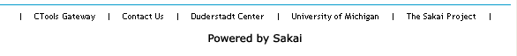

(The ‘Powered by Sakai’ icon is controlled by the powered.url and associated properties)

Note: Since Sakai is xhtml, links should be xhtml (e.g.,
<a href="" title="" target="">Anchor</a>
The title should contain a warning if target="_blank".

powered.url

powered.img

powered.alt
# powered by config for the bottom of the portal

powered.url.count=1
powered.url.1=http://sakaiproject.org
powered.img.count=1
powered.img.1=/library/image/sakai_powered.gif
powered.alt.count=1
powered.alt.1=Powered by Sakai

These control the display and hyperlink of the ‘powered by’ icon in the footer. You can add additional logos with their own links and alt text. For example, if you added a gif file named ‘wolverine.gif’ to /library/image directory, and had the following in sakai.properties, the ‘powered by’ section of the footer would look as follows.

powered.url.count=2
powered.url.1=http://sakaiproject.org
powered.url.2=http://www.umich.edu
powered.img.count=2
powered.img.1=/library/image/sakai_powered.gif
powered.img.2=/library/image/wolverine.gif
powered.alt.count=2
powered.alt.1=Powered by Sakai
powered.alt.2=University of Michigan



Clicking on the wolverine icon sends the user to the University of Michigan web site.

The ‘powered by’ icons open their links in a new browser window.

bottom.copyrighttext
# strings for the portal pages

bottom.copyrighttext =Copyright 2003-2008 The Sakai Foundation. All rights reserved. Portions of Sakai are copyrighted by other parties as described in the Acknowledgments screen.
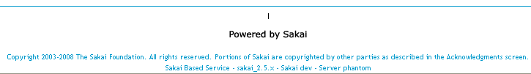

Specifies a line of text just under the ‘powered by’ icon in the footer.

version.service

version.sakai
version.service=dev
version.sakai=dev

Specifies versioning footer text. Installations may want to designate their own versioning scheme.


For example, at UM, we have
version.service= [r51984]
version.sakai= Sakai_2-5-2H

which produces the following in the footer:


Also see ui.service (set to ‘CTools’ in the example above), and bottom.copyrighttext (set to ‘Copyright © 2003 – 2008, the Regents of The University of Michigan’ above)

OOTB Information Files
Note regarding content of these files. Since Sakai is xhtml, links in the files should be xhtml (e.g., <a href="" title="" target="">Anchor</a> ). The title should contain a warning if target="_blank".

server.info.url

server.info.url=/library/content/server_info.html

Displayed by the sakai.iframe.service tool, which is typically found on the !gateway site. The server_info.html file has been used to provide information about the institution’s installation.

To be able to change the displayed content without having to re-deploy Sakai, you could change the location to
server.info.url= /content/public/server_info.html.
Then you could upload a file called server_info.html into the Admin’s Resources/public folder, and make edits there anytime as needed without a re-deploy.

myworkspace.info.url

myworkspace.info.url=/library/content/myworkspace_info.html

Displayed by the sakai.iframe.myworkspace tool, which is typically found on the Home page of My Workspaces. The myworkspace_info.html file has been used to provide information to users about the function of their My Workspace.

See the comments for server.info.url for information about why you may want to change the location of the myworkspace_info.html file.

webcontent.instructions.url

webcontent.instructions.url=/library/content/
webcontent_instructions.html

Displayed by the sakai.iframe tool when the URL field for that tool is blank. The webcontent.instructions.html file contains text that explains what to do to point a sakai.iframe tool (Web Content tool) to a particular URL. If the URL field for the Web Content tool contains a URL, then the Web Content tool displays the content at the URL rather then the webcontent.instructions.html text.

See the comments for server.info.url for information about why you may want to change the location of the myworkspace_info.html file

User Presence List

display.users.present
# to enable presence display in the portal

display.users.present=false

Controls whether or not the Users Present list shows in the left hand menu column below page names. When display.users.present=true, the left hand menu column includes the Users Present list in each site. The list shows those who are ‘present’ (looking at) any page of the site. In the example below, 3 users are present in the site. You cannot tell from the list which page in the site users are focused on.
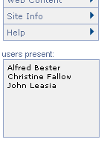
Users Present list is displayed if
display.users.present=true

presence.inchat.icon

As of 2.1.2, the presence in chat icon is to the left of the username, and is controlled by the tool_base.css file. The icon used is chatpresicon.gif.

.presenceList li.inChat {
background:url(images/chatpresicon.gif) -.1em center no-repeat;
}

One way to change the presence in chat icon is to replace the chatpresicon.gif file in your installation’s \tomcat\webapps\library\skin\default\images folder with the gif you want to use.

Skins
See the following documents in the Sakai Development site Resources/Architecture Docs/Sakai 2 folder on http://collab.sakaiproject.org for more detailed information on skinning in Sakai.

Skinning Sakai Portal
http://collab.sakaiproject.org/access/content/group/1097928811887-22636/Architecture%20Docs/Sakai%202/sakai_skin_portal.pdf

Skinning Sakai Tools
http://collab.sakaiproject.org/access/content/group/1097928811887-22636/Architecture%20Docs/Sakai%202/sakai_skin_tool.pdf

And in the Sakaipedia at Confluence –
http://bugs.sakaiproject.org/confluence/display/ENC/Skinning+in+Sakai+2.0

wysiwyg.editor
# specify the wysiwyg editor
wysiwyg.editor=FCKeditor

Used to set the wysiwyg editor used in tools. It controls the toolbar that appears above multiline text entry fields where html formatting is supported (e.g., when creating an Announcement). Default is to use the FCKeditor. If wysiwyg.editor= HTMLarea, then the HTML editor is used. The FCK editor has a few more capabilities than does the HTMLarea editor, including an icon to load images, and one for pasting in content copied from a Word doc.

HTMLarea editor

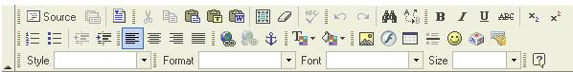
FCK editor

skin.default
# The default skin for sites without a skin setting

skin.default=default

Sites get this skin if no value is selected when creating a course site. All project sites use this skin.

skin.repo
# the path to the skin files

skin.repo=/library/skin

The location of css and image files used in skinning Sakai.

iconNames.count

iconNames.n
# for worksite setup, which offers a list of Appearance (Icon) choices (course sites only)

iconNames.count=4
iconNames.1=*default*
iconNames.2=humanities
iconNames.3=engineering
iconNames.4=pig

Sets the values that will show up in the ‘Appearance (icon)’ field dropdown.

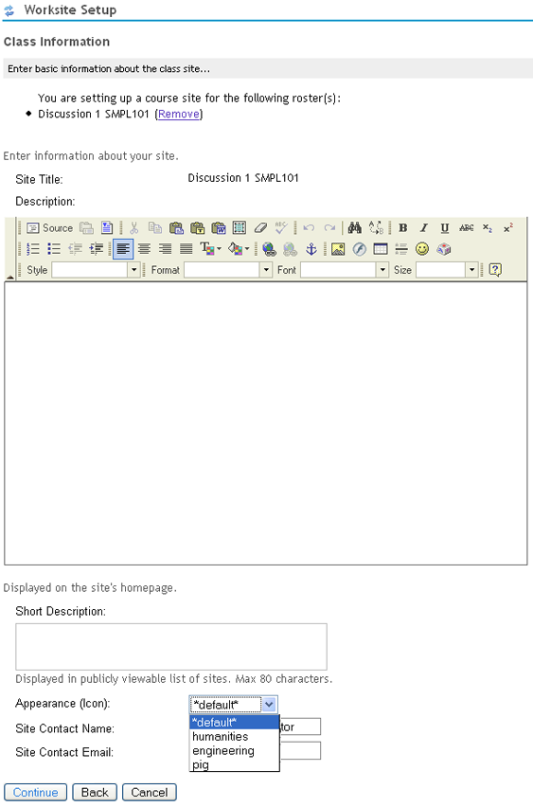

Values that appear in the Appearance (Icon): dropdown are
specified in iconNames.n properties

The names are associated (via the iconUrls property) with gif files. The gif selected via the dropdown shows up at the top of the left hand menu column in the worksite (see the figure in the iconUrls description)

iconUrls.count

iconUrls.n

iconUrls.count=4
iconUrls.1=
iconUrls.2=/library/icon/humanities.gif
iconUrls.3=/library/icon/engineering.gif
iconUrls.4=/library/icon/pig.gif

Specifies the location of the image which shows up at the top of the left hand menu column in the worksite. The particular image is chosen using the ‘Appearance (icon)’field dropdown menu when creating a class worksite.

For example, selecting ‘humanities’ (the iconNames.1 property) from the dropdown when creating a class site puts the humanities icon (the iconUrls.1 icon) in the left hand menu column.

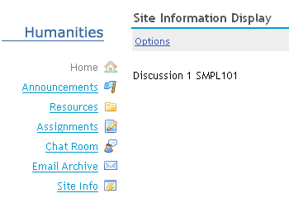

Placement of the iconUrls.n icon

iconSkins.count

iconSkins.n

iconSkins.count=4
iconSkins.1=
iconSkins.2=
iconSkins.3=
iconSkins.4=examp-u

Used to provide additional skins which will override the default skin if desired. Normally, the default skin is used in a site, and the iconName.n value selected in the Appearance dropdown when creating a class site just indicates which worksite icon to use. However, if a value is set for an iconSkins.n property, then that value is used as the skin when the corresponding iconName.n value is chosen from the Appearance dropdown.

With the defaults, selecting the ‘pig’ value (the iconNames.4 property) from the Appearance dropdown when creating a class site gives the site the examp-u skin (set by the iconSkins.4 property).

disable.course.site.skin.selection
#show/hide icon/url list with course site edit info

disable.course.site.skin.selection=

When creating a course site, the appearance of the site skin can be customized by adding an icon at the top of the left hand menu column. disable.course.site.skin.selection controls the ability to edit that skin once the site has been created. If set to true, the Appearance Icon dropdown does not appear when editing the site with Worksite Setup or Site Info’s Edit Site Information function.

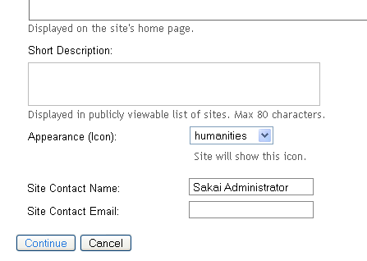
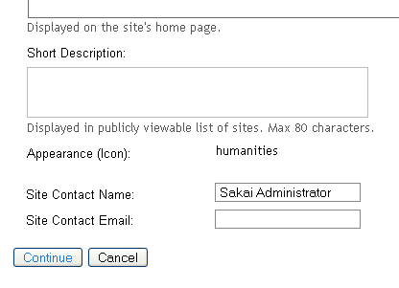

By default, the Appearance Icon dropdown appears when editing a site (above left).
If disable.course.site.skin.selection=true, the field will
be a display only field when editing a site (above right).

logout.icon

logout.icon=

If set, causes the image specified by the URL value to appear in the upper right corner of the Sakai page after login.

For example, if logout.icon=<url to a closing door gif>, the image will replace the Logout button.
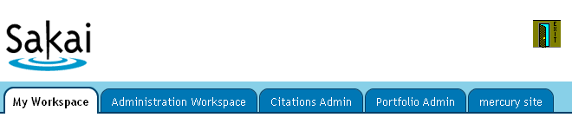

java.beep
# to enable some beeping in the user interfaces

java.beep=false

Accessibility

accessibility.url
#the location (url) of the accessibility info
#accessibility.url=

If there is a value (URL), it renders an invisible link in the portal to the URL given by the value. This is so that screen reader users can go to a summary page of how to navigate Sakai with a screen reader.

Sakai OOTB does not have a value set for accessibility.url.

Announcement Tool control

announcement.merge.display

# announcement.merge.display

The default behavior is to show the merge item in the Announcement toolbar (to those with site.upd permission). If you want to prevent users from using the merge feature, set

announcement.merge.display=0

Assignment Tool control

allowGroupAssignments
# Use to disable group awareness option in assignments.
# By default this is true and Assignments is group aware.

allowGroupAssignments@org.sakaiproject.assignment.api.AssignmentService=false

This property is set in the components.xml in the Assignment package (assignment/trunk/assignment-impl/pack/src/webapp/WEB-INF/components.xml). An example of setting the property to false is above. By default, when creating an assignment, if there are groups defined in the site, the ‘Display to Selected Groups’ option is available. If an institution wants to enable the ability to create an Assignment that is visible to only one or more groups, but not the entire site, then they do not need to define this property. If they want to prevent assignments per group, then set this property to false in the sakai.properties file to override the default.

allowGroupAssignmentsInGradebook
# Use to permit group specific assignments to enter Gradebook.
# By default this is false.

allowGroupAssignmentsInGradebook@org.sakaiproject.assignment.api.AssignmentService=true

This property is set in the components.xml in the Assignment package (assignment/trunk/assignment-impl/pack/src/webapp/WEB-INF/components.xml). The default setting is false – assignments directed to a specific group can not be auto inserted into Gradebook because the ‘Add to Gradebook’ option when adding an assignment will not appear. An example of setting the property to true is above. When set to true, the ‘Add to Gradebook’ option will appear when an assignment is created that is directed to a specific group.

As of 2.2, Gradebook does not yet handle group specific Assignment completely – students will see all assignments in Gradebook even though an assignment might be for a group they are not in. All assignments – those for the entire site and to specific groups - are used in calculating the cumulative grade whether or not the student is in a particular group. For that reason, an institution may want to prevent group specific assignments from entering the Gradebook, to avoid confusion amongst those viewing the Gradebook.

assignment.useContentReview

assignment.useContentReview=false

This property controls whether or not Assignment submissions are added to a queue that will be processed by a content review service such as TurnItIn. By default the property is set to false. This is only used in conjunction with a commercial content review application (which is not delivered as part of the standard Sakai release).

assignment.instructor.notifications

assignment.instructor.notifications=true

Determines whether the feature which emails instructors submission notifications is available in the installation. If set to true (the default), the submission notification option for the instructor appears on the Add Assignment page

Also see assignment.instructor.notifications.default which controls the default manner in which instructors receive notifications.

assignment.instructor.notifications.default

assignment.instructor.notifications.default=none

This sets the default for the option that controls whether/how instructors receive submission notification emails. Instructors can choose to not receive any notifications (none), receive a notification for each submission (each), or receive a digest of all notifications once per day (digest). The default is set to none for Sakai out of the box.

See also assignment.instructor.notifications which determines whether instructors see the option to receive notifications.

assignment.submission.confirmation.email

assignment.submission.confirmation.email=false

Determines whether the feature which sends students an email confirmation when they submit is turned on in the installation. If set to true, an email is sent to the student whenever they click the submit button on the Submit Assignment page. The default is false.

Calendar Summary Tool

calendarSummary.viewMode
# Calendar view default(week or month)
# Default: month

calendarSummary.viewMode = week

Used to specify which view (month view or week view) of the Calendar Summary is the default. The example above changes the default view to be the week view.

calendarSummary.[high | medium | low]PriorityColor
# Calendar day background color (as hexadecimal value).
# Default: background-color as defined in the tool CSS (.calDayWithActivity) for all priorities

calendarSummary.highPriorityColor = #FF0000
calendarSummary.mediumPriorityColor = #00FF00
calendarSummary.lowPriorityColor = #0000FF

Used to specify which view (month view or week view) of the Calendar Summary is the default. The default for all 3 priorities is that specified in the tool’s CSS for .calDayWithActivity. The examples above set the 3 priority colors to green, blue, and red for low, medium, and high priority events. The priority of an event type is set in the Options page of the Calendar Summary tool.

calendarSummary.highPriorityEvents.count

calendarSummary.highPriorityEvents.n
# Define high priority calendar events
# Default: no events specified as high priority

calendarSummary.highPriorityEvents.count=2
calendarSummary.highPriorityEvents.1 = Deadline
calendarSummary.highPriorityEvents.2 = Exam

Used to specify which type of event(s) are considered high priority. By default, all events are considered low priority. The calendarSummary.highPriorityEvents.count and calendarSummary.highPriorityEvents.n properties specify which properties are considered High Priority. The priority an event is given can dictate the color used to mark an event of the priority as occurring on a particular day (depending on the color setting in the calendarSummary.highPriorityColor property setting).

Note: there is no need to set low priority events – all events are by default low priority. Event types can be changed to high or medium priority, or left as low priority by not specifying them as high or medium priority..

calendarSummary.mediumPriorityEvents.count

calendarSummary.mediumPriorityEvents.n
# Define medium priority calendar events
# Default: no events specified as medium priority

calendarSummary.mediumPriorityEvents.count=1
calendarSummary.mediumPriorityEvents.1 = Web Assignment

Used to specify which type of event(s) are considered medium priority. By default, all events are considered low priority. The calendarSummary.mediumPriorityEvents.count and calendarSummary.mediumPriorityEvents.n properties specify which properties are considered Medium Priority. The priority an event is given can dictate the color used to mark an event of the priority as occurring on a particular day (depending on the color setting in the calendarSummary.mediumPriorityColor property setting).

Note: there is no need to set low priority events – all events are by default low priority. Event types can be changed to high or medium priority, or left as low priority by not specifying them as high or medium priority..

Fourms Tool control

mc.showForumLinksInNav

mc.showForumLinksInNav=true

Disables the links to the Forum-level pages, i.e. so users can navigate between the index page and topic pages but don't get lost in intermediate forums pages. The default is true.

mc.disableLongDesc

mc.showForumLinksInNav=false

Removes the long descriptions (mostly to avoid visual clutter) that show up in the Forums listings..

Help Tool control

helpPath

helpPath=/help

Specifies the URL to the help path. This partial URL is used to construct the full URL for accessing help content. For example, http://localhost:8082/portal/help/TOCDisplay/content.hlp?docId=aqyk

display.help.menu

display.help.menu=

This property controls the global display of Help in the side menubar for an installation. By default display.help.menu=true, and the Help item shows in all tool menubars (and cannot be removed using the Edit Tools page of Site Info). When set to false, Help will not appear in the side menubar of any site. This property functions independently of display.help.icon

display.help.icon

display.help.icon=

This property controls the global display of the context sensitive help icon (the ? icon) in tool titlebars. By default display.help.icon=true, and the ? icon shows in all tool titlebars. When set to false, the ? icon will not appear in tool titlebars. This property functions independently of display.help.menu

help.location

help.location=

help.location allows the Help tool to use an external content collection rather than the content bundled with Sakai. help.location should contain the URL of the help collection, e.g.: help.location = http://www.school.edu/helpdocs/

The external location must contain:
- A help.xml registration file, listing the topics and items
- Help documents in HTML format.

On startup, the Help tool reads the help.xml registration file. When a document is selected from the index, the Help tool sends a redirect to the appropriate external document. The format of the help.xml file is documented in the README file located in the Help source (help/README).

help.location is by default unset and so the help tool renders help content for pages from /portal/help/TOCDisplay/content.help.

help.welcomepage

help.welcomepage=

This property can be used to change the default help welcome page. By default, Help will display html/help.html (relative to the webapp url, usually portal/help/). The URL can be a relative or absolute path, or external URL. To create a help welcome page which is stored in Content Hosting, a URL such as help.welcomepage=/access/content/public/help.html can be used.

help.redirect.external.webapp

help.redirect.external.webapp=

Specifies an external location for help information. If this is set to "sakai" (the default), help information will be displayed as usual. If not, help requests will be redirected to the specified URL.

help.collections

help.collections=

Allows a comma-separated list of help collections to be added (provided these are
deployed on the classpath). For example, in sakai.help.xml

<!-- generic help collections -->
<configuration name="help.collections"
value="sakai_iframe_myworkspace,sakai_menubar,sakai_course_sites,
sakai_permissions,sakai_accessibility"

help.hide

help.hide=
Sites may wish to hide help for specific tools, for example for stealthed tools. To hide help for particular tools, specify their tool ids in this property. The format is a comma delimited list, e.g. help.hide=sakai.maps,sakai.rsf.evaluation.

Message Center

mc.threadedview

mc.threadedview = false

If set to true, Message Center will display a threaded view. Otherwise, with the default setting of false, the view is a linear, flat view.

OSP

sakai.reports.useWarehouse

sakai.reports.useWarehouse=1

The types of reports to generate from the OSP data warehouse. Accepts a value of 0,1,2 or 3. Set to 0 to disable reports, 1 to generate warehouse reports, 2 to generate live reports, and 3 for both warehouse and live reports. The default value is 1.

This property is used instead of osp.reports.useWarehouse as of Sakai 2.5.

osp.upgrade25

osp.upgrade25=true

For 2.5, the OSP ePortfolio project was brought into Sakai. A conversion script which changed the permission model previously used in OSP to be more Sakai like can cause problems when installing 2.5 if the OSP ePortfolio project isn’t included. This property when set to false causes the OSP related conversions to be bypassed.

displayToolCategories

displayToolCategories@displayToolCategories@org.theospi.portfolio.
portal.intf.PortalManage=true

Portfolio sites group tools into categories. If you don't want to organized tools by categories in Portfolio sites, you can set this property to false. The page order set in toolOrder.xml and set by the page order tool will then be used instead.

Preferences

preference.pages
# controls which pages show in the preference tool, and the order of the actions in the toolbar

preference.pages=

This is available as of 2.6

The Preferences tool displays various preferences on several different pages, accessed by clicking actions in the Preference toobar. preference.pages controls the order of the actions (and therefore the first page that appears when first entering the Preferences tool), and whether an action is displayed in the toolbar at all.

Pages are referenced in the property by their bundle property name:
Tab preferences prefs_tab_title
Notification preferences prefs_noti_title
Timezone preference prefs_timezone_title
Language preference prefs_lang_title
Privacy preferences prefs_privacy_title

By default (with no setting for preference.pages), the toolbar actions show in the following order:
Customize Tabs, Notifications, Time Zone, Language
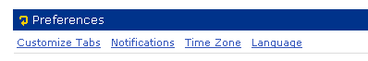
and the Privacy preference action is not displayed.

To show all actions, set
preference.pages= prefs_tab_title, prefs_noti_title, prefs_timezone_title, prefs_lang_title, prefs_privacy_title

Note: Prior to 2.6, the Privacy Status preference page toolbar action was not shown by default, and was enabled using the sakai property enable.privacy.status. In 2.6, the Privacy Status action is still off by default, and is enabled by including prefs_privacy_title in the preference.pages setting. The enable.privacy.staus property is no longer used.

prefs.research.collab

prefs.research.collab = false

Installations of Sakai for research & collaboration have no need for "Syllabus" in the User Preferences Notifications tool, and there are likely to be other research-specific customizations as well. This property can be used to hide the Syllabus notifications section of the Preferences tool Nofitication page. By default, the property is false and Syllabus notification preferences are displayed. Set to true to hide the Syllabus notification preference setting. .

Resources

content.upload.max
# upload limit per request, in megs

content.upload.max=20

When uploading files into Resources, there can be a limit set to control the size of files uploaded. Some institutions may want to control how large files in Resources are to minimize problems site participants may have downloading large files over dial-up lines.

This limit is not enforced when uploading files via WebDav.

The limit applies to all files in an upload action. If 3 files are uploaded, the combined size of all 3 files cannot exceed the content.upload.max setting.

MySQL note: The MySQL database has its own file size limit, stored in a variable called max_allowed_packet, which is 1Mb by default. Visit this page for instructions on changing it: http://dev.mysql.com/doc/mysql/en/program-variables.html

This limit should not be confused with the max space setting that can be set per site, which puts a limit on the total size of all resources in a site. The max size per site limit is set in the components.xml file (/content/trunk/content-impl/pack/src/webapp/WEB-INF/components.xml). The siteQuota property in the
org.sakaiproject.content.api.ContentHostingService bean sets the limit to a default of 1Gb.
<bean id=”org.sakaiproject.content.api.ContentHostingService”
...snip...
<property name=”siteQuota”><value>1048576</value></property>
</bean>

This can be overridden in sakai.properties. For example, siteQuota@org.sakaiproject.content.api.ContentHostingService = 2000000

The max size limit of a site’s Resources can be set on a site by site basis, to override the installation default set by siteQuota. Visit the site as admin, click on the Edit Properties link for the top level folder. An editable field on the properties page can be used to override the siteQuota value for the site. If the field is set to 0, no check is made on quota – the site has no limit on size.

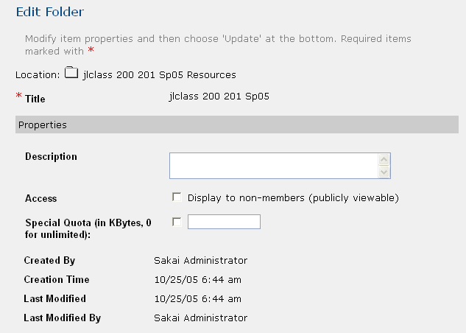
The Edit Properties page – editing the top level Folder in a site’s Resources to
Override the siteQuota limt

content.upload.ceiling

content.upload.ceiling=

Specifies an absolute max value that cannot be exceeded on uploads which use the request filter init parameter upload.max. When not set, the value of content.upload.max is used.
In addition to the Sakai-wide setting content.upload.max, a request filter init parameter (upload.max) can be used to allow any form POST that includes one or more files being uploaded to have, in the URL parameters, a "upload.max=nnn" setting. This will override the upload max set by content.upload.max for the request to have a different upload.max. The "nnn" value is in megabytes. The parameter must be in the URL, not the POST data (i.e. not a form field), as it needs to be readable before we parse the POST data.

When the upload.max parameter is used in a URL, in order to prevent malicious abuses the content.upload.ceiling value controls the absolute max size of the upload. This allows certain tools, like Melete, to upload files larger than the system wide content.upload.max, but limit potential problems with server memory being overwhelmed by uploads.

content.upload.dir

content.upload.dir=

Specifies the location where commons-fileupload stores uploads as they are being processed.

copyrighttype.n

copyrighttype.count

# the copyright options for the resources tool

copyrighttype.count=6
copyrighttype.1=Material is in public domain.
Copyrighttype.2=I hold copyright.
Copyrighttype.3=Material is subject to fair use exception.
Copyrighttype.4=I have obtained permission to use this material.
Copyrighttype.5=Copyright status is not yet determined.
Copyrighttype.6=Use copyright below.

Configures copyright options that appear when adding/creating a file in Resources.

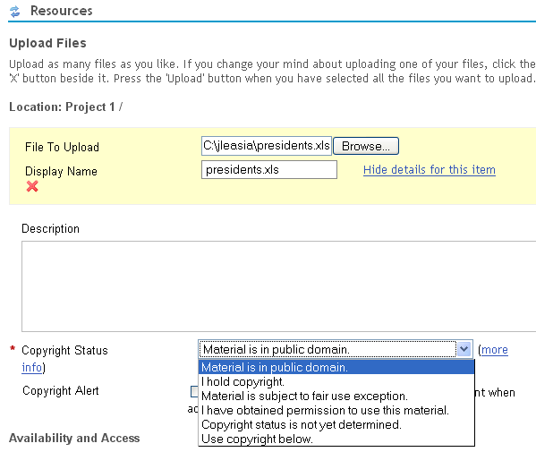

Copyright options when adding/creating a file in Resources

Default copyright selections as set by coyprighttype.n and copyrighttype.count

default.copyright
default.copyright=I hold copyright.

Specifies which copyrighttype option is the default selection in the Copyright Status dropdown list which is available when adding/revising a Resources.

copyrighttype.own

copyrighttype.own=I hold copyright.

The copyright for an item in Resources can be automatically constructed to include the user’s name. copyrighttype.own specifies which item in the Copyright Status list (which copyrighttype.n value) when chosen causes the Copyright Information field to be seeded with a default copyright notice that includes the user’s name.

With the defaults, if the user selects ‘I hold copyright.’ From the Copyright Status list, the Copyright Information field is seeded with the text “copyright © <year>, <username>. All rights reserved” where <year> is the current year, and <username> is replaced by the users First Last name.

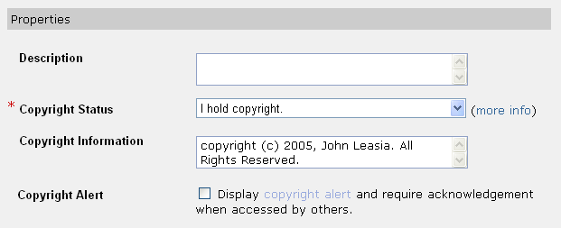
If ‘I hold copyright’ is selected, text in the Copyright Information field
is automatically constructed and includes the user’s name

Note: As of Sakai 2.5.3, the above feature has a bug where the copyright information field does not appear for the I hold copyright option. SAK-14447. There are also problems with what is shown in the alert message presented when a resource is opened if the Display copyright alert’ option was selected when the resource was created.

copyrighttype.new

copyrighttype.new=Use copyright below.

Specifies which item in the Copyright Status list (which copyrighttype.n value) when chosen causes the user entered text in the Copyright Information field to be used for the file’s copyright.

With the defaults, if the user selects ‘Use copyright below’ From the Copyright Status list, then text they enter in the Copyright Information field will be used for the Copyright.

default.copyright.alert

default.copyright.alert=true

Specifies whether the Copyright Alert checkbox on the Add Item page in Resources should be checked on (true) or off (false) by default.
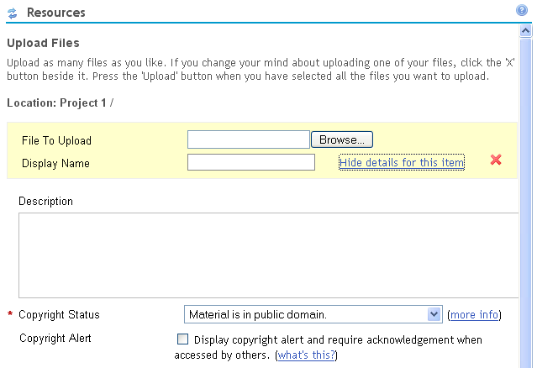

Default setting of the ‘Copyright Alert’ checkbox controlled by default.copyright.alert

fairuse.url

fairuse.url=http://fairuse.stanford.edu

On the Add Item page of Resources, there is a ‘more info’ link next to the ‘Copyright Status’ field that can be used to provide information about copyright issues. The default points to a page served by Stanford about Fair Use.
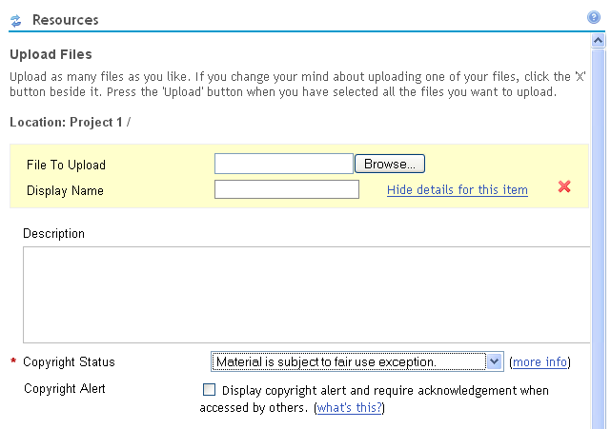

The fairuse.url property specifies what URL to use for the ‘more info’ link

newcopyrightinput

newcopyrightinput=true

Controls the appearance of the ‘Copyright Information’ field on the Add Item page of Resources. If newcopyrightinput=false, the Copyright Information field is not shown.
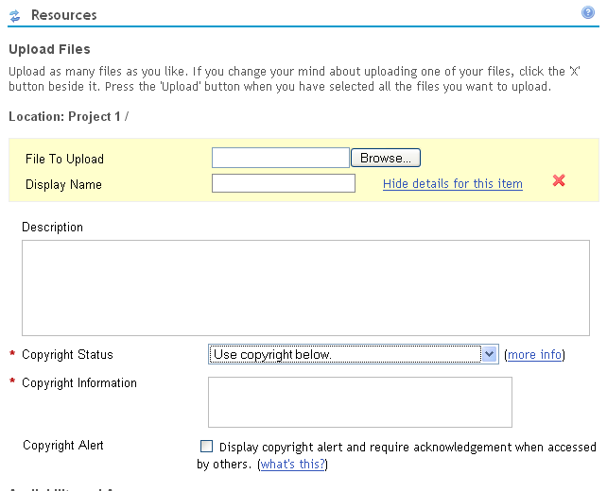

newcopyrightinput must be set to true for
the Copyright Information field to appear

Note: See SAK-14447. This feature is not working properly in Sakai 2.5.3

resources.show_all_collections.tool
# indicates whether users should see "Show Other Sites" twiggle in list mode of resources tool

resources.show_all_collections.tool=true

The Resources list changed with 2.1 to include the ability to show resources from other sites in which the user is a participant. When resources.show_all_collections.tool=true, the list includes a twiggle control that is used to toggle open the list of Resource folders from other sites. If resources.show_all_collections.tool=false, the twiggle control does not appear and users see only resources for the site in a site.

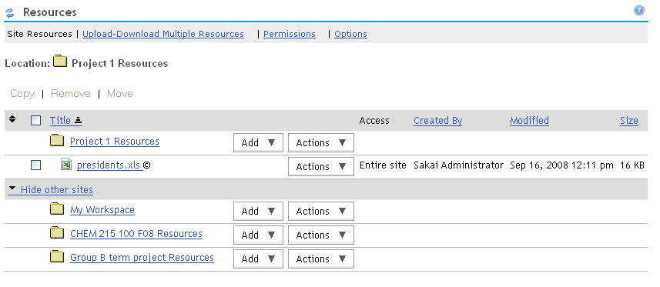

Resources from other sites are shown when
resources.show_all_collections.tool=true, and can be
shown or hidden with the
‘hide other sites|show other sites’ toggle

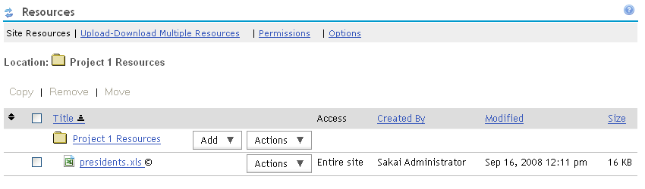

Only resources from the site are shown in the
Resources tool when resources.show_all_collections.tool=false

resources.show_all_collections.dropbox
# indicates whether users should see "Show Other Sites" twiggle in list mode of dropbox tool

resources.show_all_collections.dropbox=false

The DropBox list changed with 2.1 to include the ability to optionally show resources from other sites in which the user is a participant.

If resources.show_all_collections.dropbox=true, then the ‘show other sites | hide other sites’ toggle is present.

As is the case with dropbox, maintain/instructor type roles see all dropboxes. Resources from other sites they participate in will show if Show other sites is toggled open. Users with a role that permits them to see only their own dropbox will similarly have the toggle to open resources from sites they participate in.

resources.show_all_collections.helper
# indicates whether users should see "Show Other Sites" twiggle in list mode of file picker

resources.show_all_collections.helper=true

The Attachment widget (file picker) changed with 2.1 to include the ability to optionally show resources from other sites in which the user is a participant when browsing for a file to attach.

For example, when resources.show_all_collections.helper=true, creating an attachment to an Announcement includes resources from other sites in the Select a resource section of the attachment page.

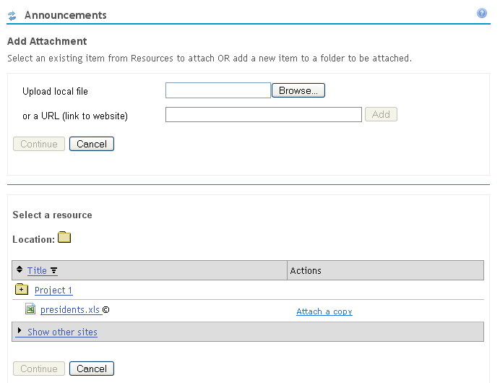

The ‘Show other sites | hide other sites’ toggle
Appears in the file picker when making attachments if
resources.show_all_collections.helper=true

allowGroupResources
# Use to disable group awareness option in resources.
# By default this is true and Resources is group aware.

allowGroupResources@org.sakaiproject.content.api.ContentHostingService=true

Used to disable groups in resources. When set to false, the ability to select groups when creating or revising a resource is not available. The default is true, and groups if present can be selected when creating/revising a resource to make the resource available to one or more groups only.

siteAttachments
# Use to set the default for protecting site-scoped attachments
# If false - attachments are protected by a long GUID (security-by
# obscurity)
# If this is true, users must both know the GUID and be a
# member of the site

siteAttachments@org.sakaiproject.content.api.ContentHostingService=true

Prior to Sakai 2.4 attachments were protected by a GUID in the filename that was impossible to guess - these GUIDs typically arrived in E-Mail notifications or were generated as URLs in tools that used attachments. When users click on the URL there is no ID/PW prompt to view the resource. For Sakai 2.5 and later, users must be a member of the site that the resource is attached to and if the user is not logged in (i.e. clicking on a link in an E-Mail) they will be prompted for their ID/PW. For Sakai 2.5 the default is "true" - to keep to the 2.4 and earlier behavior in Sakai 2.5 and later set this value to false. When this value is changed all site-scoped attachments are affected - this is a global setting for a Sakai instance - not a file-by-file setting.

availabilityChecksEnabled

availabilityChecksEnabled@org.sakaiproject.content.api.ContentHostingService = false

Used to enable/disable the ability in Resources to control availability of folders and files by beginning and ending dates. If set to true, a folder or file may have an optional beginning and/or ending date set. The file will not be visible until the beginning date, and will not be visible after the ending date. There is also an option to hide the file, regardless of date. When true, the following fields show up when creating/revising a resource.

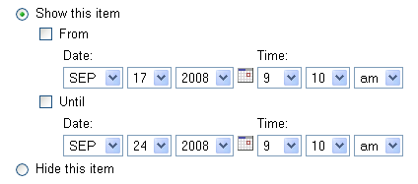

The default setting in the content component.xml file is true.

Those in the site with the ‘hidden’ permission enabled are able to see resources regardless of the Show or Hide setting.

prioritySortEnabled

prioritySortEnabled@org.sakaiproject.content.api.ContentHostingService = true

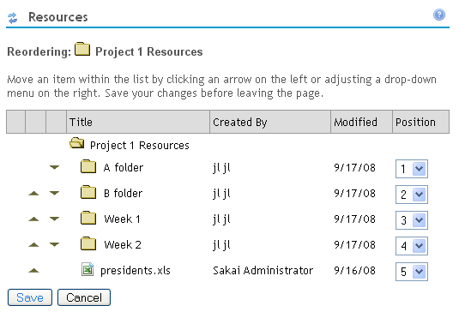
Used to enable the ability to customize the order of items listed in Resources. The default is true. If set to true, then an additional ‘Reorder’ link will appear in a folder’s Action dropdown menu for those with permission to edit the site. When clicked, the Reorder link provides a page that is used to modify the display order of the items in the folder. If the property is set to false, then the Reorder link does not show up in the interface.
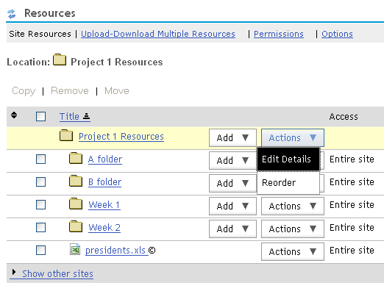

By default, prioritySortEnabled is set to true, and the Reorder link is
available to reorder folder contents, using ‘up’/’down’ arrows

Roster Tool control

roster.display.firstNameLastName

roster.display.firstNameLastName=true

This determines how names are displayed in the roster view. the default is firstName LastName. if set to false the names are displayed as LastName,FirstName format. The default value is true.

roster.display.hideSingleGroupFilter

roster.display.hideSingleGroupFilter=true

If there is only one group in the site, the group filter can be hidden from the UI to simplify the display. The default is to show the group filter. Setting this property to false will hide the group filter when there is only one group defined in the site.

roster.defaultSortColumn

roster.defaultSortColumn=sortName

The Roster display can be sorted by columns. This property controls which column is used to sort the list by default. Possible values are sortName, role, displayed, or email. Only one value should be used. The first time into the Roster tool, the list will be sorted by the column cooresponding to the value set in this property. If not set, the default is by role.

roster_view_email

roster_view_email = true

The email address at some institutions is identical to the user ID, making the display of the column redundant (except for the email link). This property can be set to true or false. By default, the property is true, and the email address column is shown.

Schedule Tool control

calendar.merge.display

# calendar.merge.display

The default behavior is to show the merge item in the Schedule toolbar (to those with site.upd permission). If you want to prevent users from using the merge featue, set

calendar.merge.display=0

ical.experimental

ical.experimental=false

iCal import/export is available in 2.5, though it doesn't currently support re-occurring events. In order to enable, set ical.experimental = true. The default setting is false.

config@org.sakaiproject.section.api.SectionManager

config@org.sakaiproject.section.api.SectionManager=

Used to control how sections are created in the Section Info tool. Possible values and the behavior are:

MANUAL_MANDATORY | The section Info tool does not allow for externally managed sections, and sections will never be created automatically
MANUAL_DEFAULT | The section Info tool allows the user to choose whether sections should be internally or externally managed. Sections will not be generated for sites unless a site maintainer switches the default "manual" setting to automatic
AUTOMATIC_DEFAULT | The section Info tool allows the user to choose whether sections should be internally or externally managed. Sections will be generated for sites associated with any number of rosters. The default setting for new sites will be automatic management of sections.
AUTOMATIC_MANDATORY | The section Info tool does not allow for internally managed sections. Add sections are created automatically, based on the rosters associated with the site.

Test & Quizzes (Samigo)

samigo.saveMediaToDb

samigo.saveMediaToDb=

Controls whether files uploaded in response to Test & Quizzes questions are stored directly in the Database, or whether they are stored first, temporarily, in a location specified by samigo.answerUploadRepositoryPath. The default value is set to false If present in the sakai.properties file, this overrides the com.corejsf.UploadFilter.saveMediaToDb setting in the samigo web.xml file.

samigo.answerUploadRepositoryPath

samigo.answerUploadRepositoryPath=

For files uploaded in response to Test & Quizzes questions, the location where such files will be stored if saveMediaToDB=false. If saveMediaToDB=true, this location acts as a temporary directory for storage, and the file is deleted from this location after the file is moved to the Database. If present in the sakai.properties file, this overrides the com.corejsf.UploadFilter.repositoryPath setting in the samigo web.xml file.

samigo.sizeThreshold

samigo.sizeThreshold=512

Overrides the max file size for files uploaded in response to a Test & Quizzes question to be kept in memory before writing to disk. The default value is 512. If present in the sakai.properties file, this overrides the com.corejsf.UploadFilter.sizeThreshold setting in the samigo web.xml file.

samigo.sizeMax

samigo.sizeMax=

Overrides the max file size that can be uploaded for files uploaded in response to a Test & Quizzes question. The default is 20480 (20 Mb). If present in the sakai.properties file, this overrides the com.corejsf.UploadFilter.sizeMax setting in the samigo web.xml file.

samigo.smtp.server
#SMTP Server
samigo.smtp.server=

Because regular Sakai email service doesn't support real attachments, Test&Quizzes implements a separate email module. Different properties from regular Sakai email service are used. They will not override the regular Sakai SMTP settings, and vice versa.

samigo.smtp.port
#SMTP Port
samigo.smtp.port=

Because regular Sakai email service doesn't support real attachments, Test&Quizzes implements a separate email module. Different properties from regular Sakai email service are used. They will not override the regular Sakai SMTP settings, and vice versa.

samigo.email.bypassAuth
samigo.email.bypassAuth=false

Should bypass username/password Authentication. Default is false. If it is set to true, you don't need to provide username/password in the samigo.email.username and samigo.email.password properties.

samigo.email.username
samigo.email.username =

Set to a valid username if samigo.email.bypassAuth is true.

samigo.email.password
samigo.email.password =

Set to a valid password for the user specified in samigo.email.username if samigo.email.bypassAuth is true.

samigo. email.prefixedPath
samigo.email.prefixedPath=

Should be set to a file system location. This is where attachments for Test & Quizzes will be stored. For example, samigo.email.prefixedPath=C:/sakaitmp/

samigo.samliteEnabled

samigo.samliteEnabled=false

This is for Samlite (word-2-QTI converter). By default it is set to false. When set to true, the Word-2-QTI tool is available within Test & Quizzes. .

WebDAV

webdav.ignore
webdav.ignore.count=2
webdav.ignore.1=/.DS_Store
webdav.ignore.2=/._

This is used to list of patterns in file names that WebDAV will refuse to store using the PUT method. The use case that drives this property is Apple's Mac OS/X storage of files named .DS_Store and resource "forks" which start with "._". Using this property, WebDAV simply does not store files that match these patterns. You notice that the patterns in the example start with the slash (/) character this way we only prohibit files and folders which begin with "._".

Be careful when setting this parameter. If you made the following setting:

webdav.ignore.1=/

webdav would refuse to store any files. Paths are of the form "/access/content/user/zt10/.DS_Store" so every path has the character "/" - so WebDAV will completely refuse to store any files. Likely your WebDAV users would catch this configuration mistake quickly.

Out of the box this is set to the proper setting to ignore the files produced by Mac OS/X's WebDAV client. You can comment all of these out and WebDAV will allow the storage of any path pattern.

maxElementsInMemory

maxElementsInMemory@org.sakaiproject.user.api.AuthenticationManager.cache

The default for this property is 10000,

timeToLive

timeToLive@org.sakaiproject.user.api.AuthenticationManager.cache

The default for this property is 120.

Wiki

wiki.experimental
#Controls whether experimental wiki features are available in the wiki tool

wiki.experimental = false

If wiki.experimental is set to true, experimental features of the wiki tool will be available.

wiki.comments

wiki.comments=true

This controls whether the Comment field is visible on wiki pages. If false, users cannot add comments to wiki pages.

wiki.notification

wiki.notification=true

This controls whether edits to wiki pages can trigger a notification. If false, notifications will not be sent. If true, notifications are sent when a wiki page is edited unless the ‘Minor Change’ checkbox is clicked.

wiki.display.user.id

# id display control in wiki
wiki.display.user.id=false

The ID might be private or sensitivve information at some installations. By default it is not shown in the wiki. Setting wiki.display.user.id=true will cause the ID to be displayed.

Worksite Setup / Site Info

activeInactiveUser
# worksite setup - enable the ability to control a participant's activation in a site

activeInactiveUser=true

Used to control whether the ‘Active/Inactive’ control is available, in the list of users that is shown when revising a site via Worksite Setup or in Site Info.
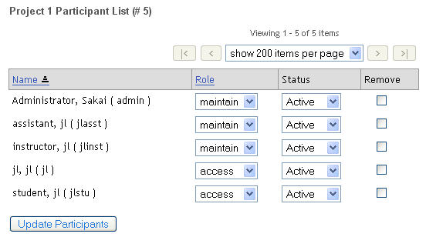

If activeInactiveUser=false this column does not appear

Some institutions may not want to give site owners the ability to inactivate users (such as registered students) due to local policy. See also disable.membership.unjoin.selection for a related feature.

wsetup.group.support
# whether to support group in Worksite Setup tool. Default to be true

wsetup.group.support=true

Use to hide or show the group support feature in Worksite Setup/Site Info tools.
If wsetup.group.support=true (or not set), Worksite Setup and Site Info will show the ‘Manage Groups’ action in the toolbar. The Manage Groups action will not be shown in Worksite Setup and Site Info if wsetup.group.support=false.
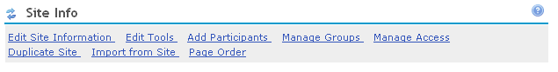

The Manage Groups action is shown in Worksite Setup and Site Info tool
if wsetup.group.support=true

site.setup.import.file

# disable from worksite setup the "import file" option

site.setup.import.file = true

The toolbar of the Site Info tool can optionally hide the action ‘Import from File’ if site.setup.import.file = false.
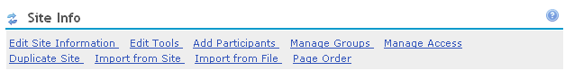

This feature allows one to import site materials from a zip file that includes information formatted in a way that Sakai can understand. It's basically the Site Archive tool, but in zip format so that someone can bring material in from outside of the system.

Installations will want to hide the Import from File action from the toolbar unless they have files of the appropriate format available for import (e.g., from their legacy system).

An example of its use: Indiana has built an export zip file from their legacy system that contains content zipped into one file. Their users can then use the Import from File action to import the zip file content.

See the Worksite Archiving.pdf document in the Sakai Development Resources/Configuration docs folder on http://collab.sakaiproject.org for more information on archiving in Sakai. http://collab.sakaiproject.org/access/content/group/1097928811887-22636/Configuration%20docs/Worksite%20Archiving.pdf

site.setup.allow.editRoster
# controls the visibility of the Site Info toolbar action ‘Edit Class Roster(s)’. If set to true, the action is present. If set to false, the action is not present in the toolbar. If not set, or set to true, the action is present in the toolbar.

# site.setup.allow.editRosters=

If an institution loads the courses for their users, the Edit Course Rosters action in the Site Info tool may not be something they would want to reveal to their users. This property can be used to turn off that capability by hiding the Edit Class Roster(s) action in the Site Info toolbar.

wsetup.skipCourseSectionSelection

wsetup.skipCourseSectionSelection=

In the process of setting up a course site, the pages having to do with manually selecting a subject, course, and section from dropdowns can be avoided by setting this property to true. These dropdown selections need an implementation in the provider which an institution may not have from their institution data.

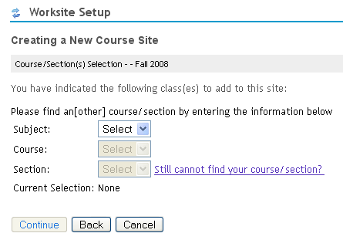
The default behavior, when not set or set to false, is to present the dropdown subject, course, and section selections during course site creation

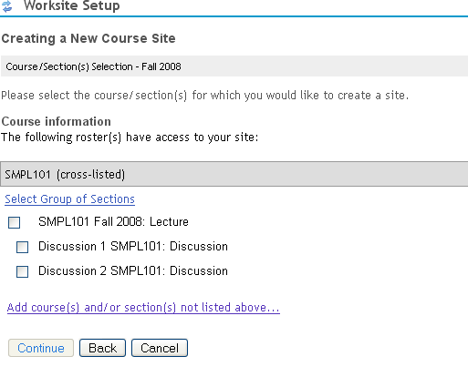

= false
(or not set)

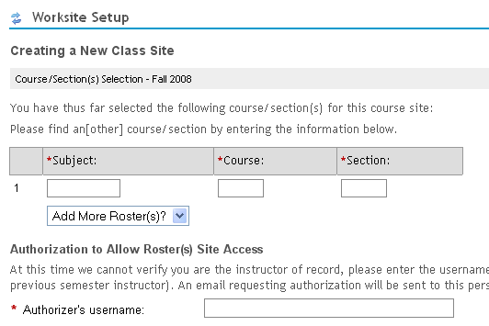

= true

titleEditableSiteType
# for worksite setup

titleEditableSiteType.count=1
titleEditableSiteType.1=project

Controls end user editing of site titles. Titles of sites with types specified by the titleEditableSiteType.n property can be changed by roles with site.upd permission. If a site type is not specified by a titleEditableSiteType.n property, the title field on the Edit Site Information page is a display only field

For example, with the default settings shown above, where Group B term project is a project site, and CHEM 215 100 F08 is a class site, the following images are from Site Info > Edit Site Information for the two sites.
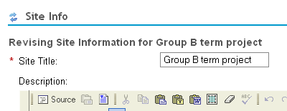

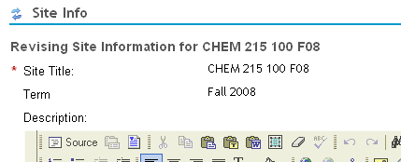

To allow site title editing for both course and project sites, the following settings could be used:
titleEditableSiteType.count=2
titleEditableSiteType.1=project
titleEditableSiteType.2=course

courseSiteType

courseSiteType=course

Specifies the type of site that is treated as a ‘course’ site. For the course site type, the term field can be edited with the Admin Sites tool. The term field does not show up for other types of sites (e.g., project).
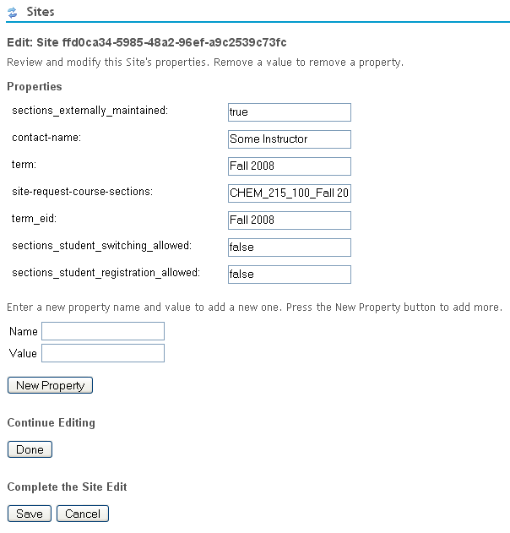

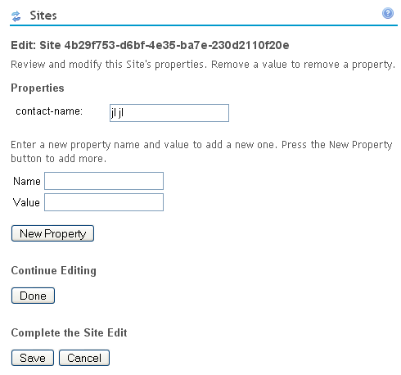

Course site Project site

wsetup.disable.joinable.count

wsetup.disable.joinable.n

# is site joinable option setable within Worksite Setup or Site Info tool for certain type of site?
# wsetup.disable.joinable.count=1
# wsetup.disable.joinable.1=course

Since there is sometimes confusion over what making a worksite joinable means to new users when creating a site, some institutions may want to prevent the joinable option from appearing when creating sites of a certain type. A course site which is mistakenly made joinable for example may expose content that the instructor hadn’t intended on making public. Some institutions have policy which prevents official course site content from being made available to anyone not officially registered for the course.

wsetup.disable.joinable.count is set to the number of sites which will have the ‘Can be joined by anyone with authorization to login’ checkbox hidden during the site creation (and site editing) process. wsetup.disable.joinable.n values are set to the site types that will not have the set joinable option.
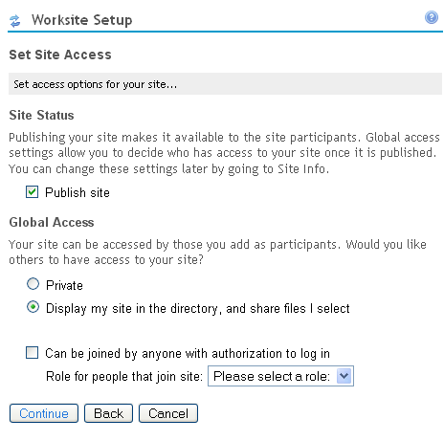

The ‘Can be joined by anyone with authorization to login’ checkbox can be hidden during the site creation process for sites of a particular type using wsetup.disable.joinable settings

wsetup.disable.unjoin.count

wsetup.disable.unjoin.n
# wsetup.disable.joinable.count=
# wsetup.disable.joinable.1=

If you would like to disable the ability to unjoin a site of a certain type, rather than disable unjoin for all sites with the disable.membership.unjoin.selection = true, use the wsetup.disable.unjoin properties. For example, if you wanted to prevent students from unjoining course and research sites (given that your system has sites of those types) use the following:
wsetup.disable.joinable.count=2
wsetup.disable.joinable.1=course
wsetup.disable.joinable.2=research

These properties are not set by default, so users are free to unjoin any site type (unless disable.membership.unjoin.selection is set to true).

roster.available.weeks.before.term.start

roster.available.weeks.before.term.start=4

Controls the flow through Worksite Setup when creating a new course site. The value is the number of weeks before start of next term when class lists will be presented to instructors for section selection when creating class sites. If an instructor creates a class site for the next term before roster.available.weeks.before.term.start weeks from start of next term, they will not see a list of their assigned classes when creating the site. Instead, the flow through Worksite Setup has them enter the class information manually.

This is to prevent the confusion that can arise when instructors create class sites too early, when information about teaching assignments is still in flux.

At UM, roster.available.weeks.before.term.start=8
If an instructor creates a class site 8 weeks before term starts, they must enter the class information manually as seen in the following
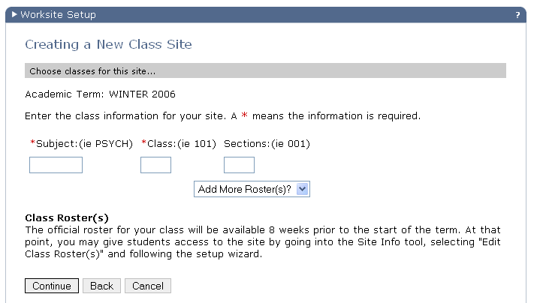

If the instructor creates a class site 7 weeks before term starts, they will see this page instead, which includes a listing of the classes they will be teaching for the term.
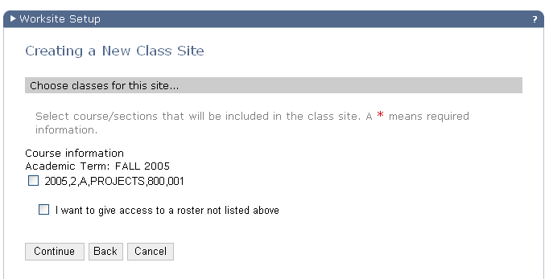

officialAccountLabel

officialAccountLabel = Official Email Address or Username

Specifies the label of the first entry field on the Add Participants page in Worksite Setup and Site Info tools. The first entry field is where provided user account names or local Sakai account names are entered.
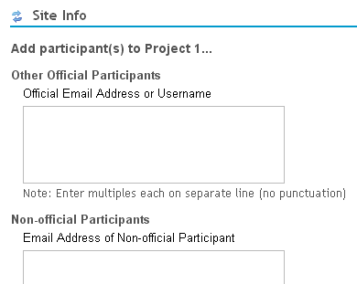
officialAccountSectionTitle

officialAccountLabel

nonOfficialAccountSectionTitle

nonOfficialAccountLabel

Properties and the text labels they define

Note: As of Sakai 2.5, officialAccountLabel replaces noEmailInIdAccountLabel

nonOfficialAccountLabel

nonOfficialAccountLabel = Email Address of Non-official Participant
Specifies the label of the second entry field on the Add Participants page in Worksite Setup and Site Info tools. The second entry field is where non-provided user account names are entered. See the diagram in the description of the officialAcocuntLabel property.

Note: As of Sakai 2.5, nonOfficialAccountLabel is used instead of emailInIdAccountLabel

officialAccountSectionTitle

officialAccountSectionTitle = Other Official Participants

Specifies the section title of the first entry field on the Add Participants page in Worksite Setup and Site Info tools.. See the diagram in the description of the officialAcocuntLabel property.

nonOfficialAccountSectionTitle

nonOfficialAccountSectionTitle = Non-official Participants

Specifies the label of the second entry field on the Add Participants page in Worksite Setup and Site Info tools. See the diagram in the description of the officialAcocuntLabel property.

nonOfficialAccountInstru

nonOfficialAccountInstru=To log in, you must first get a guest account. A guest account is a special kind of account that is used to give non-Sakai University members access to the general Sakai University web environment. The Sakai University web environment includes many tools and services, one of which is Sakai

When a new guest account is added via the 2nd entry box on the Add Participants page, an email can be sent to the new user notifying them that they have been authorized to login to Sakai (see notifyNewUserEmail). At institutions where there is an external login authority, this message can be used to inform the user that there may be some other account creation needed.

Note: As of Sakai 2.5, nonOfficialAccountInstru is used instead of emailInIdAccountInstru

nonOfficialAccount.url

nonOfficialAccount.url=

When a new guest account is added via the 2nd entry box on the Add Participants page, an email can be sent to the user with instructions about how to create a guest account. Included in that email can be a URL to the institution’s webpage where such guest accounts can be created. This property sets the URL to use in that email message.

Note: As of Sakai 2.5, nonOfficialAccount.url is used instead of emailInIdAccount.url

emailInIdAccount

emailInIdAccount.url=

The URL where guests go to get an institution’s guest account. The value of this property is used in the email message sent to new users whose account has been created by entering their email address in the 2nd entry box on the Add Participants page. See emailInIdAccount. See also notifyNewUserEmail which controls whether new users get an email when their account has been created via the Add Participant page.

Note: As of Sakai 2.5, this property is not used. Contents of the email can be modified by editing strings in the UserNotificationProvider.properties file inside site-manage-impl.

notifyNewUserEmail

notifyNewUserEmail=true

In Sakai, when an external authority is used to grant access, there may be two types of users attempting to gain access. Institutional users are assumed to have authority to enter Sakai and are let in. Guest users, though they may be able to login to the institution’s system, are not automatically assumed to have authority to enter Sakai. A guest account must be authorized to use Sakai.

When Sakai is handed a user who has a valid institutional guest account and has logged in successfully, Sakai has to know whether to let the user in – whether the guest user is authorized to use Sakai.

The authorization is accomplished using a local account in Sakai that corresponds to the institutional account. If a local account exists in Sakai for a guest user, then that guest user gets all the way in and is placed at their My Workspace.

The Sakai account can be created by support using the Admin User tool. But since that takes a support intervention, it’s also possible for site maintainers to authorize guest accounts to use Sakai. This happens automatically when a guest account is entered into the 2nd field on the Add Participants page. If the guest account entered there doesn’t already exist in Sakai, a new user account is created. The Sakai account then exists which matches the institution guest account, and when the user logs into Sakai via the institution’s login mechanism, they get all the way into Sakai.

When an account is created in Sakai, the account has a password. In the scenario above, the Sakai account password isn’t used – it is the guest account/pwd setup with the institution that the guest user signs on with. It is just the account name in Sakai that is used to authorize the guest user. So in that case, the Sakai password is not used, and the user doesn’t need to know it. The notifyNewUserEmail property should be set to false in that case, so the user doesn’t get an email with the (not used) Sakai password in it.

When would you set notifyNewUserEmail=true? For installations where there is no external authorization mechanism (e.g., http://collab.sakaiproject.org), the local Sakai account password is used. The Sakai account/pwd is the only means used to log in to Sakai. If a user is added to a site and doesn’t already have a Sakai account, a new account is created. Setting notifyNewUserEmail=true causes an email to be sent to the new user informing them of their password. Otherwise, they would have a new account and no one would know the password. They couldn’t login without support getting involved and changing their password to some known value, emailing them, etc.

invalidNonOfficialAccountString

invalidNonOfficialAccountString=

Though the guest account must be an email address, it must not contain this string.

For example, at UM, guest accounts must be email addresses, and cannot contain umich.edu (since if they have a umich.edu email address, they must have a UM uniqname and therefore a regular UM account). This is a way of preventing mistakes – site maintainers cannot add a guest account which contains umich.edu because we have invalidEmailInIdAccountString=umich.edu

This also prevents adding users with an email address containing alumni.umich.edu. If we wanted to allow alumni.umich.edu, but prevent engine.umich.edu, we could set the property to @umich.edu.

Note: this property replaces invalidEmailInIdAccountString as of Sakai 2.5

site.enableCreateAnyUser

site.enableCreateAnyUser=false

When creating a course site, the ability to type in another user’s accountname to see list their courses for selection can be enabled. By default, this feature is disabled. Setting site.enableCreateAnyUser=true will cause the following to appear in the course creation process.

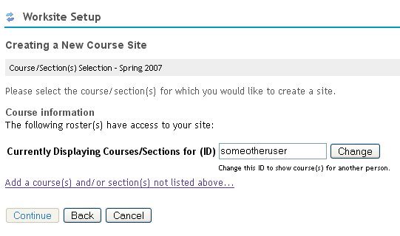

.

site.enableCreateAnyUser controls the visibility of this field

site-manage.courseManagementSystemImplemented
# if this is false, all course site can only be created manually, no CM lookup

site-manage.courseManagementSystemImplemented=true

If set to true, the CM service is consulted to find courses associated with the user in order to create a course selection list. The user can still choose to setup sites ‘manually’ (by entering the course information rather than selecting from a list or dropdowns). If set to false, users are only able to setup course sites by manually entering the course information. The default is true.

site-manage.campusUserDirectory
# url to look up a user id in your institute
site-manage.campusUserDirectory=

For example, site-manage.campusUserDirectory=https://school.edu/lookup

site-manage.cms.subject.category
# the default should match the category used for subject/department in the default CM impl data

site-manage.cms.subject.category=DEPT

site-manage.cms.subject.label
# the default should match the category used for subject/department in the default CM impl data

site-manage.cms.subject.label=Department

site.templates

site.templates=

When creating a site, template sites can be used to define the tool set rather than having the user pick from a list of tools. If template sites are defined (these are sites created normally that have some set of tools in them), the user is presented with a list of such sites on the first page of Worksite Setup. If they pick a template, the setup process is shortened and they are not presented with a list of tools (though they can add/remove tools with Site Info once the site is created).

This property defines the template site(s) to use. For example if a site exists with a site id of ‘template.engin’, and the property is defined

site.templates=template.engin

then the user will see the following in Worksite Setup when creating sites
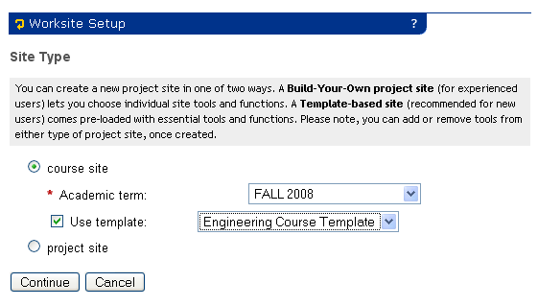

Template sites are shown in dropdown lists underneath the course site or project site radio button according to the site type of the template. The text in the dropdown entry is the template site title.

Sites tool control

sitebrowser.termsearch.type

sitebrowser.termsearch.type=course

In the Sites tool commonly placed on the Gateway site (site.browser), searches for sites can be constrained by a particular semester/term. This property specifies which type of site can be constrained by term when searching.

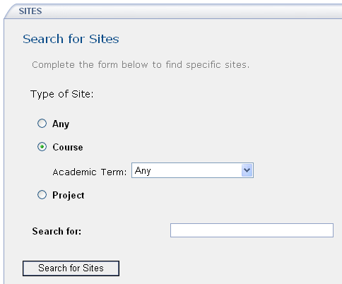
The term constraint shows up for course site types in the
Sites tool when sitebrowser.termsearch.type=course

sitebrowser.termsearch.property

sitebrowser.termsearch.property=term

Defines the name of the property that is used to constrain searches on sites of type sitebrowser.termsearch.type when searching using the Sites tool.

sitesearch.noshow.sitetype

sitesearch.noshow.sitetype=

Used to specify the types of sites which shouldn’t be shown as a search option in the Site Browser tool. The default is to not prevent any type from being shown (all types are shown).

At UM, the setting is sitesearch.noshow.sitetype=GradTools as we don’t allow users to search through GradTools sites. If you wanted to keep project sites from showing up as a search option in the Site Browser tool, you could set sitesearch.noshow.sitetype=project. The value should match a site type that exists in your installation.

Email
For details on configuring James see documentation in Confluence in the Sakaipedia. See the Administrator Information section and in particular the postings on Configuring Mail
http://bugs.sakaiproject.org/confluence/display/ENC/Configuring+Mail
and the Sendmail Integration document under Integrating Sakai
http://bugs.sakaiproject.org/confluence/display/ENC/Sendmail+integration

support.email
# contact support email address (contact support tool)

support.email=

If you send email to a site and there is a problem and the email gets bounced, this is the email referenced inside the bounced email reply that gives the user somewhere to email for further help. For example, with the setting

support.email= support@some.edu
results in the following bounce reply email when sending to a non-existent site
.
The attached message was not delivered.

Error message below:
Your message cannot be delivered because the address is unknown.

If you have further questions about this feature, please email support@some.edu

Message details:
Subject: testing
Sent date: Wed Sep 02 09:28:37 EST 2008
To: nonexistantsite@some.edu
Size (in bytes): 4

portal.error.email
# email address to send errors caught by the portal, and user bug reports in response

portal.error.email=

If the portal catches any errors while processing a user request, and this property is set to an email address, the error report and the user’s bug report, if made, will be emailed. See:
http://collab.sakaiproject.org/access/content/group/1097928811887-22636/Architecture%20Docs/Sakai%202/sakai_errors.pdf

for details.

mail.support
# email for support (contact support tool only)

#mail.support=

An early version of the Help tool (sakai.contactSupport) included a ‘contact support’ form that emailed the content of the form to the email address set by the mail.support property.

This is not used in the current Help system.

setup.request
# email address used as the “from” address for any email sent by Worksite Setup tool or Site Info tool

setup.request=

When a class site is created, several emails will be sent by Worksite Setup tool:

1. An email can be sent to the support organization notifying them of the site creation. When a class site is created by manually entering course information rather than by selecting a class from the list of classes presented to the user, support may need to manually add the provider id. Setting setup.request to the support email address gives support notice that such a site has been created and that there may need to be some manual processing to link the roster to the class site.

2.When the class site is created manually, an request for authorization email will be sent to class site authorizer, who can verify whether the current user can create this course site or not.

3. Site creator will always get a notification/verification email about site creation.

Notification email will be sent to added participant including site information.

If a guest account user is added in Site Info tool and if “notifyNewUserEmail” variable is not set to false, an email will be sent to the guest user notifying the account creation with password.

smtp.dns.1

smtp.dns.2
# dns addresses used by James for incoming email

smtp.dns.1=
smtp.dns.2=

smtp.port
# SMTP port on which James runs. Default is 25. Recommend running on 8025, and using a standard mailer on 25 to forward mail to Sakai.

smtp.port= 25

smtp.enabled
# flag to enable or disable James for incoming email (true | false)

smtp.enabled=false

ui.institution

ui.service
# some fill-ins for the css/vm ui (Worksite Setup, Digest Service, Email notification, Worksite Setup, Contact Support, Portal)

ui.institution=Sakai Using Institution
ui.service=Sakai Based Service

The institution name and Sakai installation name (e.g. for UM, CTools). These values are used in various places in the UI and in messages sent from Sakai.

force.url.secure
# force all URLs out of Sakai back to Sakai to be secure, i.e. to use https, on this port. Leave out to respond with the same transport as the request.
# Otherwise, the URLs will reflect the attributes of the request URL. (443 | 8443 | or any other port) [defaults to missing]

#force.url.secure=443

smtp

smtp@org.sakaiproject.email.api.EmailService=smtp.school.edu

Set the SMTP server for outbound mail. This server will need to accept and relay mail from the Sakai server without authentication. Typically this is done by IP address. Sometimes for testing your ISP may allow open relay from addresses within their network.

smtpFrom

smtpFrom@org.sakaiproject.email.api.EmailService=admin@someschool.edu

Set the address for bounces in the attempted delivery of mail.

testMode

testMode@org.sakaiproject.email.api.EmailService=

By default, the service will send email. It is sometimes useful when testing to disable the actual sending of email by enabling testmode for email. You can enable the test mode by setting testMode@org.sakaiproject.email.api.EmailService=true.
and then email will not be sent, but instead it will be logged. This is very nice when working with test servers that might have real users and email addresses.

mail.importDir

mail.importDir =

Used to specify the directory where email will be found when importing a non-Sakai email archive into Sakai. This allows users to migrate their email activities from other email archives (e.g. Lyris) to Sakai. The import procedure is

1. Define the mail import directory in sakai.properties, via the mail.importDir property, e.g. mail.importDir = /tmp/emailDump
2. Copy email export files in raw format (e.g. headers, mime-encoded attachments, etc) into mail.importDir
3. Each email should be modified to include the Sakai mail archive email address as a recipient (e.g. "To: demo@sakai.umich.edu"). A perl script is available to modify files exported from Lyris.
4. The Sakai email archive should be open to accept email from anyone for the duration of the import (executed at Sakai boot time).
5. Email in mail.importDir will be deleted after import to prevent duplicate imports when Sakai is restarted later.

maxRecipients@org.sakaiproject.email.api.EmailService

maxRecipients@org.sakaiproject.email.api.EmailService = 100

Used to set the max recipients per outgoing emails. It defaults to 100, which is the minimum that the RFCs say an SMTP server should accept. If an announcement was made with notification, in a site with 500 participants, a setting of 100 results in 5 emails with 100 recipients each.

mailarchive.message-threshold

mailarchive.message-threshold=250

Used to set the number of messages that the MailArchive tool will store in the session. If there are more than this number of messages, the MailArchive tool will only allow sorting by date and use the database for paging through the mail messages. This reduction in functionality keeps the MailArchive tool functioning in the face of large mail archives. This feature is in Sakai 2.5.1 and later.

email.precedence.bulk

email.precedence.bulk=false

Email notifications can have a precedence:bulk header added to mark notifications as a type of bulk mail. This allows some email systems to deal with it correctly, e.g. they won't send replies / vacation messages. Set to false by default. To turn on this capability, set to true.

emailFromReplyable

emailFromReplyable@org.sakaiproject.event.api.NotificationService=false

When set to true, the sending user’s email address is in the From field of emails. When set as the default (false), the From address is no-reply.

News Tool

news.title

news.feedURL
# default title and feed URL for the news tool

news.title = Sakai News
news.feedURL = http://sakaiproject.org/news-rss-feed

When the News tool is added to a site, it is added with a default News feed URL.

Membership tool

disable.membership.unjoin.selection
#Disable the unjoin link in membership tool

disable.membership.unjoin.selection=

Before 2.1, a site that is not joinable could be unjoined with the Membership tool. The availability of unjoin for such sites caused problems to users who unjoined by mistake as they couldn’t rejoin.

However, there is also the desire to allow someone to unjoin a project site they might have been added to which they don’t want to belong.

The disable.membership.unjoin.selection= property allows institutions to set their own policy. If set to true, then users cannot unjoin sites (the unjoin action is not shown in the Membership tool). If set to false, users can unjoin sites.
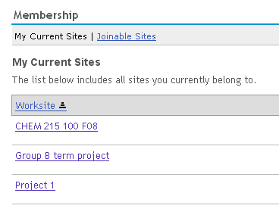

disable.membership.unjoin.selection=true
The ‘unjoin’ action is not shown under site names

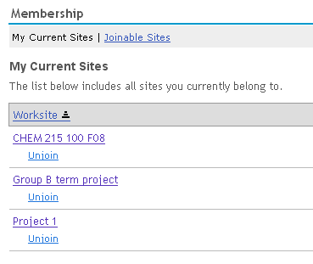

disable.membership.unjoin.selection=false
The ‘unjoin’ action is shown under site names

Automatic User Adds – ‘Affiliates’

affiliatesubjects.count

affiliatesubjects.n
# course affiliates

affiliatesubjects.count=
affiliatesubjects.1=

Until hierarchy comes to Sakai, using the affiliatesubjects.count and related properties is a way to automatically add certain users to sites with certain subject codes. This is useful if you have support personnel in the field at the unit level. All subject codes for that unit can be specified along with the user accounts that should be added to the site whenever a class site is created that contains one of the subject codes.

For example, if the College of Pharmacy has the subject codes of INTERHUM, INTERNS, and INTERSS, the following would define the subject codes which, if present in a provider id for a class site, would cause associated user accounts to be added to the site.

# course affiliates
affiliatesubjects.count=1
affiliatesubjects.1=INTERHUM,INTERNS,INTERSS

Which accounts get added are specified with the affiliateuniqnames properties.

Affiliates are added during the class site creation process if the site is created ‘automatically’. When a class site is created, if the creator is the instructor of record, they can pick the class from a list of their classes presented. In that case, since the list comes from the Registrar, they are known to be authorized to see the roster, and the provider id can be automatically attached to the site. At that point, affiliates are added as participants, with the Affiliate role.

If the class site creator isn’t the instructor of record, the class does not show up in their class list, and they must enter the class info manually. Support will vet the request, and if valid (creator has the right to create the class site and see the roster), support will add the provider id (using the Admin Realm tool). At that point, when the provider id is added manually, support must add affiliates manually to the site as participants with the Affiliate role.

Note: Another mechanism is being tested at UM in CTools, whereby affiliates are added via the provider id watcher. The watcher notices whenever a provider id changes (either via Worksite Setup or the Admin Realm tool). This insures Affiliates are added when support personnel add the provider id for a manually created class site. Check the CTools branch if you are interested in this code.

Institutions using the affiliate add mechanisms should also insure that the Affiliate role exists in the !site.template and/or !site.template.course realms.

The affiliatesubjects.count value should match the number of years specified by affiliatesubjects.n entries.

See appendix B for examples when there are more than one affiliatesubjects.n property.

affiliatecampus.count

affiliatecampus.n

affiliatecampus.count=
affiliatecampus.1=

Used to specify a particular campus for an affiliate. The affiliatecampus.count property specifies the number of affiliatecampus values.

For example, at UM, the College of Pharmacy is on the Ann Arbor campus (designated as ‘A’), and we would use the following to go along with the affiliatesubject property example used above.

affiliatecampus.count=1
affiliatecampus.1=A

The affiliatecampus.count value should match the number of years specified by affiliatecampus.n entries.

See appendix B for examples when there are more than one affiliatecampus.n property.

affiliateuniqnames.count

affiliateuniqnames.n

affiliateuniqnames.count=
affiliateuniqnames.1=

affiliateuniqnames.n specifies the user account names that will be added when class sites with the subject codes specified in affiliatesubjects.n on the campus affiliatecampus.n are created.

For example, the settings below insure the accounts peterwolf and abester are added to class sites created on the Ann Arbor campus with subject codes of INTERHUM, INTERNS, or INTERSS given the property settings shown in the examples for affiliateuniqnames and affiliatesubjects.

affiliateuniqnames.count=1
affiliateuniqnames.1=petewolf, abester

The affiliateuniqnames.count value should match the number of years specified by affiliateuniqnames.n entries.

See appendix B for examples when there are more than one affiliateuniqnames.n property.

GradTools
The GradTool is not currently used at many institutions other than UM. Values are included for completeness.

withDissertation

withDissertation=

Specifies whether GradTools shows up as a site type option when creating sites in Worksite Setup. When set to true, a user creating a site will see class, project, and dissertation as options when creating a site. However, they well only see dissertation as an option if they are in the PhD program at the institution, and have not yet created their GradTools site.

gradToolsSiteType.count

gradToolsSiteType.n
# gradtools site types

gradToolsSiteType.count=
gradToolsSiteType.1=

Specifies the types of sites used by GradTools. For example, at UM, we have

gradToolsSiteType.count=3
gradToolsSiteType.1=GradToolsStudent
gradToolsSiteType.2=GradToolsRackham
gradToolsSiteType.3=GradToolsDepartment

The gradToolsSiteType.count value should match the number of years specified by gradToolsSiteType.n entries.

WebServices

webservices.allowlogin
#Indicates whether or not we allow web-service logins

webservices.allowlogin=true

webservice.portalsecret
# Indicates the shared secret between the Sakai JSR-168 Portlet and this instance of Sakai

webservice.portalsecret=plugh-xyzzy

webservice.IPCheck
# Indicates that the Portal login web service is to check IP addresses
# and not function except for the specified addresses.

wwebservice.IPCheck=true

webservice.portalIP
# Indicates a list of IP Addresses which the portal log in web service
# will accept connections from.

webservice.portalIP=127.0.0.1

webservices.allow

webservices.deny
# Web Services IP Filtering
# if (explicitly denied) "Forbidden";
# else if (explicitly allowed) "Pass";
# else if (allow set is null, but deny is not) "Pass";
# else "Forbidden";

webservices.log-allowed=true
webservices.log-denied=true
webservices.allow=localhost,127\.0\.0\.1,192\.168\.[0-9.]+,10\.[0-9.]+,172\.1[6-9]\.[0-9.]+,172\.2[0-9]\.[0-9.]+,172\.3[0-1]\.[0-9.]+

# webservices.allow=:empty:
# webservices.deny=192.168.0.106

This set of properties determine which IP addresses can access web services. The default is to only allow “localhost” or non-routed IP addresses. You can either set the allow and it only allows those addresses. Or you can set the allow list to :empty: and then it accepts all requests except the explicitly denied list. Since the web.xml has a default for allow, to override that default, you must set the allow to :empty or the default will be taken.

It is OK to leave allow as default so local/non-routed connections work and then add some deny’s explicitly.

In testing, in particular on a Macintosh - you will get reject in the default situation if you go to localhost:

http://localhost:8080/sakai-axis/SakaiLogin.jws?wsdl

The error looks like this:

INFO RemoteHostFilter.java:203 RemoteHostFilter:203 - Access denied (implicit): 0:0:0:0:0:0:0:1%0/0:0:0:0:0:0:0:1%0

To work around simply use your local IP address to loop back instead of localhost:

http://192.168.0.105:8080/sakai-axis/SakaiLogin.jws?wsdl

And it will work:

INFO RemoteHostFilter.java:187 RemoteHostFilter:187 - Access granted (192.168.[0-9.]+): 192.168.0.105/192.168.0.105

Miscellaneous Control

portal.use.dhtml.more

portal.use.dhtml.more=false

Changes the ‘more’ tab used to display sites when there is no more room for tabs to a My Active Sites panel that shows all user sites. The panel displays sites in several categorized columns rather than in a dropdown list. Set the property to true to display the panel rather than the ‘more’ dropdown list.

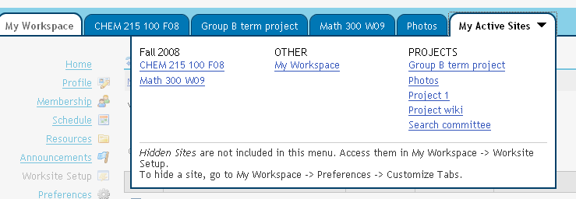

stealthTools
# In this example, the rwiki tool, su tool, roster tool, and the assignment tool w/o grading are stealthed:

#stealthTools@org.sakaiproject.api.kernel.tool.ActiveToolManager=
sakai.rwiki,sakai.su,sakai.site.roster,sakai.assignment

The org.sakaiproject.api.kernel.tool.ActiveToolManager can be configured with the "stealthTools" property, a list of comma-separated tool ids (no spaces) for all tools that are to be stealthed. Stealth refers to tools that can be added to a site using the Admin’s Sites tool, but which do not show up to site creators in Worksite Setup or when editing tools with Site Info.
Stealthed tools will not be listed by the tool manager when findTools() is called with a category - this has the effect of ignoring these tools' categories as defined in their tool.xml (without the need to edit those tool.xml files). This results in the tools not showing up in Worksite Setup's tool lists, but showing up in the Admin Site Editor.

visibleTools@org.sakaiproject.tool.api.ActiveToolManager

# visibleTools@org.sakaiproject.tool.api.ActiveToolManager

A property used to explicitly specify which tools to show on the Edit Tools page. It can be set to a comma separated list of tool IDs to make visible, regardless of whether they are hidden or stealthed. Any valid tool listed here will appear on the Edit Tools menu. Provided it has been specified via the category property in the tool’s registry file. This property is not set in the default sakai.properties file.

hiddenTools@org.sakaiproject.tool.api.ActiveToolManager

# hiddenTools@org.sakaiproject.tool.api.ActiveToolManager

The list of tool IDs to hide from the Edit Tools menu. This option and the stealthTools@org.sakaiproject.tool.api.ActiveToolManager together make up the entire list of tools that will not appear. You might use this if you wished to preserve the default settings for stealthTools but add a few additional tools to the list. This property is not set in the default sakai.properties file.

locales
# Supported language locales for user preferences

locales = en_US, en_GB, en_AU, en_NZ, en_ZA, ja_JP, ko_KR, nl_NL,
zh_CN, es_ES, fr_CA, fr, ca_ES, sv_SE, ar, ru_RU, pt_PT, pt_BR

Changes the locale. Available locales within Sakai are

en_US Language English Country USA
en_GB Language English Country Great Britain
ja_JP Llanguage Japanese Country Japan
ko_KR Language Korean Country South Korea
nl_NL Lanugage Dutch Country Netherlands
zh_CN Language Chinese (simplified) Country China
es_ES Language Spanish Country Spain
fr_CA Language French Country Canada
ca_ES Language Catalan Country Spain
sv_SE Language Swedish Country Sweden
ar Language Arabic Country Non Specified
en_AU Language English Country Australia
en_NZ Language English Country New Zealand
en_ZA Language English Country South Africa
fr Language French Country Non Specified
ru_RU Language Russian Country Russia
pt_PT Language Portuguese Country Portugal
pt_BR Language Portuguese Country Brazil

For reference, see Sun's complete list of supported locales at

http://java.sun.com/j2se/1.5.0/docs/guide/intl/locale.doc.html

As additional translations become available, additional locales will be added to this list.

mecury.enabled

mercury.enabled=

By default, starting with Sakai 2.2, the mercury portal is disabled for security reasons. To enable, set mercury.enabled=true.

portal.includesubsites

# Indicate that default subsite behavior
# true - Include subsites unless the sakai-subsites property
# on the site is false
# false - Only include subsites if the sakai-subsites property
# on the site is true
# never - Never include subsites
# the default is to include subsites

portal.includesubsites=true

This option controls sub-site support based on site properties. A property can be added to a site called sakai:parent-id which indicated the site id of the parent site.

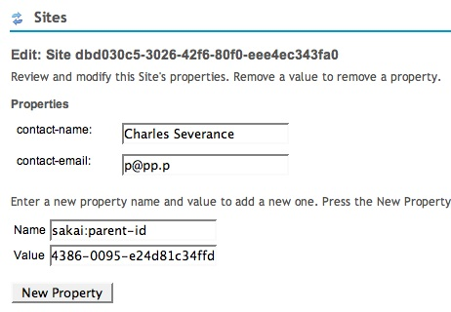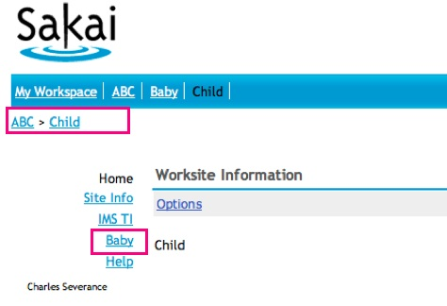

Once this is enabled, the portal shows breadcrumbs, and shows sub-sites as part of the tool bar when you are within a site. This feature is present in Sakai 2.5 and beyond.

portal.iframesuppress

# Control the PDA Portal's use of iframe buffering and inlining
# The default is that all tools are buffered and inlined
# You can list a set of Sakai tool IDs that *should* be buffered,
# or you can list tools that *should not* be buffered - there is
# a debug mode as well that can be triggered that helps figure
# out if the buffer process is having problems with tool markup.

# Buffer all tools (default)
portal.iframesuppress=:all:

# Only buffer a tool if it is in this list
portal.iframesuppress=:sakai.createuser:sakai.motd:sakai.iframe:sakai.ifame.service:sakai.iframe.myworkspace:

# Buffer all tools except those in this list
portal.iframesuppress=:all:sakai.createuser:sakai.motd:

# Buffer all tools and turn debug mode on
portal.iframesuppress=:all:debug:

# Turn this feature off completely
portal.iframesuppress=:none:

This controls the buffering of tool content in the PDA portal (/portal/pda). As of Sakai 2.5 this feature is turned on by default. When this is enabled, the PDA portal buffers output from tools and merges the tool output with the portal navigation. The result is zero i-frames in the output. This depends on the tools producing reasonable HTML as the output of the tool must be parsed into header and body content so it can be merged into the PDA output in the proper locations.

If during testing, several tools exhibit problems, you can suppress buffering of the output of those tools by adding :all: to the property and then listing the tools in this property separated by colons. This means to buffer "all but these tools".

If you want to be more conservative, and only buffer a few tools - simply list the tools separated by colons in the property - then only the listed tools will be buffered.

If you want this feature turned off simply add :none: to the property.

Also if you are having problems with a tool - you can cause the buffer parsing to be rather verbose in the log by adding :debug: to the property. If you want to continue to buffer all tools and debug the parsing set the property to :debug:all: because once the property is set it is assumed to contain the list of tools to buffer.

This feature is available in Sakai 2.5 and later.

charon.directurl

# if set to true enables direct urls to access deep content inside a tool
charon.directurl=true

This enables you to address the deep content of a tool by changing the /portal/tool URL to /portal/directtool provided the tool supports deep GETs and POSTS

portal.experimental.auto.reset

portal.experimental.auto.reset=true

Used to control whether a tool’s state is saved when traveling outside of the tool and then back. If portal.experimental.auto.reset set to true (the default), when you navigate to another tool and then come back, you are at the same page in the tool as you were when you left. If you were in the middle of adding a Resource file for example, and you leave Resources to go to Announcements, when you come back to Resources you will be where you left off. This is the default behavior.

If portal.experimental.auto.reset=false, then whenever you come back to a tool after having navigated out of it, you are placed at the first ‘entry’ page of the tool.

portal.includesubsites

# Indicate that default subsite behavior
# true - Include subsites unless the sakai-subsites property on the site is false
# false - Only include subsites if the sakai-subsites property on the site is true
# never - Never include subsites
portal.includesubsites=true

This turns on the ability to support a site hierarchy for navigation purposes. If on (true), then a site can have the notion of sub-sites, and sub-sites will show up in the parent site’s left hand menu column. The default value is true. To establish the sub-site behavior, add the site property Sakai:parent-id to a site(using the Admin Sites tool), with a value of the parent site’s site_id.

For example, in the example below, the Dig 1, Dig 2, Dig 3 sites each have a site property of Sakai:parent-id set to the site id of the Anthro 100 001 site.
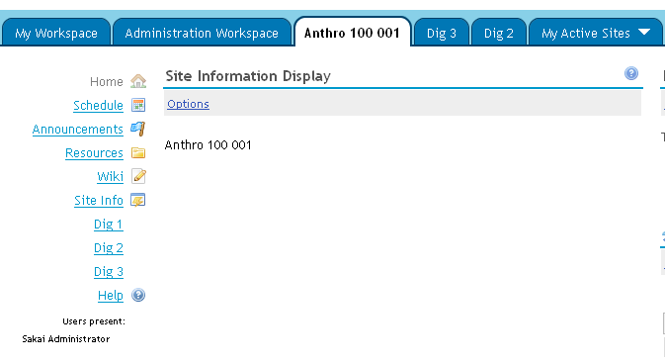

portal.experimental.maximizesinglepage

# Indicate that where there is only one page viewable on the site -
# suppress the left column including the tool list and presence

portal.experimental.maximizesinglepage=true

This option makes it so a single tool such as the Wiki, Melete, Resources, Web Content, etc can be the entire site. If a user would only see one tool on the left hand side the tools list is suppressed. This depends on the user's role - for example an instructor might see 5-6 tools but using Page Order tool they have hidden all but one from the students.

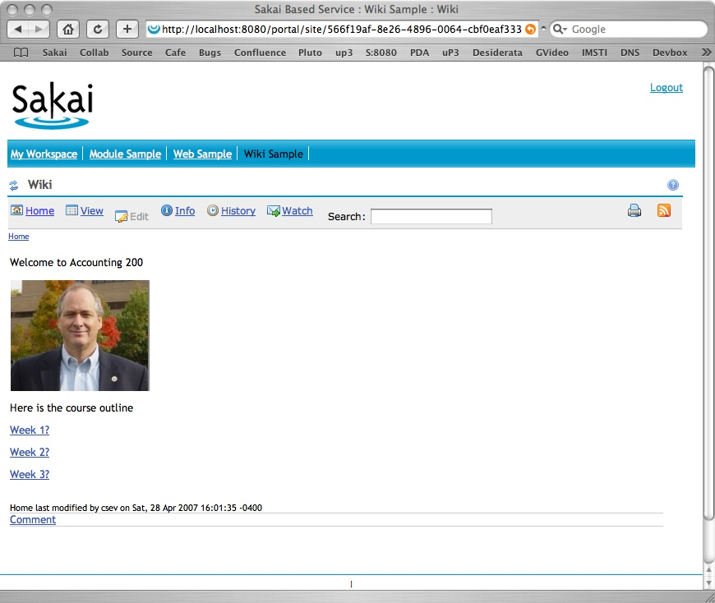

In this case the students will not see a tool bar and the instructor will see a tool bar. In this case, using a skin with horizontal buttons on the site would probably look better for the instructor view. This feature is present in Sakai 2.5 and beyond.

portal.iframesuppress

# This controls code in Charon that eliminates iframes
# add the String :debug: to indicate we want to see output
# from the content buffering and parsing in the log

portal.iframesuppress=debug:sakai.createuser:sakai.motd:sakai.iframe:sakai.ifame.service:sakai.iframe.myworkspace: […]

# Only use this for testing

portal.iframesuppress=:all:debug:

This is an experimental feature that is part of the Charon portal. It brings a feature from the PDA of buffering content and merging tool content into the navigation frame into the main Charon portal. If this is turned on, the Charon buffers output from tools and merges the tool output with the portal navigation.

The proper way to use this feature is to test each tool for functionality and then add the tool ids to this property - this way you are confident that a tool will work in this mode. You can simply indicate that you want all tools done this way by adding :all: to your property. Also if you are having problems with a tool - you can cause the buffer parsing to be rather verbose in the log by adding :debug: to the property.

This feature can significantly improve the accessibility of the Charon as well as it puts the navigation and content in the same frame.

This feature is available in Sakai 2.5 and later.

overrideViewable

overrideViewable@org.sakaiproject.component.privacy.PrivacyManagerImpl=true

If you are not using the privacy manager, you can disable the queries it otherwise sends to the db (2 for every presence query) by setting this to true in sakai.properties. The default is false (the queries are made).:

Provisional and Contrib Tools
Provisional and Contrib tools are not in the standard Sakai release, but may be in use at some institutions.

Facebook

facebook.entriesPerRow

Controls the number of Facebook entries displayed per row.

FLUID

# Whether or not to attempt to generate a custom stylesheet based on the user preferences.
# Can be set to true or false.
#portal.styleable=false

# Whether or not to attempt to generate javascript to support a custom stylesheet based on
# the user preferences. Can be set to true or false.
#portal.styleable.contentSummary=false

Linktool

# linktool.enabled = false

Prior to 2.5, the default was linktool.enabled=true. In 2.5, the default is false, so to turn the tool on, you need to explicitly set the property to true in your sakai.properties file.

Mailtool
Mailtool should function adequately OOTB for *nix systems (i.e. systems which have /tmp), but attachments may have a problem on Windows systems without configuration. Group awareness will also typically need configuration, and is the only setting left un-commented below.

# MAILTOOL

# Maximum number of allowed attachments per message. If below setting is not set, the default is 10000. If set to zero, attachment capability will be disabled.
# mailtool.max.num.attachment=

# Temp directory for handling attachment files. Default is /tmp
# mailtool.upload.directory=/tmp/

# Reveal additional config options on "Options" screen for renaming roles. Default is false.
# mailtool.show.renaming.role=false

# Roles which should be group-aware in the interface, comma-separated.
mailtool.group.aware.role=Student,access
Mailtool's mail-sending also makes use of the following settings in sakai.properties:
#####Mailtool is looking the following global settings: Three (3)
smtp@org.sakaiproject.email.api.EmailService=acs-smtp.bu.edu
content.upload.max=20
wysiwyg.editor=FCKeditor

#Note: content.upload.max is being overrided in web.xml's "upload.max", default=5 (5 MB).

#If there is no "upload.max" in web.xml, sakai.properties "content.upload.max" will be the max attachment's file size

Reset Password

Reset Password is a simple RSF tool which allows users to request that a new password be emailed to them by entering their email address. Its primary use case is to allow guest users to change their password if they no longer know what their current password is.
By default, Reset Password will only reset passwords for users of the guest type. This can be configured by a sakai.properties setting, e.g.
resetRoles.count=2
resetRoles.1=guest
resetRoles.2=staff

Search

# search.experimental =
# Set to true or false. By default it is false since the Search tool is stealthed

Used to turn on Search if the tool is being used.

sharedSegments@org.sakaiproject.search.api.SearchService.SegmentStore=
location@org.sakaiproject.search.api.SearchService.SegmentStore
# Specify the file system location of shared segments and index file
# used by search.
# The default OOTB settings are good default locations for a single
# cluster node, a multi node cluster still needs specific
# configuration, e.g., /tmp/segment and /tmp/index/

# search.enable=true
As of 2.4, Search is *on* by default There will be sites where search is not wanted in production. To disable all search functionality, set search.enable=false.

#readerSizeLimit@org.sakaiproject.search.component.adapter.contenthosting.ContentHostingContentProducer
# Sets the limit above which files are streamed from Content Hosting
# Service default 2M

#digesterSizeLimit@org.sakaiproject.search.component.adapter.contenthosting.ContentHostingContentProducer
# Sets the size limit above which files are parsed using the char
# stream parser rather than a file type parser. This means that
# PDF documents above this size will be passed to the char stream
# parser which will try and extract strings.
# Default 5M

#maxDigestSize@org.sakaiproject.search.component.adapter.contenthosting.DefaultContentDigester
# Is the maxim file size that will be digested. default 20M

# search.indexbuild
# whether or not to build search indexes for the Search tool. Can be
# set to true or false

Styleable

StyleAble is a component that generates customized style sheets based on a user's stated preferences, allowing them to control the overall appearance of the site, including the font size, face, foreground color, background color, highlight color, and link appearance. To activate StyleAble, you will need to set

portal.styleable=true

Turnitin Integration

An integration with the Turnitin plagiarism checking application is available for Assignments. Turnitin is a for fee application not part of Sakai. To turn on the integration in Assignments, use

assignment.useContentReview=true

iTunes U

customItunesPermissionsPerSite@org.sakaiproject.tool.itunesu.api.ITunesUService = false

Add an option to the service that can be configured via sakai.properties. Only create custom permissions per iTunes site if enabled. Disabled by default.

These properties need to be set in coordination with Apple. They provide secure access to private iTunes U pages via the Sakai iTunes U tool.

iTunesU_site_id=
iTunesU_site_sharedSecret=

Index

accessibility.url, 27
accessPath, 14
activeInactiveUser, 51
affiliatecampus.count, 73
affiliatecampus.n, 73
affiliatesubjects.count, 72
affiliatesubjects.n, 72
affiliateuniqnames, 73
affiliateuniqnames.count, 73
allowGroupAssignments, 28
allowGroupAssignmentsInGradebook, 28
allowGroupResources, 44
announcement.merge.display, 27
assignment.instructor.notifications, 29
assignment.instructor.notifications.default, 29
assignment.submission.confirmation.email, 29
auto.ddl, 11
availabilityChecksEnabled, 44
bottom.copyrighttext, 20
bottomnav.count, 18
bottomnav.n, 18
calendar.merge.display, 47
calendarSummary.highPriorityColor, 30
calendarSummary.highPriorityEvents.count, 30
calendarSummary.highPriorityEvents.n, 30
calendarSummary.lowPriorityColor, 30
calendarSummary.mediumPriorityColor, 30
calendarSummary.mediumPriorityEvents.count, 31
calendarSummary.mediumPriorityEvents.n, 31
calendarSummary.viewMode, 30
charaon.directurl, 80
config@org.sakaiproject.section.api.SectionManager, 47
container.login, 14
content.upload.ceiling, 37
content.upload.dir, 37
content.upload.max, 36
copyrighttype.count, 38
copyrighttype.n, 38
copyrighttype.new, 39
copyrighttype.own, 39
courseSiteType, 56
default.copyright, 38
default.copyright.alert, 40
defaultTransactionIsolationString, 9
disable.course.site.skin.selection, 26
disable.membership.unjoin.selection, 70
display.help.icon, 32
display.help.menu, 32
display.users.present, 22
displayToolCategories, 34
driverClassName, 9
email.precedence.bulk, 70
emailFromReplyable, 70
emailInIdAccount, 61
enabled, 16
fairuse.url, 40
force.url.secure, 68
gatewaySiteId, 12
gatewaySiteList, 13
gradToolsSiteType.count, 74
gradToolsSiteType.n, 74
help.collections, 33
help.hide, 33
help.location, 32
help.redirect.external.webapp, 33
help.welcomepage, 33
helpPath, 32
hibernate.dialect, 10
hibernate.show_sql, 10
hiddenTools@org.sakaiproject.tool.api.ActiveToolManager, 77
ical.experimental, 47
iconNames.count, 24
iconNames.n, 24
iconSkins.count, 25
iconSkins.n, 25
iconUrls.count, 25
iconUrls.n, 25
invalidNonOfficialAccountString, 62
java.beep, 27
locales, 77
log.config.count, 17
log.config.count.n, 17
loggedOutUrl, 13
login.use.xlogin.to.relogin, 16
logout.icon, 26
mail.importDir, 69
mail.support, 67
maxElementsInMemory, 50
maxRecipients@org.sakaiproject.email.api.EmailService, 69, 70
mc.disableLongDesc, 31
mc.showForumLinksInNav, 31
mc.threadedview, 34
mecury.enabled, 78
myworkspace.info.url, 21
newcopyrightinput, 41
news.feedURL, 70
news.title, 70
nonOfficialAccount.url, 60
nonOfficialAccountInstru, 60
nonOfficialAccountLabel, 59
nonOfficialAccountSectionTitle, 60
notifyNewUserEmail, 61
officialAccountLabel, 59
officialAccountSectionTitle, 60
osp.upgrade25, 34
overrideViewable, 83
password@javax.sql.BaseDataSource, 10, 11
portal.error.email, 66
portal.experimental.auto.reset, 80
portal.iframesuppress, 82
portal.includesubsites, 80
portal.experimental.maximizesinglepage, 81
portal.includesubsites, 78
portal.pda.iframesuppress, 79
portal.use.dhtml.more, 76
portalPath, 14
powered.alt, 19
powered.img, 19
powered.url, 19
preference.pages, 35
prefs.research.coll, 35
prioritySortEnabled, 45
resources.show_all_collections.dropbox, 42
resources.show_all_collections.helper, 43
resources.show_all_collections.tool, 41
roster_view_email, 46
roster.available.weeks.before.term.start, 58
roster.defaultSortColumn, 46
roster.display.firstNameLastName, 46
roster.display.hideSingleGroupFilter, 46
sakai.reports.useWarehouse, 34
samigo. email.prefixedPath, 49
samigo.answerUploadRepositoryPath, 48
samigo.email.bypassAuth, 49
samigo.email.password, 49
samigo.email.username, 49
samigo.samliteEnabled, 50
samigo.saveMediaToDb, 48
samigo.sizeMax, 48
samigo.sizeThreshold, 48
samigo.smtp.port, 49
samigo.smtp.server, 49
server.info.url, 21
serverId, 12
serverName, 12
serverUrl, 12
setup.request, 67
site.enableCreateAnyUser, 62
site.setup.import.file, 52
site.templates, 64
siteAttachment, 44
sitebrowser.termsearch.property, 65
sitebrowser.termsearch.type, 65
site-manage.campusUserDirectory, 63
site-manage.cms.subject.category, 63
site-manage.cms.subject.label, 64
site-manage.courseManagementSystemImplemented, 63
sitesearch.noshow.sitetype, 65
skin.default, 23
skin.repo, 23
smtp.dns.1, 67
smtp.dns.2, 67
smtp.enabled, 68
smtp.port, 68
stealthTools, 77
support.email, 66
testMode, 69
timeToLive, 50
titleEditableSiteType, 53, 54
top.login, 14
ui.institution, 68
ui.service, 68
url, 9
username@javax.sql.BaseDataSource, 11
validationQuery, 11
vendor, 10
version.sakai, 20
version.service, 20
visibleTools@org.sakaiproject.tool.api.ActiveToolManager, 77
webcontent.instructions.url, 21
webdav.ignore, 50
webservice.portalsecret, 75
webservices.allowlogin, 75
wiki.comments, 51
wiki.display.user.id, 51
wiki.experimental, 51
wiki.notification, 51
withDissertation, 74
wsetup.disable.joinable.count, 56
wsetup.disable.joinable.n, 56
wsetup.disable.unjoin.count, 57
wsetup.disable.unjoin.n, 57
wsetup.group.support, 52
wsetup.skipCourseSectionSelection, 53
wysiwyg.editor, 23
xlogin.enabled, 15
xlogin.icon, 16
xlogin.text, 15

How to Configure Sakai is in the Sakai Development worksite Resources on http://collab.sakaiproject.org at http://collab.sakaiproject.org/access/content/group/1097928811887-22636/Architecture%20Docs/Sakai%202/sakai_config.pdf Also see Sakai 2.0 Configuration information http://bugs.sakaiproject.org/confluence/display/ENC/Sakai+2.0+Configuration in the Confluence Sakaipedia at http://bugs.sakaiproject.org/confluence

