PSEUDO HIERARCHY IN CHARON
Charles Severance
csev@umich.edu

May 8, 2007

Introduction

Note: This feature is in the post 2.4.0 trunk at revision r30129 or later.

Sakai's portal now supports the display of parent-child relationships between sites. This does not implement hierarchical inheritance of Authorizations (realms) - simply the hierarchical display of sites and subsites.

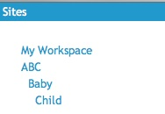

Features are effectively hidden until enabled by a combination of settings in sakai.properties and/or properties placed on a site so current use of Sakai's portal is unchanged.

The design of this approach was developed a series of meetings at Charles Sturt University - April 2007

User Interface

In the PDA portal, child sites are sorted to appear below their parent sites and indented by the depth of the site in the tree.

As the user navigates up and down the tree of sites, a breadcrumb is maintained giving the user of their current location.
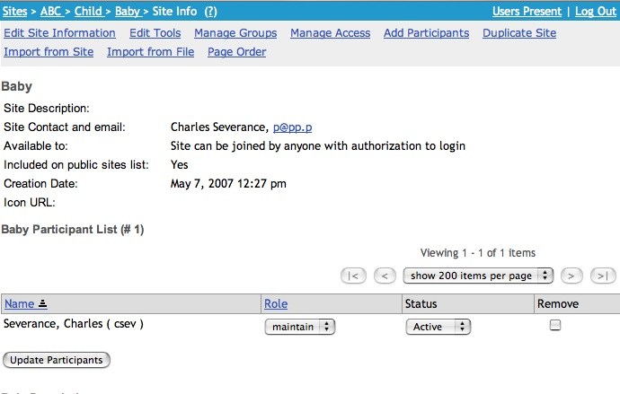

When a site has a subsite, (depending on property settings) the subsite appears as a button at the bottom of the tools. In the example below, Baby is a subsite below the Child site and so it appears at the end of a tool list for the Child site.

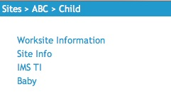
The main portal also has support for pseudo hierarchy. When a site had subsites they are shown as buttons between the last tool and the Help button.
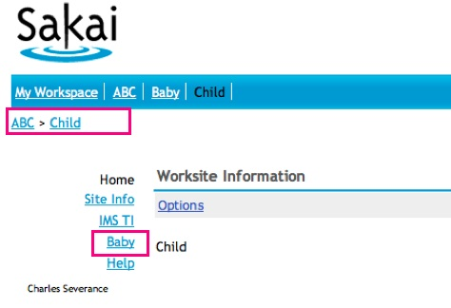
When you are in a site that has a parent, a breadcrumb trail appears showing where the current site fits in its lineage. All of the links are clickable. When you are at a "root" site there is no breadcrumb. The current condition in Sakai is that all sites are root sites.

Enabling the Feature in Sakai

This is a latent feature and must be enabled by system-wide and per-site properties. The system-wide property controlling this feature is:
# Indicate that default subsite behavior
# true - Include subsites unless the sakai-subsites
# property on the site is false
# false - Only include subsites if the sakai-subsites
# property on the site is true
# never - Never include subsites
portal.experimental.includesubsites=true

The default is "true" - to include subsites when they are encountered. Unless this set to "never", each site can override the default by setting a property.

Including subsites uses one additional SQL query per "tool list paint" to find subsites - so this I a feature that you might want to turn off. But it is *exactly one* query on well indexed tables so the performance impact should not be too great.

All of the other features (breadcrumb) work using highly cached information so there should be no performance impact,

You also need to add some classes to your portal.css.

/*site hierarchy breadcrumb*/
#siteHierarchy{
clear:both;
float:none;
margin:0;
list-style: none;
padding:.5em 0;
}
/*style the standard breadcrumbseparator
can set display:none if needed because
the list-style is taking care of it*/
.breadSeparator{
}
#siteHierarchy li{
display:inline;
}
#siteHierarchy li a, #siteHierarchy li a:visited{
color:#09c;
}

These have been added to the default skin.

There is also a property in the interbationalization files to set the breadcrumb separator:

sit_reset = Reset
bread_separator = >

Using CSS and properties should allow you to customize the look and feel of the breadcrumb.

Configuring a Site to Have a Parent

So far there are no tools to automatically configure parent/child relationships. The feature (much like page ordering) is simply supported in Charon waiting for a tool to be written or a web service script to set these values.

The only way to set this up is to use the Administrator interface.

- First find the site Id of the parent site that you want to add a child too. Using copy/paste grab the parent's site id.

- Find the child site in the sites list, and press Properties.

- Create a property named sakai:parent-id and enter the parent's site id.

- Save the site.

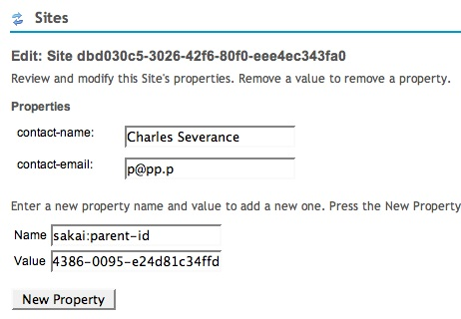
You can also optionally suppress the addition of the subsites to the tool list by setting the property sakai:show-subsites to be false. This works with the overall system wide default. The per-site setting of this property overrides the system default unless the system default is set to "never".

TODO List

This is an early feature and initial UI design - we can evolve it. I introduced it early in the 2.5 development cycle so that we can evolve it a bit before the next freeze. Feedback is welcome.

This is not an ultimate solution for AUTHZ-aware hierarchy - work underway in Tetra in the UK is leading us toward the real general solution - that is a much more involved task than putting support in the UI. But we conveniently now have initial support in the UI when a more powerful hierarchy mechanism becomes available and can work through UI issues in anticipation of the new features.

I plan to write a simple sub site management tool that will allow the creation of subsites and associate those sites with groups or sections in a site.

I plan to make a tag for organizations wanting this feature in their 2.4 systems. I will also make a branch for 2.3 and provide a version of the new portal for 2.3 users as well.

