The Sakai Helper Realm

Permissions granted to a Sakai worksite are specified in the worksite’s realm. A realm contains role definitions and for each role, the permissions which that role has for each tool. Changes to permissions are made in the site via the Permissions page in tools, or via the Admin Realms tool (sakai.realms). There are times when it is convenient to make changes to all worksites however, and the !helper.realm can be used to facilitate that.

When a worksite is created, it takes a copy of a realm template as its own. From then on, changes to the site’s permissions are made by editing the site’s realm (not the template). Changes made to the template realm affect only new sites (sites created after the change to the template is made).

A site’s realm can be found using the search capability of the Admin Realms editor in the Administration Workspace. Searching for the <siteid> will find the site’s realm. Site realms are listed as /site/<siteid>. The Realm editor deals with other realms too (e.g., realms that control permission settings on a particular folder in Resources).

Sites have types, and the template realm which supplies a newly created worksite with a realm definition has a name cooresponding to the worksite’s type. For a worksite of type <sitetype>, the !site.template.<sitetype> template is used (e.g., course sites when created get their realm from the !site.template.course realm). For a site with no type, the !site.template realm is used. If a site has a type, but there is no corresponding !site.template.<sitetype>, then the !site.template is used.

Editing a template realm affects all future sites. Editing a site’s realm affects the site only. It is sometimes desirable to add a permission to all existing sites. For example, a new tool is added with its set of permissions. It would be nice to add the new tool’s default permission settings to roles in all sites so that if an existing site wanted to add the new tool, permissions would be setup properly for the various roles. The !site.helper realm provides such a capability.

In addition to permissions set in a worksite’s realm, role permissions set in the !site.helper realm also apply. When a permission check is made to determine whether a user has the right to perform a certain action, permissions for their role in the site’s realm and permissions in the !site.helper realm are used..
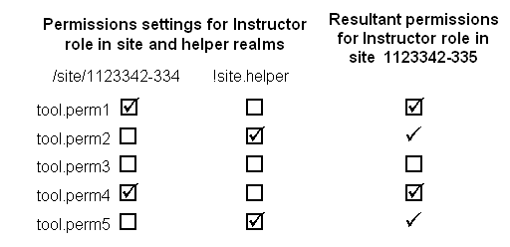

- The !site.helper realm affects every site, regardless of site type.

- A permission granted via the !site.helper cannot be removed via editing Permissions in the site. The only way to remove it is to remove the permission from the !site.helper.

To use !site.helper to grant a permission for a role in all sites, use the Admin Realms tool to edit the !site.helper realm. Click on the role to edit that role’s permissions, and then check on the permission(s) you want to add to all sites. You may need to create the role first if it does not already exist in !site.helper.

Example:
A new assignment permission (asn.grade) is added to the Assignment tool, and at UM we rolled that to production in the break between Summer05 and Fall05 terms. Many have created Fall05 class sites during Summer05 term, before the asn.grade permission was added. These sites will have Instructor roles with no permissions set for asn.grade.

Rather than edit each of these sites to add the asn.grade permission to the Instructor role we did the following.

- Added the asn.grade permission in the Instructor role in the !site.template.course realm.
This insures that any class site created from then on had the asn.grade permission checked on for the Instructor role.

- Added asn.grade permission to !site.helper realm.
This gives asn.grade permission to Instructor role in all existing class sites.

- About 4 weeks into Fall05 term, we unchecked (removed) the asn.grade permission setting from !site.helper.
Summer05 sites were no longer being used, and any sites created for Fall05 term and beyond had correct permissions (because of step 1. above). So we no longer need to augment site realms with !site.helper asn.grade permission.

Step 3 was taken to avoid the issue of site maintainers not being able to remove asn.grade permission from a the Instructor role when it was granted via !site.helper.

To give Instructors in existing sites the asn.grade permission, asn.grade was checked on for the Instructor role in the !site.helper realm.
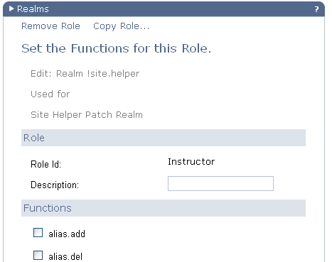

!site.helper realm

Instructor role
asn.grade checked on

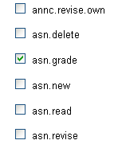
. . .

. . .
Admin Realms editor – editing the Instructor role in !site.helper

With asn.grade checked on for the Instructor role in the !site.helper realm, a site with the Instructor role has asn.grade checked on too.
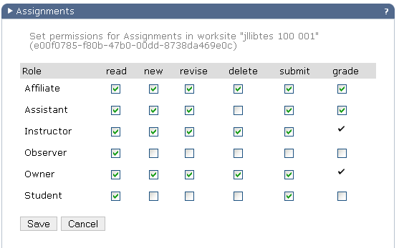
Permissions page from the Assignment tool

Note that the asn.grade permission can not be unchecked in worksites since it has been granted via the !site.helper.

