PYTHON PROGRAMMING
10 CASE STUDIES
Algorithms • Flowcharts • Pseudocode • Source Code • Test Cases

Name
Class / Section
Roll Number

CONTENTS
Program 1: Area and Perimeter of a Rectangle
Program 2: Examination Result Analysis
Program 3: Attendance Calculation
Program 4: Electricity Billing System
Program 5: Retail Billing System
Program 6: Student Performance Analysis
Program 7: ATM Transaction Simulation
Program 8: Student Email Validation
Program 9: Library Fine Calculation
Program 10: Bus Passenger Occupancy

PROGRAM 1

Case Study: Area and Perimeter of a Rectangle

1. Problem Statement
Develop a Python program to accept the length and breadth of a rectangle from the user, calculate its area and perimeter, and display the results.

2. Objectives
- Accept the length and breadth from the user.
- Calculate the area of the rectangle.
- Calculate the perimeter of the rectangle.
- Display the results.

3. Assumptions
- Length and breadth must be positive numbers.
- All measurements are in the same unit.
- Area is expressed in square units and perimeter in units.

4. Algorithm
- Start.
- Input the length and breadth.
- Calculate area = length × breadth.
- Calculate perimeter = 2 × (length + breadth).
- Display the area and perimeter.
- Stop.

5. Flowchart
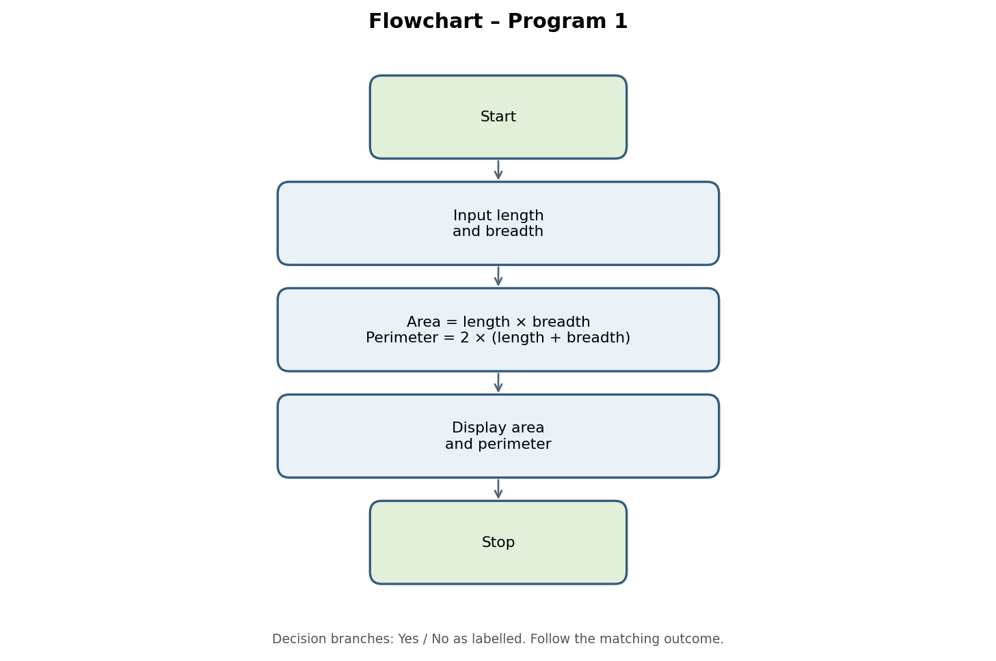

6. Pseudocode
START
INPUT length
INPUT breadth
area = length * breadth
perimeter = 2 * (length + breadth)
DISPLAY area
DISPLAY perimeter
STOP

7. Python Source Code
length = float(input("Enter length: "))
breadth = float(input("Enter breadth: "))

area = length * breadth
perimeter = 2 * (length + breadth)

print("Area =", area)
print("Perimeter =", perimeter)

8. Test Cases
Test Case 1
Enter length: 5
Enter breadth: 3
Area = 15.0
Perimeter = 16.0

Test Case 2
Enter length: 10
Enter breadth: 4
Area = 40.0
Perimeter = 28.0

9. Output Screenshots
Run the program in Python IDLE, VS Code, or an online Python compiler. Take screenshots of the output and attach them to your practical record.

10. Conclusion
The program calculates the area and perimeter of a rectangle using Python arithmetic operators and user input. It helps students understand variables, input/output functions, and mathematical calculations.

PROGRAM 2

Case Study: Examination Result Analysis

1. Problem Statement
Develop a Python program to accept marks in three subjects, calculate the total marks and average marks, and display whether the student has passed or failed.

2. Objectives
- Accept marks in three subjects from the student.
- Calculate the total marks.
- Calculate the average marks.
- Check whether the student has passed or failed.
- Display the examination results.

3. Assumptions
- Marks are entered as whole numbers.
- Each subject has a maximum of 100 marks.
- A minimum of 35 marks is required to pass each subject.
- The student passes only if they score at least 35 marks in all three subjects.

4. Algorithm
- Start.
- Input marks in Subject 1, Subject 2, and Subject 3.
- Calculate total marks and average marks.
- If all three marks are at least 35, display PASS; otherwise, display FAIL.
- Display total and average marks.
- Stop.

5. Flowchart
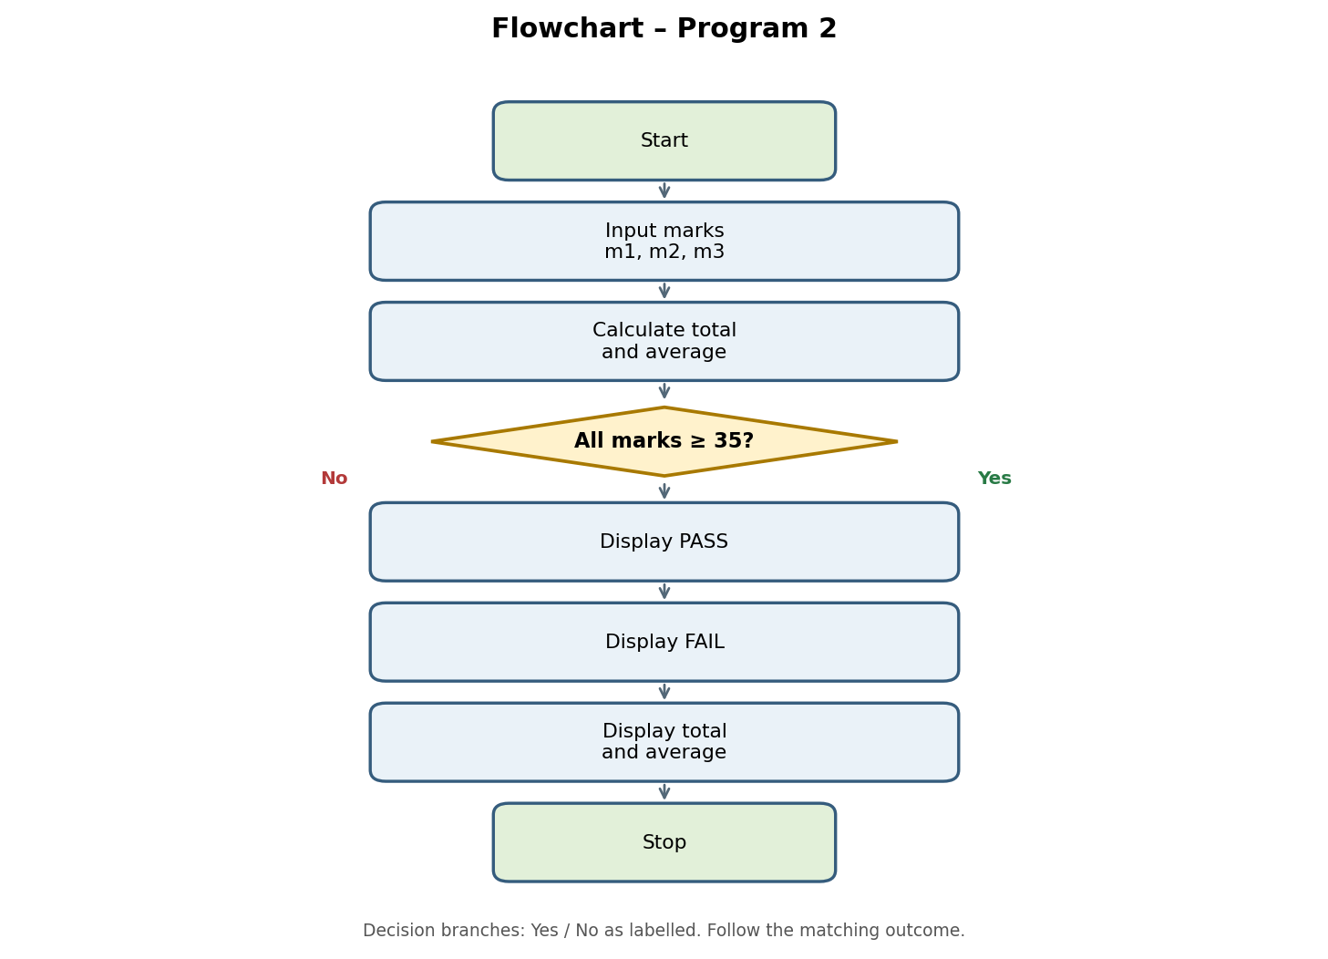

6. Pseudocode
START
INPUT m1, m2, m3
total = m1 + m2 + m3
average = total / 3
DISPLAY total
DISPLAY average
IF m1 >= 35 AND m2 >= 35 AND m3 >= 35:
DISPLAY "PASS"
ELSE:
DISPLAY "FAIL"
STOP

7. Python Source Code
m1 = int(input("Enter marks in Subject 1: "))
m2 = int(input("Enter marks in Subject 2: "))
m3 = int(input("Enter marks in Subject 3: "))

total = m1 + m2 + m3
average = total / 3

print("Total Marks =", total)
print("Average =", round(average, 2))

if m1 >= 35 and m2 >= 35 and m3 >= 35:
print("Result: PASS")
else:
print("Result: FAIL")

8. Test Cases
Test Case 1: Student Passes
Enter marks in Subject 1: 80
Enter marks in Subject 2: 70
Enter marks in Subject 3: 90
Total Marks = 240
Average = 80.0
Result: PASS

Test Case 2: Student Fails
Enter marks in Subject 1: 80
Enter marks in Subject 2: 30
Enter marks in Subject 3: 90
Total Marks = 200
Average = 66.67
Result: FAIL

9. Output Screenshots
Run the program in Python IDLE, VS Code, or an online Python compiler. Take screenshots of the output and attach them to your practical record.

10. Conclusion
The Examination Result Analysis program uses Python variables, arithmetic operations, conditional statements, and logical operators to calculate total and average marks and determine whether a student has passed or failed.

PROGRAM 3

Case Study: Attendance Calculation

1. Problem Statement
Develop a Python program to calculate a student's attendance percentage based on the total number of classes and the number of classes attended. Display whether the student is eligible for the examination.

2. Objectives
- Accept the total number of classes.
- Accept the number of classes attended.
- Validate the given inputs.
- Calculate the attendance percentage.
- Check examination eligibility.
- Display the attendance percentage and eligibility status.

3. Assumptions
- Total classes must be greater than zero.
- Classes attended cannot be negative.
- Classes attended cannot exceed total classes.
- A minimum of 75% attendance is required to be eligible for the examination.

4. Algorithm
- Start.
- Input total classes and classes attended.
- If total classes ≤ 0, attended < 0, or attended > total classes, display Invalid input.
- Otherwise, calculate percentage = (attended / total classes) × 100.
- If percentage ≥ 75, display Eligible; otherwise, display Not eligible.
- Stop.

5. Flowchart
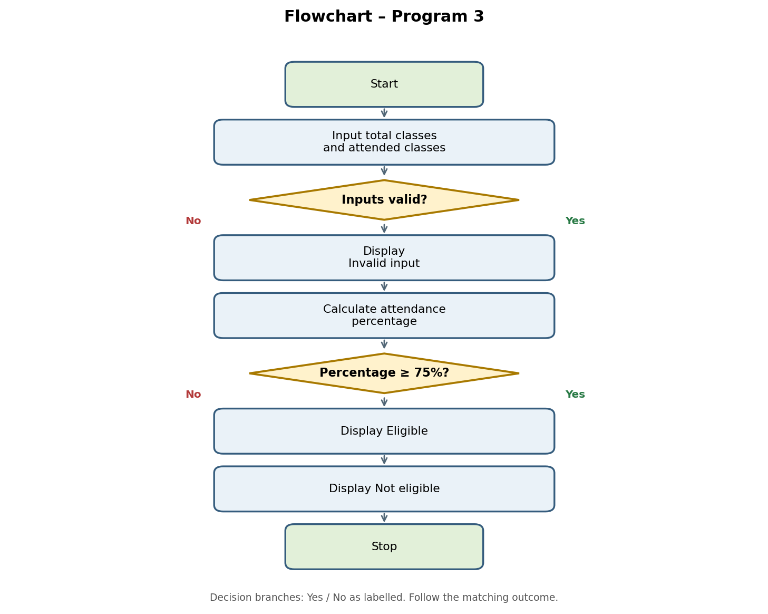

6. Pseudocode
START
INPUT total_classes
INPUT attended
IF total_classes <= 0 OR attended < 0 OR attended > total_classes:
DISPLAY "Invalid input"
ELSE:
percentage = (attended / total_classes) * 100
DISPLAY percentage
IF percentage >= 75:
DISPLAY "Eligible for examination"
ELSE:
DISPLAY "Not eligible for examination"
STOP

7. Python Source Code
total_classes = int(input("Enter total classes: "))
attended = int(input("Enter classes attended: "))

if total_classes <= 0 or attended < 0 or attended > total_classes:
print("Invalid input")
else:
percentage = (attended / total_classes) * 100
print("Attendance Percentage =", round(percentage, 2), "%")

if percentage >= 75:
print("Eligible for examination")
else:
print("Not eligible for examination")

8. Test Cases
Test Case 1: Eligible Student
Enter total classes: 100
Enter classes attended: 80
Attendance Percentage = 80.0 %
Eligible for examination

Test Case 2: Not Eligible Student
Enter total classes: 100
Enter classes attended: 60
Attendance Percentage = 60.0 %
Not eligible for examination

Test Case 3: Invalid Input
Enter total classes: 50
Enter classes attended: 60
Invalid input

9. Output Screenshots
Run the program in Python IDLE, VS Code, or an online Python compiler. Take screenshots of the output and attach them to your practical record.

10. Conclusion
The Attendance Calculation program uses Python conditional statements, arithmetic operations, and logical operators to validate attendance details, calculate the attendance percentage, and determine examination eligibility based on the 75% attendance requirement.

PROGRAM 4

Case Study: Electricity Billing System

1. Problem Statement
Develop a Python program to calculate an electricity bill based on the number of units consumed by a customer. The program applies different rates for different unit ranges and displays the final bill amount.

2. Objectives
- Accept electricity units consumed by the customer.
- Validate the entered units.
- Calculate the bill using different unit rates.
- Apply the appropriate charges based on electricity consumption.
- Display the final electricity bill.

3. Assumptions
- Electricity units must be zero or a positive number.
- The first 100 units cost ₹2 per unit.
- The next 100 units (101–200) cost ₹3 per unit.
- Units above 200 cost ₹5 per unit.
- The bill is calculated using slab-wise rates.

4. Algorithm
- Start.
- Input electricity units.
- If units < 0, display Invalid units.
- If units ≤ 100, bill = units × 2.
- If units ≤ 200, bill = 100 × 2 + (units − 100) × 3.
- Otherwise, bill = 100 × 2 + 100 × 3 + (units − 200) × 5.
- Display the bill and stop.

5. Flowchart
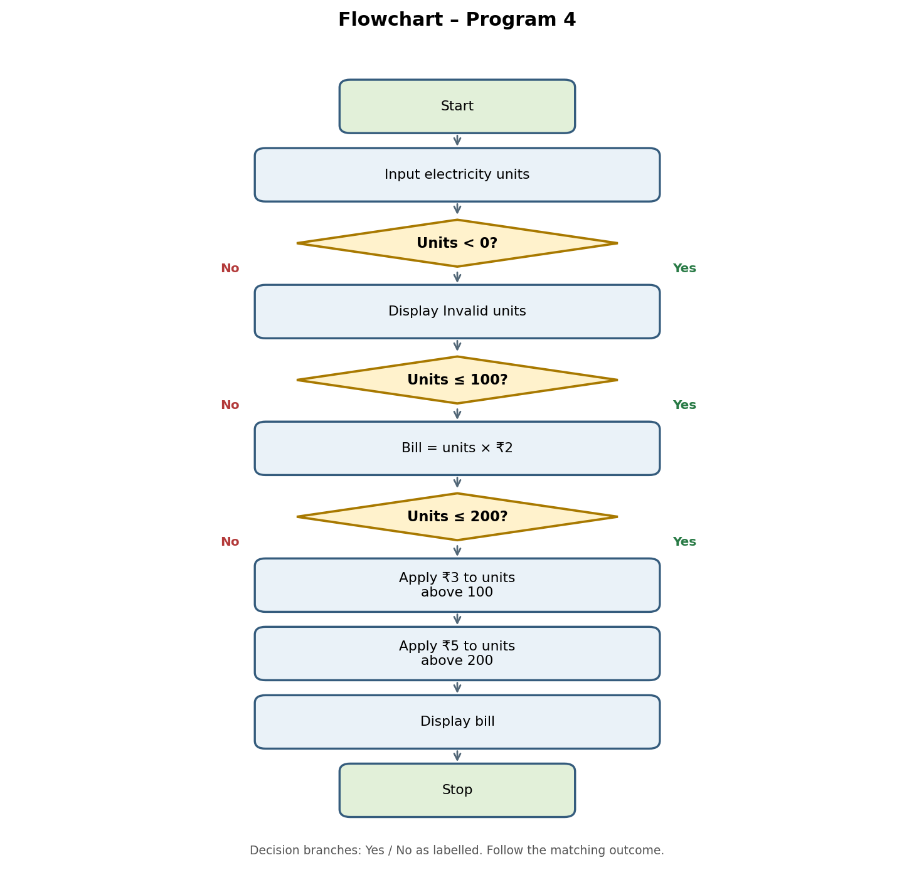

6. Pseudocode
START
INPUT units
IF units < 0:
DISPLAY "Invalid units"
ELSE IF units <= 100:
bill = units * 2
ELSE IF units <= 200:
bill = (100 * 2) + (units - 100) * 3
ELSE:
bill = (100 * 2) + (100 * 3) + (units - 200) * 5
IF units >= 0:
DISPLAY bill
STOP

7. Python Source Code
units = int(input("Enter electricity units: "))

if units < 0:
print("Invalid units")
elif units <= 100:
bill = units * 2
elif units <= 200:
bill = (100 * 2) + (units - 100) * 3
else:
bill = (100 * 2) + (100 * 3) + (units - 200) * 5

if units >= 0:
print("Electricity Bill = ₹", bill)

8. Test Cases
Test Case 1: Up to 100 units
Enter electricity units: 80
Electricity Bill = ₹ 160

Test Case 2: 101–200 units
Enter electricity units: 150
Electricity Bill = ₹ 350

Test Case 3: Above 200 units
Enter electricity units: 250
Electricity Bill = ₹ 650

Test Case 4: Invalid Input
Enter electricity units: -10
Invalid units

9. Output Screenshots
Run the program in Python IDLE, VS Code, or an online Python compiler. Take screenshots of the output and attach them to your practical record.

10. Conclusion
The Electricity Billing System uses Python conditional statements and arithmetic operations to calculate electricity charges based on slab-wise rates. It helps students understand if, elif, else, input validation, and basic billing calculations.

PROGRAM 5

Case Study: Retail Billing System

1. Problem Statement
Develop a Python program to accept a product name, price per item, and quantity purchased by a customer. Calculate the total amount, apply a discount based on the purchase amount, and display the final bill.

2. Objectives
- Accept product details from the customer.
- Validate the price and quantity.
- Calculate the total amount.
- Apply a discount based on the total amount.
- Calculate the final payable amount.
- Display the itemized bill.

3. Assumptions
- The product name is entered as text.
- The price per item must be zero or positive.
- The quantity must be zero or positive.
- A 10% discount applies when the total amount is ₹1,000 or more.
- No discount applies when the total amount is below ₹1,000.
- The final amount is calculated after deducting the discount.

4. Algorithm
- Start.
- Input product name, price, and quantity.
- If price or quantity is negative, display Invalid input.
- Otherwise, calculate total = price × quantity.
- If total ≥ ₹1,000, discount = 10% of total; otherwise, discount = 0.
- Calculate final amount = total − discount.
- Display the itemized bill and stop.

5. Flowchart
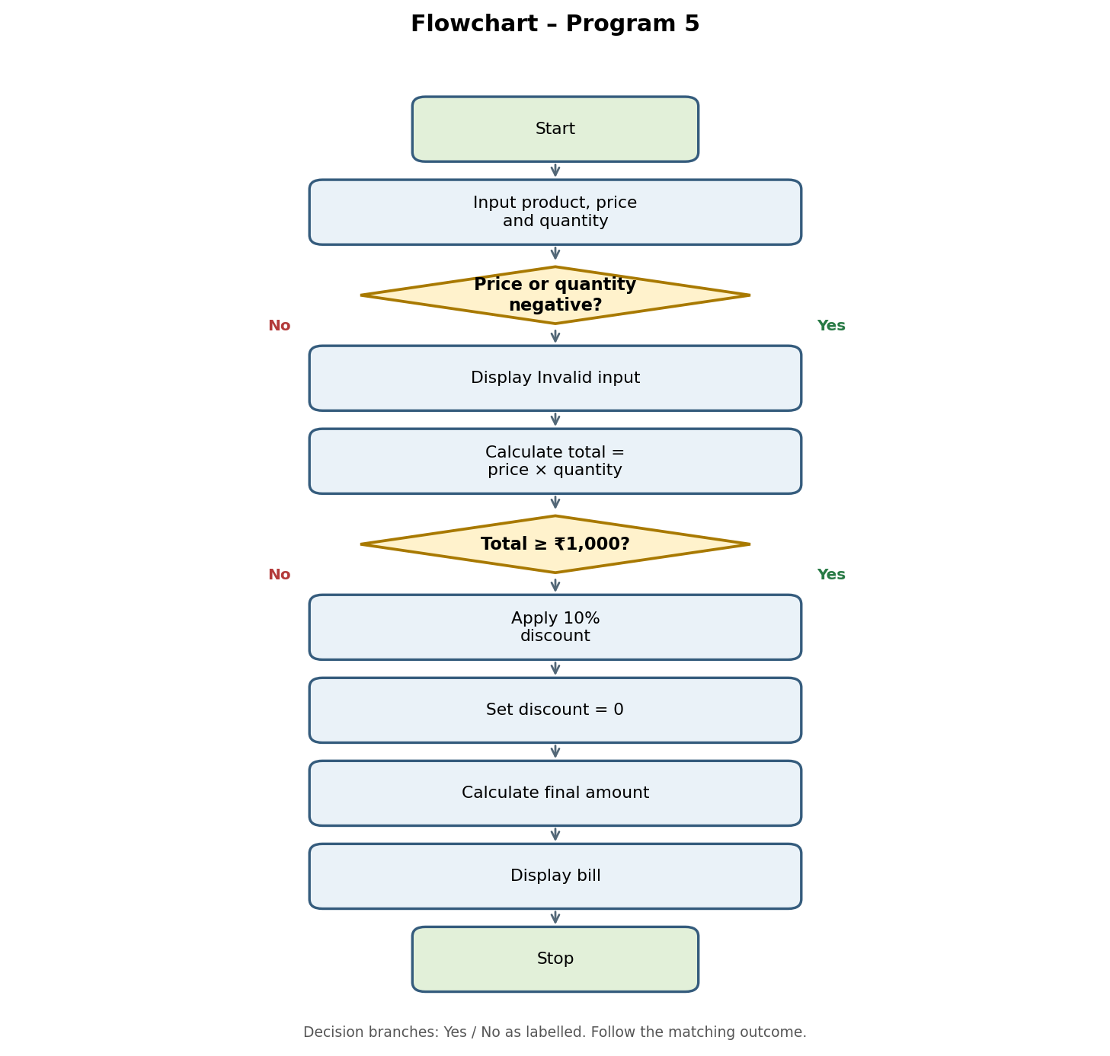

6. Pseudocode
START
INPUT name
INPUT price
INPUT quantity
IF price < 0 OR quantity < 0:
DISPLAY "Invalid input"
ELSE:
total = price * quantity
IF total >= 1000:
discount = total * 0.10
ELSE:
discount = 0
final_amount = total - discount
DISPLAY name, total, discount, final_amount
STOP

7. Python Source Code
name = input("Enter product name: ")
price = float(input("Enter price per item: "))
quantity = int(input("Enter quantity: "))

if price < 0 or quantity < 0:
print("Invalid input")
else:
total = price * quantity

if total >= 1000:
discount = total * 0.10
else:
discount = 0

final_amount = total - discount

print("Product:", name)
print("Total Amount =", round(total, 2))
print("Discount =", round(discount, 2))
print("Final Amount =", round(final_amount, 2))

8. Test Cases
Test Case 1: Discount Applied
Enter product name: Bag
Enter price per item: 1200
Enter quantity: 1
Product: Bag
Total Amount = 1200.0
Discount = 120.0
Final Amount = 1080.0

Test Case 2: No Discount
Enter product name: Pen
Enter price per item: 50
Enter quantity: 5
Product: Pen
Total Amount = 250.0
Discount = 0
Final Amount = 250.0

Test Case 3: Invalid Input
Enter product name: Book
Enter price per item: -100
Enter quantity: 2
Invalid input

9. Output Screenshots
Run the program in Python IDLE, VS Code, or an online Python compiler. Take screenshots of the output and attach them to your practical record.

10. Conclusion
The Retail Billing System uses Python variables, arithmetic operations, and conditional statements to calculate the total cost, apply discounts, and display the final payable amount.

PROGRAM 6

Case Study: Student Performance Analysis

1. Problem Statement
Develop a Python program to accept marks obtained by a student in multiple subjects. Calculate and display the highest marks, lowest marks, and average marks to analyze the student's academic performance.

2. Objectives
- Accept the number of subjects.
- Input marks for each subject.
- Store the marks in a list.
- Find the highest marks.
- Find the lowest marks.
- Calculate the average marks.
- Display the student's performance.

3. Assumptions
- The number of subjects must be greater than zero.
- Marks are entered as numerical values.
- Marks are assumed to be out of 100.
- The program calculates the highest, lowest, and average marks from the entered values.

4. Algorithm
- Start and create an empty marks list.
- Input the number of subjects.
- If n ≤ 0, display Invalid number of subjects.
- Otherwise, input marks for each subject and add them to the list.
- Find highest = max(marks), lowest = min(marks), and average = sum(marks) / n.
- Display the results and stop.

5. Flowchart
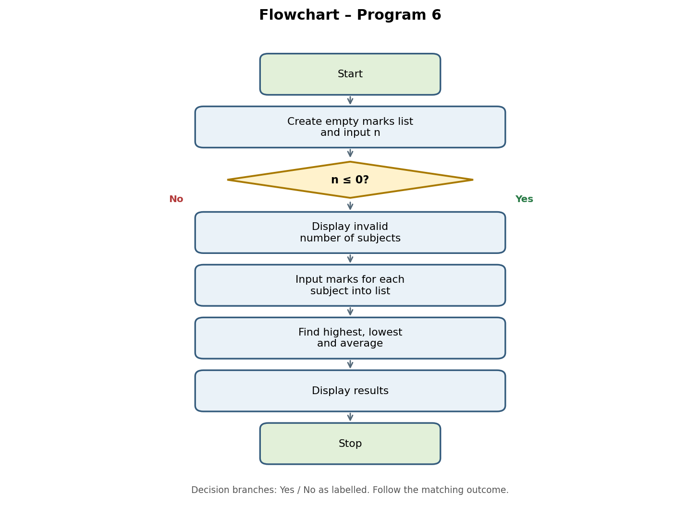

6. Pseudocode
START
marks = []
INPUT n
IF n <= 0:
DISPLAY "Invalid number of subjects"
ELSE:
REPEAT n times:
INPUT mark
ADD mark TO marks
highest = MAX(marks)
lowest = MIN(marks)
average = SUM(marks) / n
DISPLAY highest, lowest, average
STOP

7. Python Source Code
marks = []

n = int(input("Enter number of subjects: "))

if n <= 0:
print("Invalid number of subjects")
else:
for i in range(n):
mark = float(input("Enter marks: "))
marks.append(mark)

print("Highest Marks =", max(marks))
print("Lowest Marks =", min(marks))
print("Average Marks =", round(sum(marks) / n, 2))

8. Test Cases
Test Case 1: Valid Input
Enter number of subjects: 3
Enter marks: 85
Enter marks: 90
Enter marks: 75
Highest Marks = 90.0
Lowest Marks = 75.0
Average Marks = 83.33

Test Case 2: Invalid Number
Enter number of subjects: 0
Invalid number of subjects

Test Case 3: Five Subjects
Enter number of subjects: 5
Enter marks: 80
Enter marks: 65
Enter marks: 95
Enter marks: 70
Enter marks: 90
Highest Marks = 95.0
Lowest Marks = 65.0
Average Marks = 80.0

9. Output Screenshots
Run the program in Python IDLE, VS Code, or an online Python compiler. Take screenshots of the output and attach them to your practical record.

10. Conclusion
The Student Performance Analysis program uses Python lists, loops, built-in functions, and arithmetic operations to analyze marks obtained in multiple subjects.

PROGRAM 7

Case Study: ATM Transaction Simulation

1. Problem Statement
Develop a Python program to simulate an ATM system that allows users to check their account balance, deposit money, withdraw money, and exit the system. The program validates transactions and updates the balance accordingly.

2. Objectives
- Initialize the account balance.
- Display ATM menu options.
- Allow the user to check the current balance.
- Allow the user to deposit money.
- Allow the user to withdraw money.
- Validate transaction amounts and check the available balance.
- Exit the ATM system when requested.

3. Assumptions
- The initial account balance is ₹1,000.
- Deposit and withdrawal amounts must be positive.
- A withdrawal cannot exceed the available balance.
- The user can perform multiple transactions until choosing Exit.
- This is a simulation and does not connect to a real bank account.

4. Algorithm
- Start and initialize balance = ₹1,000.
- Display the ATM menu and input the user's choice.
- If choice is 1, display balance.
- If choice is 2, input deposit amount; add it if positive, otherwise display Invalid amount.
- If choice is 3, input withdrawal amount; validate it and check the balance before deducting.
- If choice is 4, display Thank you and exit.
- For an invalid choice, display Invalid choice. Repeat until Exit.

5. Flowchart
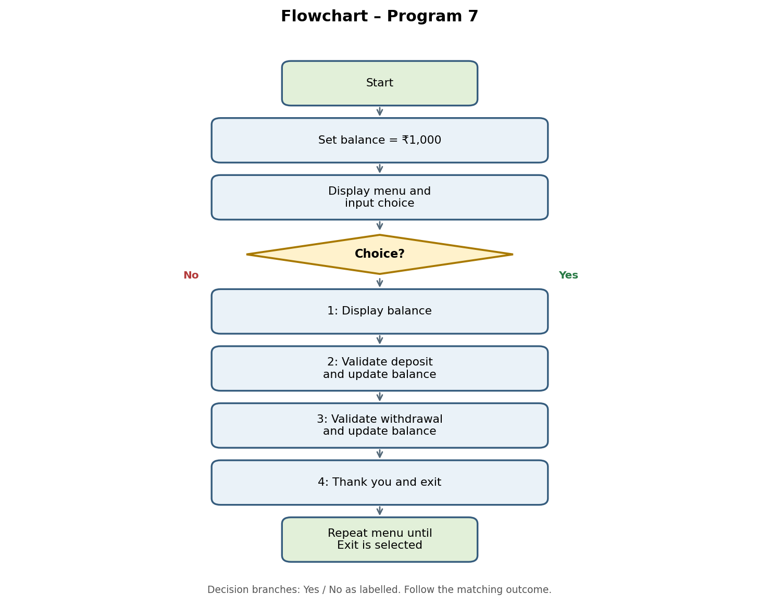

6. Pseudocode
START
balance = 1000
WHILE TRUE:
DISPLAY ATM MENU
INPUT choice
IF choice == "1":
DISPLAY balance
ELSE IF choice == "2":
INPUT amount
IF amount > 0:
balance = balance + amount
DISPLAY "Deposit successful"
ELSE:
DISPLAY "Invalid amount"
ELSE IF choice == "3":
INPUT amount
IF amount <= 0:
DISPLAY "Invalid amount"
ELSE IF amount <= balance:
balance = balance - amount
DISPLAY "Withdrawal successful"
ELSE:
DISPLAY "Insufficient balance"
ELSE IF choice == "4":
DISPLAY "Thank you!"
BREAK
ELSE:
DISPLAY "Invalid choice"
STOP

7. Python Source Code
balance = 1000

while True:
print("\n1. Check Balance")
print("2. Deposit")
print("3. Withdraw")
print("4. Exit")

choice = input("Enter your choice: ")

if choice == "1":
print("Balance = ₹", balance)

elif choice == "2":
amount = float(input("Enter deposit amount: "))
if amount > 0:
balance += amount
print("Deposit successful")
else:
print("Invalid amount")

elif choice == "3":
amount = float(input("Enter withdrawal amount: "))
if amount <= 0:
print("Invalid amount")
elif amount <= balance:
balance -= amount
print("Withdrawal successful")
else:
print("Insufficient balance")

elif choice == "4":
print("Thank you!")
break

else:
print("Invalid choice")

8. Test Cases
Test Case 1: Check Balance
1. Check Balance
2. Deposit
3. Withdraw
4. Exit
Enter your choice: 1
Balance = ₹ 1000

Test Case 2: Deposit
Enter your choice: 2
Enter deposit amount: 500
Deposit successful
Updated balance = ₹1,500

Test Case 3: Withdraw
Enter your choice: 3
Enter withdrawal amount: 300
Withdrawal successful
Updated balance = ₹1,200 (after the previous deposit)

Test Case 4: Insufficient Balance
Enter your choice: 3
Enter withdrawal amount: 2000
Insufficient balance

Test Case 5: Exit
Enter your choice: 4
Thank you!

9. Output Screenshots
Run the program in Python IDLE, VS Code, or an online Python compiler. Take screenshots of the output and attach them to your practical record.

10. Conclusion
The ATM Transaction Simulation demonstrates how Python can be used to create a simple banking system. It uses loops, conditional statements, arithmetic operators, and input/output functions to manage deposits, withdrawals, and balance checking.

PROGRAM 8

Case Study: Student Email Validation

1. Problem Statement
Develop a Python program to accept a student's email address and check whether it follows a basic email format. The program validates the presence of the @ symbol, a dot in the domain part, and the absence of spaces.

2. Objectives
- Accept the student's email address.
- Check whether the email contains the @ symbol.
- Verify that the domain part contains a dot.
- Check that the email does not contain spaces.
- Display whether the email format is valid or invalid.

3. Assumptions
- The email address is entered as a string.
- The email must contain the @ symbol.
- The part after the last @ must contain a dot.
- The email must not contain spaces.
- This program checks only the basic email format; it does not verify whether the email account actually exists.

4. Algorithm
- Start.
- Input the student's email address.
- Check that it contains @, the domain part contains a dot, and there are no spaces.
- If all conditions are satisfied, display Email format is valid; otherwise, display Invalid email format.
- Stop.

5. Flowchart
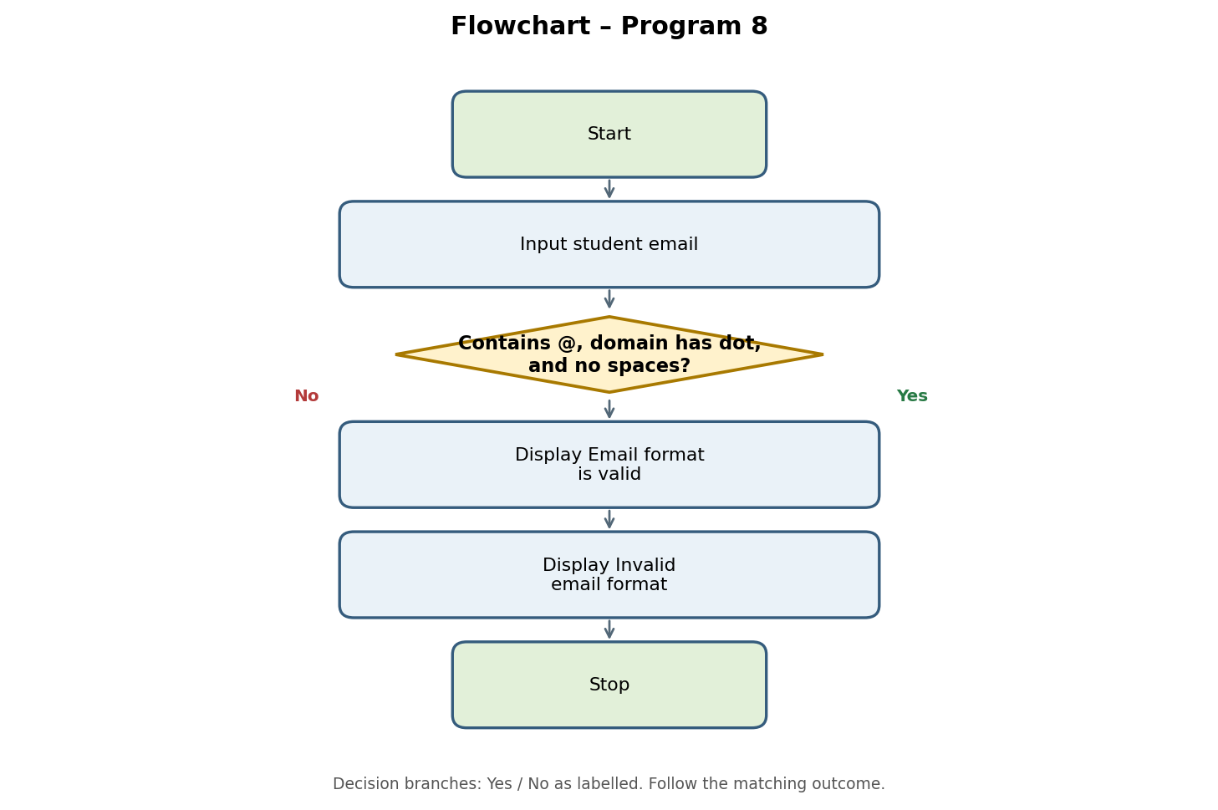

6. Pseudocode
START
INPUT email
IF "@" is in email
AND "." is in the domain part
AND " " is not in email:
DISPLAY "Email format is valid"
ELSE:
DISPLAY "Invalid email format"
STOP

7. Python Source Code
email = input("Enter student email: ")

if "@" in email and "." in email.split("@")[-1] and " " not in email:
print("Email format is valid")
else:
print("Invalid email format")

8. Test Cases
Test Case 1: Valid Email
Enter student email: student@gmail.com
Email format is valid

Test Case 2: Missing @
Enter student email: studentgmail.com
Invalid email format

Test Case 3: Missing Dot
Enter student email: student@gmail
Invalid email format

Test Case 4: Contains Spaces
Enter student email: student @gmail.com
Invalid email format

9. Output Screenshots
Run the program in Python IDLE, VS Code, or an online Python compiler. Take screenshots of the output and attach them to your practical record.

10. Conclusion
The Student Email Validation program uses Python strings, the in operator, the split() method, and conditional statements to check a basic email format.

PROGRAM 9

Case Study: Library Fine Calculation

1. Problem Statement
Develop a Python program to calculate the library fine based on the number of days a student returns a book late. The program accepts the number of late days, validates the input, and displays the total fine amount.

2. Objectives
- Accept the number of late days from the student.
- Validate the entered number of days.
- Calculate the library fine.
- Display the final fine amount.
- Display an error message for invalid input.

3. Assumptions
- The number of late days must be zero or a positive integer.
- The fine is ₹2 per late day.
- No fine is charged if the book is returned on time.
- The fine is calculated by multiplying the late days by ₹2.

4. Algorithm
- Start.
- Input the number of late days.
- If late days < 0, display Invalid number of days.
- Otherwise, calculate fine = late days × 2.
- Display the library fine and stop.

5. Flowchart
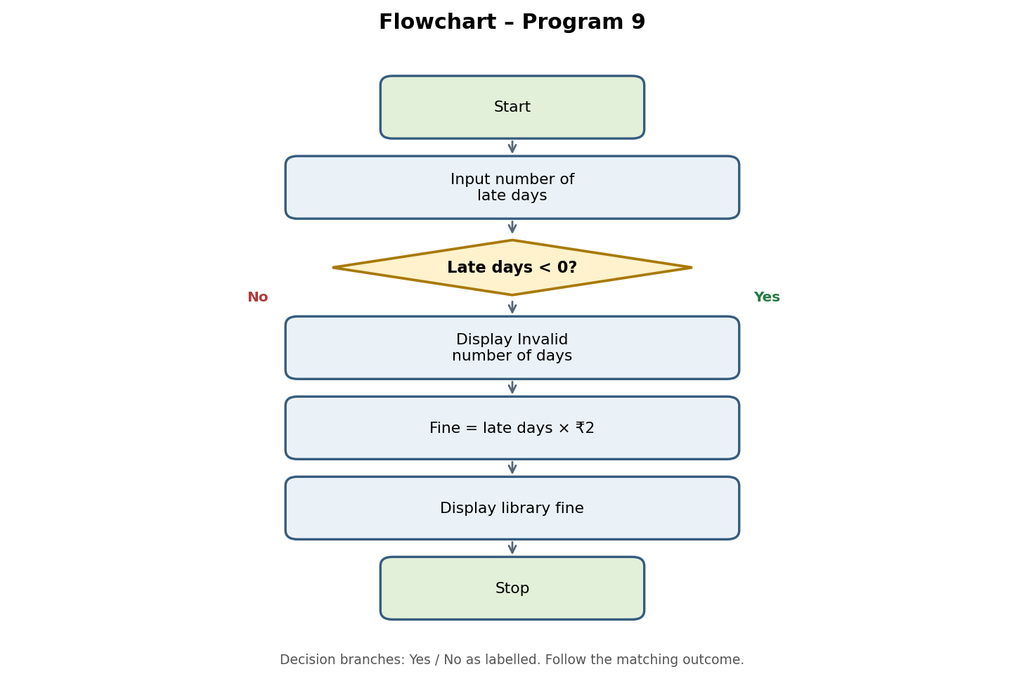

6. Pseudocode
START
INPUT late_days
IF late_days < 0:
DISPLAY "Invalid number of days"
ELSE:
fine = late_days * 2
DISPLAY "Library Fine =", fine
STOP

7. Python Source Code
late_days = int(input("Enter number of late days: "))

if late_days < 0:
print("Invalid number of days")
else:
fine = late_days * 2
print("Library Fine = ₹", fine)

8. Test Cases
Test Case 1: 5 Days Late
Enter number of late days: 5
Library Fine = ₹ 10

Test Case 2: 10 Days Late
Enter number of late days: 10
Library Fine = ₹ 20

Test Case 3: Returned on Time
Enter number of late days: 0
Library Fine = ₹ 0

Test Case 4: Invalid Input
Enter number of late days: -3
Invalid number of days

9. Output Screenshots
Run the program in Python IDLE, VS Code, or an online Python compiler. Take screenshots of the output and attach them to your practical record.

10. Conclusion
The Library Fine Calculation program uses Python input/output functions, arithmetic operations, and conditional statements to calculate fines based on late days.

PROGRAM 10

Case Study: Bus Passenger Occupancy

1. Problem Statement
Develop a Python program to monitor the number of passengers travelling on a bus at different stops. The program accepts the bus capacity, number of stops, and the number of passengers boarding and leaving at each stop. It calculates the current passenger count and displays a warning if the number of passengers exceeds the bus capacity.

2. Objectives
- Accept the bus capacity from the user.
- Accept the number of stops.
- Input the number of passengers boarding and leaving at each stop.
- Validate the passenger data.
- Calculate and display the current passenger count.
- Display a warning if the bus capacity is exceeded.
- Display the final passenger count.

3. Assumptions
- Bus capacity must be greater than zero.
- The number of stops cannot be negative.
- The initial number of passengers is zero.
- Boarding and leaving passenger counts cannot be negative.
- The number of passengers leaving cannot exceed the current passenger count.
- The program displays a warning when passengers exceed the bus capacity.

4. Algorithm
- Start and input bus capacity.
- If capacity ≤ 0, display Invalid bus capacity and stop.
- Input number of stops; if stops < 0, display Invalid number of stops.
- For each stop, input boarding and leaving counts.
- If either count is negative or leaving > current passengers, display Invalid passenger data and skip that stop.
- Otherwise, update passengers = passengers − leaving + boarding.
- Display current passengers and warn if passengers exceed capacity.
- After all stops, display final passenger count and stop.

5. Flowchart
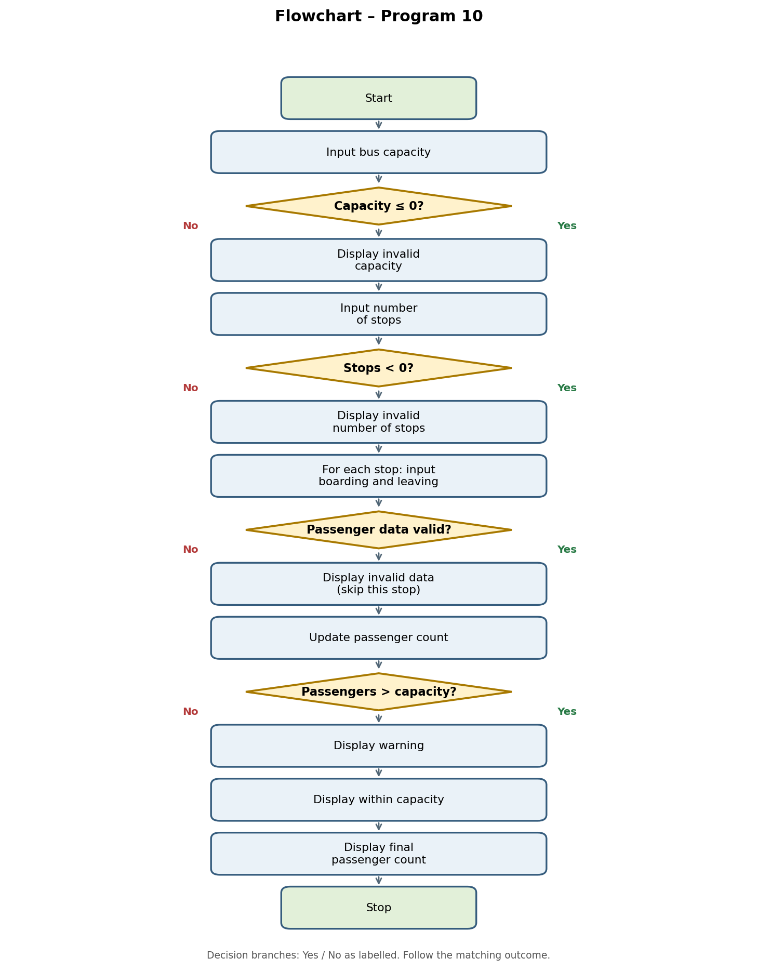

6. Pseudocode
START
INPUT capacity
passengers = 0
IF capacity <= 0:
DISPLAY "Invalid bus capacity"
ELSE:
INPUT stops
IF stops < 0:
DISPLAY "Invalid number of stops"
ELSE:
FOR each stop:
INPUT boarding
INPUT leaving
IF boarding < 0 OR leaving < 0 OR leaving > passengers:
DISPLAY "Invalid passenger data"
CONTINUE
passengers = passengers - leaving + boarding
DISPLAY current passengers
IF passengers > capacity:
DISPLAY "Warning: Bus capacity exceeded!"
ELSE:
DISPLAY "Bus is within capacity"
DISPLAY final passenger count
STOP

7. Python Source Code
capacity = int(input("Enter bus capacity: "))
passengers = 0

if capacity <= 0:
print("Invalid bus capacity")
else:
stops = int(input("Enter number of stops: "))

if stops < 0:
print("Invalid number of stops")
else:
for i in range(stops):
print("\nStop", i + 1)

boarding = int(input("Passengers boarding: "))
leaving = int(input("Passengers leaving: "))

if boarding < 0 or leaving < 0 or leaving > passengers:
print("Invalid passenger data")
continue

passengers = passengers - leaving + boarding
print("Current passengers =", passengers)

if passengers > capacity:
print("Warning: Bus capacity exceeded!")
else:
print("Bus is within capacity")

print("\nFinal passenger count =", passengers)

8. Test Cases
Test Case 1: Normal Boarding
Capacity = 40; 3 board, 0 leave
Current passengers = 3

Test Case 2: Invalid Leaving Count
Capacity = 40; current passengers = 3; 5 leave
Invalid passenger data

Test Case 3: Capacity Exceeded
Capacity = 5; 7 board, 0 leave
Warning: Bus capacity exceeded!

Test Case 4: Invalid Capacity
Capacity = 0
Invalid bus capacity

Test Case 5: Zero Stops
Capacity = 30; 0 stops
Final passenger count = 0

Test Case 6: Invalid Stops
Capacity = 40; negative number of stops
Invalid number of stops

9. Output Screenshots
Run the program in Python IDLE, VS Code, or an online Python compiler. Take screenshots of the output and attach them to your practical record.

10. Conclusion
This Python program monitors bus passenger occupancy at different stops. It uses loops, conditional statements, arithmetic operations, and input validation to update passenger counts and identify when the bus capacity is exceeded.

