# fast_attack

题目是求解椭圆曲线上离散对数的问题，发现曲线的阶是和模数相同的，因此使用SmartAttcak方法

EXP：

from pwn import *

def SmartAttack(P,Q,p):

    E = P.curve()

    Eqp = EllipticCurve(Qp(p, 2), [ ZZ(t) + randint(0,p)*p for t in E.a_invariants() ])

    P_Qps = Eqp.lift_x(ZZ(P.xy()[0]), all=True)

    for P_Qp in P_Qps:

        if GF(p)(P_Qp.xy()[1]) == P.xy()[1]:

            break

    Q_Qps = Eqp.lift_x(ZZ(Q.xy()[0]), all=True)

    for Q_Qp in Q_Qps:

        if GF(p)(Q_Qp.xy()[1]) == Q.xy()[1]:

            break

    p_times_P = p*P_Qp

    p_times_Q = p*Q_Qp

    x_P,y_P = p_times_P.xy()

    x_Q,y_Q = p_times_Q.xy()

    phi_P = -(x_P/y_P)

    phi_Q = -(x_Q/y_Q)

    k = phi_Q/phi_P

    return ZZ(k)

pp=remote("139.155.139.109",10000)

for i in range(10):

    x=pp.recvline()

    y=pp.recvline()

    x_str = x.decode('utf-8').strip(">")

    y_str = y.decode('utf-8').strip()

# strip() 去除两端的空白字符，包括换行符

# 使用冒号分割字符串，并转换为列表

    parts = x_str[1:-1].split(':')  # [1:-1] 去除字符串两端的括号

    parts_y = y_str[1:-1].split(':')

    print(x_str)

    print(parts)

    print(y_str)

    print(parts_y)

# 提取前两个元素，并转换为整数

    first_number_x = int(parts[0].strip())

    second_number_x = int(parts[1].strip())

    first_number_y = int(parts_y[0].strip())

    second_number_y = int(parts_y[1].strip())

    print(first_number_x)

    P=(int(first_number_x),int(second_number_x))

    Q=(int(first_number_y),int(second_number_y))

    a = 0

    b = -3045286915816228928193649683228046896481316

    p = 235322474717419

    P1 = GF(p)

    E = EllipticCurve(P1, [a, b])

    P=E(P)

    Q=E(Q)

    result=SmartAttack(P,Q,p)

    pp.sendline(str(result).encode())

flag=pp.recvline()

print(flag)

# 签到

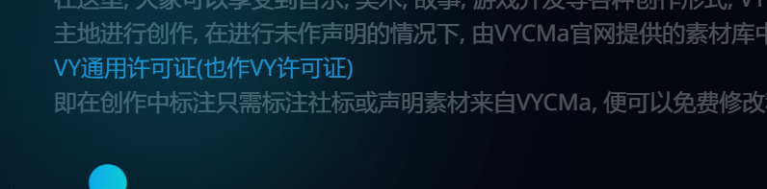

进入查看源代码

