HTML

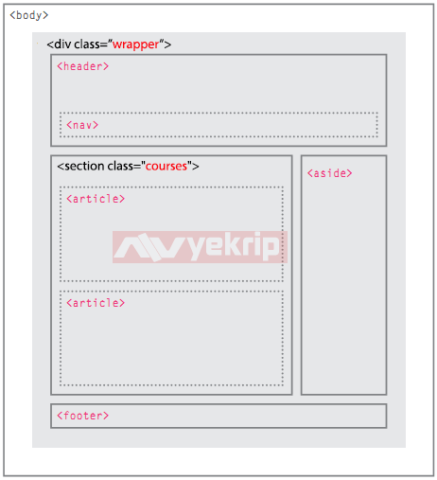

Sketsa HTML web

# Organel-organel Html

## Basic Organel

1. **Numbering**

Buller : <ul> </ul>

Example

<ul>

<li>Arctos</li>

<li>Collarus</li>

<li>Horribilis</li>

<li>Nelsoni (extinct)</li>

</ul>

Number : <ol> </ol>

1. **Image**

<img src="image-location.jpg" alt= alt="A red prickly pear fruit"/>

Alt : untuk memberi meta data pada gambar (tidak ditampilkan di page)

1. **Video**

<video src="myVideo.mp4" width="320" height="240" controls>

Video not supported

</video>

1. **Link**

<a href="https://en.wikipedia.org/wiki/Brown\_bear" target="\_blank">The Brown Bear</a>

target="\_blank" : untuk buka di new tab

1. **Link to Relative Page**

<a href="./aboutme.html">About Me</a>

The ./ in ./aboutme.html tells the browser to look for the file in the current folder.

1. **Linking with image :**

<a href="https://en.wikipedia.org/wiki/Opuntia" target="\_blank"><img src="#" alt="A red prickly pear fruit"/></a>

1. **Link to Specific Section**

When users visit our site, we want them to be able to click a link and have the page automatically scroll to a specific section.

# <a href="#top">Top</a></li> link to <p id="top">This is the top of the page!</p>

# <a href="#bottom">Bottom</a> link to <h1 id="bottom">This is the bottom! </h1>

1. **Comment**

<!-- This is a comment that the browser will not display. -->

Contoh:

<!-- Favorite Films Section -->

<p>The following is a list of my favorite films:</p>

Comment bisa juga membuat code seakan “menghilang” untuk experiment

<!-- <p> Test Code </p> -->

1. **Table**
2. **Border**

Using HTML code

<table border="1">

<tr>

<td>73</td>

<td>81</td>

</tr>

</table>

Using CSS code

table, td {

border: 1px solid black;

}

1. **Spaning**

Column:

<td colspan="2">Adam's Greenworks</td>

Row:

<td rowspan="2">Davie's Burgers</td>

1. **Table Head**

<thead>

<tr>

<th>Company Name</th>

<th>Number of Items to Ship</th>

<th>Next Action</th>

</tr>

</thead>

Note: <td> sama <th> itu tampilan visualnya sama, cuma penting banget buat di bedain untuk saat pemberian style di CSS

## Input Organel

# **Text Box**

# <input type="text" value="nama anda" size= 100 maxlength="1">

Ketertangan

size : Ukuran kotak kesampingnya nya

Maxlength : Jumlah karakter maksimal yang bisa diketik

Type : bisa diganti dengan password dan number

# **2. Check Box dan Radio**

<body>

Jenis Kelamin :

<input type="radio" name="jenis\_kelamin" value="laki-laki" checked />

Laki - Laki

<input type="radio" name="jenis\_kelamin" value="perempuan" />Perempuan

<br/>

Hobi: <input type="checkbox" name="hobi\_baca" /> Membaca Buku

<input type="checkbox" name="hobi\_nulis" checked /> Menulis

<input type="checkbox" name="hobi\_mancing" /> Memancing <br/>

</body>

Output :

# 

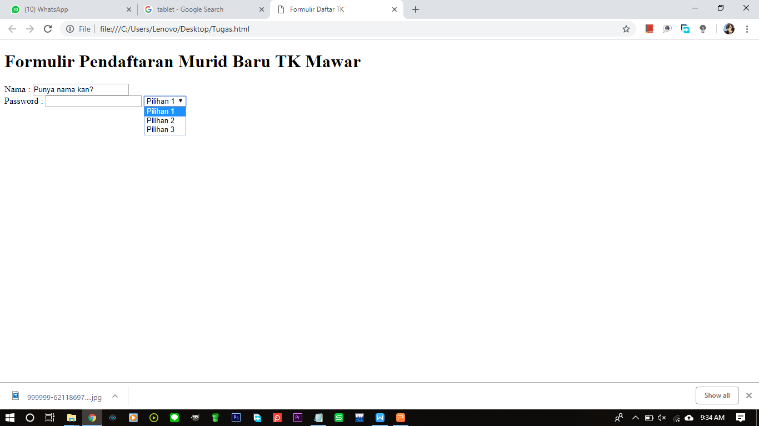

Output:

**3. Select Row**

Code :

<select>

<option>Pilihan 1</option>

<option>Pilihan 2</option>

<option value="pilihan ketiga">Pilihan 3</option>

</select>

1. **Text Area dan Submit**

Code :

<textarea name="komentar" rows="5" cols="20"> Silahkan katakan isi hati anda </textarea> <br />

<input type="submit" value="Proses!" >

Output :

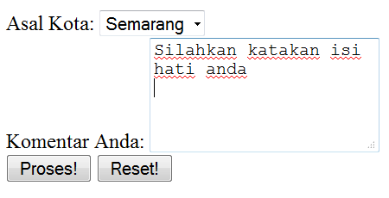

# **Review**

Congratulations on completing the first lesson of HTML! You are well on your way to becoming a skilled web developer.

Let's review what you've learned so far:

1. ****HTML**** stands for ****H****yper****T****ext ****M****arkup ****L****anguage and is used to create the structure and content of a webpage.
2. Most HTML elements contain opening and closing tags with raw text or other HTML tags between them.
3. HTML elements can be nested inside other elements. The enclosed element is the child of the enclosing parent element.
4. Any visible content should be placed within the opening and closing <body> tags .
5. Headings and sub-headings, <h1> to <h6>tags, are used to enlarge text.
6. <p>, <span> and <div> tags specify text or blocks.
7. The <em> and <strong> tags are used to emphasize text.
8. Line breaks are created with the <br> tag.
9. Ordered lists (<ol>) are numbered and unordered lists (<ul>) are bulleted.
10. Images (<img>) and videos (<video>) can be added by linking to an existing source.

Let’s review what you’ve learned this lesson:

1. The <!DOCTYPE html> declaration should always be the first line of code in your HTML files. This lets the browser know what version of HTML to expect.
2. The <html> element will contain all of your HTML code.
3. Information about the web page, like the title, belongs within the <head> of the page.
4. You can add a title to your web page by using the <title> element, inside of the head.
5. A webpage's title appears in a browser's tab.
6. Anchor tags (<a>) are used to link to internal pages, external pages or content on the same page.
7. You can create sections on a webpage and jump to them using <a> tags and adding ids to the elements you wish to jump to.
8. Whitespace between HTML elements helps make code easier to read while not changing how elements appear in the browser.
9. Indentation also helps make code easier to read. It makes parent-child relationships visible.
10. Comments are written in HTML using the following syntax: <!-- comment -->.

**Table Review**

Let's review what you've learned so far:

1. The <table> element creates a table.
2. The <tr> element adds rows to a table.
3. To add data to a row, you can use the <td>element.
4. Table headings clarify the meaning of data. Headings are added with the <th> element.
5. Table data can span columns using the colspan attribute.
6. Table data can span rows using the rowspan attribute.
7. Tables can be split into three main sections: a head, a body, and a footer.
8. A table's head is created with the <thead>element.
9. A table's body is created with the <tbody>element.
10. A table's footer is created with the <tfoot>element.
11. All the CSS properties you learned about in this course can be applied to tables and their data.

**CSS**

1. **Set Color**

* To set a background color, use [background-color](https://www.quackit.com/css/properties/css_background-color.cfm).
* To set the text color, use [color](https://www.quackit.com/css/properties/css_color.cfm)
* To set a border color, use [border-color](https://www.quackit.com/css/properties/css_border-color.cfm).

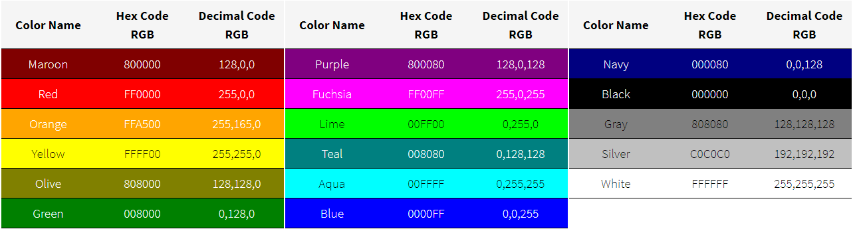

1. **Background setting**

.hero-image {  
  background-image: url("photographer.jpg"); /\* The image used \*/  
  background-color: #cccccc; /\* Used if the image is unavailable \*/  
  height: 500px; /\* You must set a specified height \*/  
  background-position: center; /\* Center the image \*/  
  background-repeat: no-repeat; /\* Do not repeat the image \*/  
  background-size: cover; /\* Resize the background image to cover the entire container \*/  
}

# Clear Property

Do not allow floating elements on the left or the right side of a specified element:

## CSS Syntax

clear: none|left|right|both|initial|inherit;

## Property Values

|  |  |
| --- | --- |
| **Value** | **Description** |
| none | Default. Allows floating elements on both sides |
| left | No floating elements allowed on the left side |
| right | No floating elements allowed on the right side |
| both | No floating elements allowed on either the left or the right side |
| initial | Sets this property to its default value. [Read about initial](https://www.w3schools.com/cssref/css_initial.asp) |
| inherit | Inherits this property from its parent element. [Read about inherit](https://www.w3schools.com/cssref/css_inherit.asp) |

# CSS text-align Property

div.a {  
    text-align: center;  
}  
  
div.b {  
    text-align: left;  
}  
  
div.c {  
    text-align: right;  
}  
  
div.c {  
    text-align: justify;  
}

# 2018-09-09_16h02_572018-09-09_16h02_57CSS padding Property