ConveyorFlow: Decentralized Capability-Aware Self-Selection for Heterogeneous LLM Agent Teams
Sakan Punyanon
Affiliation and corresponding-author e-mail to be confirmed before submission
Abstract—Heterogeneous large-language-model agents differ in capability, latency, token demand, and cost, yet task assignment is commonly fixed or centrally controlled. This paper presents ConveyorFlow, a decentralized assignment mechanism in which idle agents inspect dependency-ready tasks on a shared belt, assess capability-task fit locally, volunteer, and temporarily stand down when overqualified. A pre-specified discrete-event simulation, frozen before execution, evaluated public-data-derived ML-build and bug-fix workloads across 22,500 unique runs and 50 paired seeds. Against static controls, CF-Fit increased verified throughput by 9.4-45.3% and reduced P95 terminal flow time by 67.9-83.1%, but increased cost by 4.7-52.4% and explicit dead letters as it converted horizon backlog into terminal outcomes. Against a matched centralized fit controller, cost and time were near parity, throughput was 1.1-1.5% lower, and completion non-inferiority passed in 8/8 prespecified contrasts. Controlled team compositions show that capability heterogeneity is beneficial only conditional on resource mapping. Ablations identify fit, assessment, and aging as consequential components, while stand-down is a bounded refinement. In a supplementary ten-seed Real-LLM study, CF-Fit delivered 99.5% higher throughput and 62.1% lower wall time than static round robin, but 24.7% lower completion and 62.1% higher cost per verified task; it detected no metric-level difference from a centralized fit matcher at the prespecified threshold; a separately frozen extension probes stand-down and homogeneous-team boundary conditions. ConveyorFlow is therefore supported as an interpretable trade-off mechanism rather than a universally dominant allocator.
Index Terms—decentralized task allocation, heterogeneous agents, large language models, self-selection, discrete-event simulation

I. INTRODUCTION
Teams of large-language-model (LLM) agents increasingly divide complex work into specialized roles. Existing frameworks demonstrate the value of structured conversations and role-based workflows [1]–[3], yet assignment is often fixed in advance or delegated to a central orchestrator. That assumption becomes consequential when agent capability, service time, token demand, and price differ: sending every task to the most capable agent can be accurate but expensive, while routing every task to a cheap agent can increase retries and tail latency.
ConveyorFlow treats allocation as a stream of dependency-ready tasks on a shared belt. Idle agents inspect a bounded window, assess the visible task locally, and volunteer. The assignment decision is decentralized—there is no component that globally ranks all agents for CF-Fit—although the ready belt, atomic claim operation, and event ledger remain shared coordination infrastructure. This distinction avoids the stronger and unsupported claim that the entire system is fully distributed.
The scientific contribution is therefore not a catalog of policies. It is a connected mechanism: capability heterogeneity creates a reason for local selection; capability–task fit shapes volunteering; an overqualified agent can stand down temporarily; and task aging relaxes hesitation so that low-fit work does not wait indefinitely. The study asks how this mechanism changes a vector of cost, throughput, completion time, utilization, and failure outcomes, rather than requiring a universal winner.
The contributions are threefold: (1) a reproducible decentralized self-selection mechanism with explicit fit, stand-down, aging, and bounded no-volunteer behavior; (2) a controlled design that changes capability variance while holding team size and mean latent ability constant; and (3) a pre-specified event-ledger simulation, frozen before execution, with public-data-derived workloads, static and centralized controls, component ablations, fallback stress tests, and annotation/resource robustness analyses.

II. RELATED WORK
Classical distributed task allocation includes negotiation protocols such as Contract Net [7], formal task-allocation taxonomies [8], [9], and consensus-based decentralized auctions [10]. These approaches establish that local or market-based decisions can reduce dependence on a central controller, but their communication, bidding, and objective assumptions differ from a shared ready-belt architecture for LLM-agent work.
LLM multi-agent systems such as AutoGen, MetaGPT, ChatDev, CAMEL, and AgentVerse coordinate specialized agents through conversation, role play, or standardized workflows [1]–[5]. A recent survey organizes this broader design space by environment interface, profiling, communication, and capability acquisition [6]. ConveyorFlow is complementary: it isolates who chooses a ready task and why, using capability fit and bounded stand-down rather than prescribing a full conversational software-development process. The controlled simulation provides the primary causal comparisons, while the completed Real-LLM study supplies narrower implementation-level evidence under dated provider aliases and deterministic validators.
The task-difficulty protocol is informed by work on LLM-based evaluation [11], while studies of prompting choices and judge bias motivate a strict validity boundary [12], [13]. Three role-conditioned passes from the same underlying model measure procedural stability, not inter-expert human agreement or external ground truth. This limitation is carried into the robustness design and the claims.

III. SYSTEM MODEL AND OBJECTIVE
A job is a finite directed acyclic graph (DAG). A task enters the ordered READY frontier only after all dependencies are verified. The system contains at most four agents. An agent has workload-specific latent ability theta, a speed factor, a token factor, and a price factor; ability is deliberately separated from resource cost.
The primary objective is to reduce cost per verified task subject to prespecified completion-quality constraints. Completion non-inferiority requires the lower confidence limit of CF-Fit minus comparator to be at least -0.03. Dead-letter and unsettled non-inferiority require the upper confidence limit to be at most +0.03. Verified throughput and P95 terminal flow time are key secondary outcomes; utilization is explanatory and is not assumed to be better merely because it is higher.
No post-hoc weighted score collapses these outcomes. A policy can be cheaper but slower, faster but less complete, or operationally attractive only under one resource regime. The estimand is thus a trade-off vector conditional on workload, load, team composition, and resource mapping.

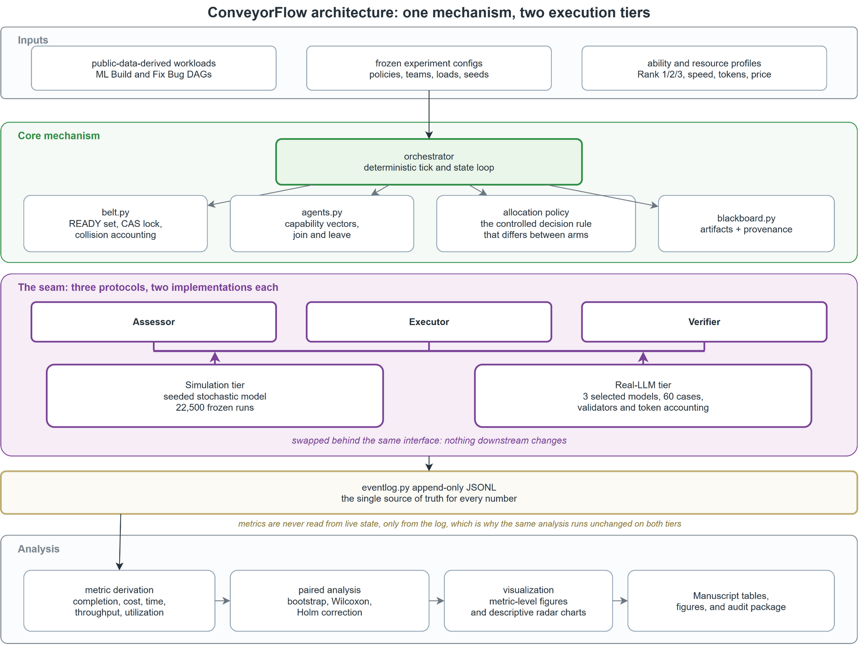
Fig. 1. ConveyorFlow system architecture. Frozen workloads, allocation rules, and ability/resource profiles feed one state-machine core. The assessor, executor, and verifier interfaces are implemented by both the 22,500-run simulation tier and the 60-case Real-LLM tier; both tiers write append-only ledgers that drive the same metric and analysis pipeline.

IV. CONVEYORFLOW MECHANISM

A. Local Observation and Eligibility
Each idle agent scans at most K_scan=8 visible READY tasks. For each task it estimates difficulty d-hat, pass probability p-hat, effort, and confidence. A task is eligible only when skill constraints and retry-diversity rules hold and p-hat exceeds an age-dependent threshold tau(age). The default threshold decreases from 0.60 to 0.50 and then 0.35 as waiting increases.

B. Capability Fit and Stand-Down
For an eligible task, the local claim delay combines capability mismatch, overqualification, urgency, and deterministic keyed jitter: backoff = |level-d-hat| + 0.8*max(0, level-d-hat)*(1-urgency) - 0.5*urgency + jitter. An overqualified agent therefore hesitates early, preserving advanced capacity for difficult work. This is bounded hesitation, not permanent refusal: the penalty decays with age and is removed at the second aging threshold.

C. Atomic Claim and No-Volunteer Handling
Each agent selects at most one candidate. Claims are ordered by local claim time and resolved by an atomic compare-and-swap abstraction; losing agents return to the next decision round. Under the default F2 mechanism, tasks are re-offered, moved to the tail at W1=8 and W2=20, and evaluated with relaxed thresholds and stand-down. At W3=50 or after eight requeues, the task becomes DEAD_LETTER and dependent work is terminally accounted. F3 instead forces a centrally selected rescue and is reported only as a hybrid reference.

D. End-to-End Process Architecture
Figure 2 traces one task from belt admission through self-assessment, volunteering or stand-down, atomic claiming, execution, deterministic verification, artifact publication, retry, and terminal accounting. The decision boundary is explicit: the belt broadcasts only READY work; each idle agent independently evaluates can-do status, estimated difficulty, and confidence; and the claim primitive resolves races without selecting a preferred agent. A failed attempt returns to the belt while retries remain, whereas the frozen retry bound produces ABANDONED/DEAD_LETTER accounting. A job is complete only when every constituent task is verified DONE.

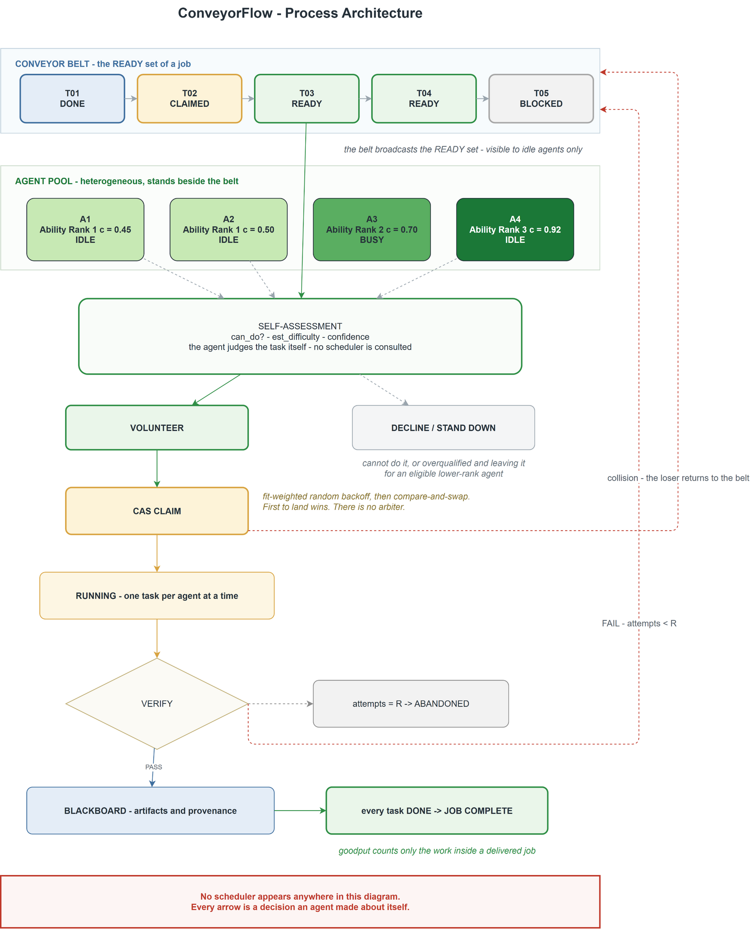
Fig. 2. ConveyorFlow process architecture. Heterogeneous Ability Rank 1/2/3 agents observe the same READY belt, self-assess, volunteer or stand down, and contend through an atomic claim. Execution and verification feed the blackboard and either complete the job or re-enter bounded retry handling. Editable source: page 'ConveyorFlow - Process Architecture' in ConveyorFlow_diagrams_en_working.drawio.

E. Controlled Belt Comparison and Tick Semantics
Figures 3 and 4 make the experimental control explicit. Both CF-Fit and the static baseline receive the same dependency-released tasks, place them on the same ordered READY belt, use the same execution and verification semantics, and apply the same retry and terminal-accounting rules. What changes is allocation authority. Under CF-Fit, every idle agent observes a bounded belt window, evaluates capability-task fit locally, and may volunteer or stand down. The shared atomic claim operation only resolves simultaneous claims; it does not globally rank agent-task pairs.

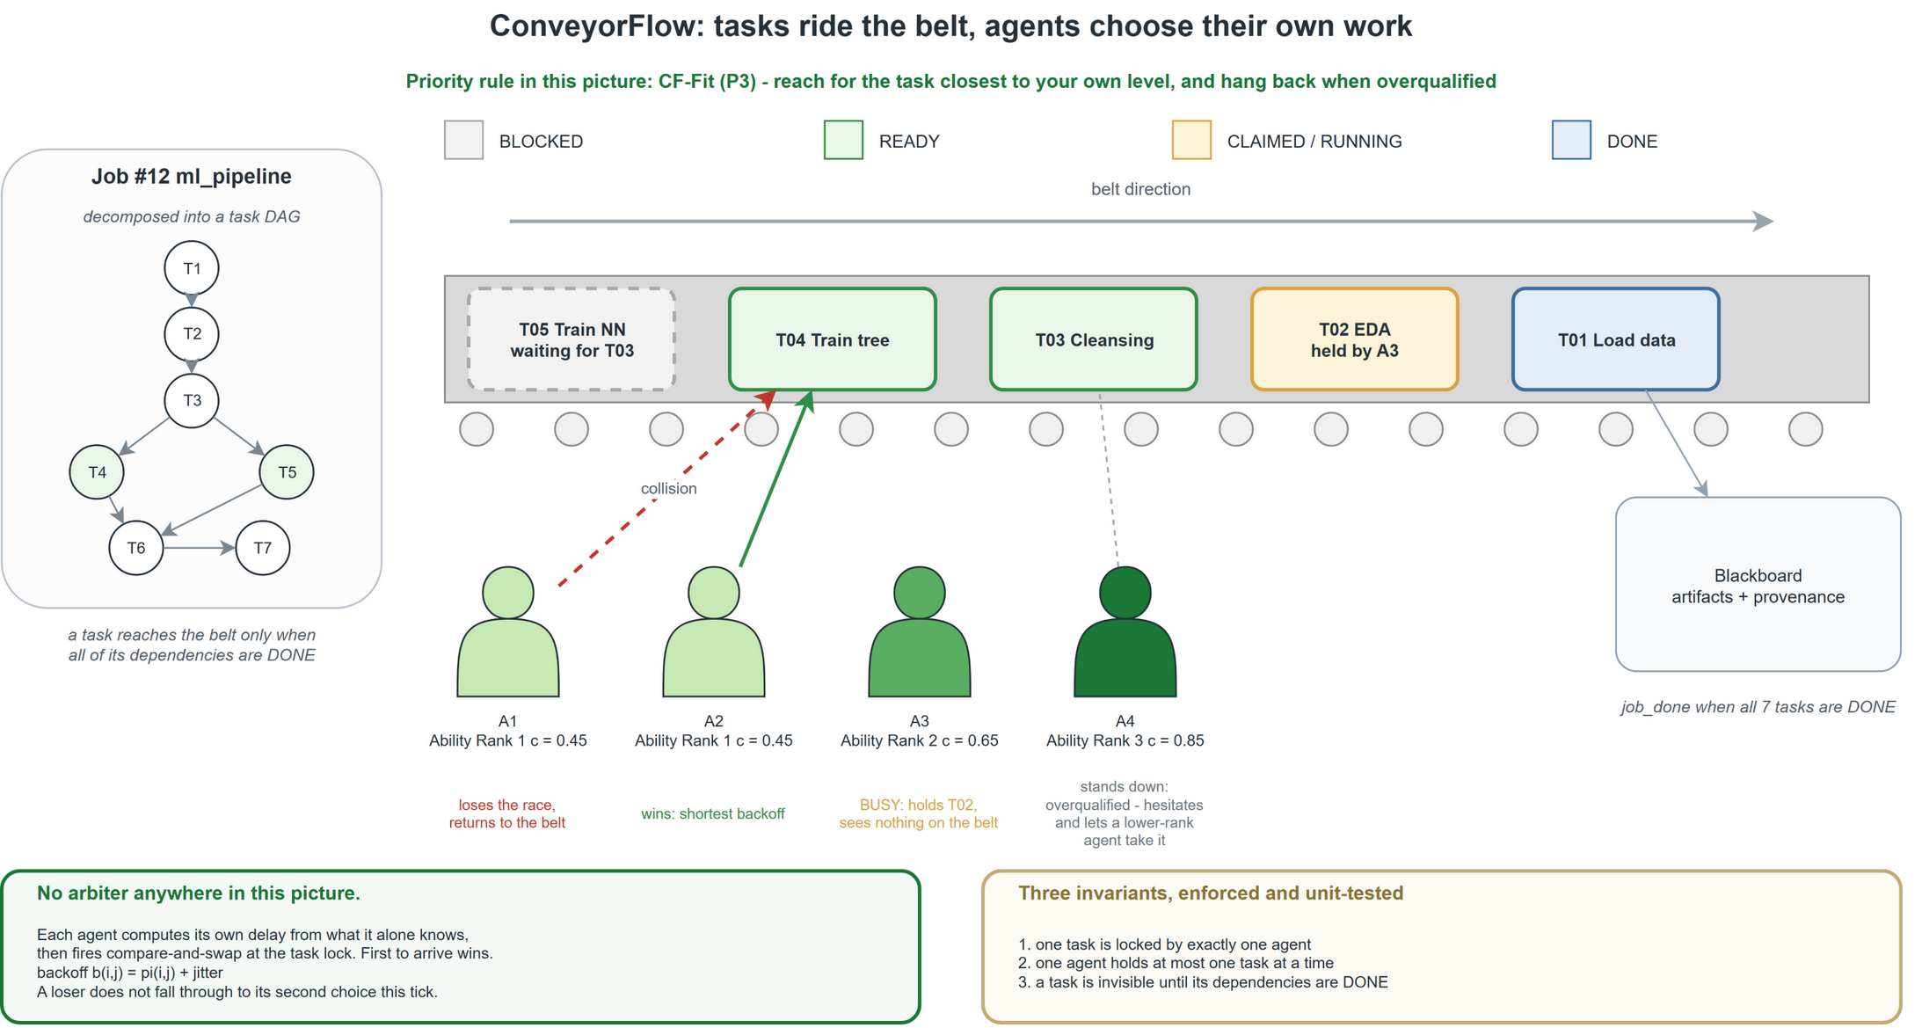
Fig. 3. CF-Fit task flow. Dependency-ready tasks ride the shared belt; idle heterogeneous agents independently assess visible tasks, volunteer when eligible, and use an atomic claim only to resolve collisions. The editable source is the page 'Belt - CF-Fit (P3)' in ConveyorFlow_diagrams_en_working.drawio.
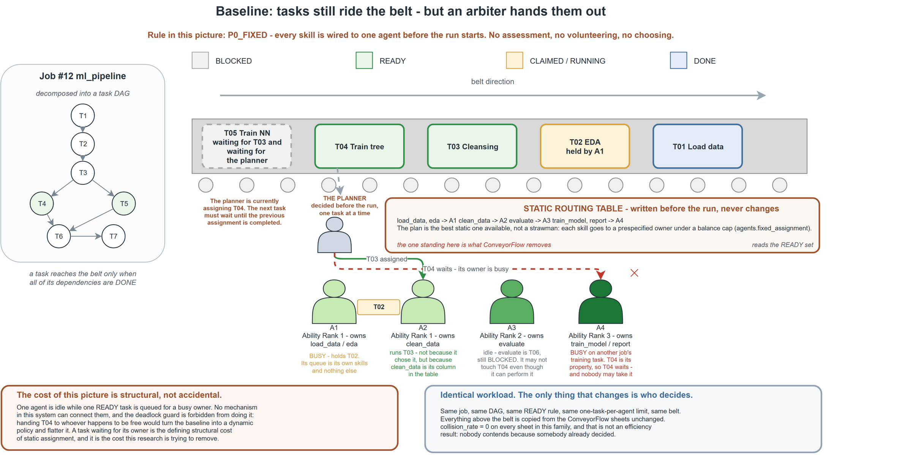
Fig. 4. Static-allocation control on the same belt. A task-to-agent rule is fixed before execution, so agents do not self-select at run time; arrivals, readiness, execution, verification, and failure accounting remain controlled. The editable source is the page 'Baseline - Static assignment (P0_FIXED)' in ConveyorFlow_diagrams_en_working.drawio.

In the static control, a frozen ownership or routing table assigns each task class before the run; an idle agent merely executes work already mapped to it. Therefore, observed differences cannot be attributed to a different queue, workload, dependency rule, or verifier. They estimate the effect of changing from predetermined allocation to decentralized self-selection under otherwise matched simulation conditions. Central-Fit is a separate active centralized comparator: it uses comparable assessment and fit inputs but a global matcher selects the assignment.
Figure 5 defines one simulation tick and prevents ambiguity about causality. The engine first applies scheduled churn, collects arrivals, admits tasks whose dependencies are verified, and refreshes belt order and age. Idle agents then scan, assess, and emit at most one claim. Atomic resolution starts non-conflicting winners; execution, verification, cost, tokens, busy time, retries, and terminal states are then recorded in the immutable event ledger. A failed task is re-offered while attempts remain. If no agent volunteers, F2 keeps the task on the belt, ages and requeues it with relaxed thresholds, and eventually sends it to DEAD_LETTER after the prespecified wait/requeue bounds. The run terminates only when the belt is empty, no agent is busy, and no future arrival or dependency release remains.

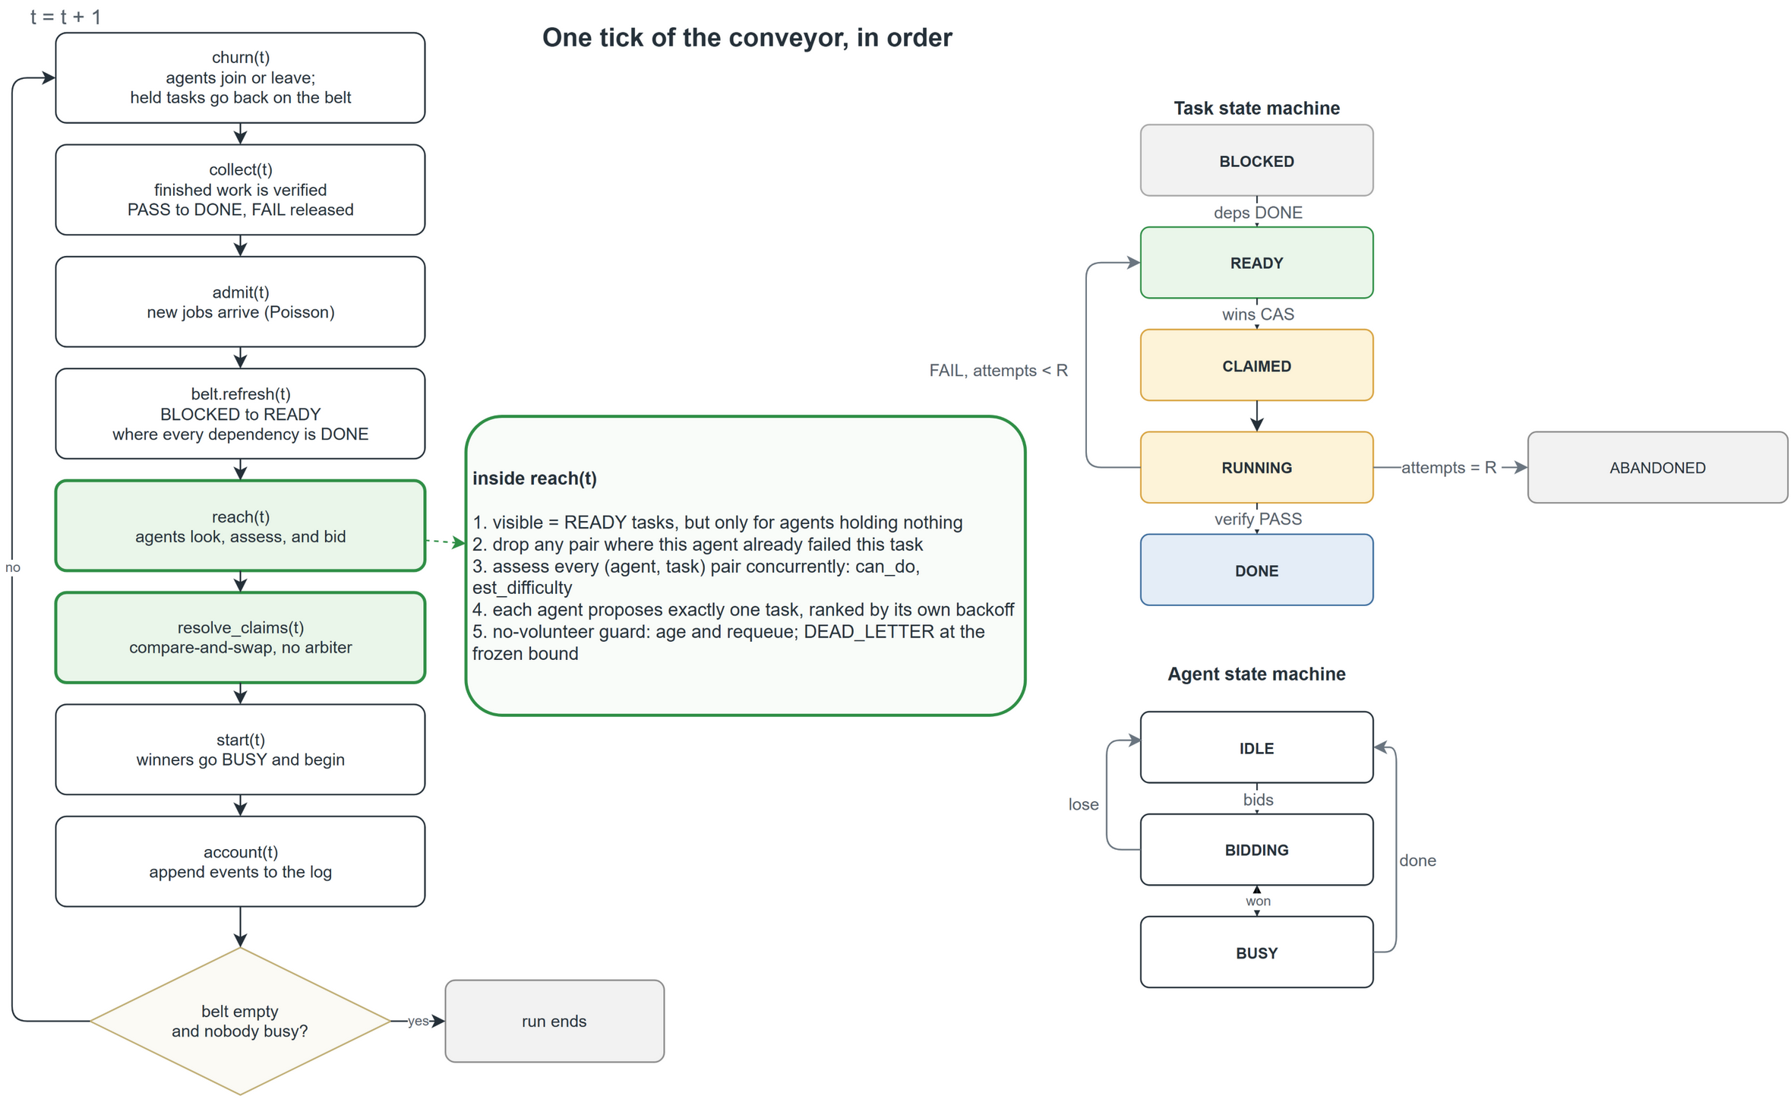
Fig. 5. One deterministic simulation tick, in execution order. The same tick skeleton is used by all policies; only the allocation-decision block changes. Editable source: page 'One tick of the conveyor, in order' in ConveyorFlow_diagrams_en_working.drawio.

V. METHODOLOGY

A. Public Workload Sources
Workload distributions were derived from UCI Adult (48,842 records) [14], UCI Beijing Multi-Site Air Quality (420,768 records) [15], and the CodeXGLUE Bugs2Fix small training corpus (46,680 buggy/fixed function pairs) [16]. Adult and Beijing instantiate seven-stage ML-build DAGs; Bugs2Fix instantiates five-stage reproduce–localize–repair–regression-test–report DAGs. Bugs2Fix pairs provide distributional characteristics only and are not represented as executable repository tests. Source URLs, licenses, byte counts, and SHA-256 hashes were frozen in the data manifest.

B. Operational Task Difficulty
Difficulty was operationalized over 304 stage-by-stratum specifications from 48 deterministic public-data-derived variants. Three blinded passes used the same underlying LLM under ML Methodologist, Software Reliability Reviewer, and Workflow/Resource Reviewer roles. Five rubric dimensions were scored 0–2; totals 0–3, 4–6, and 7–10 mapped to D1, D2, and D3. Pairwise exact agreement ranged from 0.770 to 0.829; quadratic-weighted kappa [20] ranged from 0.793 to 0.823; adjacent agreement was 1.000. Ninety-four non-unanimous items were separately adjudicated, yielding D1=52, D2=113, and D3=139. Seventeen decisions differed from mechanical consensus. The frozen label SHA-256 is 56207cd87a28ab221911c2bf07ee0cf6f8ec6547bab7880fc5ef268ad24b2add.
The passes are not independent human experts. Their agreement is evidence of same-model procedural stability only. The minimum subgroup kappa was 0.628 for one Beijing rater pair; lower and upper vote mappings, each changing 47 labels, were therefore retained as sensitivity bounds.

C. Ability and Team Compositions
Ability is represented by three behavioral ranks rather than model names. Ability Rank 1, 2, and 3 (AR1–AR3) use theta=-1, 0, and +1 in logit[P(pass)] = alpha_w + 0.85theta - 1.2(d-2), with alpha_Adult=0.88 and alpha_Beijing=alpha_Bugs2Fix=0.86. H0=(2,2,2,2), H1=(1,2,2,3), and H2=(1,1,3,3) all have four agents and mean rank 2, but variances 0, 0.5, and 1. These boundary compositions isolate capability variance. AR1x4 is used only as a fallback stress team.

D. Controls, Ablations, and Resource Regimes
Static controls are fixed skill ownership (S1), precomputed difficulty-level routing (S2), and precomputed round robin (S3). Central-Fit uses comparable assessment and fit inputs but globally matches free agents and tasks. Ablations remove assessment (A1), fit (A2), stand-down (A3), or aging (A4). R0 equalizes speed, token, and price factors. R1 associates AR1/AR2/AR3 with speed 0.90/1.00/1.15, token factor 0.80/1.00/1.30, and price factor 0.50/1.00/3.00. Reversed and permuted mappings test resource confounding.

TABLE I. CONFIRMATORY EXPERIMENT DESIGN
Block | Policies / factors | Team | Load | Resource | Memberships
RQ1 | CF-Fit, S1–S3, Central-Fit | H1 | low/med/high | R0/R1 | 4,500
RQ2 | CF-Fit; H0/H1/H2 | controlled mean | low/med/high | R0/R1 | 2,700
RQ3 | Full, A1–A4 | H1/H2 | med/high | R0/R1 | 6,000
E4 | F0–F3; mixed/D3-heavy | AR1x4/H1 | med/high | R0/R1 | 9,600
Sensitivity | resource + label mappings | H1 | med/high | specified | 2,400
Membership totals overlap where one run satisfies multiple scopes; the frozen design contains 22,500 unique runs.

E. Experimental Unit and Statistics
The experimental unit is a complete run/seed within a matched workload–load–team–resource cell. Tasks within a run are not independent replicates. All policies in a matched cell share arrivals, task attributes, and keyed potential outcomes. Main inference uses 50 paired seeds (1000–1049), seed-cluster median effects, 10,000 paired bootstrap resamples with analysis seed 20260922, Wilcoxon signed-rank tests, and Holm correction within each question and metric family [17]–[19]. Zero-success runs remain infeasible rather than being replaced by zero; dead-letter and unsettled tasks are never dropped.
The execution completed 22,500 unique runs with 0 duplicate IDs and 0 zero-success runs. All 22,500 compressed event ledgers matched their recorded hashes, and the execution source hash matched the current simulation source. The pre-execution source archive SHA-256 was 91e2cec400769fce8cea53682ebfe0b67c93bdc2756b365ad0bf56a1c8995c25.
An infrastructure interruption after 9,654 runs was resumed from the exact checkpoint without changing seeds or configuration. Before execution completed and before comparative effects were computed, the analysis implementation was corrected to separate R0/R1 and add the interactions already required by the frozen plan. Engine, data, outcomes, margins, and exclusions were unchanged; both events are recorded in the protocol-deviation log.
After the confirmatory results were locked, two secondary descriptive analyses were added. Two-objective Pareto frontiers use the RQ1 descriptive medians without forming a weighted score. Competing-risk curves use task creation as time zero, VERIFIED and DEAD_LETTER as competing events, and UNSETTLED work as right-censored at the run horizon. Aalen-Johansen curves are estimated separately for each run and summarized across 450 runs per policy-resource cell; the percentile envelopes describe run heterogeneity and are not confidence intervals. These additions do not change the pre-specified estimands, tests, or multiplicity families.

F. Simulation Execution and Outcome Construction
Every paired policy run uses the same fixed observation horizon H, arrival schedule, task attributes, churn schedule, and keyed potential outcomes. A task is offered once its job is admitted and its dependencies permit release. At each tick the engine executes the ordered sequence shown in Fig. 5, then appends state transitions and resource accounts to a compressed event ledger. The simulation never reads a reported metric from mutable live state: outcomes are reconstructed after the run from the ledger. Runs stop at the common horizon; verified work, DEAD_LETTER work, and nonterminal UNSETTLED work are all retained. This prevents one policy from receiving extra drain time and prevents unresolved work from silently disappearing.
Task completion rate is the number of verified tasks divided by all offered tasks; dead-letter and unsettled rates use the same denominator. Verified throughput is verified tasks divided by H. Productive utilization is productive busy ticks divided by H times the number of available agents. Terminal flow time is measured from task creation to either verified completion or terminal failure, and the reported tail statistic is its run-level 95th percentile. Total cost includes all recorded assessment, execution, verification, and retry charges. Cost per verified task divides that total by the verified count; a zero-success run is retained as infeasible rather than assigned a zero cost. These definitions make cost interpretable only together with completion and terminal disposition.

G. Real-LLM Execution and Validation Protocol
The Real-LLM tier freezes 60 executable cases: 20 Adult-derived ML cases, 20 Beijing-derived ML cases, and 20 Bugs2Fix-derived repair cases. The selected three-agent team is evaluated under CF-Fit, Static S3, and Central-Fit with ten paired seeds and the same case bundles, eligibility rules, retry limits, and deterministic validators. Each agent holds at most one task, but different agents issue provider calls concurrently without a global round barrier. A successful API response counts as verified only when its task-specific validator passes; pass=false is therefore a functional validation failure, not automatically a provider failure. Provider failures that exhaust the frozen retry rule invalidate the policy run instead of being relabeled as task-quality failures.
For each valid run, completion is verified cases divided by 60, cost is computed from recorded input/output tokens and the frozen observed price metadata, cost per verified task divides total cost by verified cases, throughput divides verified cases by monotonic wall-clock duration, and utilization divides summed agent busy seconds by wall time times three agents. Main comparisons are seed-paired and Holm-adjusted across the prespecified metric family. The extension retains all ten runs per condition for completion and cost. Timing uses the frozen provider-gap rule: timing-valid sample sizes are 10/10/8/9 for HET_FULL, HET_NO_STANDDOWN, HOM_GLM_GENERALIST, and HOM_GPT_PROFILE, respectively; cross-window timing contrasts are exploratory because provider load was not randomized across windows.

VI. RESULTS

A. RQ1: Allocation Trade-Offs
Table II reports CF-Fit minus each control separately for R0 and R1. Percent effects are relative to the comparator median; an asterisk marks Holm-adjusted p<0.05. The non-inferiority columns must be read jointly with cost and speed: a cheaper outcome is not treated as preferable when its completion or terminal-failure constraint is violated.

TABLE II. CF-FIT MINUS COMPARATOR: PAIRED MEDIAN EFFECTS AND NON-INFERIORITY
Regime | Comparator | Cost | Throughput | P95 time | Completion NI | Dead NI | Unsettled NI
R0 | S1 | +5.8%* | +42.0%* | -77.9%* | Yes | No | Yes
R0 | S2 | +52.3%* | +25.8%* | -83.1%* | Yes | No | Yes
R0 | S3 | +4.7%* | +9.4%* | -67.9%* | Yes | No | Yes
R0 | CENTRAL_FIT | +0.1% | -1.1%* | -0.6% | Yes | Yes | Yes
R1 | S1 | +52.4%* | +45.3%* | -77.3%* | Yes | No | Yes
R1 | S2 | +4.9%* | +22.8%* | -82.5%* | Yes | No | Yes
R1 | S3 | +8.8%* | +14.7%* | -74.2%* | Yes | No | Yes
R1 | CENTRAL_FIT | +0.5%* | -1.5%* | +0.0% | Yes | Yes | Yes
* Holm-adjusted p<0.05. Percent entries are paired median differences relative to the comparator median.

Across 8 prespecified resource-stratified contrasts, the left-hand mechanism had lower cost in 0/8 cases (0 Holm-significant), higher throughput in 6/8 (6 significant), and lower P95 terminal time in 7/8 (6 significant). Completion, dead-letter, and unsettled non-inferiority passed in 8/8, 2/8, and 8/8 contrasts, respectively.
Against the static controls, CF-Fit increased completion by 4.49–16.39 percentage points and reduced unsettled work by 26.15–57.39 points, but increased explicit dead letters by 17.50–35.84 points. The failed dead-letter margins therefore describe a disposition trade-off: static routing left substantial work unresolved at the horizon, whereas CF-Fit terminalized it. Against Central-Fit, completion was lower by only 0.50 points in R0 and 0.89 points in R1, dead letters were higher by 0.57 and 0.69 points, and all three non-inferiority constraints passed.
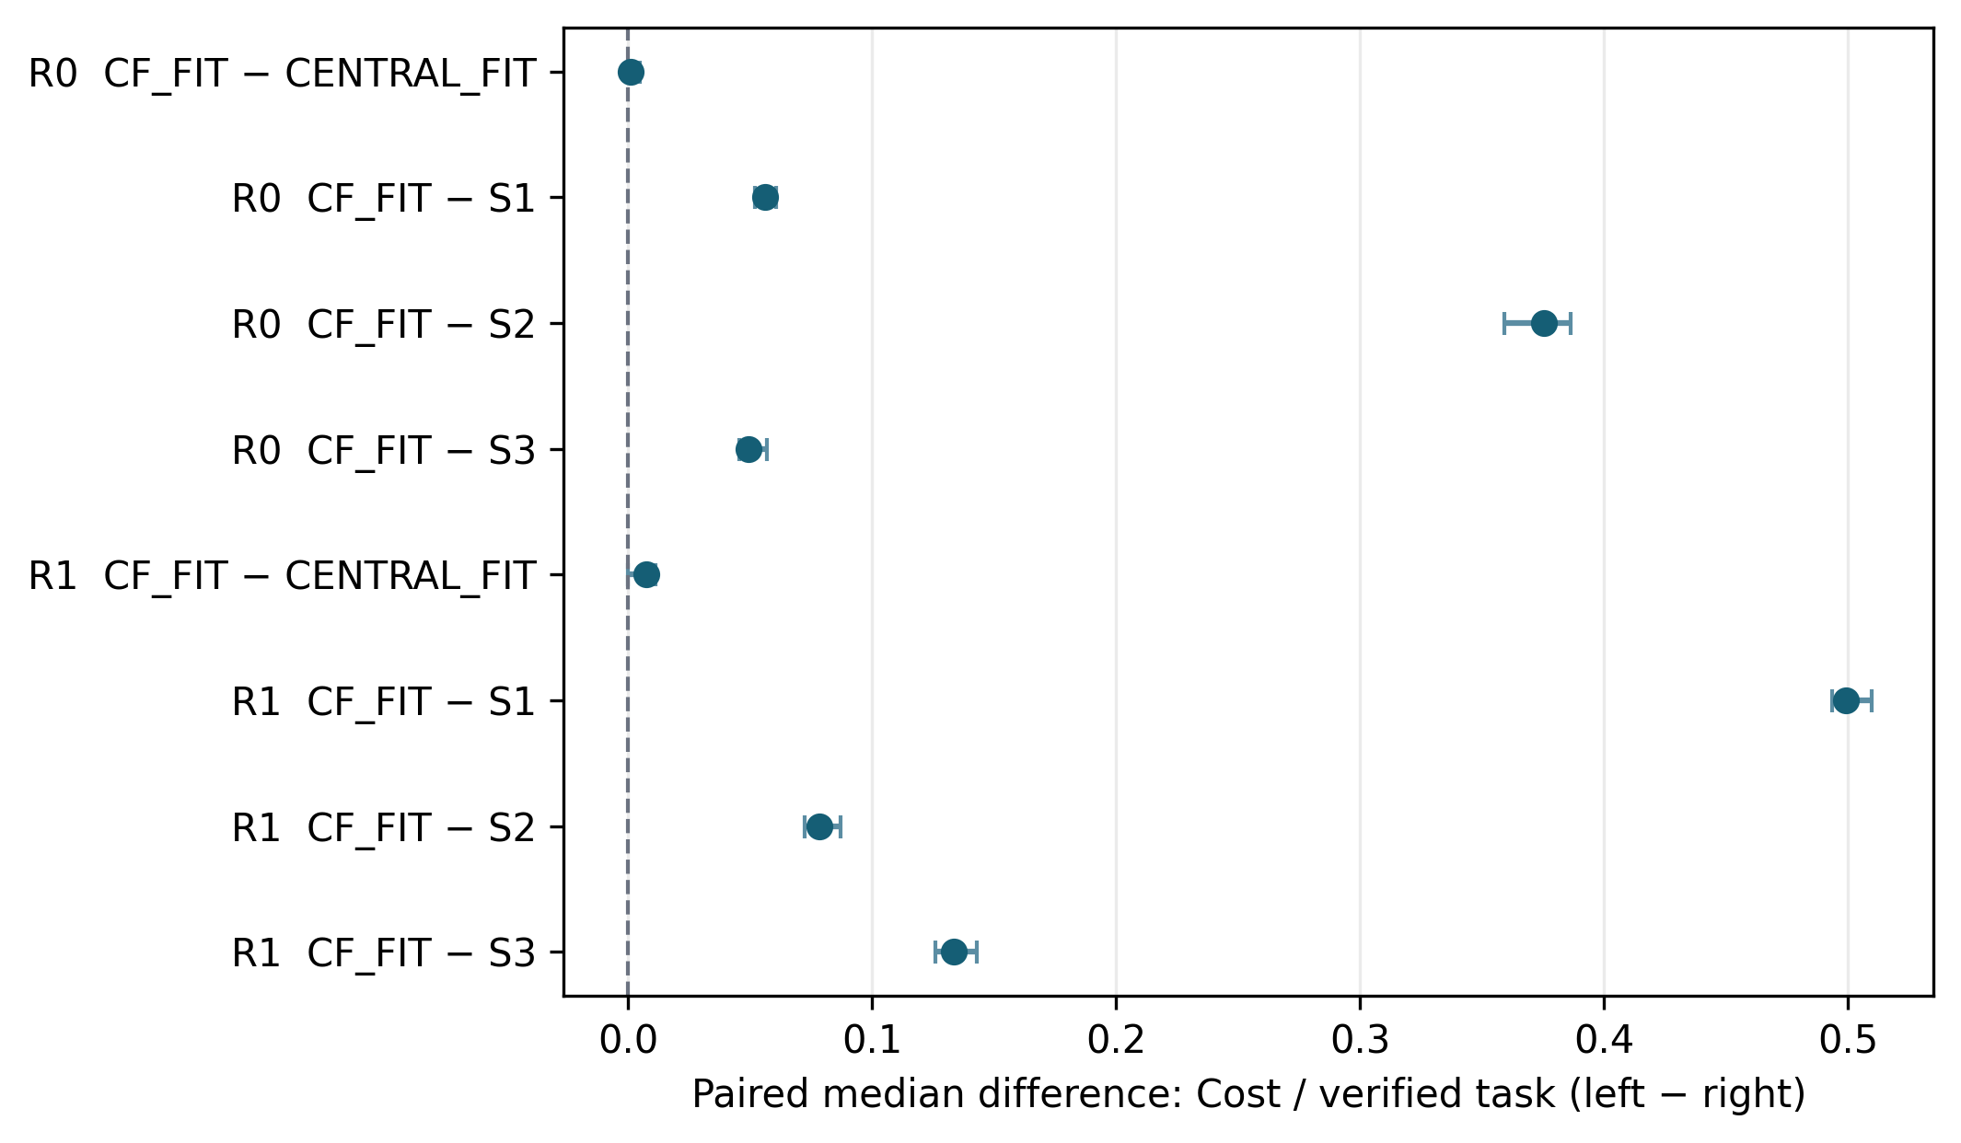
Fig. 6. RQ1 paired median cost differences with 95% seed-cluster bootstrap intervals. Negative values favor CF-Fit.

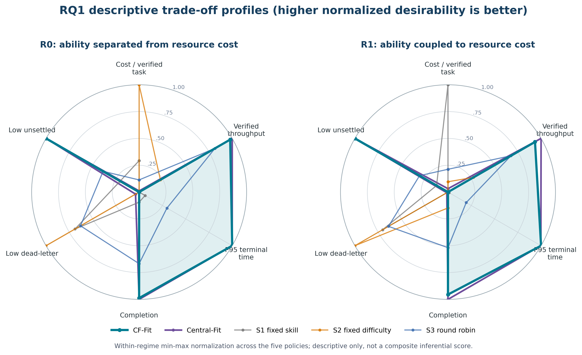
Fig. 7. RQ1 descriptive trade-off profiles. Each axis is min-max normalized within one resource regime so that higher is preferable; the chart is not a composite inferential score.

The radar chart is a visualization aid only. It shows why a single winner is inappropriate: CF-Fit and Central-Fit are similar on throughput, terminal time, completion, and unsettled work, whereas different static controls occupy the favorable cost or dead-letter extremes. All formal claims remain based on the prespecified metric-level contrasts and non-inferiority tests.

B. RQ2: Capability Heterogeneity
Table III changes capability variance without changing team size or mean level. H2-H0 is the prespecified linear boundary contrast; H1 comparisons reveal whether an effect emerges gradually or only at the extreme composition. R0 isolates capability variance, while R1 evaluates the same composition change when ability is correlated with speed, token use, and price.

TABLE III. CAPABILITY-HETEROGENEITY EFFECTS UNDER CF-FIT
Regime | Contrast | Cost | Throughput | P95 time | Completion delta | 95% CI (completion)
R0 | H1-H0 | -5.1%* | -0.5% | -63.0%* | -0.003 | [-0.004, 0.001]
R0 | H2-H0 | -5.2%* | -1.4%* | -64.3%* | -0.007* | [-0.009, -0.004]
R0 | H2-H1 | -0.2% | -1.5%* | -3.2%* | -0.009* | [-0.012, -0.005]
R1 | H1-H0 | +39.6%* | +2.3%* | -61.6%* | +0.011* | [0.007, 0.016]
R1 | H2-H0 | +81.8%* | +4.7%* | -63.1%* | +0.021* | [0.020, 0.024]
R1 | H2-H1 | +29.0%* | +1.4%* | -3.9%* | +0.007* | [0.005, 0.010]
* Holm-adjusted p<0.05. Percent entries are paired median differences relative to the comparator median.

Across 6 prespecified resource-stratified contrasts, the left-hand mechanism had lower cost in 3/6 cases (2 Holm-significant), higher throughput in 3/6 (3 significant), and lower P95 terminal time in 6/6 (6 significant). Because the direction is the more heterogeneous team minus the less heterogeneous team, signs must be interpreted by metric rather than as an overall heterogeneity benefit.
The large P95 reduction also has a competing-risk explanation: H0 retained a median unsettled fraction of 0.342, while H1 and H2 reached zero unsettled work and had higher explicit dead-letter fractions. Under R0, heterogeneity reduced cost by about 5% but slightly reduced throughput; under R1 it increased cost by 40–82% while improving throughput by 2–5%. Thus, the economic conclusion depends strongly on whether high capability is coupled to high price.
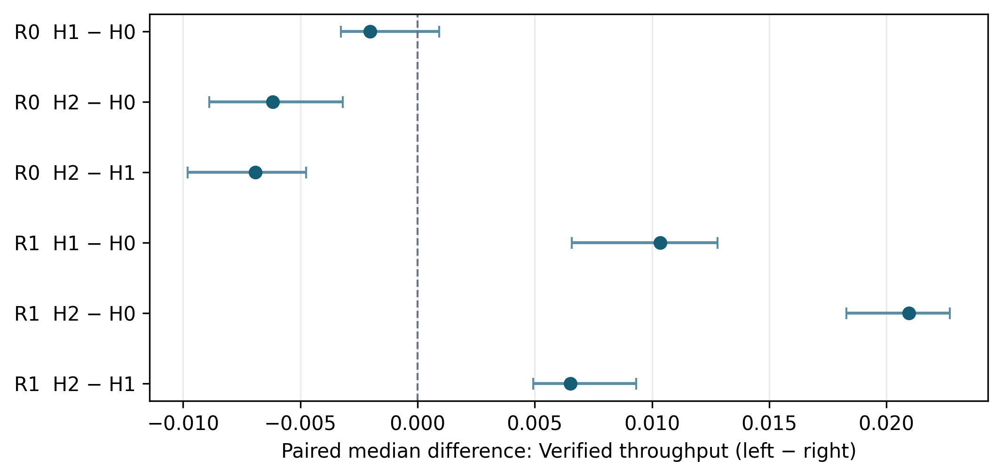
Fig. 8. RQ2 verified-throughput effects under controlled capability heterogeneity.

C. RQ3: Mechanism Contribution
Full-minus-ablation effects identify which component changes observed outcomes. A null or small A3 effect is retained and interpreted as evidence that stand-down is a bounded refinement rather than the sole source of ConveyorFlow behavior. Assessment, fit, and aging are evaluated independently rather than bundled into a single policy count.

TABLE IV. MECHANISM ABLATIONS; DIRECTION IS FULL MINUS ABLATION
Regime | Full-ablation | Cost | Throughput | P95 time | Completion delta | Cost 95% CI
R0 | A1 assessment | +6.7%* | +4.0%* | -65.9%* | +0.015* | [0.063, 0.072]
R0 | A2 fit | -3.7%* | +2.2%* | -11.9%* | +0.009* | [-0.045, -0.034]
R0 | A3 stand-down | +0.1% | +0.2% | +1.2%* | +0.001 | [-0.003, 0.004]
R0 | A4 aging | -8.1%* | +37.3%* | +77.1%* | +0.108* | [-0.103, -0.090]
R1 | A1 assessment | +4.6%* | +4.1%* | -64.4%* | +0.017* | [0.067, 0.085]
R1 | A2 fit | -3.5%* | +2.3%* | -11.8%* | +0.010* | [-0.074, -0.050]
R1 | A3 stand-down | +0.3% | -0.2% | +0.8%* | -0.001 | [-0.001, 0.010]
R1 | A4 aging | -15.0%* | +33.0%* | +85.5%* | +0.104* | [-0.315, -0.271]
* Holm-adjusted p<0.05. Percent entries are paired median differences relative to the comparator median.

Across 8 prespecified resource-stratified contrasts, the left-hand mechanism had lower cost in 4/8 cases (4 Holm-significant), higher throughput in 7/8 (6 significant), and lower P95 terminal time in 4/8 (4 significant). Here, a favorable Full-minus-ablation sign is evidence that the removed component improves that metric; an unfavorable or null sign limits that component claim.
Assessment increased cost by 4.6–6.7% but increased throughput and completion while converting approximately 35–37 points of horizon backlog into terminal outcomes. Fit reduced cost by 3.5–3.7%, raised throughput by about 2.2%, and reduced P95 time by about 12%, although it also shifted some unsettled work to dead letters. Aging produced the clearest completion effect (+10.4–10.8 points) and reduced dead letters by about 12.4 points, at the cost of 77–86% longer P95 terminal time. Stand-down changed cost, throughput, and completion only trivially and slightly worsened P95 time; it is therefore supported only as a bounded refinement, not as the primary mechanism.
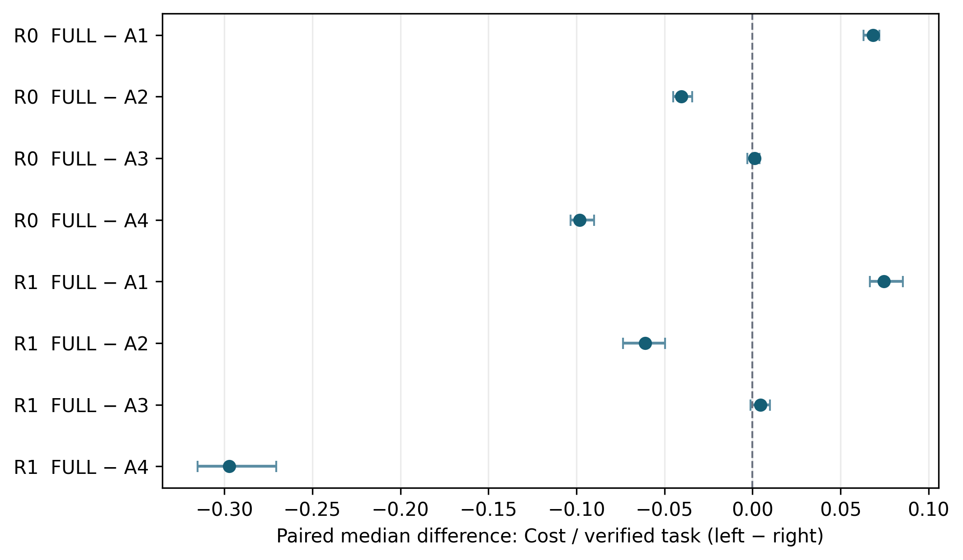
Fig. 9. RQ3 cost effects. Direction is full CF-Fit minus each ablation.

D. E4: No-Volunteer Fallback
The fallback analysis combines mixed and D3-heavy task profiles and includes both H1 and the AR1x4 stress team. Terminal time is interpreted together with dead-letter and unsettled fractions to avoid survivorship bias. F3 uses a central rescue decision and therefore cannot be used as evidence for a purely decentralized ConveyorFlow mechanism.

TABLE V. DEFAULT F2 FALLBACK MINUS ALTERNATIVES
Regime | Contrast | Cost | Throughput | P95 time | Dead-letter delta | Unsettled delta
R0 | F2-F0 | -23.9%* | +61.6%* | +73.5%* | -0.113* | +0.000
R0 | F2-F1 | -23.6%* | +61.7%* | +74.0%* | -0.113* | +0.000
R0 | F2-F3 | -0.0% | -5.7%* | +9.6%* | +0.017* | +0.000
R1 | F2-F0 | -34.5%* | +56.0%* | +79.5%* | -0.111* | +0.000
R1 | F2-F1 | -34.5%* | +56.5%* | +81.0%* | -0.112* | +0.000
R1 | F2-F3 | +1.6%* | -3.7%* | +12.2%* | +0.011* | +0.000
* Holm-adjusted p<0.05. Percent entries are paired median differences relative to the comparator median.

Across 6 prespecified resource-stratified contrasts, the left-hand mechanism had lower cost in 5/6 cases (4 Holm-significant), higher throughput in 4/6 (4 significant), and lower P95 terminal time in 0/6 (0 significant). The direction is default F2 minus the alternative; therefore the F3 comparison quantifies a decentralization trade-off rather than a like-for-like ConveyorFlow policy change.
Relative to F0/F1, F2 spent longer on terminal disposition but substantially lowered cost and dead-letter fractions while increasing verified throughput. Relative to the hybrid F3 rescue, F2 had similar cost but 3.7–5.7% lower throughput, 9.6–12.2% longer P95 time, and 1.1–1.7 points more dead letters. This is the measured price of retaining decentralized no-volunteer handling in the tested stress conditions.
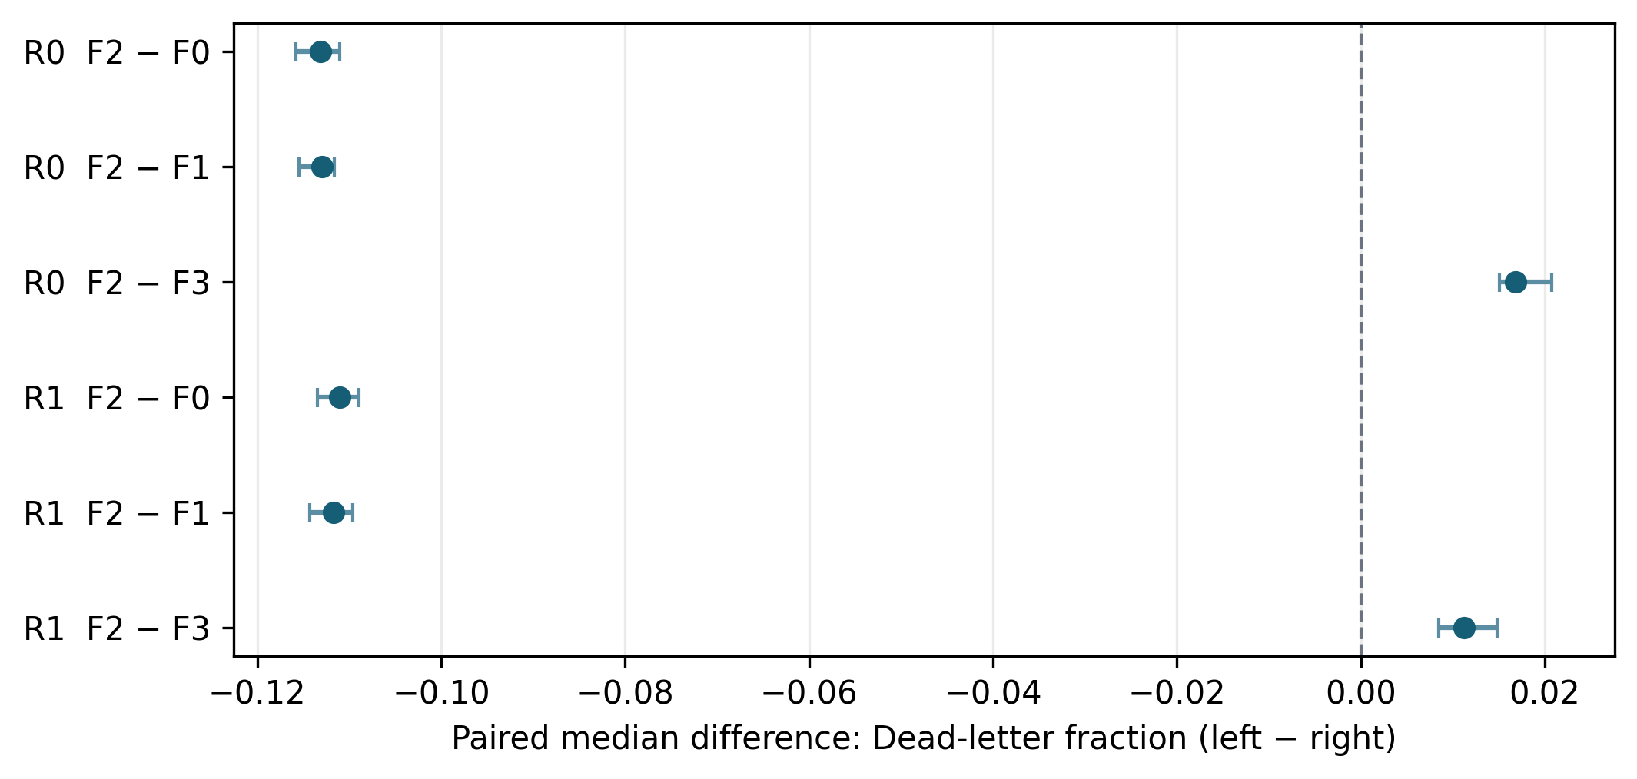
Fig. 10. F2-minus-alternative dead-letter effects under no-volunteer stress.

E. Robustness
Resource-mapping effects were recomputed under reversed and permuted R1 assignments; 10/14 metric-level effects were Holm-significant. Annotation sensitivity reran CF-Fit, S2, and Central-Fit with lower and upper role-vote mappings on medium/high R0 cells; 11/14 absolute-performance effects were Holm-significant. In a transparently labeled secondary derived summary, the CF-Fit-versus-S2 direction for cost (higher), throughput (higher), and P95 time (lower) was stable across all three mappings=True; CF-Fit-versus-Central-Fit cost was significant in 0/3 mappings. The pre-specified policy-by-load, policy-by-workload, and policy-by-resource analysis identified 217/308 Holm-significant difference-in-differences. These analyses test dependence on assumed resource coupling, difficulty boundaries, and context; they do not replace the adjudicated mapping in primary inference.

F. Secondary Pareto and Competing-Risk Views
The cost-throughput Pareto frontier contains Central-Fit, Static AR1-only, and Static round-robin in R0, and Central-Fit, Static AR3-only, and Static round-robin in R1. CF-Fit is not economically nondominated because Central-Fit has slightly lower cost and higher throughput in both regimes. In the time-completion space, Central-Fit alone is nondominated in R0, while CF-Fit joins Central-Fit in R1 by trading a 1.5-tick lower median P95 for a 0.86-point lower completion rate. This is descriptive support for the trade-off framing, not a new hypothesis test.

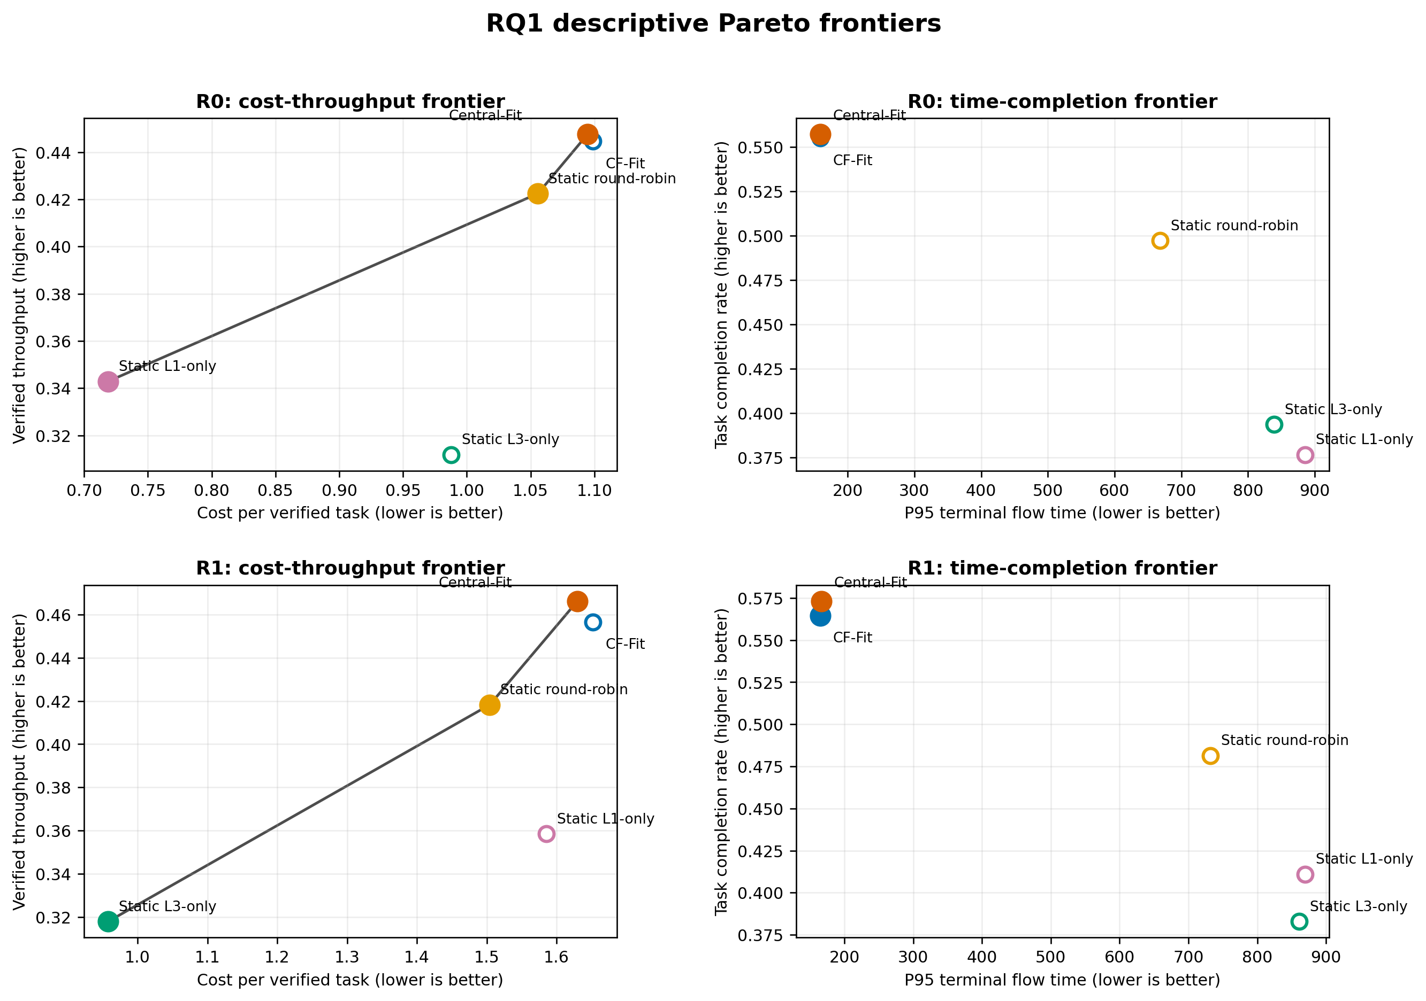
Fig. 11. RQ1 descriptive two-objective Pareto frontiers. Filled markers are nondominated within the displayed metric pair; no cross-metric weighting is applied.
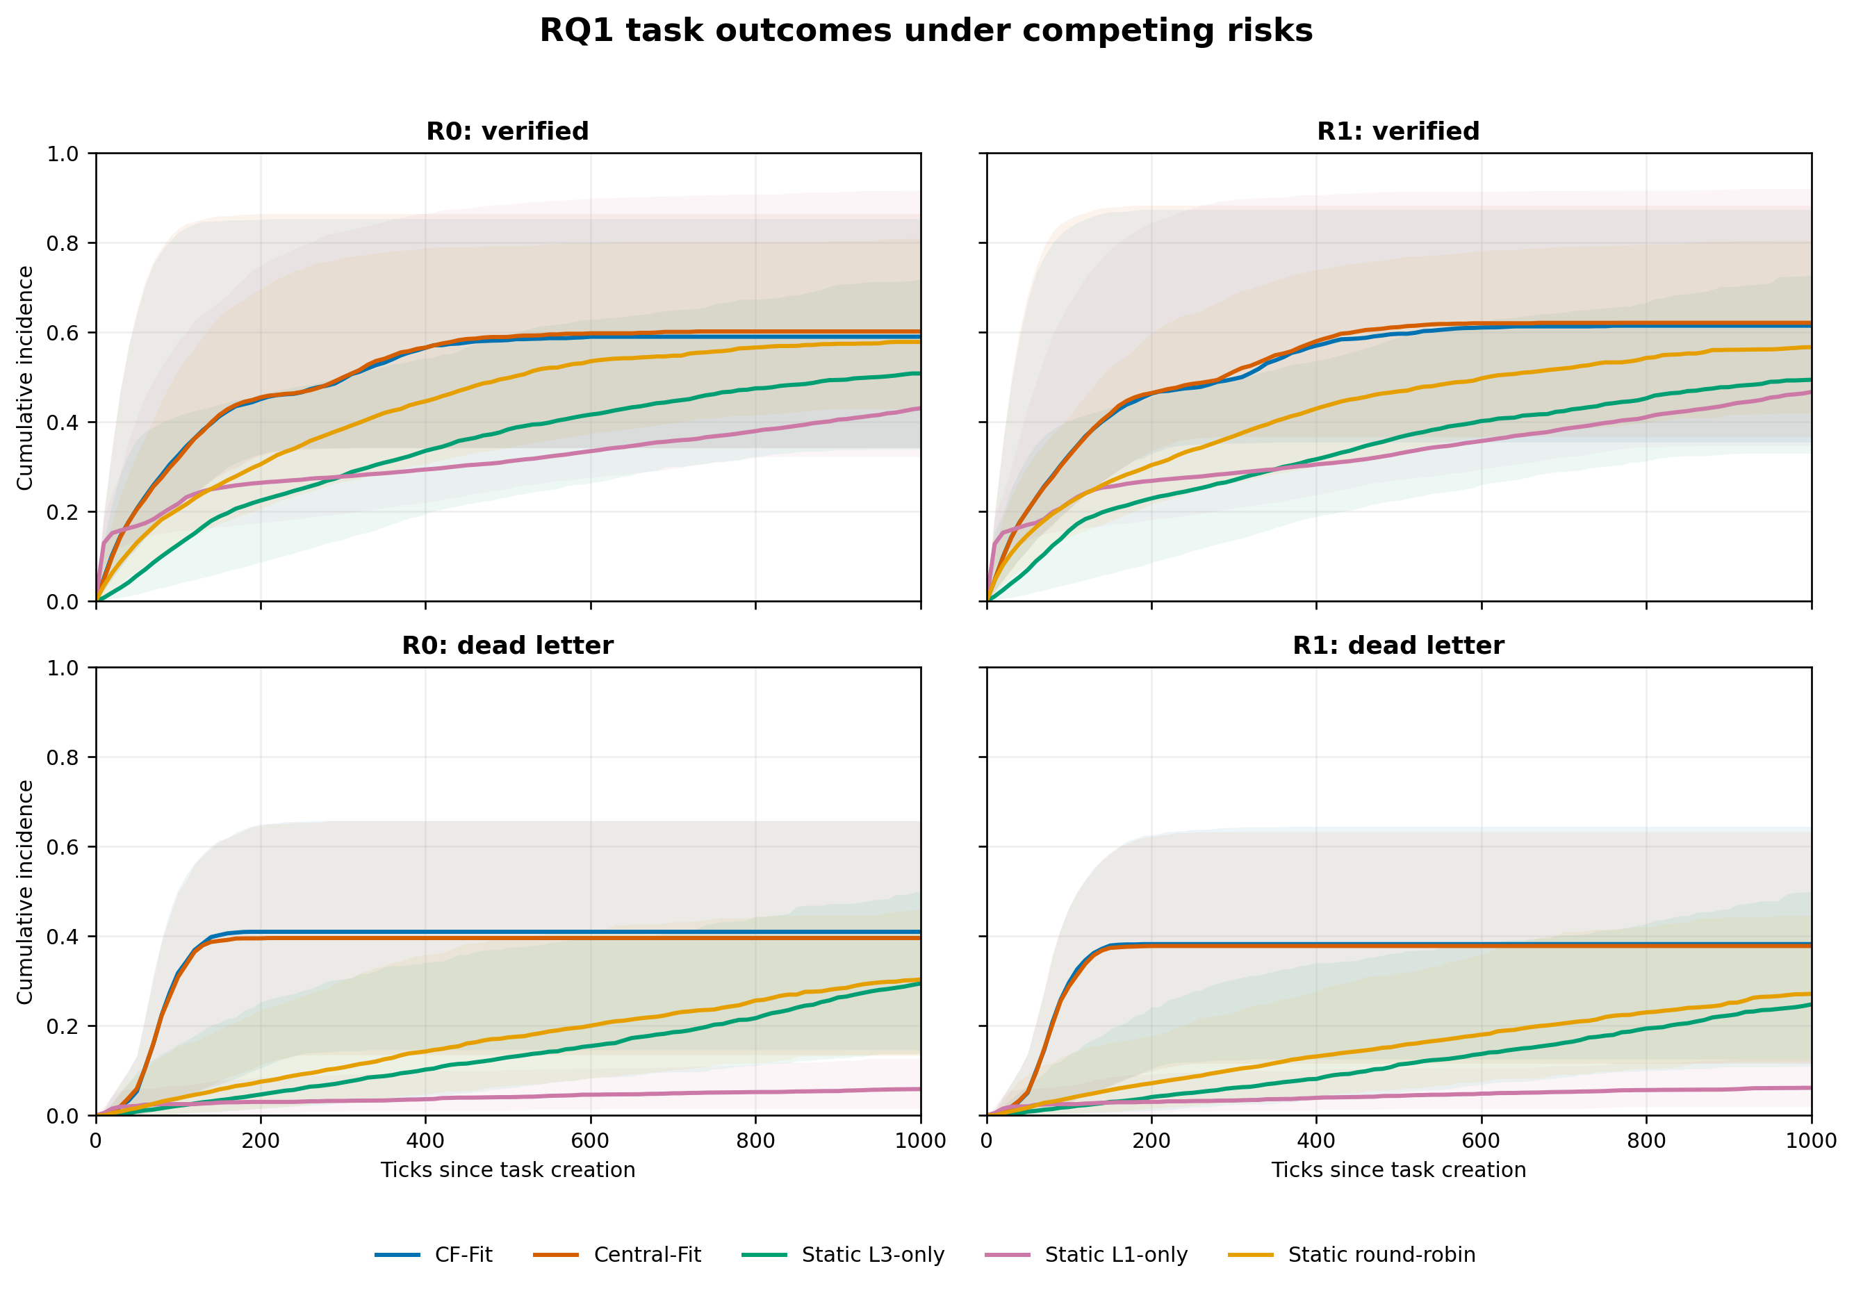
Fig. 12. Run-level Aalen-Johansen cumulative incidence for verified and dead-letter outcomes. Lines are medians across 450 runs; shading is the 2.5th-97.5th percentile run envelope, not a confidence interval.

At 1,000 ticks, median verified cumulative incidence for CF-Fit versus Central-Fit was 0.590 versus 0.602 in R0 and 0.615 versus 0.621 in R1; dead-letter incidence was 0.410 versus 0.396 and 0.382 versus 0.378, respectively. Static policies accumulated verified outcomes more slowly and retained more right-censored work. The curves therefore reinforce the primary result: CF-Fit closely tracks the matched centralized controller, while terminal-time summaries alone can favor policies that leave work unresolved.

G. Pre-Main Real-LLM Ability Calibration
A separate pre-Main calibration called MFEC deployment aliases on 30 held-out probes per screened model. It did not execute or compare allocation policies. Ability was assigned separately by workload using predeclared Wilson lower-95% gates under a common 4,096 completion-token budget; model name, price, latency, and token use were excluded from rank assignment. A stopping rule selected a three-agent profile-heterogeneous team before any Real-LLM policy run: Tencent HY3 (ML Rank 3/Fix Rank 1), GPT-5 mini (ML Rank 2/Fix Rank 3), and GLM 5.3 Flash (ML Rank 3/Fix Rank 3). These are operational ranks of dated MFEC aliases, not universal model-family rankings.
MFEC alias | ML Build | Fix Bug | Operational role
tencent-hy3 | Rank 3 | Rank 1 | ML specialist / basic repair
gpt-5-mini | Rank 2 | Rank 3 | Intermediate ML / advanced repair
glm-5.3-flash | Rank 3 | Rank 3 | Advanced generalist

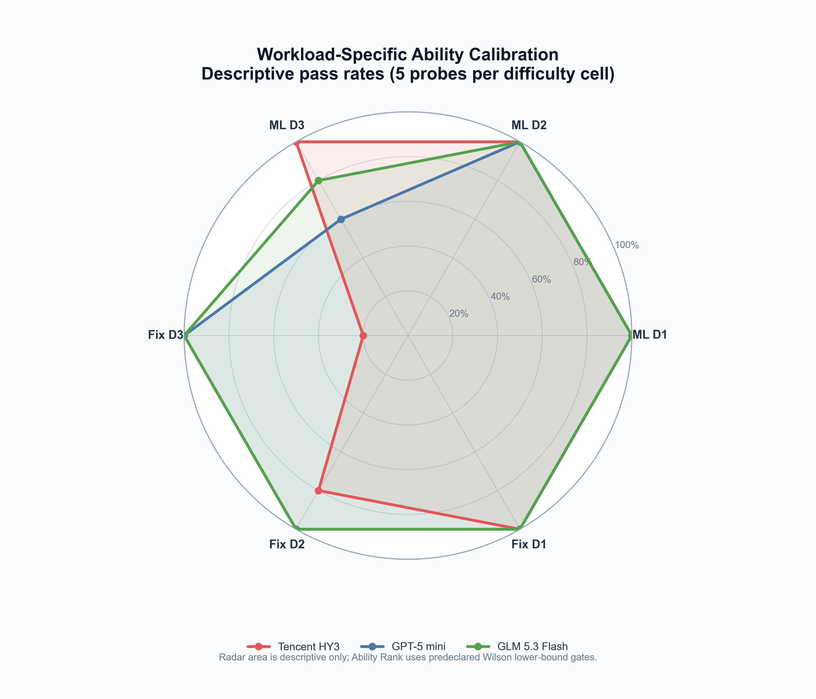
Fig. 13. Descriptive pass-rate profiles used for pre-Main team selection. Radar area is not an inferential composite score; ordinal ranks use the prespecified confidence-bound gates.

Calibration instrument corrections are fully logged: non-executable exact-match repair was replaced by hidden executable tests; an unintended 1,024-token adapter cap was corrected by rerunning only length-terminated cells at the frozen 4,096-token setting; and safe-parser false rejections were revalidated offline. Original and corrected ledgers were retained. The 60 executable bundles, deployment hashes, provider-reported cost accounting, and reviewed allocation engine were frozen before policy execution.

H. Supplementary Real-LLM Allocation Validation
The Real-LLM study used the selected three-agent team, 60 executable cases, deterministic validators, and ten paired seeds. Each atomic-claim winner was executed once at a time per agent, while independent agents ran concurrently without a round barrier. Provider failures after the frozen retry limit invalidated a policy run rather than being counted as task-quality failures. This study is a supplementary validation with ten paired seeds; the 22,500-run simulation remains the confirmatory causal analysis.

TABLE VI. REAL-LLM DESCRIPTIVE OUTCOMES ACROSS TEN PAIRED SEEDS
Condition | N (primary/timing) | Completion | Cost / verified | Wall time (s) | Throughput / s | Utilization
CF-Fit | 10/10 | 41.17% | $0.005095 | 284.58 | 0.08855 | 89.88%
Static round robin | 10/10 | 54.67% | $0.003143 | 750.85 | 0.04440 | 54.95%
Central-Fit | 10/10 | 41.83% | $0.004972 | 283.00 | 0.08966 | 95.22%

Across ten paired seeds, CF-Fit completed 41.17% of cases with mean wall time 284.58 s, verified throughput 0.08855 tasks/s, utilization 89.88%, and cost per verified task $0.005095. Static S3 completed 54.67% at 0.04440 tasks/s and $0.003143 per verified task. Central-Fit completed 41.83% at 0.08966 tasks/s and $0.004972 per verified task. These descriptive levels establish the operational scale before paired inference.
Relative to static round robin, CF-Fit changed completion by -13.50 percentage points and cost per verified task by +62.08%, while wall time changed by -62.10%, throughput by +99.45%, and utilization by +63.57%. All six prespecified metric-level comparisons were Holm-significant (adjusted p=0.005859). This is a speed-utilization versus completion-cost trade-off, not Pareto superiority.
CF-Fit and Central-Fit were descriptively close under the selected team, and none of the six paired comparisons reached Holm-adjusted p<0.05 (minimum adjusted p=0.105469). This result does not establish equivalence; it states only that the ten-seed supplementary study detected no difference at the prespecified threshold.

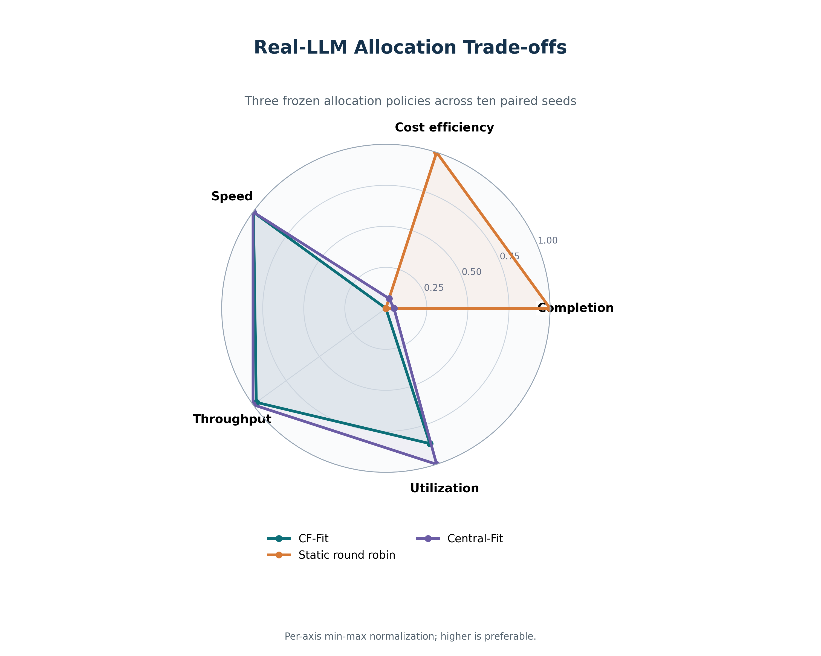
Fig. 14. Descriptive Real-LLM policy profiles. Each axis is min-max normalized within the three policies so that higher is preferable; the radar is not an inferential composite score.

I. Real-LLM Stand-Down and Team-Composition Extension
A separately frozen extension added one single-component ablation and two homogeneous boundary conditions. HET_NO_STANDDOWN retained decentralized self-selection, eligibility, fit scoring, aging, retry, and requeue while removing only stand-down. HOM_GLM_GENERALIST replicated the calibrated GLM Rank-3/Rank-3 deployment across three slots; HOM_GPT_PROFILE replicated the GPT ML-Rank-2/Fix-Rank-3 deployment. These homogeneous teams are ecological boundary conditions, not mean-ability-matched causal controls. Controlled mean-ability evidence for RQ2 therefore remains in the simulation.

TABLE VII. REAL-LLM ABLATION AND HOMOGENEOUS BOUNDARY OUTCOMES
Condition | N (primary/timing) | Completion | Cost / verified | Wall time (s) | Throughput / s | Utilization
Heterogeneous full CF-Fit | 10/10 | 41.17% | $0.005095 | 284.58 | 0.08855 | 89.88%
Heterogeneous without stand-down | 10/10 | 41.17% | $0.005159 | 303.64 | 0.08376 | 88.99%
Homogeneous GLM | 10/8 | 86.67% | $0.000889 | 701.93 | 0.08031 | 64.15%
Homogeneous GPT | 10/9 | 28.83% | $0.007305 | 127.33 | 0.13552 | 95.41%

For the primary extension outcomes, HET_FULL and HET_NO_STANDDOWN both completed 41.17% of cases; their mean costs per verified task were $0.005095 and $0.005159, respectively. HOM_GLM_GENERALIST completed 86.67% at $0.000889 per verified task, whereas HOM_GPT_PROFILE completed 28.83% at $0.007305. The opposite homogeneous outcomes demonstrate model-specific boundary behavior; they do not identify a causal effect of team homogeneity.
Removing stand-down changed completion by -0.00 percentage points and cost per verified task by +1.25%. The cross-window wall time, throughput, and utilization changes were +6.70%, -5.40%, and -0.98%, respectively. After Holm correction, significant outcomes were: none of the reported outcomes.
The homogeneous GLM boundary changed completion by +45.50 percentage points and cost per verified task by -82.55%. The cross-window wall time, throughput, and utilization changes were +144.45%, -9.83%, and -28.43%, respectively. After Holm correction, significant outcomes were: completion, cost per verified task, wall time, utilization.
The homogeneous GPT boundary changed completion by -12.33 percentage points and cost per verified task by +43.39%. The cross-window wall time, throughput, and utilization changes were -54.91%, +51.22%, and +5.78%, respectively. After Holm correction, significant outcomes were: completion, cost per verified task, wall time, throughput, utilization.
The extension ran after HET_FULL. Provider load and network conditions were therefore not randomized across execution windows. Completion, cost, and allocation-event contrasts are the main supplementary evidence and retain all ten paired seeds per condition. Wall time, throughput, and utilization comparisons are explicitly exploratory: timing-valid sample sizes were 10 for HET_FULL and HET_NO_STANDDOWN, 8 for HOM_GLM_GENERALIST, and 9 for HOM_GPT_PROFILE after applying the frozen provider-gap rule. The three timing exclusions remain included for completion and cost. A Windows path-length failure interrupted the first seed before a policy summary existed; the attempt was retained as infrastructure-invalid and rerun through a short temporary drive without changing any research parameter. A later user-requested pause interrupted GLM seed 3004 before summary creation; its partial ledger was retained and the seed was rerun from the beginning under a new timestamp with the same frozen parameters.

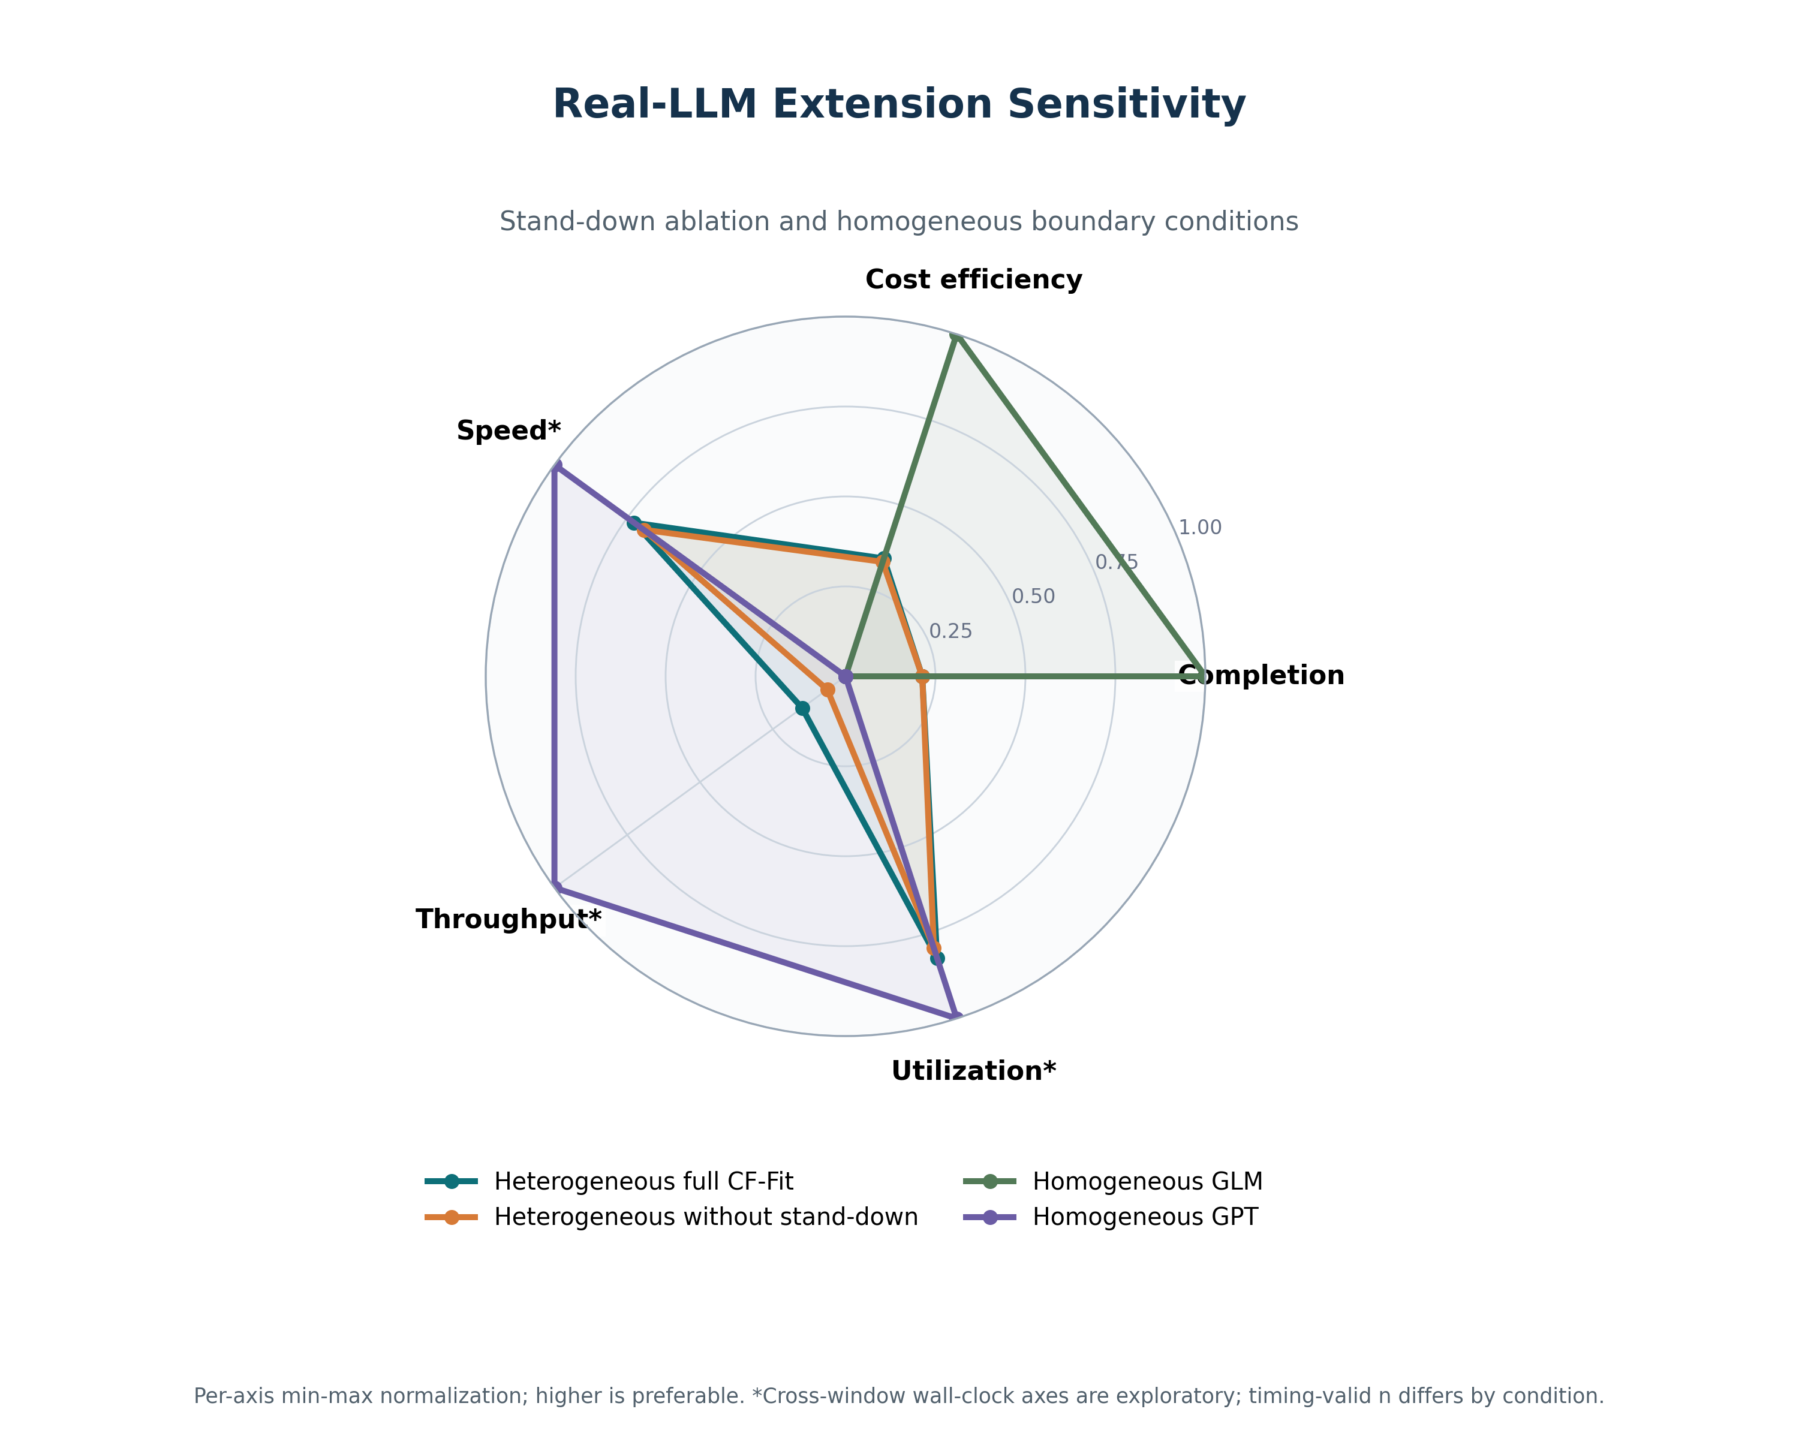
Fig. 15. Descriptive Real-LLM sensitivity profiles for the stand-down ablation and homogeneous boundary teams. Per-axis normalization is visual only; cross-window timing axes are exploratory.

VII. DISCUSSION
The results should be read as a Pareto-style trade-off map. ConveyorFlow is supported when local self-selection produces an operationally useful cost–throughput–time combination while respecting completion and terminal-failure margins; it need not dominate every centralized or static control on every axis. Resource-stratified reporting is essential because a mechanism that protects high-ability agents can have different economic consequences when capability is or is not expensive.
The heterogeneity experiment distinguishes diversity from average team strength. H0, H1, and H2 share the same mean latent ability; differences therefore arise from composition and task matching rather than simply adding a stronger team. The ablations further separate the contribution of noisy local assessment, fit ranking, temporary overqualification stand-down, and task aging.
Operationally, stand-down should not be presented as refusal. It is a decaying backoff term that reserves scarce capability early and disappears as waiting becomes urgent. Aging and bounded dead-letter behavior are therefore part of the mechanism’s safety story: they prevent an easy task from being postponed forever when the preferred lower-level agent is unavailable.
The live MFEC execution provides a complementary implementation check rather than replacing the controlled simulation. Relative to Static S3, CF-Fit completed fewer tasks and spent more per verified task, but finished the observed workload window faster with substantially higher verified throughput and utilization. Relative to Central-Fit, the ten paired seeds produced descriptively close results and no Holm-significant metric-level contrast; this is absence of detected difference, not evidence of equivalence. The extension tests whether the live pattern is sensitive to removing stand-down and to two ecologically plausible homogeneous deployments. Because homogeneous models change both capability profile and provider behavior, those conditions bound deployment behavior but do not isolate heterogeneity as cleanly as the mean-matched simulation compositions.
The secondary Pareto and competing-risk views sharpen, but do not broaden, that conclusion. They show why a single rank is unstable across objective pairs and why terminal latency must be interpreted with the probability of verification, dead letter, and censoring. Because these views were added after confirmatory inspection, they are evidence for interpretation and future preregistration rather than additional confirmatory claims.

VIII. THREATS TO VALIDITY
Construct validity is limited by simulated success, time, token, assessment, and cost functions. Ability ranks represent calibrated behavioral envelopes, not specific model versions. Public corpora shape workload distributions, but a simulation task is not equivalent to executing a real ML project or repository repair. CodeXGLUE pairs are non-executable in this study.
Difficulty labels were produced by three role-conditioned passes of one underlying LLM and one adjudication pass. This improves reproducibility but does not establish human-expert validity or rater independence. The Beijing subgroup kappa=0.628 signals a local reliability limitation; alternate mappings bound, but do not eliminate, this concern.
Internal validity is strengthened by frozen seeds, common random numbers, keyed potential outcomes, an immutable event ledger, source and artifact hashes, and no outcome-based exclusions. Nevertheless, the chosen logistic ability curve, load process, scan window, aging thresholds, retry limit, and four-agent cap can interact. External validity is limited to the tested architecture and ranges. The supplementary Real-LLM evidence uses 10 paired seeds, 60 task bundles, a single MFEC-compatible endpoint, and dated provider aliases rather than independently verified immutable model versions. Provider latency and load can drift, and the main and extension windows were not randomized together; cross-window timing contrasts are therefore exploratory. Homogeneous boundary teams also conflate capability composition with model-specific behavior. Human difficulty validation, additional providers and team sizes, and communication-failure sensitivity remain future work.
The live validators establish task-specific functional success for the selected ML-build and bug-fix bundles, but they do not cover every semantic, security, maintainability, or production-quality property. Ten seeds provide useful paired sensitivity evidence rather than definitive population estimates. One pre-summary extension attempt failed because of Windows path length, was retained as infrastructure-invalid, and was rerun after a path-only wrapper correction; no scientific parameter, seed, model, task, validator, or analysis rule was changed.
The competing-risk envelopes summarize between-run dispersion rather than sampling uncertainty, and right-censoring at the fixed simulation horizon assumes that unresolved work is not reclassified after observation ends. The Pareto frontiers depend on the two displayed objectives and would change under a different objective set. Both analyses are explicitly secondary.

IX. CONCLUSION
ConveyorFlow reframes heterogeneous LLM-agent allocation as decentralized capability-aware self-selection over a ready-task belt. Its scientific story joins local decision authority, capability heterogeneity, fit, temporary stand-down, and aging. A pre-specified simulation frozen before execution across 22,500 unique runs evaluates the resulting trade-offs against realistic static and centralized controls rather than claiming universal dominance. A completed, safety-locked Real-LLM study adds implementation-level evidence: it exposes a statistically clear speed-utilization versus completion-cost trade-off against static assignment, while the selected decentralized and centralized fit mechanisms were not distinguishable with ten paired seeds. The separately frozen stand-down and homogeneous-team extension supplies sensitivity and deployment-boundary evidence, not a replacement for the simulation’s controlled causal comparisons. Human validation of task difficulty remains separate and pending.

DATA AND CODE AVAILABILITY
The v2 research package contains source code, frozen configurations, public-data manifests, annotation packets and prompts, event-ledger hashes, analysis scripts, secondary-analysis outputs, the pre-execution source snapshot, and the vendor-neutral Real-LLM protocol and harness. The editable ConveyorFlow_diagrams_en_working.drawio source contains the system architecture, process architecture, CF-Fit belt, static baseline, and one-tick pages reproduced in Figures 1–5. Dated MFEC calibration and execution ledgers, team-selection evidence, immutable configuration and case hashes, validated main and extension run manifests, statistical summaries, figures, and the documented path-only extension deviation are included. Provider aliases and prices are recorded as observed configuration metadata and should not be interpreted as independently verified model lineage. Raw CodeXGLUE files remain subject to their upstream license. A public archival DOI should be added after advisor approval and repository release.

REFERENCES
[1] Q. Wu et al., “AutoGen: Enabling next-gen LLM applications via multi-agent conversation,” in Proc. COLM, 2024.
[2] S. Hong et al., “MetaGPT: Meta programming for a multi-agent collaborative framework,” in Proc. ICLR, 2024.
[3] C. Qian et al., “ChatDev: Communicative agents for software development,” in Proc. ACL, pp. 15174–15186, 2024, doi: 10.18653/v1/2024.acl-long.810.
[4] G. Li, H. Hammoud, H. Itani, D. Khizbullin, and B. Ghanem, “CAMEL: Communicative agents for ‘mind’ exploration of large language model society,” in Adv. Neural Inf. Process. Syst., vol. 36, 2023, doi: 10.52202/075280-2264.
[5] W. Chen et al., “AgentVerse: Facilitating multi-agent collaboration and exploring emergent behaviors,” in Proc. ICLR, 2024.
[6] T. Guo et al., “Large language model based multi-agents: A survey of progress and challenges,” in Proc. IJCAI, pp. 8048–8057, 2024, doi: 10.24963/ijcai.2024/890.
[7] R. G. Smith, “The contract net protocol: High-level communication and control in a distributed problem solver,” IEEE Trans. Comput., vol. C-29, no. 12, pp. 1104–1113, 1980, doi: 10.1109/TC.1980.1675516.
[8] B. P. Gerkey and M. J. Matarić, “A formal analysis and taxonomy of task allocation in multi-robot systems,” Int. J. Robot. Res., vol. 23, no. 9, pp. 939–954, 2004, doi: 10.1177/0278364904045564.
[9] G. A. Korsah, A. Stentz, and M. B. Dias, “A comprehensive taxonomy for multi-robot task allocation,” Int. J. Robot. Res., vol. 32, no. 12, pp. 1495–1512, 2013, doi: 10.1177/0278364913496484.
[10] H.-L. Choi, L. Brunet, and J. P. How, “Consensus-based decentralized auctions for robust task allocation,” IEEE Trans. Robot., vol. 25, no. 4, pp. 912–926, 2009, doi: 10.1109/TRO.2009.2022423.
[11] Y. Liu et al., “G-Eval: NLG evaluation using GPT-4 with better human alignment,” in Proc. EMNLP, pp. 2511–2522, 2023, doi: 10.18653/v1/2023.emnlp-main.153.
[12] C.-H. Chiang and H.-Y. Lee, “A closer look into using large language models for automatic evaluation,” in Findings EMNLP, pp. 8928–8942, 2023, doi: 10.18653/v1/2023.findings-emnlp.599.
[13] G. H. Chen, S. Chen, Z. Liu, F. Jiang, and B. Wang, “Humans or LLMs as the judge? A study on judgement bias,” in Proc. EMNLP, pp. 8301–8327, 2024, doi: 10.18653/v1/2024.emnlp-main.474.
[14] B. Becker and R. Kohavi, Adult [Dataset], UCI Machine Learning Repository, 1996, doi: 10.24432/C5XW20.
[15] S. Chen, Beijing Multi-Site Air Quality [Dataset], UCI Machine Learning Repository, 2017, doi: 10.24432/C5RK5G.
[16] S. Lu et al., “CodeXGLUE: A machine learning benchmark dataset for code understanding and generation,” arXiv:2102.04664, 2021.
[17] F. Wilcoxon, “Individual comparisons by ranking methods,” Biometrics Bull., vol. 1, no. 6, pp. 80–83, 1945.
[18] B. Efron, “Bootstrap methods: Another look at the jackknife,” Ann. Stat., vol. 7, no. 1, pp. 1–26, 1979.
[19] S. Holm, “A simple sequentially rejective multiple test procedure,” Scand. J. Stat., vol. 6, no. 2, pp. 65–70, 1979.
[20] J. Cohen, “Weighted kappa: Nominal scale agreement with provision for scaled disagreement or partial credit,” Psychol. Bull., vol. 70, no. 4, pp. 213–220, 1968.

