HR data: which contact centre site should get the retention budget?
Student tasks | Original TBS lesson for AQA A-level Business 7132 (exam cohorts of 2027, not the new 7138) | Section 3.6.2 Analysing human resource performance
Kestrel Contact Ltd runs a customer contact centre. Its staff answer phone calls from the customers of one client, an energy supplier, at two sites: Leeds and Plymouth. The client pays Kestrel for the calls it handles. The operations director has £150,000 to spend on a one-year staff retention scheme (mentoring for new staff and more predictable shift patterns), but only at ONE site. Your job is to use human resource data to recommend which site should get it.
Before you start you should know: you need a calculator. Labour turnover is about employees who leave. In "employee costs as percentage of turnover", turnover means sales revenue. This is original classroom practice, not an exam paper. Kestrel Contact and every figure are fictional; all figures are for the same 12 months.

Starter: which measure?
Which measure answers each question from the operations director? Choose from: labour turnover, labour productivity, employee costs as percentage of turnover, labour cost per unit.
Question from the operations director | Measure
(i) How many calls does each employee handle in a year?
(ii) What share of our employees left during the year?
(iii) How much do we spend on staff for each call we handle?
(iv) How much of the money we earn goes on paying our staff?

Task 1: calculate the four measures (pairs)
Work in pairs. Partner A calculates the four measures for Leeds and partner B for Plymouth. Then swap, check each other's working and complete both columns.
Data for the year | Leeds site | Plymouth site
Average number of employees | 200 | 120
Employees who left during the year | 70 | 12
Calls handled (output) | 1,800,000 | 840,000
Employee costs (pay, National Insurance and pensions) | £5,040,000 | £3,360,000
Turnover (sales revenue from the client contract) | £7,200,000 | £4,200,000

Labour turnover = employees who left during the year ÷ average number of employees × 100. Labour productivity = output (calls handled) ÷ number of employees. Employee costs as percentage of turnover = employee costs ÷ turnover × 100. Labour cost per unit = labour costs ÷ units of output; here the unit is one call and labour costs are the employee costs in the table. Give percentages to one decimal place and money to the nearest penny.
Measure | Leeds | Plymouth
Labour turnover (%)
Labour productivity (calls per employee)
Employee costs as percentage of turnover (%)
Labour cost per call (£)

Working space:

Task 2: what do the measures tell us? (pairs)
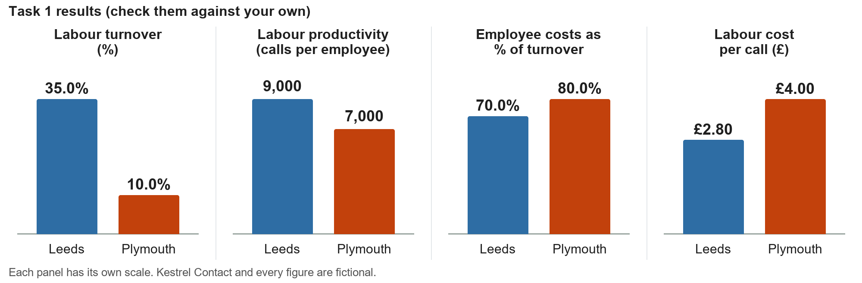
Discuss each question with your partner, then write your own answer.
a. Leeds has the higher labour turnover but the lower labour cost per call. Use the data to explain how both can be true. (Employee costs: Leeds £5,040,000 for 200 employees; Plymouth £3,360,000 for 120.)

b. The client says Leeds callers more often ring back because their problem was not solved the first time, and Plymouth handles longer, more complex billing complaints. Explain why the labour productivity figures may not show which site's staff work better.

c. Plymouth's employee costs are 80.0% of its turnover. What does this mean for the site?

Task 3: the hidden cost of labour turnover
Every leaver is replaced. Recruiting and training each new employee costs £3,000; this is NOT included in the employee costs in Task 1. The HR director forecasts that the £150,000 retention scheme would cut leavers at Leeds from 70 to 45 a year, OR at Plymouth from 12 to 8 a year. These are forecasts, not certain results.
Assume the average number of employees and the calls handled stay the same: Leeds 200 employees and 1,800,000 calls; Plymouth 120 employees and 840,000 calls. Employee costs: Leeds £5,040,000; Plymouth £3,360,000. Labour cost per call from Task 1: Leeds £2.80, Plymouth £4.00 (check them against your own).
Complete the table | Leeds | Plymouth
a. Cost of replacing this year's leavers (£)
b. Labour cost per call including replacement costs (£, nearest penny)
c. Labour turnover after the scheme (%, one decimal place)
d. Saving in replacement costs per year from the scheme (£)

Working space:

e. Stretch: how many fewer leavers a year would Leeds need for the saving in replacement costs alone to equal the £150,000 cost of the scheme? What would its labour turnover be then?

Task 4: sort the arguments (pairs)
Kestrel's managers made these points. With your partner, decide whether each point supports giving the retention budget to Leeds or to Plymouth. Write Leeds or Plymouth.
Point | Leeds or Plymouth?
1. Leeds loses 70 employees a year; Plymouth loses 12.
2. Replacing leavers costs Leeds £210,000 a year and Plymouth £36,000.
3. Leeds callers more often have to ring back because their problem was not solved the first time.
4. Plymouth's billing complaints need skills that take new employees months to learn.
5. The scheme is forecast to cut leavers by 25 a year at Leeds but only by 4 at Plymouth.
6. A new employer will recruit 300 staff near the Plymouth site next year.

b. Which point is the strongest argument for each site? Explain your choice in one sentence for each site.

Task 5: recommend
Key figures (check them against your own). The scheme costs £150,000 for one year.
Measure | Leeds | Plymouth
Labour turnover now | 35.0% | 10.0%
Labour turnover after the scheme (forecast) | 22.5% | 6.7%
Labour productivity (calls per employee) | 9,000 | 7,000
Employee costs as percentage of turnover | 70.0% | 80.0%
Labour cost per call (in brackets: including replacement costs) | £2.80 (£2.92) | £4.00 (£4.04)
Saving in replacement costs from the scheme | £75,000 | £12,000

Write about 100 words to the operations director recommending which site should get the £150,000 retention budget. Use at least three figures, give one argument for the other site and say what your recommendation depends on.

Exit ticket
a. A shop employs an average of 40 staff. During the year 6 staff left. Calculate its labour turnover.

b. A bakery's labour costs for the year are £84,000 and it makes 120,000 loaves. Calculate its labour cost per loaf.

c. Give one reason why a high labour turnover can raise a business's costs.

