Who really pays a tax on sugary drinks?
Student tasks | Original TBS lesson for A level Economics (Edexcel 9EC0 content, Theme 1, section 1.2.9 Indirect taxes and subsidies)
A government puts a specific tax of £0.60 per litre on drinks with added sugar, paid by producers. A newspaper says, "Drinks firms will pay this tax, not shoppers." Use the diagram to find out who really pays, how much the government collects and why.
Before you start you should know: a specific tax is a fixed amount per unit; it shifts the supply curve up by the amount of the tax. The incidence of a tax is how its burden is shared between consumers and producers. You need a calculator. This is original classroom practice, not an exam paper. The market and every figure are fictional.

The market for sugary drinks
 | Before the tax (E1) | After the tax (E2)
Price paid by consumers | £4.00 per litre | £4.40 per litre
Quantity (million litres a week) | 60 | 56
Tax per litre | £0 | £0.60

Starter: true or false?
Statement | True or false?
(i) A specific tax shifts the supply curve up by the amount of the tax
(ii) If producers pay the tax to the government, consumers cannot bear any of it
(iii) A subsidy shifts the supply curve down

Task 1: read the diagram
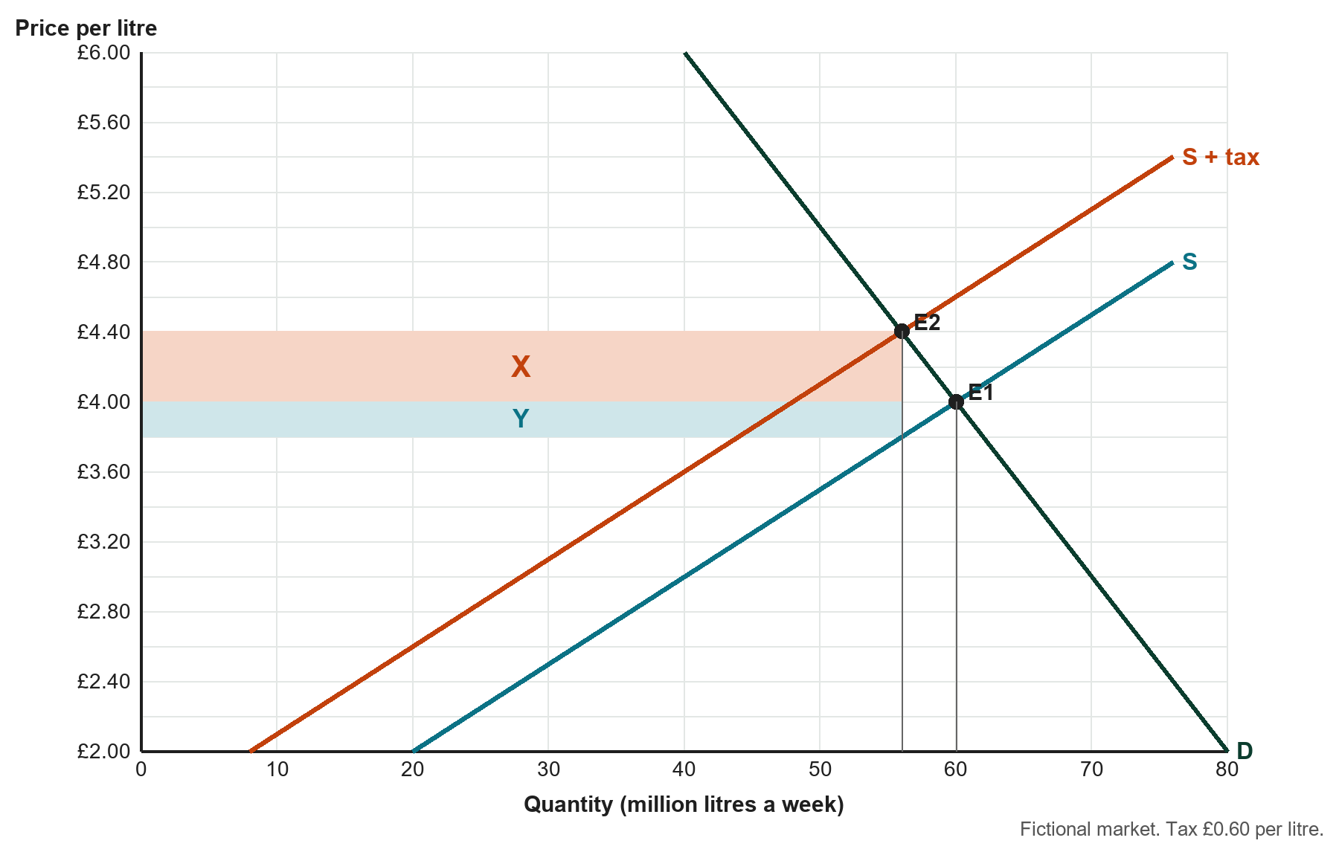
Before the tax the price was £4.00 and 60 million litres were sold; after the £0.60 tax consumers pay £4.40 and 56 million litres are sold.
a. What price per litre do producers keep after paying the tax? Show how you know.

b. How much of the £0.60 tax per litre is paid by consumers, and how much by producers? Give each as an amount and as a percentage of the tax.

Task 2: the areas on the diagram
Use the diagram on page 2 (tax £0.60; E1: £4.00 and 60 million litres; E2: £4.40 and 56 million litres; producers keep £3.80).
a. What do areas X and Y show? Calculate the value of each in £ million a week.

b. Calculate the total tax revenue the government receives each week.

c. Calculate producers' revenue before the tax (£4.00 x 60 million) and after the tax (the price they keep x 56 million). By how much has it changed?

Task 3: why do consumers pay more of it?
a. Calculate the price elasticity of demand between E1 and E2 (percentage change in quantity / percentage change in price, using E1 as the starting point).

b. Explain how this elasticity helps to explain why consumers bear most of the tax.

Task 4: the opposite of a tax
Imagine a market for low-sugar drinks with exactly the same demand and supply curves, where the government instead pays producers a subsidy of £0.30 per litre.
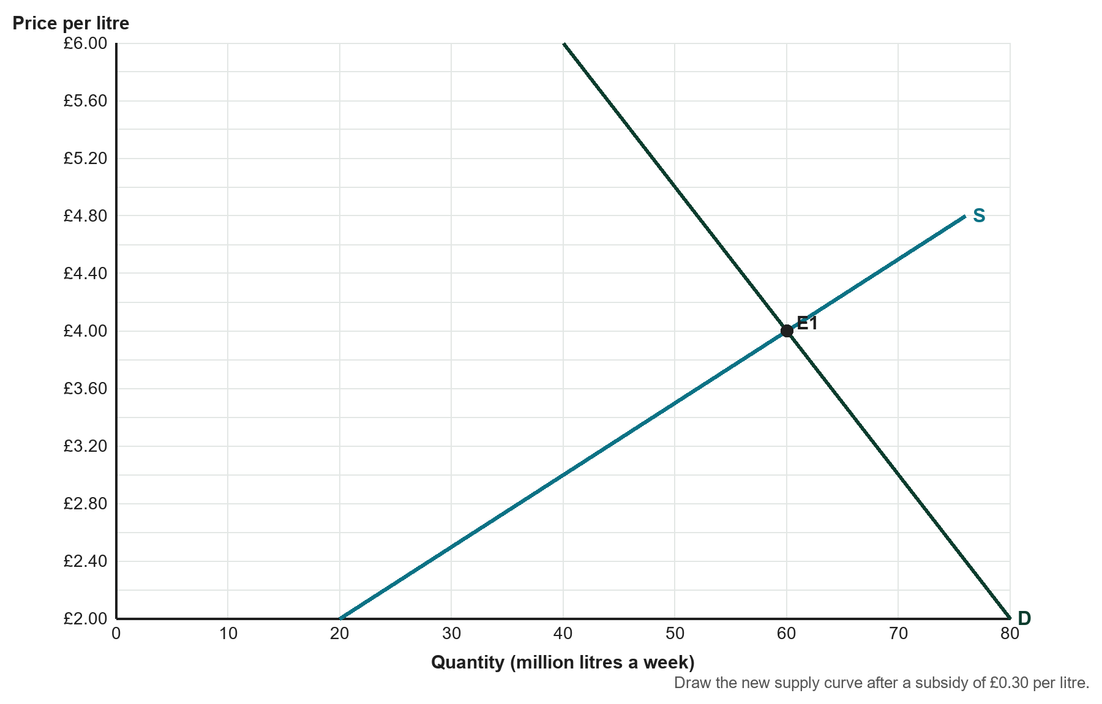
a. On the diagram, draw the new supply curve after the subsidy, label the new equilibrium E3 and shade the area that shows the total cost of the subsidy to the government.
b. The new equilibrium is £3.80 and 62 million litres. Calculate the cost of the subsidy to the government, and how much of the £0.30 per litre goes to consumers and to producers.

Task 5: judge the claim
"Drinks firms will pay this tax, not shoppers." Write about 100 words saying how far you agree. Use at least three figures from your answers and refer to price elasticity of demand.

Exit ticket
a. A tax of £1.00 per unit raises the price consumers pay from £5.00 to £5.70. What share of the tax do consumers bear?

b. If demand were perfectly price inelastic, who would bear the whole of a specific tax? Explain in one sentence.

