Sales forecasting: how many tubs for next summer?
Teacher guidance and answers | Original TBS classroom practice
Use this lesson after students have met moving averages and scatter graphs. Students calculate four-quarter centred moving averages for an ice cream maker, plot and extrapolate the trend, read a scatter graph of weekly sales against temperature, sort limitations in pairs and advise the owner how much to order for next summer. The tasks are planned to take about 55 minutes and have not been trialled in a classroom. The minutes include brief answer checking but not handing out materials or a full plenary; allow about 65 minutes in the timetable. For Year 13 classes studying Edexcel 9BS0 Theme 3 (exams 2027).

Curriculum fit
Pearson Edexcel Level 3 Advanced GCE in Business (9BS0), Specification Issue 1, September 2014, Theme 3, section 3.3.1 Quantitative sales forecasting (printed page 22): (a) calculation of time-series analysis: moving averages (three period/four quarter); (b) interpretation of scatter graphs and line of best fit – extrapolation of past data to future; (c) limitations of quantitative sales forecasting techniques. Task 4 also uses 2.2.1 Sales forecasting (printed page 15): consumer trends, economic variables and actions of competitors. Quantitative skills QS1, QS3, QS8 and QS9 (Appendix 3, printed page 51). Checked against the archived Issue 1 specification; please confirm the specification for your cohort with your exams officer. This is a TBS lesson, not a Pearson resource; it is not endorsed by Pearson and uses no Pearson exam questions or mark schemes.
Scope: the specification asks for calculation only of moving averages. Scatter graphs and lines of best fit are listed for interpretation, so students are not asked to calculate a line equation or a correlation coefficient, and the line of best fit on the scatter graph is drawn for them. Calculating seasonal variations is not listed, so Task 2c only compares one actual figure with its moving average. The specification does not say whether four-quarter moving averages are centred; this lesson centres them throughout.

Lesson plan (about 55 minutes of tasks, estimated)
Stage | Minutes | What happens
Starter: read the sales | 5 | Four quick questions on the table and chart.
Task 1: centred moving averages | 12 | Four-quarter moving totals, then centring.
Task 2: trend chart | 9 | Plot, draw a line of best fit, extrapolate.
Task 3: scatter graph | 8 | Weekly sales against temperature.
Task 4: pairs | 7 | Sort eight statements; agree the biggest limitation.
Task 5: decide | 10 | Written advice on the order.
Exit ticket | 4 | One limitation and a three-period moving average.
Total | 55

45-minute version: starter 3, Task 1 10, Task 2 7, Task 3 6, Task 4 6, Task 5 9, exit ticket 4. Skip Task 3c and ask for about 70 words in Task 5. This timing has not been trialled. The 45 minutes are task time only, so in a real 45-minute period, with handing out and feedback, move the exit ticket to homework.

Answers: starter and Task 1
Indicative guidance for teachers. This is not an exam board mark scheme and carries no marks or grades.
Conventions used in this lesson: sales are in thousands of tubs. Every four-quarter moving average is centred: two neighbouring four-quarter totals are added and divided by 8, and the result is placed against the middle quarter and given to one decimal place. Three-period moving averages need no centring. Graph readings are estimates, so accept answers within the ranges given. Q3 is treated as 13 weeks. All business details and numbers are fictional. The answers are indicative teaching guidance only. There is no official mark tariff, level descriptor or AO allocation for these tasks and no grade claim is made.
Starter | Answer
(i) Highest quarter | Q3
(ii) Lowest quarter | Q1
(iii) Rise in Q3 sales | 6 thousand tubs (74 - 68)
(iv) Is the business shrinking? | No

Starter (iv): ask for the reason aloud. Sales fall after every summer, so the drop is the seasonal pattern, not a sign of decline; Year 2 Q4 (34) is above Year 1 Q4 (28). This is why the lesson uses moving averages.
Task 1a | Working | Four-quarter moving total
1st: Year 1 Q1 to Year 1 Q4 | 22 + 43 + 68 + 28 (printed example) | 161
2nd: Year 1 Q2 to Year 2 Q1 | 43 + 68 + 28 + 28 | 167
3rd: Year 1 Q3 to Year 2 Q2 | 68 + 28 + 28 + 45 | 169
4th: Year 1 Q4 to Year 2 Q3 | 28 + 28 + 45 + 74 | 175
5th: Year 2 Q1 to Year 2 Q4 | 28 + 45 + 74 + 34 | 181

Task 1b: centred on | Totals added | Centred total | Centred moving average
Year 1 Q3 | 161 + 167 | 328 | 328 / 8 = 41.0
Year 1 Q4 | 167 + 169 | 336 | 336 / 8 = 42.0
Year 2 Q1 | 169 + 175 | 344 | 344 / 8 = 43.0
Year 2 Q2 | 175 + 181 | 356 | 356 / 8 = 44.5

The first Task 1a row is printed on the student page as a worked example. An equivalent method averages each four-quarter total first (161 / 4 = 40.25, 167 / 4 = 41.75) and then averages neighbouring pairs ((40.25 + 41.75) / 2 = 41.0); it gives the same centred moving averages.
Common errors: dividing the centred total by 4 instead of 8; placing an uncentred four-quarter average against Q2 or Q3; starting the second total at Year 1 Q3 instead of Q2; expecting centred moving averages for Year 2 Q3 and Q4.

Answers: Task 2 and Task 3
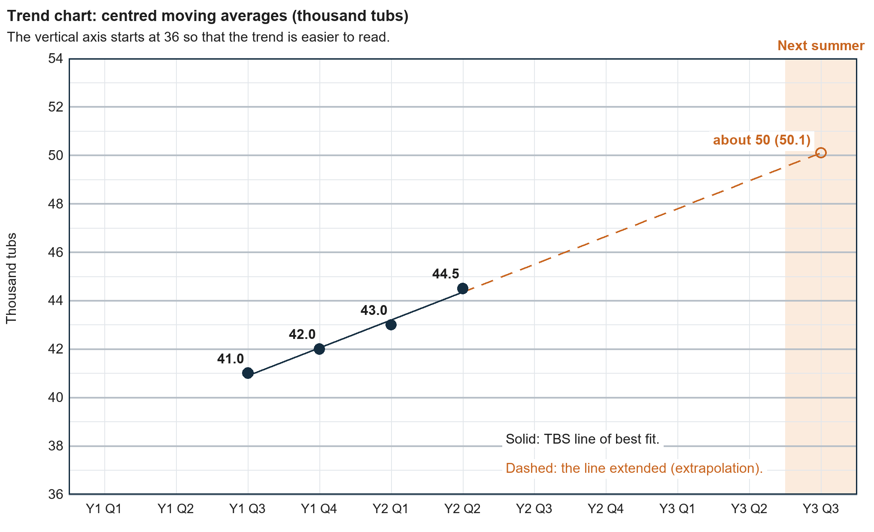
Task 2a: the plotted points are 41.0, 42.0, 43.0 and 44.5. They are not exactly in a straight line, so accept any ruled line with points on both sides of it. The TBS line of best fit (above) rises by about 1.15 thousand tubs a quarter.
Task 2b model answer: About 50 thousand tubs.
Task 2c model answer: 68 - 41.0 = 27 thousand tubs above the trend. Moving averages smooth out the summer peak, so ordering only the trend forecast (about 50 thousand) would leave her short.
Teacher note: the TBS line reads 50.1 at Year 3 Q3; accept 49 to 51 from a sensible line. The trend forecast is the underlying level of sales, not the summer figure. Both summers were far above it, which is why Option A in Task 5 is weak.
Task 3a model answer: Positive: the hotter the week, the higher the sales, about 0.4 thousand (400) more tubs for each 1°C warmer.
Task 3b model answer: 19°C: about 4.6 thousand tubs; 25°C: about 7.0 thousand. Cool summer 13 x 4.6 = 59.8 thousand; hot summer 13 x 7.0 = 91.0 thousand tubs.
Task 3c model answer: About 9.4 thousand tubs. No week was hotter than 28°C, so this extrapolates beyond the data; sales may not keep rising, for example if Megan cannot make enough.
Teacher note: on the TBS line each 1°C adds 0.4 thousand tubs a week, so 19°C reads 4.6, 25°C reads 7.0 and 31°C reads 9.4. Accept readings within 0.2 of these (Q3 totals of about 57 to 62 and 88 to 94 thousand). In Task 3c, also accept that a heatwave may change customer behaviour, or that 13 weeks of one summer are few data.

Answers: Task 4 and Task 5
Task 4a statement | Answer | Discussion point
(i) Points close to a straight line | M | A steady trend is easier to extend.
(ii) Only two years of sales | L | Few points to judge the trend from.
(iii) Five quarters beyond the last moving average | L | The further the extrapolation, the less reliable it is.
(iv) Q3 highest in both years | M or L (reason decides) | M: the pattern is regular, so past data help once the summer peak is added. L: the 50 trend figure leaves out the peak, so on its own it is too low for a summer order.
(v) Sales rise and fall with temperature | L | Summer weather cannot be known in February.
(vi) Rival gelato shop | L | Actions of competitors are not in past sales.
(vii) Families have less to spend | L | An economic variable that past sales may not reflect.
(viii) Dairy-free desserts | L | A consumer trend that may reduce demand.

Task 4b model answer: (v): summer sales depend on the weather, which Megan cannot know in February, so Q3 sales could be anywhere from about 60 to 91 thousand tubs.
Teacher note: accept any statement with a reason tied to the case. Statements (vi) to (viii) link to 2.2.1: consumer trends, economic variables and actions of competitors are things a moving average of past sales cannot show.

Task 5: indicative decision guidance
A well supported answer chooses one option, says how far the forecast can be trusted, uses figures and names two limitations tied to the case. Example response (not a mark scheme): I recommend Option C. The trend forecast of about 50 thousand tubs is too low for summer, because moving averages smooth out the peak: Year 1 Q3 sales were 27 thousand above the trend. Option B's 77 thousand may be closer, but the forecast is weak: it extrapolates five quarters ahead from only two years of data, and weather alone could mean anywhere from 60 to 91 thousand tubs. Ordering 60 thousand now limits waste, and a July top-up protects sales if it is hot.
Students could reasonably choose Option B if they argue that lost summer sales matter more than spare stock: Year 2 Q3 sales were already 74 thousand tubs, so 77 thousand allows for growth. Option A is hard to defend, because 50 thousand tubs is below both previous summers. Other limitations students may use: two years of data are few; a line of best fit assumes the past pattern continues; actions of competitors, economic variables and consumer trends are not in past sales. Look for correct figures, a clear judgement of how far to trust the forecast and a conclusion that depends on the evidence. Do not award a grade or percentage from these tasks.

Answers: exit ticket
a. Model answer: It assumes the past pattern will continue, but competitors, consumer trends or the economy can change.
b. Model answer: (12 + 18 + 21) / 3 = 17, centred on May; (18 + 21 + 27) / 3 = 22, centred on June.
Teacher note: an odd number of periods has a middle month, so a three-period moving average needs no centring.

Sources and limits
Curriculum source: Pearson Edexcel Level 3 Advanced GCE in Business specification, Issue 1, September 2014, Theme 3, section 3.3.1 (printed page 22), with 2.2.1 (printed page 15) and Appendix 3: Quantitative skills (printed page 51). The specification verifies the topic scope only. The tasks, figures, charts, timings and guidance are original TBS teaching design.

