Market research: should Mei open a bubble tea kiosk?
Student tasks | Original TBS lesson for GCSE Business (AQA 8132 content, section 3.5.3 The purpose and methods of market research)
Mei is 19 and wants to open a bubble tea kiosk in the centre of Marrowfield, a UK town. Before she spends her savings she needs to know three things: is there demand, who are the competitors, and who should her target market be? You will plan her research, work out what her survey and other data show, judge how far she can trust the data, and recommend a launch price and a target segment.
Before you start you should know: market research means collecting information about demand, competition and the target market. A market segment is a group of customers with something in common, such as their age. You need a calculator. Give percentages to one decimal place where they are not whole numbers. This is original classroom practice, not an exam paper. Mei, the town, the shops and every figure are fictional.

Starter: which word?
Match each description to one word: primary, secondary, qualitative or quantitative.
Description | Word
(i) Information Mei collects herself for the first time, for example by asking shoppers
(ii) Information that already exists because someone else collected it, such as a newspaper article
(iii) Information about opinions, feelings and reasons, usually in words
(iv) Information in numbers that can be counted, such as how many people said yes

Task 1: what should Mei find out?
Methods Mei could use: questionnaire or survey, interview, focus group, internet research, printed press (for example newspapers).
Market research collects information about three things: demand, competition and the target market.
a. For each thing Mei wants to know, write which of the three it is about, choose the best method from the list, and say whether it is primary or secondary research.
What Mei wants to know | Demand, competition or target market? | Best method | Primary or secondary?
(i) How many shoppers in the town centre would buy bubble tea from a kiosk
(ii) What the nearby drink shops charge for a bubble tea
(iii) Why young people choose one drink shop over another, and which flavours excite them

b. Give one benefit and one drawback of using a focus group for question (iii).

Task 2: what did the survey say?
On one Saturday afternoon, Mei asked 80 shoppers in the town centre: "Would you buy bubble tea from a kiosk here?" Her results are below.
a. Complete the last column. Percentage who said yes = number who said yes / number asked x 100.
Age group | Number asked | Number who said yes | Percentage who said yes
13 to 18 | 20 | 14
19 to 30 | 30 | 18
31 to 50 | 20 | 6
51 and over | 10 | 1
All shoppers asked | 80 | 39

Working space:

b. Which age segment should Mei target first? Use two figures from your table.

c. What percentage of the 39 yes answers came from people aged 13 to 30? Show your working.

Task 3: how much would people pay?
Mei asked the 39 shoppers who said yes one more question: "What is the most you would pay for a regular bubble tea?" Everyone answered. The bar chart shows their answers.
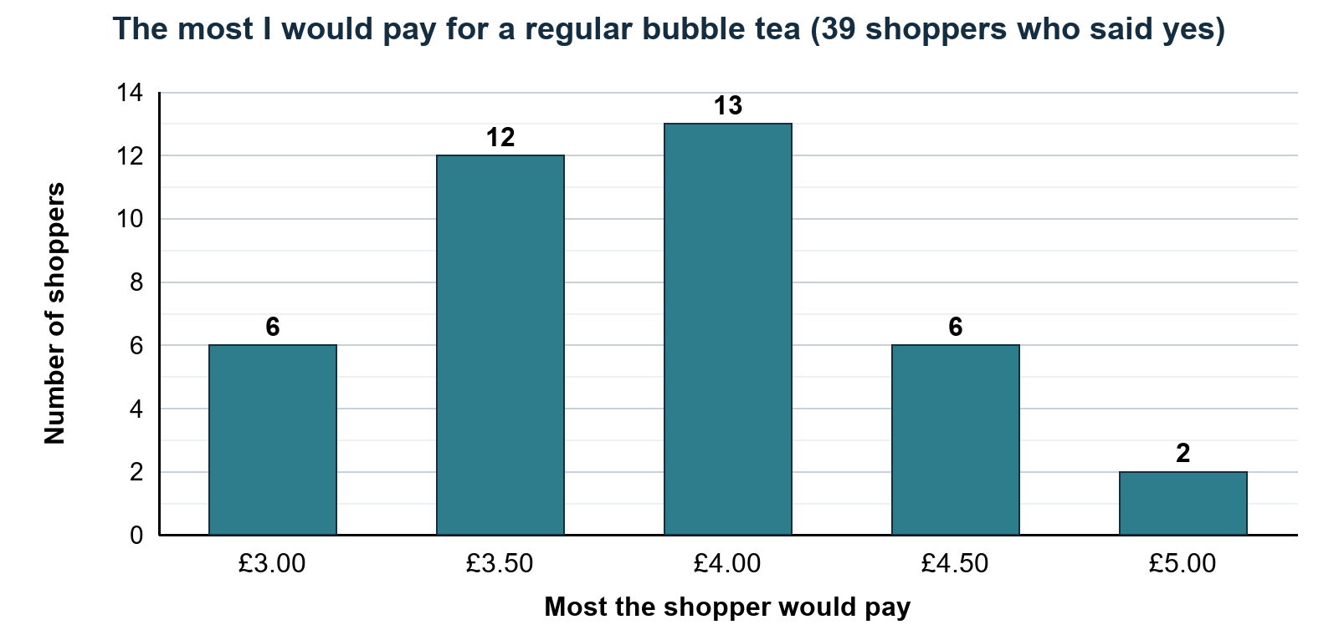
Assume that a shopper who would pay up to £4.50 would also buy at £4.00 or £3.50.
a. How many of the 39 shoppers would still buy at a price of £4.00? What percentage of the 39 is this? Show your working.

b. How many of the 39 would buy at £3.50? What percentage of the 39 is this? Show your working.

c. What happens to the number who would buy as the price rises from £3.50 to £4.00? What does this tell Mei about price and demand?

Task 4: what does the secondary data say?
Mei used internet research to find what the three nearby drink shops charge for a regular bubble tea: Tea Cloud £4.50, Boba Corner £3.90 and Juice Junction £3.60.
She also found a local newspaper article from three years ago. It estimated that the three shops sell about 3,000 bubble teas a week in total, and that Tea Cloud sells about 1,350 of them. Measure market share by the number of drinks sold.
a. Calculate the mean (average) price of a regular bubble tea at the three shops. Show your working.

b. What is the market size in the article, in drinks a week? Calculate Tea Cloud's market share as a percentage. Show your working.

c. Mei is thinking about competitive pricing. What does competitive pricing mean?

Task 5: how far can Mei trust her data? (pairs)
Work with a partner. For each source, decide whether it is primary or secondary and qualitative or quantitative, then agree how far Mei can trust it. Think about how many people were asked, who was asked and how old the information is.
a. Complete the table.
Source | Primary or secondary? | Qualitative or quantitative? | Trust: high, medium or low?
A. Mei's survey: 80 shoppers in the town centre, one Saturday afternoon
B. Focus group: 6 of Mei's friends, all aged 17 to 19, tasting three flavours
C. Rivals' prices for a regular bubble tea, from their websites, checked this week
D. Local newspaper article from three years ago: about 3,000 bubble teas sold a week

b. Choose the source you trust least. Give two reasons.

c. Suggest one way Mei could make her survey more reliable.

Task 6: recommend
Figures to use (check them against your own answers):
Figure | Value
Percentage who said yes, by age | 13 to 18: 70%; 19 to 30: 60%; 31 to 50: 30%; 51 and over: 10%
Share of the 39 yes answers from 13 to 30 year olds | 82.1%
Of the 39, would buy at £3.50 / at £4.00 | 84.6% / 53.8%
Rivals' prices (mean) | £3.60, £3.90 and £4.50 (mean £4.00)
Survey | 80 shoppers, one Saturday afternoon

Write about 80 words recommending to Mei a launch price for a regular bubble tea and the age segment she should target. Use at least two figures. Name one weakness in her research that she should check before she opens.

Exit ticket
a. Give one difference between qualitative and quantitative market research.

b. A survey asked 40 people and 12 said yes. Calculate the percentage who said yes.

