Types of business organisation: should Mei stay a sole trader?
Learner tasks | Original TBS lesson for Cambridge IGCSE Business (0264) / Cambridge IGCSE (9-1) Business (0774), syllabus for exams in 2027, 2028 and 2029, section 1.4.1 Different types of business organisation (not Business Studies 0450)
Mei Tan has run Pandan Lane Bakery in Singapore for eight years as a sole trader: she owns the business on her own and keeps all the profit. Her pandan cakes and buns sell out every morning, so she wants to open two more shops. They will cost about $150,000 to fit out and open, and Mei has $40,000 of savings to put in. Which type of business organisation should she use?
Before you start you should know: unlimited liability means the owners must pay the business's unpaid debts from their personal assets, such as their home and savings. Limited liability means shareholders can lose only the money they paid for their shares. You need a calculator. This is original classroom practice, not an exam paper. Mei, her bakery and every figure are fictional; all amounts are in dollars ($).

Mei's aims and options
Item | Details
Mei's aims | 1. Open two new shops within a year. 2. Keep control of recipes and quality. 3. Not risk losing her flat if the plan fails.
Mei's personal assets | $180,000 outside the business (her share of the family flat and her other savings)
A: stay a sole trader | Mei puts in $40,000 and borrows the rest from a bank. She keeps all the profit and makes every decision.
B: partnership | Her cousin Jun, a trained pastry chef, joins as a partner and also puts in $40,000. They share the profits, the decisions and any unpaid debts equally.
C: private limited company | Mei pays $40,000 for 80% of the shares and her brother Ken pays $10,000 for the other 20%. The company borrows the rest from a bank.

Starter: name the type
Write the type of business organisation for each description. Choose from: sole trader, partnership, private limited company, public limited company, franchise, joint venture.
Description | Type of business organisation
(i) A business owned and controlled by one person.
(ii) Two or more people own a business together and share the profits; it has no shares.
(iii) A company whose shares cannot be sold to the general public.
(iv) A company whose shares can be sold to the general public.
(v) A business pays to use another business's name and way of working.
(vi) Two or more businesses share the costs, risks and profits of one project.

Task 1: what could Mei lose?
Suppose the three shops do badly and the business has to close in two years. It would owe $250,000 to the bank, its suppliers and its landlord, and its assets (ovens, counters and stock) would be sold for $100,000. Mei put in $40,000; her personal assets outside the business are worth $180,000.
Rules: sole traders and partners have unlimited liability, so they must pay unpaid debts from their personal assets. Shareholders have limited liability, so they lose only the money paid for their shares. Assumptions: the debts are the same in every option; in B, Mei and Jun each pay half of any unpaid debts; in C, Mei has not promised any lender to repay the company's debts herself.
a. Calculate the debts that would still be unpaid after the assets are sold.

b. Complete the table. Total Mei could lose = money Mei put in + unpaid debts she pays from her personal assets. Personal assets left = $180,000 - unpaid debts she pays.
Option | Limited or unlimited liability? | Money Mei put in ($) | Unpaid debts Mei pays from her personal assets ($) | Total Mei could lose ($) | Mei's personal assets left ($)
A: sole trader |  | 40,000
B: partnership |  | 40,000
C: private limited company |  | 40,000

Working space:

c. Option A, worse case: suppose the assets sell for only $40,000. Calculate the unpaid debts, how much Mei would pay from her personal assets and how much would still be unpaid.

Task 2: who carries the risk?
Your Task 1 results are shown in the chart (check them against your own). In every option the business still owes $150,000 after its assets are sold. Remember: sole traders and partners have unlimited liability; shareholders have limited liability and lose only the money paid for their shares.
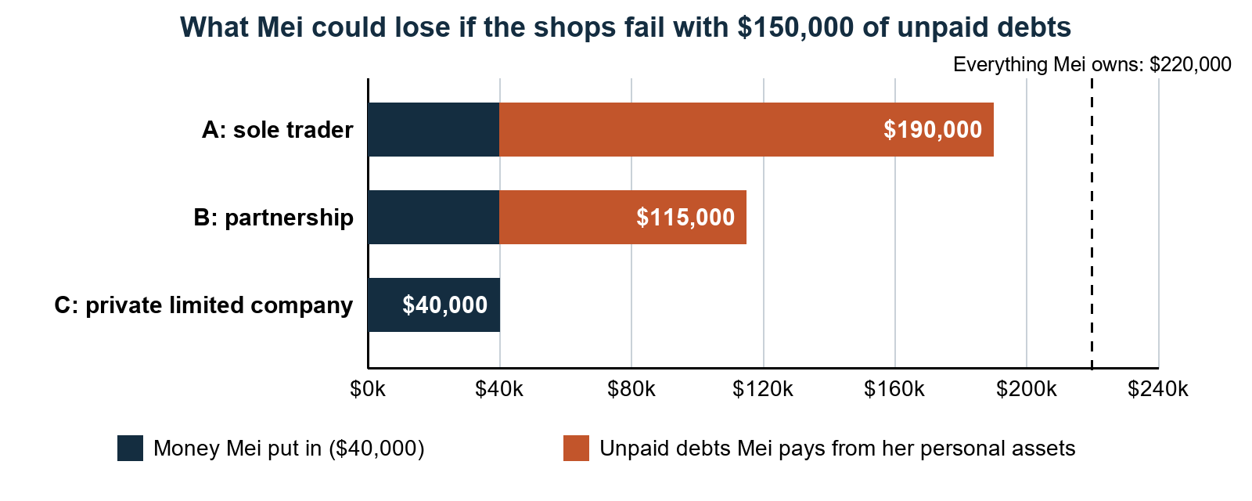
a. In Option C, the company cannot pay $150,000 of its debts, but Mei pays none of it. Who loses this money?

b. Explain why a bank might be more careful about lending to Mei's private limited company than to Mei as a sole trader.

c. Mei's brother Ken is happy to buy shares in Option C, but he would not want to become a partner. Explain why.

Task 3: sort the features (pairs)
With a partner, put a tick under every type of business organisation that has each feature. Some features belong to more than one type.
Feature | Sole trader | Partnership | Private limited company | Public limited company
1. Owned by one person, who keeps all the profit.
2. Two or more owners share the profits and all have unlimited liability.
3. Owners can lose their personal assets if the business cannot pay its debts.
4. Owners can lose only the money they paid for their shares.
5. Shares can be sold to the general public, for example on a stock exchange.
6. Shares cannot be sold to the general public; often owned by a family.
7. Quick and cheap to set up, with few legal forms to complete.
8. The business carries on if one of the owners dies.
9. Other people could buy enough shares to take control from the original owners.

b. Mei's nephew says, "Make Pandan Lane a public limited company and sell shares on the stock exchange." Use the Task 3 table to give two reasons why this is not suitable for Mei.

Task 4: a franchise or a joint venture?
Mei has two other offers that would also give Pandan Lane three shops.
Option D, franchise: Mei stays a sole trader with her own shop and becomes the franchisor. Two bakers would each open a Pandan Lane shop as franchisees. Each franchisee pays for its own shop, pays Mei a fee of $20,000 to start and then 5% of its shop's sales every year, and must use Mei's recipes and name. Each franchise shop expects sales of $300,000 a year (an estimate). Mei is not responsible for a franchisee's debts.
Option E, joint venture: Riverbend Coffee, a chain of coffee shops, would open two bakery cafes with Mei. Each business would put in $75,000, and they would share the costs, risks, profits and decisions equally. Mei has only $40,000 to put in.
a. Calculate how much Mei would receive from the two franchisees in the first year. Show your working.

b. Give one advantage and one disadvantage of the franchise for Mei, the franchisor.

c. Give one advantage and one disadvantage of the franchise for a franchisee.

d. Give one advantage and one disadvantage of the joint venture for Mei.

Task 5: recommend and justify
Mei's aims: open two new shops within a year; keep control of recipes and quality; not risk losing her flat if the plan fails. Figures to use (check them against your own answers):
Option | Figures and facts
A: stay a sole trader | Unlimited liability. If the shops fail, Mei could lose $190,000 and keep only $30,000 of her $180,000 personal assets. She keeps all the profit and makes every decision.
B: partnership with Jun | Unlimited liability. Mei could lose $115,000. Jun puts in $40,000 and is a trained pastry chef; profits and decisions are shared equally.
C: private limited company | Limited liability. Mei could lose $40,000, the money paid for her shares. She owns 80% of the shares and Ken 20%. More legal forms and costs to set up.
D: franchise | Mei receives $70,000 from the two franchisees in the first year and does not pay for the new shops. Franchisees run them using her recipes and name.
E: joint venture with Riverbend Coffee | Mei must put in $75,000 but has only $40,000. Costs, risks, profits and decisions are shared equally with Riverbend.

Write about 80 words recommending and justifying ONE option (A, B, C, D or E) for Mei. Use at least two figures, explain why your choice is better than at least one other option, and name one disadvantage of your choice.

Exit ticket
a. Three partners close their business. After its assets are sold, $45,000 of its debts are still unpaid. The partners share unpaid debts equally. How much must each partner pay from their personal assets?

b. If the business had been a private limited company with three shareholders, how much would each shareholder have to pay towards these debts from their personal assets? Explain.

