Real or nominal? Reading a country's growth figures
Student tasks | Original TBS lesson for A level Economics (Edexcel 9EC0 content, Theme 2, measures of economic performance)
A government minister in Veldia says, "Our economy grew by 8.2% last year." Use the data below to find out what that figure really measures, whether people are better off, and what the minister should have said.
Before you start you should know: nominal GDP is measured at the prices of the year it was produced; real GDP is measured at the prices of one fixed year, so it removes the effect of price changes. Real GDP = nominal GDP / price index x 100. Percentage change = (new - old) / old x 100. You need a calculator. This is original classroom practice, not an exam paper. Veldia and every figure are fictional.

The data
Veldia | Year 1 | Year 2 | Year 3 | Year 4
Nominal GDP (£ billion) | 400 | 428 | 463 | 495
Price index (Year 1 = 100) | 100 | 104 | 110 | 115
Population (millions) | 20.0 | 20.2 | 20.4 | 20.6

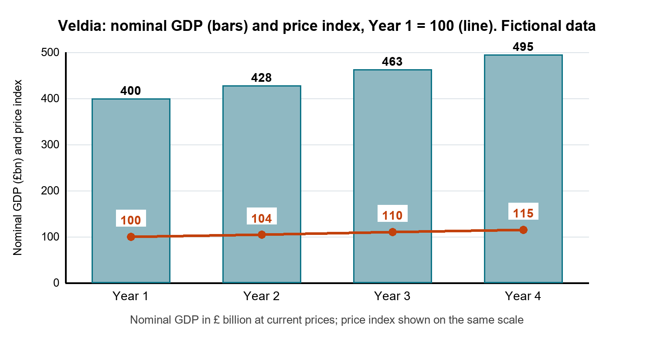
Round real GDP to one decimal place and percentage changes to one decimal place. Use the rounded real GDP figures for later steps.

Starter: which measure?
Write N (nominal) or R (real), and T (total) or P (per person), for each: (i) GDP measured at the prices of the year it was produced ___ (ii) GDP measured at constant prices of a base year ___ (iii) GDP divided by the population ___ (iv) the figure whose rate of change is normally used as the measure of economic growth ___

Task 1: real GDP
Complete the table. Year 1 is the base year, so real GDP is the same as nominal GDP in Year 1.
£ billion | Year 1 | Year 2 | Year 3 | Year 4
Real GDP (Year 1 prices) | 400.0

Show one line of working for Year 2.
________________________________________________________________________________

Task 2: growth and inflation
Calculate each percentage change from the previous year.
% change on previous year | Year 2 | Year 3 | Year 4
Nominal GDP
Real GDP
Price index (inflation)

a. In each year, which is larger, nominal growth or real growth? Explain the gap using the price index.
________________________________________________________________________________
________________________________________________________________________________
________________________________________________________________________________
b. Which rate is the better measure of economic growth, and why?
________________________________________________________________________________
________________________________________________________________________________

Task 3: evaluate the minister's claim
"Our economy grew by 8.2% last year." Assume the minister is talking about Year 3.
a. Which figure from your table is the 8.2%, and is the claim misleading? Explain.
________________________________________________________________________________
________________________________________________________________________________
________________________________________________________________________________
b. Write one sentence the minister could say instead, using the figures.
________________________________________________________________________________
________________________________________________________________________________

Task 4: living standards
a. Calculate real GDP per person for Year 1 and Year 4, in £ per person to the nearest £1 (real GDP in £ billion divided by population in millions, multiplied by 1,000). Then calculate the percentage change.
 | Year 1 | Year 4 | % change
Real GDP per person (£)

________________________________________________________________________________
________________________________________________________________________________
b. Total real GDP grew by 7.6% between Year 1 and Year 4. Why is the per person growth lower?
________________________________________________________________________________
________________________________________________________________________________

Task 5: decide
Did living standards in Veldia improve between Year 1 and Year 4? Write about 100 words. Use at least three figures from your tables, and explain one limitation of using GDP to compare living standards over time.
________________________________________________________________________________
________________________________________________________________________________
________________________________________________________________________________
________________________________________________________________________________
________________________________________________________________________________
________________________________________________________________________________
________________________________________________________________________________
________________________________________________________________________________

Exit ticket
Country Z: nominal GDP rises from £250 billion to £270 billion and its price index rises from 100 to 106.
a. Calculate nominal growth, real GDP in the new year (to one decimal place, in the old prices) and real growth.
________________________________________________________________________________
________________________________________________________________________________
________________________________________________________________________________
b. In one sentence, explain why real growth is so much lower than nominal growth.
________________________________________________________________________________
________________________________________________________________________________

