Real or nominal? Reading a country's growth figures
Teacher guidance and answers | Original TBS classroom practice
Use this lesson after students have met GDP and growth. They deflate nominal GDP with a price index, compare nominal and real growth with inflation, evaluate a political claim and judge living standards using real GDP per person. The tasks are planned to take about 55 minutes and have not been trialled in a classroom. Allow about 65 minutes in the timetable for handing out and feedback. Suitable for classes studying Edexcel 9EC0 Theme 2, in Year 12 or as Year 13 revision.

Curriculum fit
Pearson Edexcel A level Economics A (9EC0), Specification Issue 2, October 2016, Theme 2, section 2.1.1 Economic growth: (a) rates of change of real GDP as a measure of economic growth, (b) the distinction between real and nominal, total and per capita, value and volume, (d) comparison of growth rates over time and (f) the limitations of GDP for comparing living standards over time. Checked against the archived specification; the live Pearson page for the 2015 Economics A specification was opened on 10 October 2026 and showed no withdrawal notice in the fetched text (its notice banner did not render), so please confirm the specification for your cohort with your exams officer. This is a TBS lesson, not a Pearson resource; it is not endorsed by Pearson and uses no Pearson exam questions or mark scheme.
All details and numbers are fictional. The price index is a simple economy-wide index invented for the lesson; it is not the CPI. The answers are indicative teaching guidance only. There is no official mark tariff, level descriptor or AO allocation for these tasks and no grade claim is made.

Lesson plan (about 55 minutes of tasks, estimated)
Stage | Minutes | What happens
Starter: which measure? | 5 | Classify four descriptions.
Task 1: real GDP | 10 | Deflate nominal GDP for Years 2 to 4.
Task 2: growth and inflation | 12 | Nine percentage changes, then explain the gap.
Task 3: the minister's claim | 8 | Identify the 8.2% and rewrite the statement.
Task 4: living standards | 15 | Per person figures, limitations and a written judgement (Task 5 content).
Exit ticket | 5 | Country Z.
Total | 55

45-minute version: starter 4, Task 1 8, Task 2 9, Task 3 6, Tasks 4 and 5 12, exit ticket 6. Give each pair one row of the Task 2 table and share results; ask for about 60 words in Task 5. These 45 minutes are task time only: in a 45-minute period, set the exit ticket as homework. This timing has not been trialled.

Support and extension
Support: complete the Year 2 real GDP calculation with the class (428 / 104 x 100) and show that dividing by the index removes the price rise. Extension: show that nominal growth is roughly real growth plus inflation (Year 3: 2.3 + 5.8 = 8.1, close to 8.2), and ask why the match is only approximate.

Answers: starter and Task 1
Indicative guidance for teachers. This is not an exam board mark scheme and carries no marks or grades.
Starter: (i) N, T; (ii) R, T; (iii) P (per person; it can be nominal or real, so accept N or R with it); (iv) R, T (accept R, P, since growth in real GDP per person is also widely used). Real GDP is the volume measure and nominal GDP the value measure.
Real GDP (£bn, Year 1 prices) | Year 1 | Year 2 | Year 3 | Year 4
Answer | 400.0 | 411.5 | 420.9 | 430.4

Working: Year 2: 428 / 104 x 100 = 411.5; Year 3: 463 / 110 x 100 = 420.9; Year 4: 495 / 115 x 100 = 430.4.
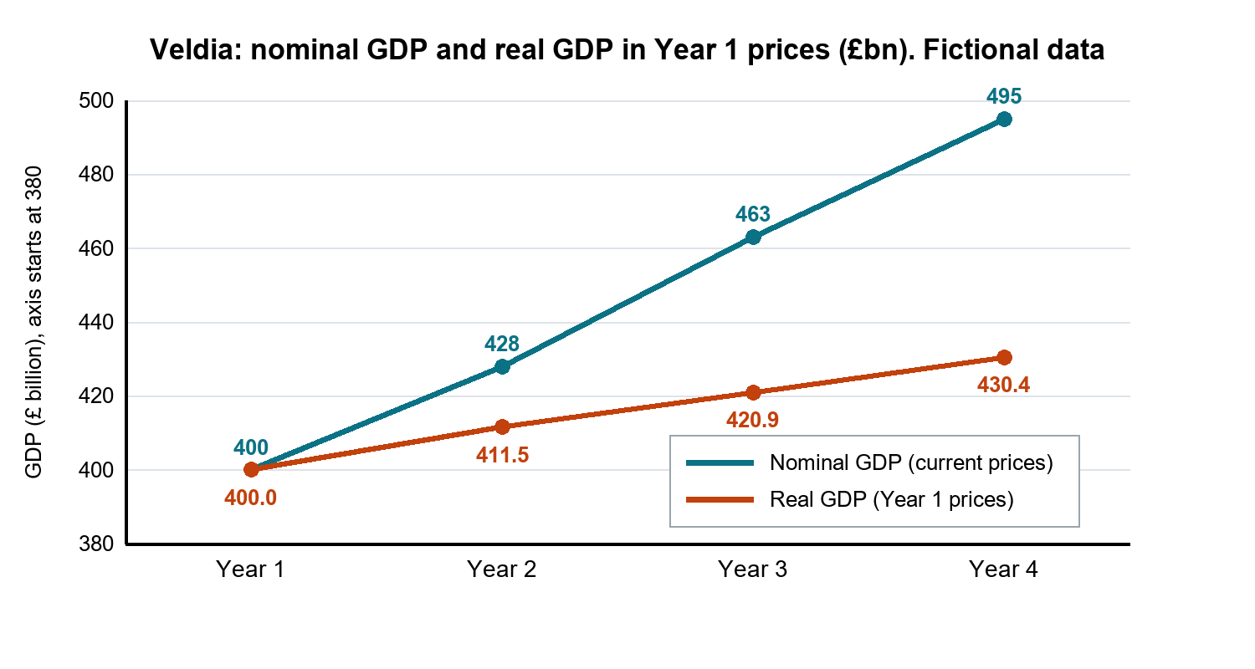

Answers: Task 2
% change on previous year | Year 2 | Year 3 | Year 4
Nominal GDP | 7.0 | 8.2 | 6.9
Real GDP | 2.9 | 2.3 | 2.3
Price index (inflation) | 4.0 | 5.8 | 4.5

Working: nominal (428 - 400) / 400 = 7.0%; (463 - 428) / 428 = 8.2%; (495 - 463) / 463 = 6.9%. Real (411.5 - 400.0) / 400.0 = 2.9%; (420.9 - 411.5) / 411.5 = 2.3%; (430.4 - 420.9) / 420.9 = 2.3%. Inflation (104 - 100) / 100 = 4.0%; (110 - 104) / 104 = 5.8%; (115 - 110) / 110 = 4.5%.
a. Nominal growth is larger every year, because nominal GDP rises when prices rise even if output does not. The gap is about the size of inflation (for example Year 3: 8.2% nominal, 5.8% inflation, 2.3% real). b. Real GDP growth, because it measures the change in the volume of output; the specification names real GDP rates of change as the measure of growth.

Answers: Tasks 3 and 4
Indicative guidance, not an exam board mark scheme.
Task 3a: the 8.2% is nominal GDP growth in Year 3. The claim is misleading: most of it is inflation (5.8%); real output grew by only 2.3%. Task 3b: for example, "Real GDP grew by 2.3% in Year 3, while prices rose by 5.8%." Accept any accurate sentence that uses the real figure.
Task 4a | Year 1 | Year 4 | % change
Real GDP per person (£) | 20,000 | 20,893 | +4.5%

Working: 400.0 / 20.0 x 1,000 = £20,000; 430.4 / 20.6 x 1,000 = £20,893; (20,893 - 20,000) / 20,000 = 4.5%. Accept £20,893 to £20,895 if unrounded real GDP is used.
Task 4b: population grew from 20.0 million to 20.6 million (3.0%), so the extra output is shared between more people: total real output rose by 7.6% but population by 3.0%, so output per person rose by only 4.5%.

Task 5: indicative decision guidance
A well supported answer concludes that average real output per person rose by about 4.5% over three years, so living standards probably improved on this measure, but also that the nominal figures (up 23.8%) would have overstated the gain because prices rose by 15.0% (strong answers may make this comparison, although the tasks do not require it). Strong answers add one limitation of GDP for comparing living standards over time, tied to Veldia: GDP says nothing about how income is distributed (average output per person can rise while many people are no better off); it ignores unpaid work, environmental damage and the quality of goods and services; and it does not measure leisure time or wellbeing. A conclusion such as "probably improved, but GDP per person alone cannot prove it" is strong. Look for correct figures, a clear distinction between nominal and real, one developed limitation and a conclusion that depends on the evidence. Do not award a grade or percentage from these tasks.

Answers: exit ticket
a. Nominal growth (270 - 250) / 250 = 8.0%; real GDP = 270 / 106 x 100 = 254.7; real growth (254.7 - 250) / 250 = 1.9%.
b. Prices rose by 6.0%, so most of the rise in the money value of output came from higher prices, not from producing more.

Sources and limits
Curriculum source: Pearson Edexcel Level 3 Advanced GCE in Economics A (9EC0) specification, Issue 2, October 2016, Theme 2, section 2.1.1 (printed page 12). The specification verifies the topic scope only. The case, figures, timings and guidance are original TBS teaching design.

