Pricing strategies: how should Tidewell price its phone cases?
Learner tasks | Original TBS lesson for International GCSE Business (Pearson Edexcel 4BS1 content, exams from 2027, section 4.3.2 Price; not Cambridge IGCSE)
Tidewell Cases is a small firm in a busy international city. Its owners, Nadia and Kenji, design and make phone cases in a small workshop. They are launching three products: the Everyday case, a basic case sold to phone repair shops; the MagLock case, a new magnetic case that Tidewell has patented, so no other firm can legally copy the design; and the Stall case, sold at a busy street market where other stalls sell similar cases. How should they price each one?
Before you start you should know: cost per item is what it costs Tidewell to make and sell one case. Profit per item = price - cost per item. Markup = profit per item / cost per item x 100. A cost-plus price = cost per item + the markup percentage of that cost added on top. You need a calculator. Give amounts in dollars to two decimal places, for example $7.50. This is original classroom practice, not an exam paper. Tidewell and every figure are fictional; all amounts are in dollars ($).
Assumption for the whole lesson: the cost per item includes every cost of making and selling one case, and it stays the same however many cases Tidewell makes and sells.

Starter: name the strategy
Write the pricing strategy for each description. Choose from: cost plus, penetration, competition, skimming, promotional.
Description | Pricing strategy
(i) Setting a high price when a new product is launched, then lowering it later
(ii) Adding a set percentage (the markup) to the cost per item
(iii) Setting a low price to enter a market and win customers quickly, then raising it later
(iv) Setting a price close to what rival businesses charge for a similar product
(v) Cutting the price for a short time, for example a special offer, to boost sales

Task 1: cost-plus prices
Tidewell adds a markup of 50% to the cost per item of each case. Cost per item = materials + packaging + labour. Profit per item = 50% of the cost per item. Cost-plus price = cost per item + profit per item. The Everyday case is done for you. Complete the table for the MagLock case and the Stall case.
Product ($) | Materials | Packaging | Labour | Cost per item | Profit per item (50% markup) | Cost-plus price
Everyday case | 2.10 | 0.40 | 1.50 | 4.00 | 2.00 | 6.00
MagLock case | 7.20 | 1.30 | 3.50
Stall case | 2.80 | 0.20 | 2.00

Working space:

b. What if? Suppose Tidewell's supplier raised the cost of MagLock materials by $1.20 per case, with everything else the same (only a test: Tasks 5 and 6 use the original cost). Calculate the new cost per item and the new cost-plus price with a 50% markup.

c. Give one advantage of cost-plus pricing for Tidewell.

Task 2: the market stall
Five other stalls at the market sell cases very similar to Tidewell's Stall case. The chart shows their prices: Stall 1 $6.00, Stall 2 $6.50, Stall 3 $7.00, Stall 4 $7.00 and Stall 5 $7.50. The Stall case costs Tidewell $5.00 per item.
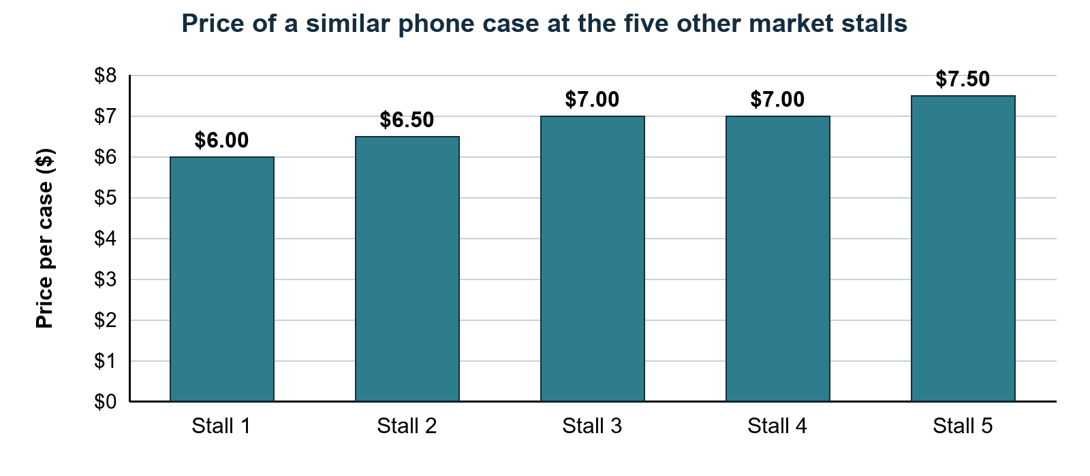
a. Calculate the mean (average) price charged by the five rival stalls. Show your working.

b. In Task 1 you found the cost-plus price of the Stall case: $7.50 (check it against your own). How many of the five rivals charge less than $7.50? How far is $7.50 above the mean rival price?

c. Tidewell decides to use competition pricing and charge $7.00 for the Stall case. Calculate the profit per item and the markup at $7.00. Show your working.

d. Use the market stall to explain one weakness of cost-plus pricing.

Task 3: which strategy fits? (pairs)
Work with a partner. Decide which pricing strategy fits each situation best. Use each strategy once: cost plus, penetration, competition, skimming, promotional.
Situation | Pricing strategy
A. Everyday case: sold to 12 phone repair shops from a price list. Tidewell knows its costs exactly and wants every case to earn the same percentage on top of its cost.
B. MagLock case at launch: Tidewell holds the patent, so no other firm can copy it for now. Some phone fans will pay a lot to have it first.
C. Stall case on a normal day: five other stalls a few metres away sell very similar cases.
D. Stall case on the opening weekend only: Tidewell wants shoppers to notice its new stall and try its cases.
E. Everyday case next year, in a second city where nobody knows Tidewell: it wants to win many customers and a share of the market quickly, then raise the price once the brand is known.

b. Choose situation B or situation C. Explain why the strategy you chose fits better than one other strategy.

c. Explain why penetration would be a poor choice for the MagLock case at launch.

Task 4: test the opening offer
For the opening weekend, Tidewell plans a promotional price: 20% off the Stall case's normal $7.00 price. Kenji estimates 40 sales a day without the offer and 100 with it. The cost per item stays $5.00 either way. Revenue per day = price x cases sold per day. Profit per day = profit per item x cases sold per day. a. Complete the table.
$ | Without the offer | With the 20% offer
Price per case | 7.00
Profit per item
Cases sold per day | 40 | 100
Revenue per day
Profit per day

Working space:

b. Calculate the percentage change in profit per day when the offer is used. Percentage change = (new - old) / old x 100.

c. How many cases would Tidewell need to sell each day at the offer price to make the same profit per day as without the offer? Round up to a whole case.

d. Give one reason why Tidewell might still run the offer.

Task 5: three launch prices for the MagLock
The MagLock case costs $12.00 per item (your Task 1a answer, before the what-if rise in Task 1b; check it against your own). Kenji has estimated how many cases customers would buy each month in the first three months at three possible prices. These are estimates, not facts.
Rule: the workshop can make at most 700 MagLock cases a month, so Tidewell cannot sell more than 700 a month, whatever the demand.
a. Complete the table. Profit per month = profit per item x cases Tidewell can sell per month.
Option | Price | Estimated demand per month | Cases Tidewell can sell per month | Profit per item | Profit per month
Skimming | $30.00 | 300
Cost plus (50% markup) | $18.00 | 600
Penetration | $15.00 | 900

Working space:

b. Which option is held back by the workshop limit? Explain what this means for Tidewell.

Background: a large rival is expected to launch a different magnetic design in about a year. Until then, the patent means no other firm can copy the MagLock.

Task 6: recommend a launch price
Figures to use (check them against your own answers):
MagLock option | Figures
Skimming at $30.00 | 300 sold a month; profit per item $18.00; profit $5,400 a month
Cost plus at $18.00 | 600 sold a month; profit per item $6.00; profit $3,600 a month
Penetration at $15.00 | demand 900 a month, but only 700 can be made; profit per item $3.00; profit $2,100 a month
Other facts | cost per item $12.00; the patent stops other firms copying the design for now; a rival design is expected in about a year

Write about 80 words recommending a launch price and a pricing strategy for the MagLock case. Use at least two figures, compare your choice with at least one other option, and name one risk.

Exit ticket
a. A phone case costs $8.00 per item and sells for $10.00. Calculate the profit per item and the markup. Markup = profit per item / cost per item x 100.

b. Name the pricing strategy. Choose from: cost plus, penetration, competition, skimming, promotional.
Situation | Pricing strategy
A games firm launches a new console at a high price, then lowers the price a year later.

