Break-even and the price decision
Student tasks | Original TBS lesson for A level Business (Edexcel 9BS0 content, Theme 2, financial planning)
Ashby Candles makes scented candles. The owner has two ideas to lift profit. Use contribution, break-even and margin of safety to compare them, then decide which one you would back and what could prove you wrong.
Before you start you should know contribution = selling price - variable cost per unit, and break-even output = fixed costs / contribution per unit. You need a calculator. This is original classroom practice, not an exam paper. Ashby Candles and every figure in it are fictional.

The business today
Monthly position (fictional, £) | Amount
Selling price per candle | £12
Variable cost per candle (wax, wick, jar, label) | £5
Fixed costs per month (rent, insurance, salaried staff, website) | £4,200
Candles made and sold per month | 800

Assume every candle made is sold, the price and variable cost per candle stay constant, and fixed costs stay the same at every output shown. Round break-even upwards to whole candles and give percentages to one decimal place.

Starter: sort the costs
Write F for fixed or V for variable next to each cost for a candle workshop: workshop rent ___ | wax ___ | glass jars ___ | insurance ___ | website hosting ___ | postage paid per order ___

Task 1: where is Ashby Candles now?
a. Calculate the contribution per candle.

b. Calculate the break-even output in candles per month.

c. Calculate monthly profit at 800 candles.

d. Margin of safety = sales - break-even output. Calculate it in candles and as a percentage of current sales.

Task 2: read the chart
The chart shows Ashby Candles as it is today. Chart readings are estimates, so a small difference from your partner is fine. Use the chart to answer these questions, then check one answer by calculation.
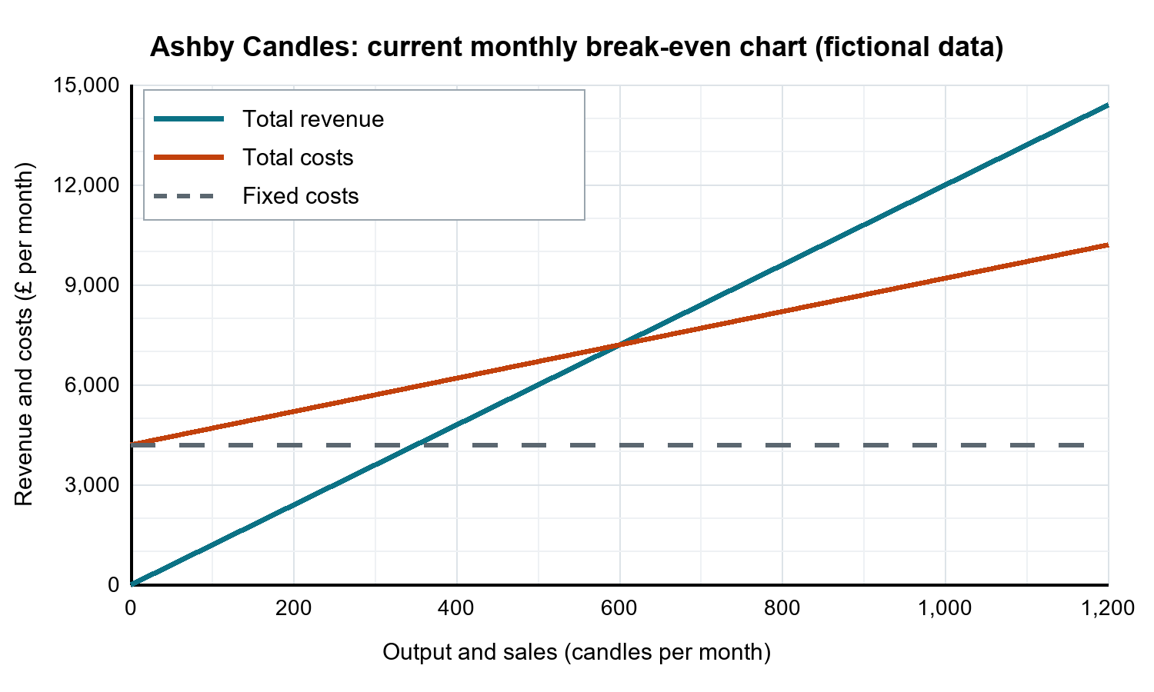
a. Estimate the break-even output and the revenue at that output. Mark the break-even point on the chart.

b. Estimate the profit or loss at 400 candles and at 1,000 candles.

c. Show by calculation that your answer for 1,000 candles is correct.

Task 3: compare the two ideas
The two ideas are separate. Treat each one on its own and start from the business today.
Idea A: cut the price to £10. Variable cost per candle and fixed costs stay the same. The owner expects to sell 1,200 candles a month.
Idea B: keep the price at £12 and spend £600 more each month on advertising, which is a new fixed cost. The owner expects to sell 950 candles a month.
Complete the table | Today | Idea A | Idea B
Contribution per candle (£) | 7
Fixed costs per month (£) | 4,200
Break-even output (candles) | 600
Expected sales (candles) | 800 | 1,200 | 950
Expected monthly profit (£) | 1,400
Margin of safety (candles) | 200
Margin of safety (% of expected sales) | 25.0%

Now test the forecasts.
a. If Idea A only lifts sales to 900 candles, what is the monthly profit?

b. How many candles would Idea A need to sell to earn the same £1,400 profit as today?

c. If Idea B brings no extra sales and stays at 800 candles, what is the monthly profit?

Task 4: decide
Write a recommendation of about 100 words. Use at least three figures from your table or tests. Name one limitation of break-even analysis that could change your decision. You can back either idea or neither, if you justify it.

Exit ticket
a. The break-even point is 600 candles. Why can this alone not prove that a plan will make a profit?

b. At £12 and £5, what is the break-even output if fixed costs fall from £4,200 to £3,500?

