Decision trees: the new musical or the safe tour?
Student tasks | Original TBS lesson for AQA A-level Business 7132 (exam cohorts of 2027, not the new 7138) | Section 3.2.2 Understanding management decision making
Harbour Theatre is a small charity-run theatre. Its mission is to bring new writing to the town, and its trustees want it to avoid losses. The director must choose ONE production for the spring season: a brand new musical, a revival tour of a popular play, or neither.
Before you start you should know: expected value (EV) = the sum of each outcome x its probability. Net gain = expected value - cost. You need a calculator. This is original classroom practice, not an exam paper. Harbour Theatre and every figure are fictional; £k means thousand pounds.

The options
Option | Cost | Possible outcomes (ticket and bar revenue)
A: new musical | £120k | Hit (probability 0.6): £300k. Flop (probability 0.4): £90k
B: revival tour | £60k | Good run (probability 0.8): £150k. Poor run (probability 0.2): £100k
C: do nothing | £0 | £0

The theatre has £100k in reserves.

Starter: which word?
Match each description to risk, reward or opportunity cost.
Description | Word
(i) The possible return from a decision
(ii) The chance that a decision turns out worse than expected
(iii) The next best alternative given up

Task 1: complete the tree
Fill in the four empty boxes on the tree: the expected revenue and the net gain for options A and B.
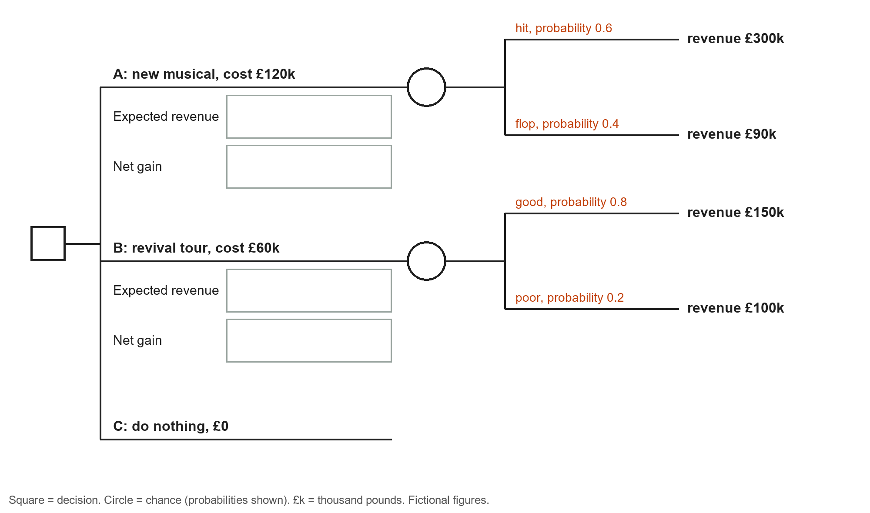
Working space:

Which option has the highest net gain?

Task 2: what could go wrong?
a. Complete the table. Actual result = revenue - cost.
 | Best actual result (£k) | Worst actual result (£k)
A: new musical (cost £120k; revenue £300k or £90k)
B: revival tour (cost £60k; revenue £150k or £100k)

b. Which option could make a loss? Why might the trustees care about this more than about expected values?

Task 3: what if the critics are less keen?
Early previews suggest the probability of a hit for the musical is only 0.4 (so a flop is 0.6). Option B does not change: its net gain is still £80k (check it against your Task 1 answer). Option A still costs £120k, with revenue of £300k for a hit and £90k for a flop.
a. Calculate the new expected revenue and net gain for option A. Which option should the theatre choose now?

b. Stretch: what probability of a hit would make options A and B give the same net gain? Give your answer to two decimal places.

Task 4: beyond the numbers (groups of three)
Each person takes one influence on the decision. Say which option it supports and why. Share your answers with the group.
Mission: to bring new writing to the town.

Objective: the trustees want to avoid losses.

Resources: the theatre has £100k in reserves.

Task 5: decide
Write about 100 words recommending option A, B or C to the director. Use at least three figures from your answers, one influence from Task 4 and one limitation of decision trees.

Exit ticket
a. A project has a 0.7 probability of making £50k and a 0.3 probability of losing £10k. Calculate its expected value.

b. Give one limitation of using a decision tree to make a decision.

