Sales forecasting: how many tubs for next summer?
Student tasks | Original TBS lesson for A level Business (Edexcel 9BS0 content, Theme 3, section 3.3.1 Quantitative sales forecasting)
Shingle Cove Ices makes ice cream in Cornwall and sells it in tubs to cafés, beach kiosks and farm shops. It is February of Year 3. Megan, the owner, must order ingredients and printed tubs for next summer (Year 3 Q3, July to September) now, because her supplier needs about four months' notice. If she orders too little, she loses sales in a heatwave; if she orders too much, cash is tied up in stock that may be wasted. Your job: forecast next summer's sales and judge how far Megan can trust the forecast.
Before you start you should know: a moving average smooths out the ups and downs in a time series so that the trend is easier to see. A four-quarter moving total adds four quarters in a row. Four is an even number, so a four-quarter average falls between two quarters. In this lesson every four-quarter moving average is centred (add two neighbouring four-quarter totals and divide by 8) and given to one decimal place. A three-period moving average has a middle period, so it needs no centring. A line of best fit shows the general pattern of plotted points; extending it beyond the data to estimate the future is extrapolation. You need a calculator and a ruler. Shingle Cove Ices and every figure are fictional. This is original classroom practice, not an exam paper.
Sales (thousand tubs) | Q1 Jan-Mar | Q2 Apr-Jun | Q3 Jul-Sep | Q4 Oct-Dec
Year 1 | 22 | 43 | 68 | 28
Year 2 | 28 | 45 | 74 | 34

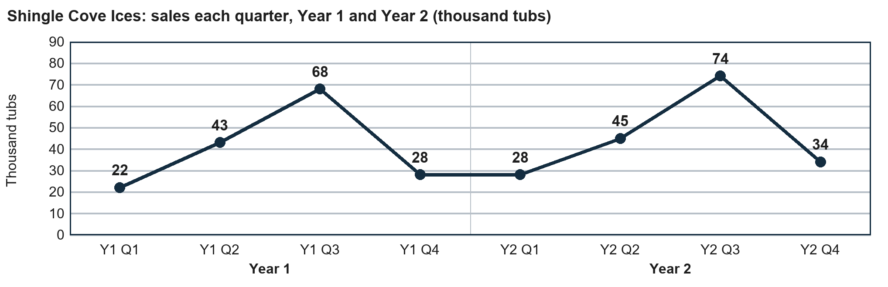

Starter: read the sales
Question | Answer
(i) Which quarter had the highest sales in both years?
(ii) Which quarter had the lowest sales in both years?
(iii) By how many thousand tubs did Q3 sales rise from Year 1 to Year 2?
(iv) Sales fell from 74 to 34 thousand tubs between Year 2 Q3 and Q4. Does this show that the business is shrinking? Answer Yes or No.

Task 1: four-quarter centred moving averages
Sales (thousand tubs): Year 1 Q1 22, Q2 43, Q3 68, Q4 28; Year 2 Q1 28, Q2 45, Q3 74, Q4 34.
a. Complete the four-quarter moving totals. Each total moves on by one quarter. The first one is done for you.
Four quarters added | Four-quarter moving total
1st: Year 1 Q1 to Year 1 Q4 | 22 + 43 + 68 + 28 = 161
2nd: Year 1 Q2 to Year 2 Q1
3rd: Year 1 Q3 to Year 2 Q2
4th: Year 1 Q4 to Year 2 Q3
5th: Year 2 Q1 to Year 2 Q4

b. Centre the totals. Centred total = two neighbouring four-quarter totals added. Centred moving average = centred total / 8, to one decimal place. Year 2 Q3 and Q4 have no centred moving average, because the quarters after them have not happened yet.
Centred on | Totals added | Centred total | Centred moving average
Year 1 Q3 | 1st + 2nd
Year 1 Q4 | 2nd + 3rd
Year 2 Q1 | 3rd + 4th
Year 2 Q2 | 4th + 5th

Working space:

Task 2: plot the trend and extrapolate
Your centred moving averages from Task 1 should be: Year 1 Q3 41.0, Year 1 Q4 42.0, Year 2 Q1 43.0 and Year 2 Q2 44.5 thousand tubs (check them against your own).
a. Plot the four centred moving averages on the grid. With a ruler, draw a line of best fit through them (it does not have to pass through every point) and extend it to Year 3 Q3.
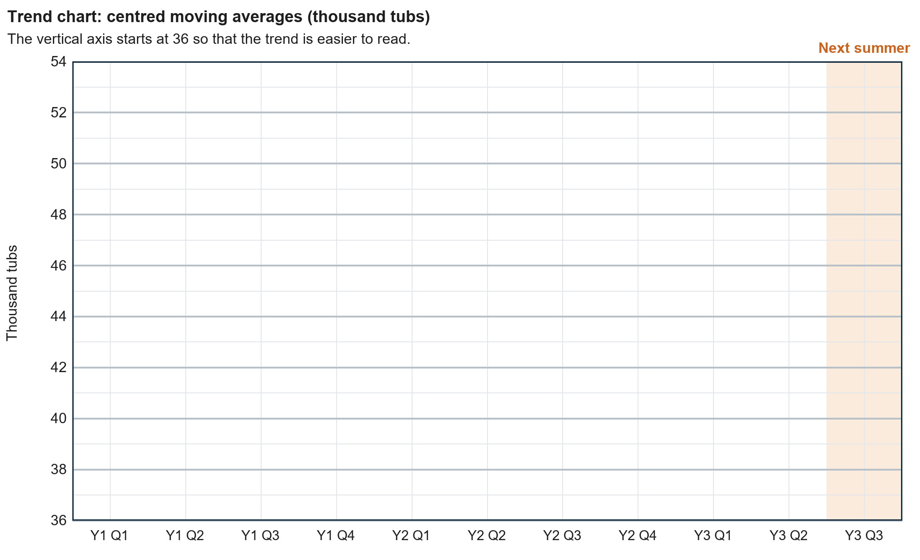
b. Read your line at Year 3 Q3. What is the trend forecast for next summer?

c. In Year 1 Q3, actual sales were 68 thousand tubs but the centred moving average was 41.0. How far above the trend were actual sales? What does this tell Megan about ordering summer stock using the trend forecast alone?

Task 3: does the weather matter?
Megan recorded the sales and the average daily maximum temperature for each of the 13 weeks of Year 2 Q3. Each circle is one week; together the 13 weeks add up to the 74 thousand tubs sold that quarter. The line of best fit is drawn for you. The dashed part extends it beyond the hottest week recorded (28°C).
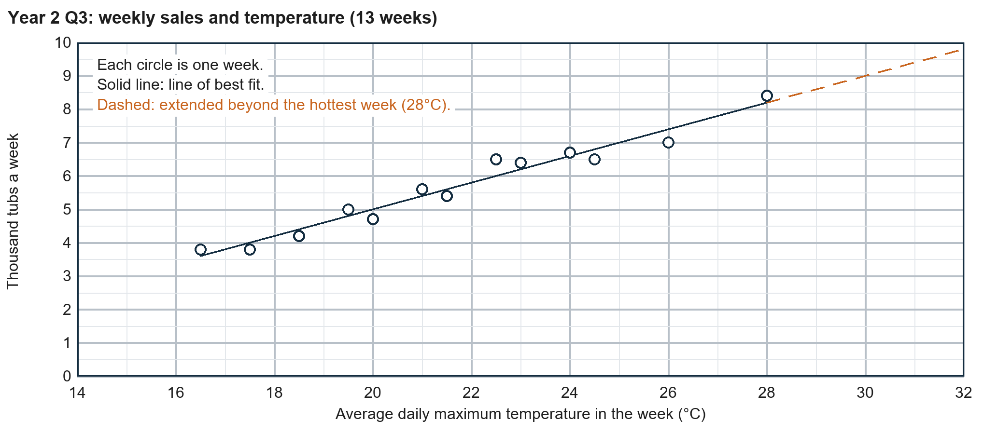
a. Describe the relationship between temperature and weekly sales that the line of best fit shows. Include a figure.

b. Use the line to estimate weekly sales at 19°C (a cool week) and at 25°C (a hot week). Q3 has 13 weeks: estimate Q3 sales if every week were cool, and if every week were hot.

c. Read the dashed line at 31°C. Why is this estimate less reliable than your estimate at 25°C?

Task 4: how far can we trust the forecast? (pairs)
The trend forecast for Year 3 Q3 is about 50 thousand tubs (Task 2; check it against your own). Work with a partner. For each statement, agree whether it gives Megan more or less reason to trust the forecast for next summer, and write M (more trust) or L (less trust).
Statement | M or L
(i) The four centred moving averages lie close to a straight line.
(ii) The forecast is based on only two years of sales.
(iii) Year 3 Q3 is five quarters after the last centred moving average.
(iv) Q3 was the highest quarter in both years.
(v) Weekly summer sales rose and fell with the temperature (Task 3).
(vi) A rival plans to open a gelato shop on the seafront next spring.
(vii) Prices are rising faster than wages, so families have less to spend on treats.
(viii) More customers are choosing dairy-free desserts, which Shingle Cove Ices does not make.

b. Together, choose the ONE statement that most reduces your trust in the forecast. Write its number and explain why.

Task 5: decide
Figures from your earlier answers (check them against your own): the trend forecast for Year 3 Q3 is about 50 thousand tubs; Year 1 Q3 sales were 27 thousand tubs above the centred moving average; Year 2 Q3 sales were 74 thousand tubs; a cool summer (19°C every week) gives about 59.8 thousand tubs and a hot summer (25°C every week) about 91.0 thousand.
Megan is choosing between three orders for Year 3 Q3:
Option | Order for next summer
A | Enough for 50 thousand tubs: the trend forecast.
B | Enough for 77 thousand tubs: the trend forecast plus the 27 thousand by which Year 1 Q3 sales beat the trend.
C | Enough for 60 thousand tubs now (about a cool summer), plus a top-up order in July if the weather is hot. A top-up costs more per tub and takes two weeks to arrive.

Write about 100 words advising Megan which option to choose. Say how far she can trust the forecast, use at least three figures and name at least two limitations of quantitative sales forecasting.

Exit ticket
a. Give one limitation of extrapolating a line of best fit to forecast sales.

b. Megan's new beach kiosk sold these tubs (hundreds): April 12, May 18, June 21, July 27. Calculate the two three-period moving averages and say which month each one is centred on.

