AQA 7136 | EDEXCEL 9EC0
A-Level Economics: The Complete Year
FREE SAMPLE | WEEK 1 OF 30

HOW THIS YEAR WORKS
This is a full first teaching year for A-level Economics: 30 weeks, planned at three timetabled hours a week. Every week has two taught lessons, written out with objectives, timings, a worked task and full answers, and a third hour that runs on the unit question bank, the weekly retrieval starter and, in the closing week of each unit, the unit assessment. Everything needed for the third hour is inside this pack, so the year holds together without any other resource. The Word version makes every page editable, and the PowerPoint carries all 30 retrieval starters with answers, ready to project.
WHICH SPECIFICATION IS THIS FOR?
Written for AQA 7136 and Edexcel 9EC0. Every lesson header carries both references: the AQA section and the Edexcel point, each with its name. The two specifications cover almost the same first year ground in a different order, and this scheme is sequenced so a class on either board follows it straight through.
THE YEAR AT A GLANCE · ALL SIX UNITS
Unit | Weeks | AQA 7136 | Edexcel 9EC0 | Assessed by
1. The economic problem and how markets work | 1 to 5 | 4.1.1 The economic problem, 4.1.3 Price determination, 4.1.4 specialisation | 1.1 Nature of economics, 1.2 How markets work | Unit 1 assessment, 40 marks, week 5
2. Elasticity and markets in action | 6 to 10 | 4.1.3 Price determination in a competitive market | 1.2 How markets work | Unit 2 assessment, 40 marks, week 10
3. Market failure and government intervention | 11 to 15 | 4.1.8 Market failure and government intervention | 1.3 Market failure, 1.4 Government intervention | Unit 3 assessment, 45 marks, week 15
4. Measuring the macroeconomy | 16 to 20 | 4.2.1 Measurement, 4.2.3 Economic performance | 2.1 Measures of economic performance, 2.4 National income | Unit 4 assessment, 45 marks, week 20
5. AD, AS and equilibrium | 21 to 25 | 4.2.2 How the macroeconomy works, 4.2.3 Economic performance | 2.2 to 2.5 Aggregate demand to economic growth | Unit 5 assessment, 50 marks, week 25
6. The policy toolkit | 26 to 30 | 4.2.4 Monetary policy, 4.2.5 Fiscal and supply side policies | 2.6 Macroeconomic objectives and policies | Unit 6 assessment, 50 marks, week 30

UNIT 1: THE ECONOMIC PROBLEM AND HOW MARKETS WORK
Where the course begins: what economics studies, why choice is unavoidable, and how a market turns millions of separate decisions into one price. The unit builds the two diagrams that carry the whole year, demand and supply, and closes with the first 40 mark assessment, which doubles as the year's baseline.
W1L1 · WHAT ECONOMICS STUDIES
AQA 4.1.1 Economic methodology and the economic problem | EDEXCEL 1.1.1 to 1.1.3 Nature of economics
Objective. Distinguish positive from normative statements, and state the economic problem in one sentence.
The hour: retrieval starter and review (10 minutes), teaching (20), the task below worked and marked (25), objective checked against evidence (5).
- Scarcity: wants are unlimited, resources are not. Every economy answers what to produce, how, and for whom.
- The four factors of production: land, labour, capital, enterprise. Their rewards: rent, wages, interest, profit.
- Positive statements can be tested against evidence. Normative statements carry a value judgement: look for ought, should, fair.
- Economists model to simplify. Ceteris paribus holds everything else still so one cause can be studied at a time.
THE TASK: SORTING THE CLAIMS
A radio phone in about fuel prices produces six claims. Students sort each as positive or normative, then justify the two hardest calls.
Item | Detail
Claim A | Petrol duty raised prices at the pump by 4p a litre last month
Claim B | The government ought to cut fuel duty for rural drivers
Claim C | Higher pump prices reduced traffic volumes on motorways
Claim D | It is unfair that fuel takes a bigger share of a low income
Claim E | If duty rises again, demand for rail season tickets will rise
Claim F | Cutting duty would be the wrong signal for the climate

# | Question | Marks
1 | Sort the six claims into positive and normative. | (6)
2 | For claims B and E, justify your sorting in one sentence each. | (4)
3 | State the economic problem, using the word scarcity. | (2)

# | Answer | Working and guidance
1 | A, C, E positive; B, D, F normative | A and C claim testable facts; E is a testable prediction. B and F say ought or wrong; D says unfair. One mark per correct placement.
2 | Model lines | B: ought signals a value judgement, so normative. E: an if then prediction that data could confirm or refute, so positive even though it is about the future.
3 | Model line | Resources are scarce while wants are unlimited, so every choice means giving something up.

W1L2 · OPPORTUNITY COST AND THE PPF
AQA 4.1.1 Economic methodology and the economic problem | EDEXCEL 1.1.4 Production possibility frontiers
Objective. Calculate an opportunity cost, and read production possibilities from a frontier.
The hour: retrieval starter and review (10 minutes), teaching (20), the task below worked and marked (25), objective checked against evidence (5).
- Opportunity cost is the value of the next best alternative given up. It is the price tag scarcity puts on every choice.
- The PPF shows the maximum combinations of two goods an economy can produce with its resources fully employed.
- Points inside the frontier waste resources. Points on it are productively efficient. Points beyond it are unattainable today.
- Moving along the frontier is a trade off measured in the other good, and the frontier makes it visible.
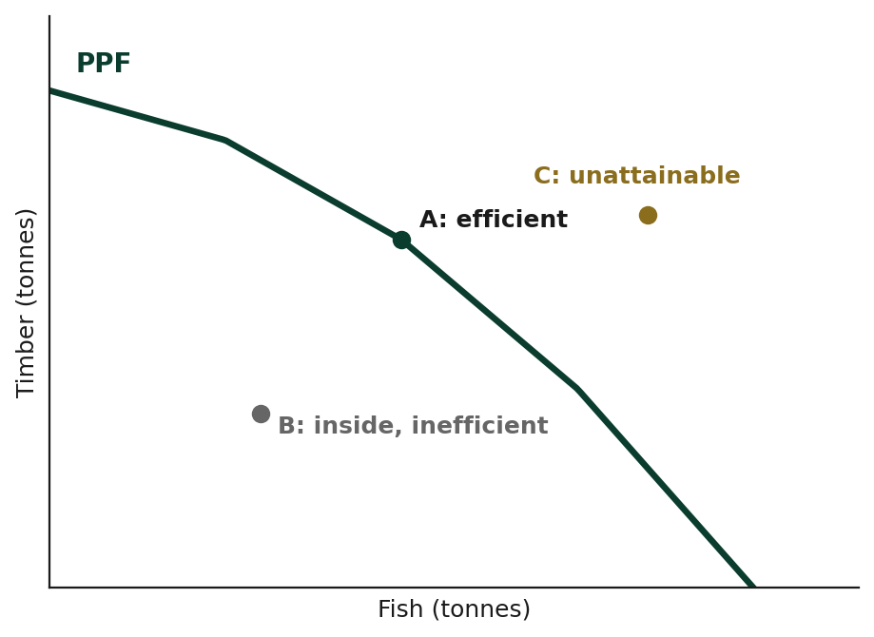
THE TASK: AN ISLAND ECONOMY ON ONE CURVE
An island economy produces fish and timber. With all resources employed it can reach these combinations in a season.
Item | Detail
Option A | Fish 0 tonnes, timber 40 tonnes
Option B | Fish 10 tonnes, timber 36 tonnes
Option C | Fish 20 tonnes, timber 28 tonnes
Option D | Fish 30 tonnes, timber 16 tonnes
Option E | Fish 40 tonnes, timber 0 tonnes

# | Question | Marks
1 | Calculate the opportunity cost of moving from A to B, and from D to E. | (4)
2 | Explain what the pattern in your two answers shows, and name the property. | (3)
3 | The island currently produces 20 tonnes of fish and 20 tonnes of timber. Describe this point. | (2)
4 | Give one change that could shift the whole frontier outward. | (2)

# | Answer | Working and guidance
1 | 4 tonnes of timber; then 16 tonnes of timber | A to B: timber falls 40 to 36 for the first 10 tonnes of fish. D to E: timber falls 16 to 0 for the last 10 tonnes.
2 | Rising opportunity cost | Each extra 10 tonnes of fish costs more timber than the last: 4, 8, 12, 16. Resources are not equally suited to both uses, so the frontier bows outward.
3 | Inside the frontier | At 20 tonnes of fish the frontier allows 28 tonnes of timber; producing only 20 leaves resources unemployed or misused, so the point is productively inefficient.
4 | Model line | More or better resources, or better technology: for example new boats, faster saws, or training that raises productivity in either industry.

RETRIEVAL STARTER · WEEK 1
Five questions with answers.
WEEK 1
# | Question | Answer
1 | Define scarcity. | Unlimited wants meeting limited resources.
2 | Name the four factors of production. | Land, labour, capital, enterprise.
3 | Positive or normative: The state should fund all universities. | Normative: should marks a value judgement.
4 | What does ceteris paribus mean? | All other things held equal.
5 | State the reward to enterprise. | Profit.

THE PRACTICE HOUR · QUESTION BANK EXTRACT
# | Question | Marks | Answer and guidance
A1 | State the economic problem in one sentence. | (2) | Unlimited wants meet scarce resources, so choices must be made. Both halves needed.
A2 | Name the four factors of production and one reward each. | (4) | Land: rent. Labour: wages. Capital: interest. Enterprise: profit.
A3 | Positive or normative: The minimum wage should rise faster than inflation. Justify. | (2) | Normative: should signals a value judgement, not a testable claim.

The other 29 weeks of the full product are built exactly like this one.
Author: Sakari Laajoki · TBS Education Ltd Oy (company number 3614159-3)
© 2026 Sakari Laajoki

