Decision trees: the new musical or the safe tour?
Teacher guidance and answers | Original TBS classroom practice
Use this lesson when teaching decision trees and influences on decision making. Students complete a decision tree, compare expected values with the actual best and worst results, test how a lower probability changes the choice and weigh the mission, objectives and resources of a small theatre. The tasks are planned to take about 55 minutes and have not been trialled in a classroom. The minutes include brief answer checking but not handing out materials or a full plenary; allow about 65 minutes in the timetable. Best suited to Year 13 classes taking AQA 7132 exams in 2027; Year 12 classes starting in September 2026 follow the new 7138 specification.

Curriculum fit
AQA AS and A-level Business specification (covers 7131 and 7132; this lesson is for A-level 7132), Version 2.0, 14 June 2023, section 3.2.2 Understanding management decision making (printed page 14): the value of decision making based on data, including interpreting decision trees and calculating expected value and net gains; risks, rewards, uncertainty and opportunity cost; the use and value of decision trees; and influences on decision making, including mission, objectives, ethics, the external environment and resource constraints. This lesson is NOT mapped to the new 7138 specification; check that specification before using it with a 7138 class. This is a TBS lesson, not an AQA resource; it is not endorsed by AQA and uses no AQA exam questions or mark schemes.
All details and numbers are fictional. The answers are indicative teaching guidance only. There is no official mark tariff, level descriptor or AO allocation for these tasks and no grade claim is made.

Lesson plan (about 55 minutes of tasks, estimated)
Stage | Minutes | What happens
Starter: which word? | 5 | Match three terms.
Task 1: complete the tree | 10 | Expected revenue and net gain.
Task 2: what could go wrong? | 7 | Best and worst actual results.
Task 3: less keen critics | 10 | New probability; stretch tipping point.
Task 4: beyond the numbers | 9 | Groups of three: mission, objective, resources.
Task 5: decide | 10 | Written recommendation.
Exit ticket | 4 | Two quick questions.
Total | 55

45-minute version: starter 4, Task 1 8, Task 2 6, Task 3 8 (skip part b), Task 4 7, Task 5 8, exit ticket 4. Ask for about 60 words in Task 5. This timing has not been trialled. The 45 minutes are task time only, so in a real 45-minute period, with handing out and feedback, move the exit ticket to homework.

Answers: starter, Task 1 and Task 2
Indicative guidance for teachers. This is not an AQA mark scheme and carries no marks or grades.
Starter: (i) reward; (ii) risk; (iii) opportunity cost.
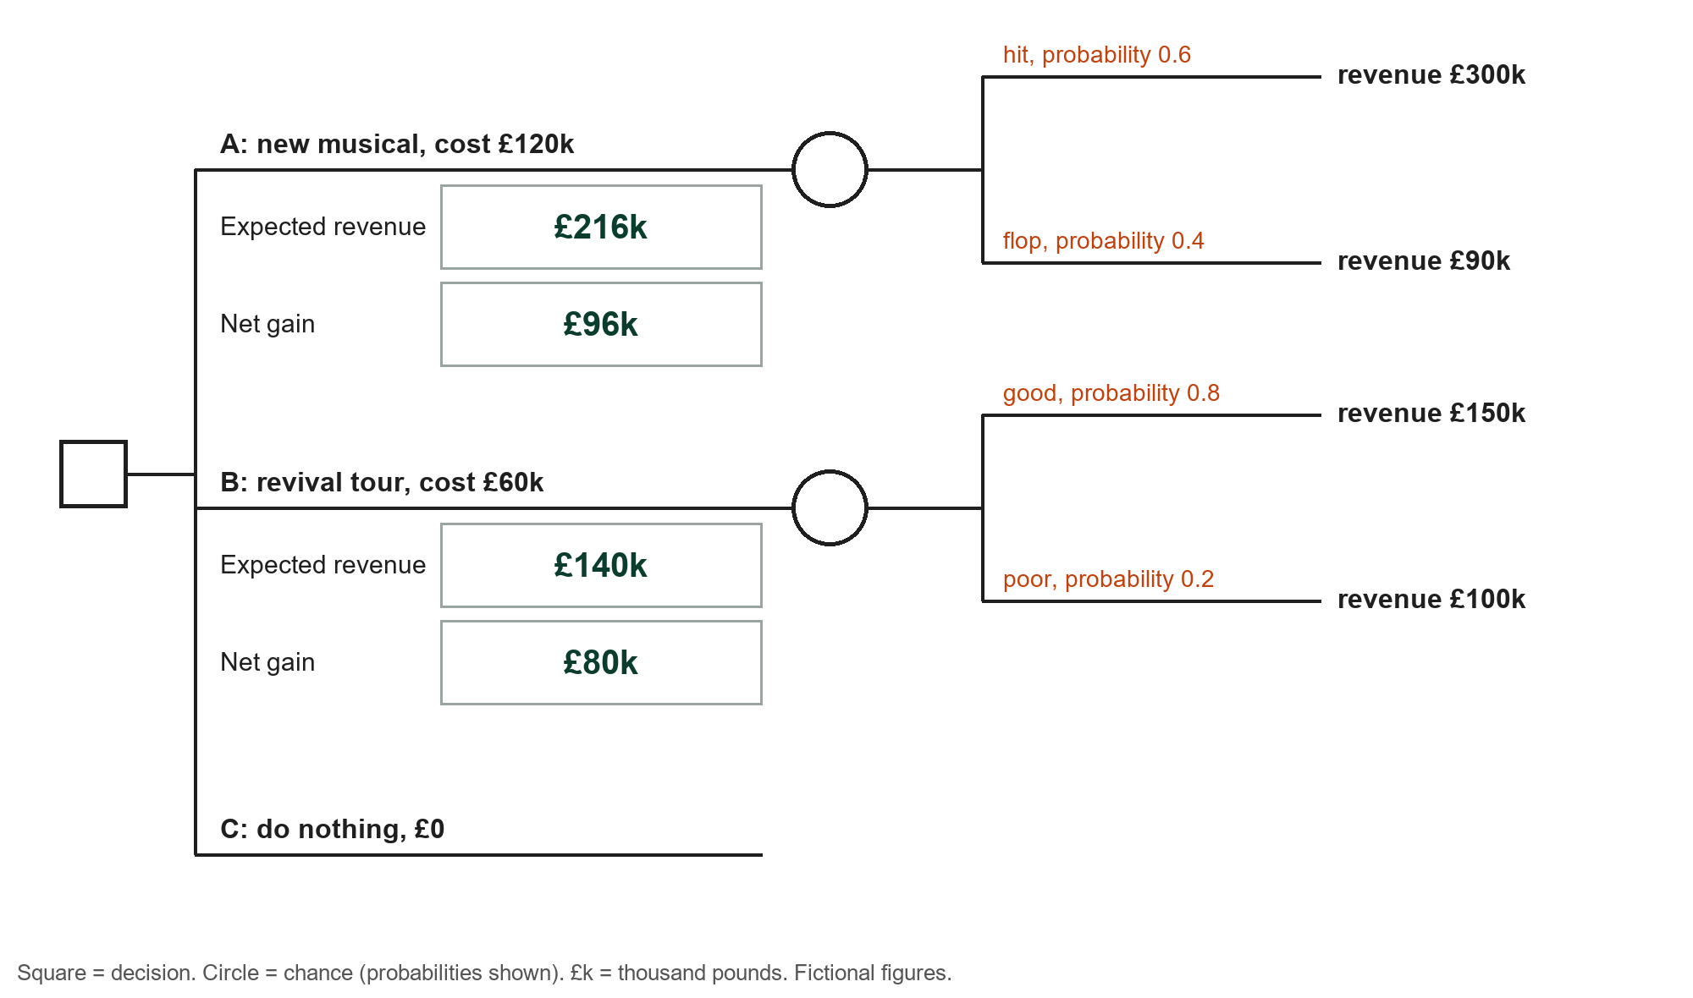
Task 1 working: A: 0.6 x 300 + 0.4 x 90 = 180 + 36 = £216k; net gain 216 - 120 = £96k. B: 0.8 x 150 + 0.2 x 100 = 120 + 20 = £140k; net gain 140 - 60 = £80k. C: £0. Option A has the highest net gain (£96k). Common errors: forgetting to subtract the cost; adding probabilities to revenues; choosing on expected revenue (£216k) rather than net gain.
Task 2a | Best actual result | Worst actual result
A: new musical | 300 - 120 = £180k | 90 - 120 = -£30k (a loss)
B: revival tour | 150 - 60 = £90k | 100 - 60 = £40k

Task 2b: only option A can make a loss (£30k). The expected value is an average over many similar decisions, but the theatre makes this decision once; trustees who must avoid losses, and who have only £100k of reserves, may prefer B, which makes at least £40k in either outcome.

Answers: Task 3, Task 4 and Task 5
Task 3a: 0.4 x 300 + 0.6 x 90 = 120 + 54 = £174k; net gain 174 - 120 = £54k. B (£80k) now has the higher net gain, so the theatre should choose B on the numbers.
Task 3b: let p be the probability of a hit. A gives 300p + 90(1 - p) - 120 = 210p - 30. Set equal to 80: 210p = 110, so p = 110 / 210 = 0.52 (0.5238). If the chance of a hit is above about 0.52, A has the higher net gain.
Task 4, accept reasoned answers: mission (new writing) supports A, because only the new musical is new writing; the objective of avoiding losses supports B, because B cannot make a loss while A could lose £30k; resources support B: A costs £120k but reserves are only £100k, while B's £60k can be paid from reserves.

Task 5: indicative guidance
A well supported answer chooses, uses figures, an influence and a limitation. Example response (not a mark scheme): I recommend the revival tour (B). The musical has the higher net gain (£96k against £80k), but only if the chance of a hit is above about 0.52, and early previews suggest 0.4, which gives just £54k. The musical could also lose £30k and costs £120k when the theatre has only £100k, while the tour makes at least £40k. The mission favours the musical, so the theatre could plan new writing next year. A decision tree relies on estimated probabilities and revenues, so the result is only as good as those estimates.
Students may choose A if they give weight to the mission and argue the theatre can raise the extra £20k; credit that if it uses figures and recognises the risk. Look for correct figures, a clear weighing of numbers against influences, a limitation and a justified conclusion. Do not award a grade or percentage from these tasks.

Answers: exit ticket
a. 0.7 x 50 + 0.3 x (-10) = 35 - 3 = £32k. b. Any one: probabilities and outcomes are estimates and may be wrong; it ignores qualitative factors such as the mission, staff morale or reputation; expected value is an average, but a one-off decision gets only one actual outcome; it can oversimplify a decision with more possible outcomes.

Sources and limits
Curriculum source: AQA AS and A-level Business specification (7131, 7132), Version 2.0, 14 June 2023, section 3.2.2 (printed page 14). The specification verifies the topic scope only. The case, probabilities, figures, timings and guidance are original TBS teaching design.

