After the ferry: unemployment in a coastal town
Student tasks | Original TBS lesson for A level Economics (Edexcel 9EC0 content, Theme 2, section 2.1.3 Employment and unemployment)
Brinmouth is a small coastal town. Last year its ferry terminal closed, and with it the jobs on the ferries, at the port and in the ticket office. The council has money for one policy to help. Measure what happened to the town's labour market, find the causes of its unemployment and decide which policy would help most. You need a calculator. This is original classroom practice, not an exam paper. The town, the people and every figure are fictional.

The town's labour market
People aged 16-64 | Last year (terminal open) | This year (after closure)
Population aged 16-64 | 40,000 | 39,000
Employed | 30,400 | 27,807
ILO unemployed (Labour Force Survey) | 1,600 | 2,418
Economically inactive | 8,000 | 8,775
Claimant count | 1,200 | 1,950
Part-time workers who want a full-time job | 900 | 1,600

Employed + ILO unemployed + economically inactive = population aged 16-64. The last two rows count people already included above.
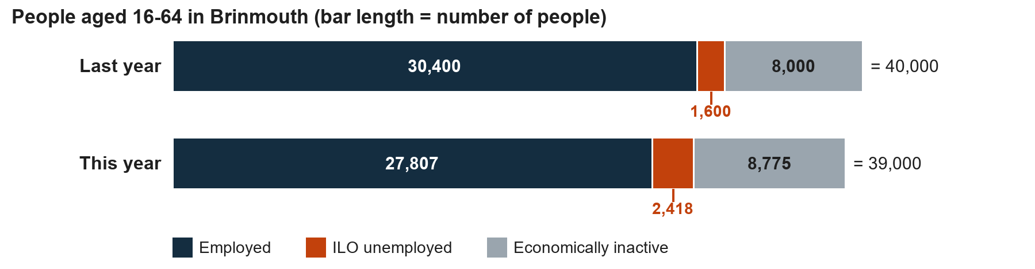

Starter: which measure?
Write the matching term from this list: claimant count, ILO unemployed, economically inactive, under-employed.
Description | Term
(i) No job, has looked for work in the past four weeks, can start within two weeks
(ii) The number of people claiming benefits because they are unemployed
(iii) Aged 16-64, no job and not looking for one, such as a full-time student
(iv) Has a job, but wants more hours than they can get

Task 1: what happened to the rates?
Use these rules. Economically active = employed + ILO unemployed. Employment rate = employed / population aged 16-64 x 100. Unemployment rate = ILO unemployed / economically active x 100. Inactivity rate = economically inactive / population aged 16-64 x 100. In this lesson all three rates use people aged 16-64. Give rates to one decimal place.
a. Complete the table.
People aged 16-64 | Last year | This year
Population aged 16-64 | 40,000 | 39,000
Employed | 30,400 | 27,807
ILO unemployed | 1,600 | 2,418
Economically inactive | 8,000 | 8,775
Economically active
Employment rate (%)
Unemployment rate (%)
Inactivity rate (%)

Working space:

b. By how many percentage points did the unemployment rate change? What was the percentage change in the unemployment rate? (A percentage point change is the difference between two percentages; a percentage change compares the change with the starting value.)

Task 1 (continued)
c. Employment fell by 2,593 (30,400 to 27,807), but ILO unemployment rose by only 818 (1,600 to 2,418). The population aged 16-64 fell from 40,000 to 39,000 and inactivity rose from 8,000 to 8,775. Where did the other people go?

Task 2: which measure tells the truth?
People aged 16-64 | Last year | This year
ILO unemployed (Labour Force Survey) | 1,600 | 2,418
Claimant count | 1,200 | 1,950
Part-time workers who want a full-time job | 900 | 1,600

a. How many more people does the ILO measure count than the claimant count in each year?

b. Give two reasons why the claimant count in the town is lower than the ILO measure.

c. Which measure gives the better picture of unemployment in the town? Give a reason.

Task 2 (continued)
d. 900 people last year and 1,600 this year worked part-time but wanted a full-time job. Are they unemployed? Explain the difference between unemployment and under-employment, using these figures.

Task 3: card sort (pairs)
Work in pairs. Each partner sorts four cards, then swap and check each other's. Agree the cause of unemployment on each card and write it in the Cause column. Causes: structural, frictional, seasonal, demand deficiency (cyclical), real wage inflexibility. Some causes are used more than once.
Card | Situation | Cause
A | Mark was a ferry deckhand for 15 years. The terminal has closed. The new jobs in town are in care work and IT, which need training he does not have.
B | The beach café closes from November to March and lays off its four summer staff every year.
C | Priya finished her degree in June. She is spending a few weeks choosing between two job offers.
D | With less wage income being spent in the town, two high-street shops sell less and cut staff.
E | The ferry ticket office staff are skilled, but the only jobs that use their skills are at a port 200 miles away.
F | Local hotels say they would hire more cleaners if pay could fall, but agreed pay rates keep wages above the level at which everyone who wants a cleaning job is hired.
G | Tom left his job in another town to move back home. He has applied for several jobs and has two interviews next week.
H | A recession cuts spending across the whole UK economy, and a factory near the town stops taking on workers.

Task 3 (continued)
b. The town's unemployment rate rose from 5.0% to 8.0% (check this against your own Task 1 answer). Which two causes best explain the rise? Use the cards.

Task 4: three policies
The council can afford only one of these policies. All costs are paid by government, and all figures are estimates.
Policy | What it is | Cost and expected effect
A. Skills centre | Interventionist supply-side policy to improve skills and quality of the labour force: courses in care, IT and construction | £6 million over three years; trains 1,200 adults; the council expects 2 in 3 of them to find work
B. New road link | Supply-side policy to improve infrastructure: a fast road to a city 25 miles away | £36 million; takes four years to build; expected to let 1,200 residents travel to jobs in the city
C. Seafront rebuild | Fiscal policy: government spending on rebuilding the seafront and promenade | £10 million; creates 500 building and tourism jobs that last two years

a. Complete the table. Cost per expected job = cost / number of people expected to find work. Assume none of these people would have found work without the policy.
Policy | Cause of unemployment it mainly targets | Cost per expected job (£)
A. Skills centre
B. New road link
C. Seafront rebuild

Working space:

Task 4 (continued)
b. Policy C (£10 million for 500 jobs that last two years) is a demand-side policy. Give one strength and one weakness of it for this town.

Task 5: decide
Key figures (check them against your own): unemployment rate 5.0% last year and 8.0% this year; cost per expected job A £7,500, B £30,000, C £20,000. Policy A takes three years, policy B four years to build, and policy C's jobs last two years.
Which one policy would best help Brinmouth? Write about 100 words. Use at least two figures, say which cause of unemployment your policy targets and name one risk.

Exit ticket
a. A town has 50,000 economically active people, of whom 2,250 are ILO unemployed. Calculate the unemployment rate.

b. A full-time college student is not looking for work. Is the student unemployed? Explain in one sentence.

